**ICECAPS-ACE Weekly Report**

January 4th – January 10th, 2021

Heather Guy

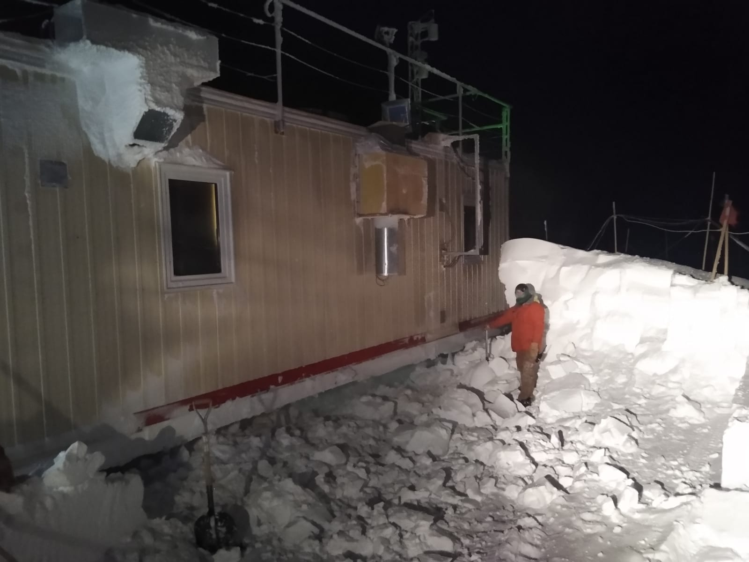

The drift on the south side of the MSF is gone!

After a snow-beast effort with the help of mechanic Justin Ryks on 2021-01-07*.*

*Photo: Justin Ryks*

**General Notes:**

A breezy week a with a couple of welcome (but cold) clear sky days on the 8th and 9th. I made progress on HATPro troubleshooting, confirming that the internal computer flash drive is functioning correctly and receiving 5.2V when the instrument is powered up. On Thursday afternoon Justin and I brought the snow-beast out to the MSF and knocked the drift on the south side of the building back to the building base, hopefully this effort will prevent drift related data issues for the rest of the season.

**General Weather Observations:**

|  |  |  |  |  |  |  |  |
| --- | --- | --- | --- | --- | --- | --- | --- |
| **Date** | **Time (Z)** | **Wind** | **Weather** | **Visibility** | **Sky** | **Temp (C)** | **Notes** |
| 01-04 | 12 | 10 kts at 317 |  | 800 | BKN041 | -43 |  |
| 01-05 | 12 | 12 kts at 180 | BR, DRSN | 800 | BKN065 | -47 |  |
| 01-06 | 12 | 12 kts at 213 | BR, -SN | 800 | BKN017 | -49 |  |
| 01-07 | 12 | 15 kts at 211 | BLSN | 800 | VV024 | -29 |  |
| 01-08 | 12 | 10 kts at 008 |  | 9999 | FEW | -54 |  |
| 01-09 | 12 | 15 kts at 292 |  | 9999 | SKC | -51 |  |
| 01-10 | 12 | 16 kts at 166 | DRSN | 9999 | BKN011 | -38 |  |

**Significant Weather Observations:**

* 2021-01-04 1030Z: Moon halo.
* 2021-01-05 1830Z: Rave ice.
* 2021-01-07 1200Z: Rave ice.

**MSF**

* 2021-01-06 1400Z: Tested MSF automatic temperature email alerts – working OK.
* 2021-01-07 1648-1800Z: Removed south MSF drift with the snow beast.
* Operating normally

**ICECAPS-ACE Data Management:**

* 01-04: Data transfer completed at 0513Z. IceCAM files not transferred.
* 01-05: Data transfer completed at 0549Z. 13 files not transferred due to ‘lost connection’.
* 01-06: Data transfer completed at 0441Z. All files caught up, including IceCAM.
* 01-07: Data transfer completed at 0435Z.
* 01-08: Data transfer completed at 0444Z.
* 01-09: Data transfer completed at 0435Z.
* 01-10: Data transfer completed at 0435Z.

**TSI:**

* Offline for the winter season.

**Radiosonde:**

* 2021-01-04: Replaced base station cabinet air filter.
* Once daily launches.
* See chart below for temperatures outside radiosonde cabinet over the last week.

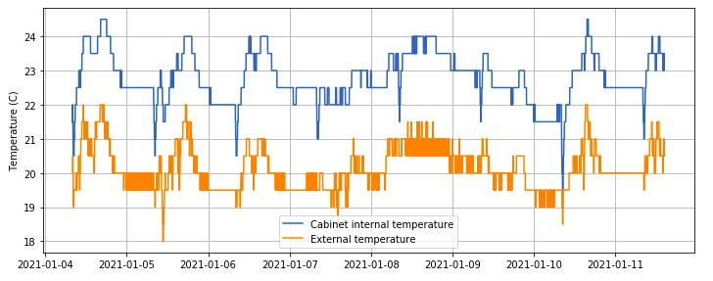

**MWR:**

* 2021-01-07 1841-1847Z: Paused 150-90 data collection whilst testing HATPro serial port.
* RPG-150-90 operating normally.
* HATPro troubleshooting ongoing: This week I confirmed that the internal flash computer drive is functioning correctly and that 5.2V is reaching the internal computer when the instrument is powered up. Still no response from the serial port.

**SODAR:**

* 2021-01-04 1400-1417Z: Cleaned and leveled the SODAR dishes.
* Operating normally.

**POSS:**

* Operating normally.

**MASC:**

* Offline for winter season.

**MMCR:**

* 2021-01-06: Cleared LabView error 7.
* 2021-01-07: Cleared LabView error 7.
* 2021-01-09 1245Z: Replaced desiccant.
* Operating normally.

**CAPABL:**

* 2021-01-07 1742-1748Z: Powered down laser to clear window after snow beasting.
* Operating normally.

**MPL:**

* No change to MSF window condition.
* Operating normally.

**CEILOMETER:**

* Operating normally.

**PAERI:**

* 2021-01-07 1650-1750Z: Paused PAERI data acquisition and covered hatch whilst snow beasting the south MSF drift.
* 2021-01-08 to 2021-01-09: Occasional maxsampleStdDev red flags due to cold temperatures.
* WSU online quick looks not updating as of 2021-01-04.
* Operating normally.

**IceCAM:**

* Operating normally.

**IcePIC:**

* No IcePICs this week ☹

**CPC:**

* Offsite for repairs.

**MSF - OPC:**

* Operating normally.

**TAWO - OPC:**

* Operating normally

**SKYOPC:**

* 2021-01-09: SKYOPC pump failed overnight. Broken carbon vanes.
* Currently offline pending pump repair and troubleshooting.

**Fluxtower instrument suite:**

* Operating normally.

**Radiometers:**

* Solar tracker misalignment persists, otherwise operating normally.