**ICECAPS-ACE Weekly Report**

January 18th – January 24th, 2021

Heather Guy

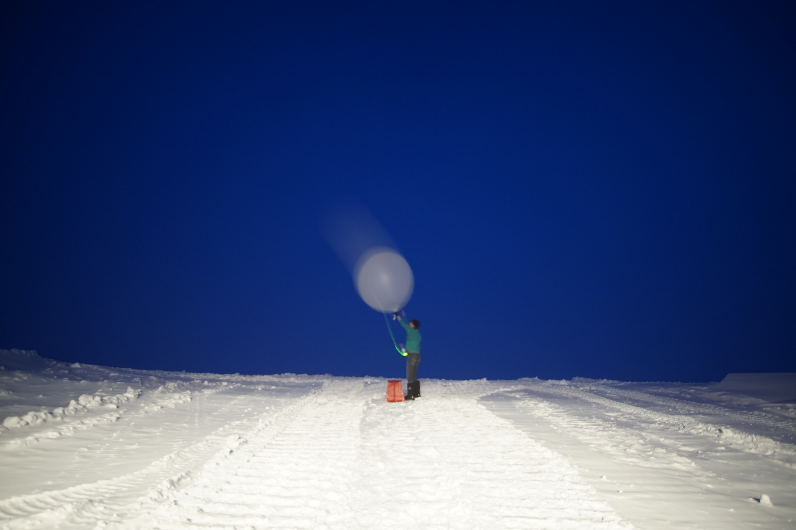

Morning radiosonde launch on 2021-01-17*.*

*Photo: Heather Guy*

**General Notes:**

This week I finished packing and labelling the ICECAPS southbound cargo; the INP cold stages, SKYOPC and the full ICECAPS data hard drive. I also wrote up some instructions for the installation of the CPC which will likely arrive on the final flight of turnover. A power outage at NOAA meant that no data were sent out on the 21st and 22nd, this was resolved, and the full backlog of data transferred overnight on the 23rd.

**General Weather Observations:**

|  |  |  |  |  |  |  |  |
| --- | --- | --- | --- | --- | --- | --- | --- |
| **Date** | **Time (Z)** | **Wind** | **Weather** | **Visibility** | **Sky** | **Temp (C)** | **Notes** |
| 01-18 | 12 | 3 kts at 308 |  | 9999 | FEW065 | -39 |  |
| 01-19 | 12 | 10 kts at 181 |  | 9999 | FEW | -52 |  |
| 01-20 | 12 | 10 kts at 289 | FZFG | 500 | BKN039 | -28 |  |
| 01-21 | 12 | 10 kts at 329 | FZFG, -SN | 800 | BKN039 | -31 |  |
| 01-22 | 12 | 8 kts at 035 | BR | 800 | FEW | -39 |  |
| 01-23 | 12 | 4 kts at 013 | BR | 800 | BKN020 | -39 |  |
| 01-24 | 12 | 15 kts at 335 |  | 9999 | SCT | -36 |  |

**Significant Weather Observations:**

* 2021-01-22 1245Z: Moon pillar.

**MSF**

* Operating normally

**ICECAPS-ACE Data Management:**

* 01-18: Data transfer completed at 0434Z.
* 01-19: Data transfer completed at 0436Z.
* 01-20: Data transfer completed at 0444Z.
* 01-21: No data transfer due to NOAA power outage.
* 01-22: No data transfer due to NOAA power outage.
* 01-23: Data transfer completed at 0932Z; all backlog transferred.
* 01-24: Data transfer completed at 0446Z.

**TSI:**

* Offline for the winter season.

**Radiosonde:**

* Once daily launches.
* See chart below for radiosonde cabinet temperatures over the last week.

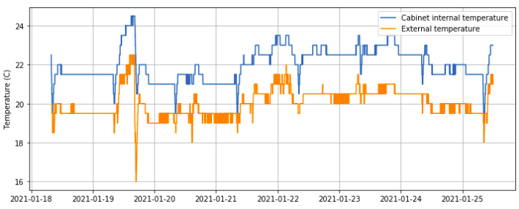

**MWR:**

* RPG-150-90 operating normally.
* HATPro troubleshooting: Awaiting final confirmation from Erik that I can start putting the HATPro back together for storage on the winter berm (ultimately for retro in the summer).

**SODAR:**

* 2021-01-18 1336-1354Z: Cleaned and leveled the SODAR dishes.
* Operating normally.

**POSS:**

* Operating normally.

**MASC:**

* Offline for winter season.

**MMCR:**

* 2021-01-21 1508-1612Z: Rebooted MMCR after persistent ‘NetCDF’ errors.
* Operating normally.

**CAPABL:**

* 2021-01-19 1330-1338Z: Powered down CAPABL to clear snow from window.
* Operating normally.

**MPL:**

* No change to MPL window condition.
* Operating normally.

**CEILOMETER:**

* Operating normally.

**PAERI:**

* 2021-01-18 1307Z: Covered PAERI hatch to clear thick rime from railing. Von noticed a large data shift between before and after this cleaning which did not appear to coincide with changes in sky condition; indicating that the thick frost might have been protruding into the PAERIs field of view.
* Operating normally.

**IceCAM:**

* Operating normally.

**IcePIC:**

* 2021-01-21 1352Z: Bullets, columns and irregulars. 17 photos.

**CPC:**

* Offsite for repairs.

**MSF - OPC:**

* Operating normally.

**TAWO - OPC:**

* Operating normally

**SKYOPC:**

* Offline, due to be sent out in February for repair.

**Fluxtower instrument suite:**

* 2021-01-21: Downloaded enclosure temperature logger data. Temperatures ranged between -22 and 8C since 8th November.
* Operating normally.

**Radiometers:**

* Solar tracker misalignment persists, otherwise operating normally.