**ICECAPS-ACE Weekly Report**

January 25th – January 31st, 2021

Heather Guy

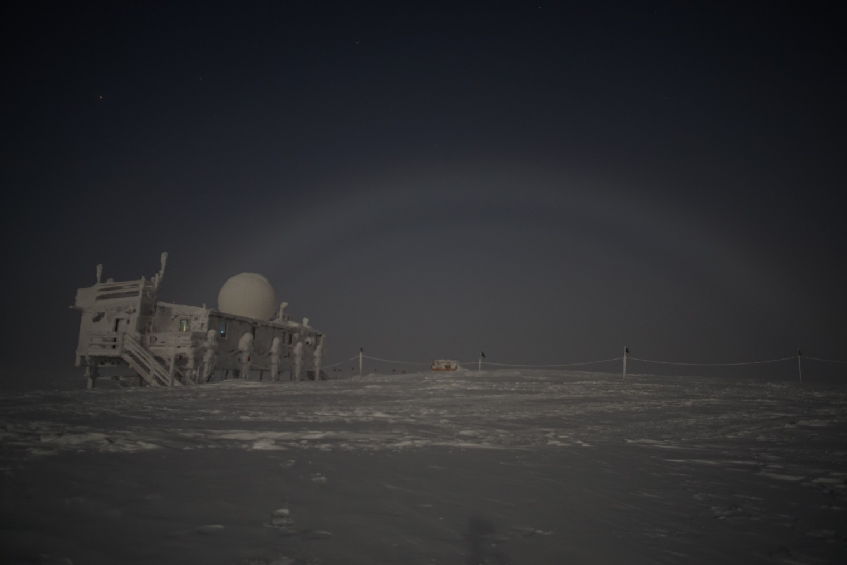

Moon fog bow at 00Z on 2021-01-31*.*

*Photo: Heather Guy*

**General Notes:**

We celebrated the first sunrise of 2021 this week, as well as our lowest temperature and wind-chill of the season so far (-62 oC and -82 oC). I’m working on cleaning and organizing the MSF in preparation for turnover; as part of that I re-organized and updated the ICECAPS-ACE inventory. We also used the one good weather window of the week to clean frost from the TAWO Met tower and inspect instruments and connections. The incoming crew will not be trained to perform tower climbs during the spring season, so this may be the last climb until the summer at the earliest. All the fluxtower instruments look healthy and are operating normally, see some photos of the tower at the end of this report.

**General Weather Observations:**

|  |  |  |  |  |  |  |  |
| --- | --- | --- | --- | --- | --- | --- | --- |
| **Date** | **Time (Z)** | **Wind** | **Weather** | **Visibility** | **Sky** | **Temp (C)** | **Notes** |
| 01-25 | 12 | 16 kts at 062 |  | 9999 | SKC | -56 |  |
| 01-26 | 12 | 21 kts at 118 | BLSN, FZFG | 300 | VV009 | -50 |  |
| 01-27 | 12 | 16 kts at 202 | BLSN, FZFG | 300 | VV002 | -45 |  |
| 01-28 | 12 | 10 kts at 234 |  | 9999 | SKC | -55 | First sunrise of 2021 at 1409Z |
| 01-29 | 12 | 11 kts at 043 |  | 9999 | SKC | -59 |  |
| 01-30 | 12 | 16 kts at 148 | DRSN, FZFG | 500 | BKN066 | -43 |  |
| 01-31 | 12 | 11 kts at 207 | -SN | 800 | OVC028 | -42 |  |

**Significant Weather Observations:**

* 2021-01-28 00Z: Moon halo
* 2021-01-31 00Z: Moon fog bow
* Reminder: Sig. weather photos still not transferring.

**MSF**

* Operating normally

**ICECAPS-ACE Data Management:**

* 01-25: Data transfer completed at 0446Z.
* 01-26: Data transfer completed at 0435Z.
* 01-27: Data transfer completed at 0441Z.
* 01-28: Data transfer completed at 0443Z.
* 01-29: Data transfer completed at 0442Z.
* 01-30: Data transfer completed at 0442Z..
* 01-31: Data transfer completed at 0440Z.

**TSI:**

* Offline for the winter season.

**Radiosonde:**

* Once daily launches.
* 2021-01-26 1901Z: SPS connection briefly lost, outside of sounding so no data impacted.
* See chart below for radiosonde cabinet temperatures over the last week.

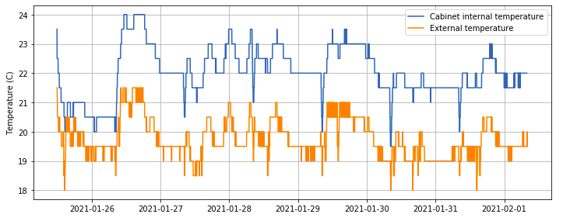

**MWR:**

* RPG-150-90 operating normally.

**SODAR:**

* 2021-01-25 1357-1419Z: Cleaned and leveled the SODAR dishes.
* Operating normally.

**POSS:**

* Operating normally.

**MASC:**

* Offline for winter season.

**MMCR:**

* Operating normally.

**CAPABL:**

* Operating normally.

**MPL:**

* No change to MPL window condition.
* Operating normally.

**CEILOMETER:**

* Operating normally.

**PAERI:**

* 2021-01-27 1645Z: Cleaned scene mirror after blowing snow.
* 2021-01-29: Intermittent maxSampleStdDev errors overnight during cold temps.
* Operating normally.

**IceCAM:**

* Operating normally.

**IcePIC:**

* No IcePICs this week ☹

**CPC:**

* Offsite: Expected back at Summit on the final flight of February turnover.

**MSF - OPC:**

* Operating normally.

**TAWO - OPC:**

* Operating normally

**SKYOPC:**

* Offline, due to be sent out in February for repair.

**Fluxtower instrument suite:**

* 2021-01-31 1330-1700Z: Inspected and cleaned frost from all Met tower instruments. Note that this might be the last tower climb before the summer season at the earliest. See tower photos below.
* Operating normally.

**Radiometers:**

* Solar tracker misalignment persists, otherwise operating normally.

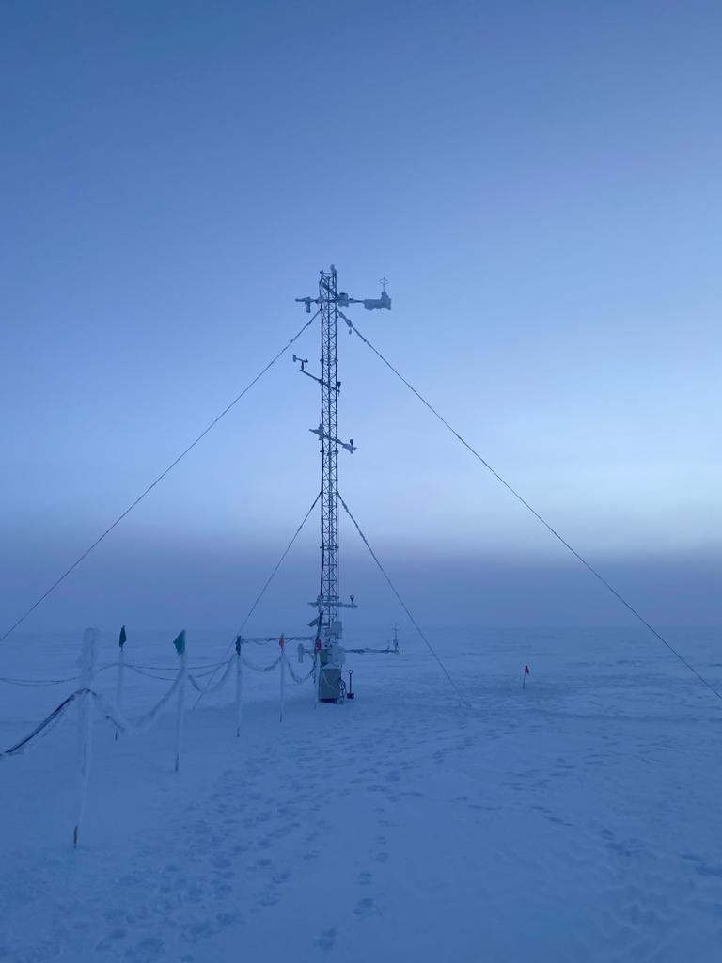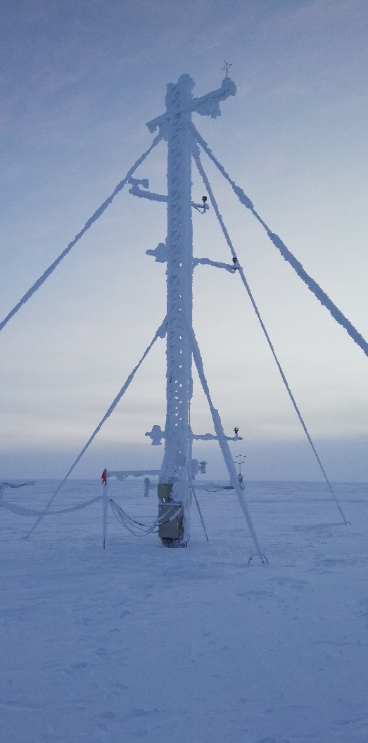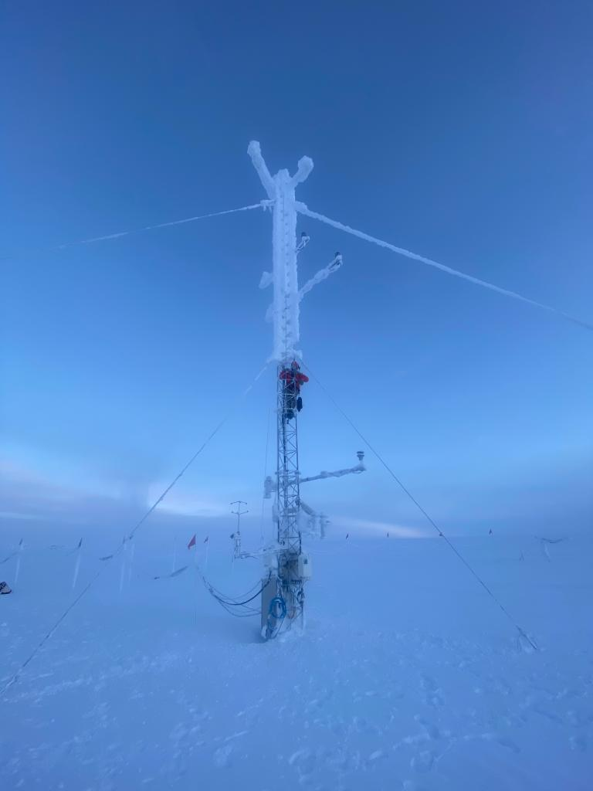

TAWO Met tower, before, during and after cleaning on 2021-01-31