**ICECAPS-ACE Weekly Report**

February 1st – February 7th, 2021

Heather Guy

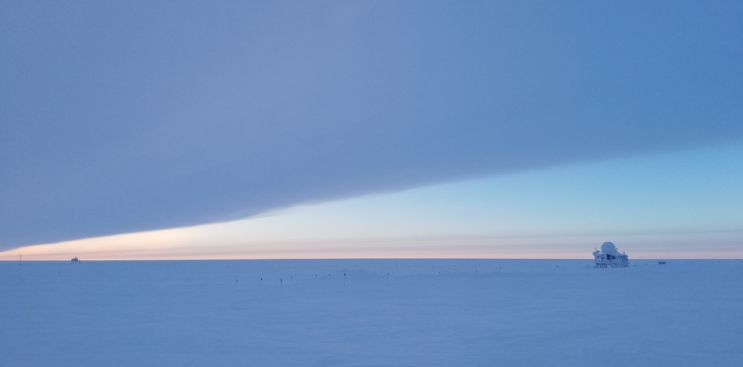

Another example of the stark transition from clear to overcast skies as a storm approached,

on 2021-02-03*.*

*Photo: Heather Guy*

**General Notes:**

Preparation and recovery from a fairly fierce mid-week storm consumed a lot of our time and energy this week. I was unable to get to the MSF on 2021-02-04 due to the high winds and poor visibility, but there were no major issues. CAPABL needed a full reboot due to persistent network communication errors that were possibly caused by static from the high winds. Otherwise our turnover preparations continue and we’re looking forward to hopefully seeing some new faces next weekend.

**General Weather Observations:**

|  |  |  |  |  |  |  |  |
| --- | --- | --- | --- | --- | --- | --- | --- |
| **Date** | **Time (Z)** | **Wind** | **Weather** | **Visibility** | **Sky** | **Temp (C)** | **Notes** |
| 02-01 | 12 | 13 kts at 180 | BR | 1500 | BKN098 | -49 |  |
| 02-02 | 12 | 14 kts at 180 | BR | 800 | SKC | -52 |  |
| 02-03 | 12 | 14 kts at 179 |  | 9999 | BKN072 | -51 | -SN at 1500 |
| 02-04 | 12 | 39 kts at 170 | BLSN | 40 | VV003 | -23 | Max wind 45 knots at 1300 |
| 02-05 | 12 | 17 kts at 169 | FZFG, DRSN | 500 | VV003 | -40 |  |
| 02-06 | 12 | 14 kts at 183 | FZFG | 500 | FEW | -40 |  |
| 02-07 | 12 | 11 kts at 337 | BR | 800 | SCT | -40 |  |

**Significant Weather Observations:**

* 2021-02-05 1310Z: Upper tangent arc.

**MSF**

* 2021-02-04: Periodic unrealistic temperature logger spikes, possibly due to static from the storm. These ceased as soon as the wind died back down.
* 2021-02-05: Dug out and cleared snow from all building air intakes and heat exchanger after the storm.
* Operating normally.

**ICECAPS-ACE Data Management:**

* 02-01: Data transfer completed at 0438Z.
* 02-02: Data transfer completed at 0438Z.
* 02-03: Data transfer completed at 0507Z. 11 files not sent due to lost connection.
* 02-05: Data transfer completed at 0426Z.
* 02-06: Data transfer completed at 0432Z.
* 02-07: Data transfer completed at 0434Z.

**TSI:**

* Offline for the winter season.

**Radiosonde:**

* Once daily launches.
* 2021-02-06: Deep cleaned radiosonde base station enclosure.
* See chart below for radiosonde cabinet temperatures over the last week.

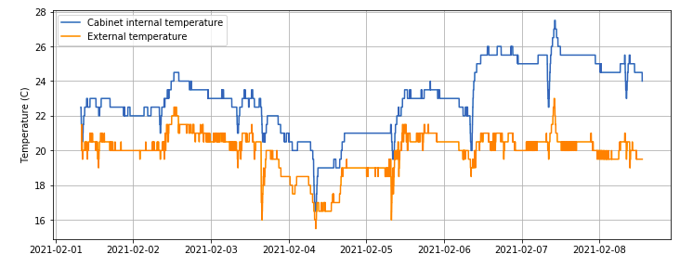

**MWR:**

* RPG-150-90 operating normally.

**SODAR:**

* 2021-02-01 1433-1446Z: Cleaned and leveled the SODAR dishes.
* 2021-02-07 1439-1452Z: Cleaned and leveled the SODAR dishes.
* Operating normally.

**POSS:**

* Operating normally.

**MASC:**

* Offline for winter season.

**MMCR:**

* Operating normally.

**CAPABL:**

* 2021-02-05: Found CAPABL with multiple network communication errors, possibly cause by static interruptions from the storm. Rebooted entire system and restarted data collection at 1459Z.
* Operating normally.

**MPL:**

* No change to MPL window condition.
* Operating normally.

**CEILOMETER:**

* Operating normally.

**PAERI:**

* Operating normally.

**IceCAM:**

* Operating normally.

**IcePIC:**

* No IcePICs this week ☹

**CPC:**

* Offsite: Expected back at Summit on the final flight of February turnover.

**MSF - OPC:**

* 2021-02-04 0415Z: OPC stopped long into high winds.
* 2021-02-05: Brought instrument inside to defrost.
* 2021-02-06 1658Z: Restarted data collection.
* Operating normally.

**TAWO - OPC:**

* Operating normally

**SKYOPC:**

* Offline, due to be sent out in February for repair.

**Fluxtower instrument suite:**

* 2021-02-04 0100-2200Z: Both 3D sonics reported invalid data, possibly due to static from the storm. Data quality returned as soon as the winds died down.
* Operating normally.

**Radiometers:**

* 2021-02-01: Jasper identified that the direct sun photometer on the solar tracker had become disconnected from the data logger box.
* 2021-02-06 1336-1615Z: We attempted to reconnect the sun photometer and discovered that the bulk head connector was damaged. We were able to reconnect the instrument and realign the tracker, but we weren’t able to secure cable without replacement nuts for the bulkhead.
* Solar tracker misalignment persists, otherwise operating normally.