**ICECAPS-ACE Weekly Report**

February 8th – February 14th, 2021

Heather Guy

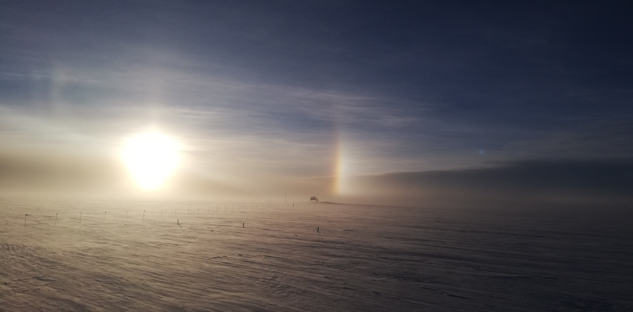

It’s so nice to be able to enjoy some solar optics again:

Parhelia above TAWO during a blowing snow event on 2021-02-13

*Photo: Heather Guy*

**General Notes:**

Our schedules have been largely dictated by high winds and blowing snow this week. We’ve been using any brief respites to clear drifts and prepare for flight ops, and while we’ve been stuck indoors, we’ve been deep cleaning station ahead of the incoming crew. We were able to complete our first February ICESat traverse during some calmer weather on Wednesday. No new ICECAPS instrument issues this week, but the sun photometer on the solar tracker remains disconnected. Weather permitting, we are expecting the new crew to fly to Summit on Tuesday 16th February. High winds continue to be forecast for the coming week.

**General Weather Observations:**

|  |  |  |  |  |  |  |  |
| --- | --- | --- | --- | --- | --- | --- | --- |
| **Date** | **Time (Z)** | **Wind** | **Weather** | **Visibility** | **Sky** | **Temp (C)** | **Notes** |
| 02-08 | 12 | 12 kts at 084 | FZFG | 800 | SKC | -44 |  |
| 02-09 | 12 | 15 kts at 098 | BR | 800 | FEW | -51 |  |
| 02-10 | 12 | 11 kts at 296 | BR | 1500 | SCT032 | -42 | -SN from 1436 |
| 02-11 | 12 | 18 kts at 172 | BLSN | 500 | VV006 | -41 |  |
| 02-12 | 12 | 24 kts at 192 | BLSN | 200 | VV007 | -28 |  |
| 02-13 | 12 | 15 kts at 164 | FZFG, DRSN | 500 | BKN213 | -32 |  |
| 02-14 | 12 | 23 kts at 126 | BLSN | 800 | OVC065 | -23 |  |

**Significant Weather Observations:**

* 2021-02-08 1600Z: Glory, and fog bow legs.
* 2021-02-11 1245Z: Upper tangent arc.
* 2021-02-13 1530Z: Parhelia.

**MSF**

* Operating normally.

**ICECAPS-ACE Data Management:**

* 02-08: Data transfer completed at 0450Z.
* 02-09: Data transfer completed at 0434Z.
* 02-10: Data transfer completed at 0436Z.
* 02-11: Data transfer completed at 0441Z.
* 02-12: Data transfer completed at 0435Z.
* 02-13: Data transfer completed at 0457Z.
* 02-14: Data transfer completed at 0438Z.

**TSI:**

* Offline for the winter season.

**Radiosonde:**

* Once daily launches.
* See chart below for radiosonde cabinet temperatures over the last week.

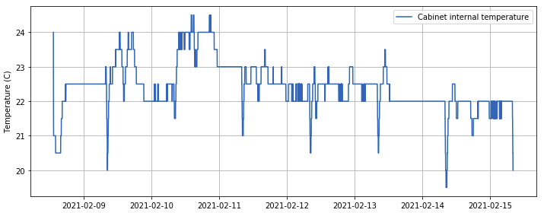

**MWR:**

* RPG-150-90 operating normally.

**SODAR:**

* Operating normally.

**POSS:**

* Operating normally.

**MASC:**

* Offline for winter season.

**MMCR:**

* Operating normally.

**CAPABL:**

* Operating normally.

**MPL:**

* No change to MPL window condition.
* Operating normally.

**CEILOMETER:**

* Operating normally.

**PAERI:**

* 2021-02-12 1302 & 1343Z: Cleaned scene mirror during blowing snow.
* Operating normally.

**IceCAM:**

* Operating normally.

**IcePIC:**

* No IcePICs this week ☹

**CPC:**

* Offsite: Expected back at Summit on the final flight of February turnover.

**MSF - OPC:**

* 2021-02-12 1700Z: OPC stopped logging in high winds.
* 2021-02-13 1221Z: Restarted data collection.
* Operating normally.

**TAWO - OPC:**

* Operating normally

**SKYOPC:**

* Offline, due to be sent out in February for repair.

**Fluxtower instrument suite:**

* Operating normally.

**Radiometers:**

* 2021-02-11: Sun photometer cable disconnected – issue ongoing.
* Solar tracker misalignment persists, otherwise operating normally.