**ICECAPS-ACE Weekly Report**

February 15th – February 21th, 2021

Dane Hansen & Heather Guy

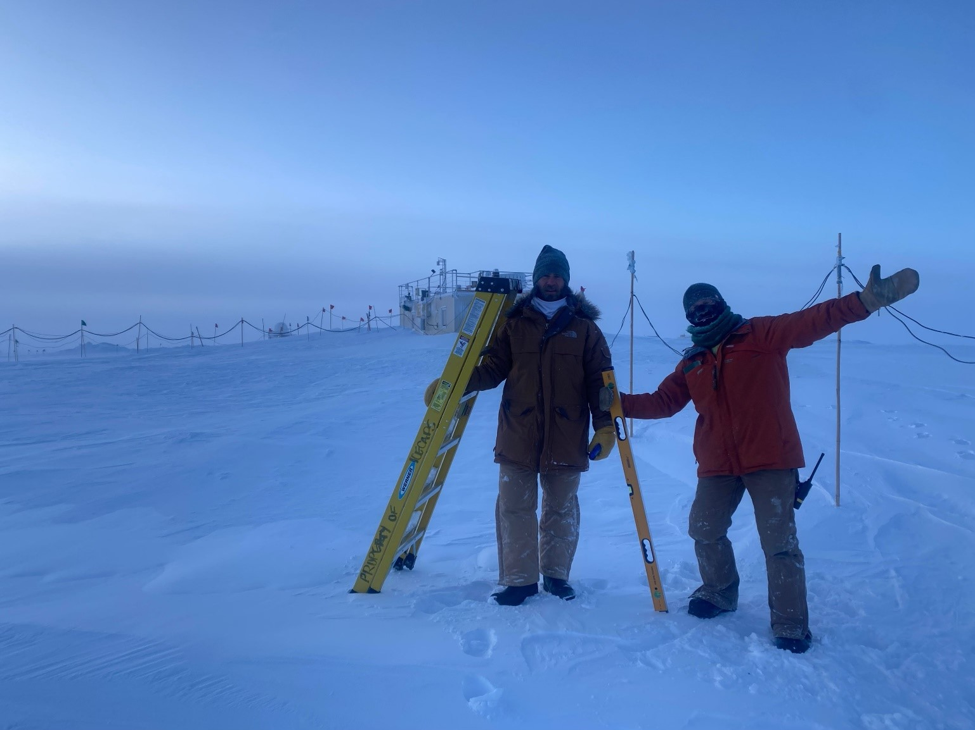

Heather and Dane celebrating after clearing snow from the SODAR

*Photo: Jasper Thompson*

**General Notes:**

Turnover was busy as well as productive. Winds were often over 25kts with blowing snow and low visibility leading to significant drifting around the MSF and limited access to the roof. Few instruments needed minor snow and frost removal, and the CAPABL was rebooted following a planned power outage on 2120-2-19. All other instruments were unaffected by the outage.

**General Weather Observations:**

|  |  |  |  |  |  |  |  |
| --- | --- | --- | --- | --- | --- | --- | --- |
| **Date** | **Time (Z)** | **Wind** | **Weather** | **Visibility** | **Sky** | **Temp (C)** | **Notes** |
| 02-15 | 12 | 25 kts at 097 | BLSN | 500 | VV016 | -25 | Max winds 45 knots at 1800Z |
| 02-16 | 12 | 26 kts at 122 | BLSN | 500 | VV002 | -25 |  |
| 02-17 | 12 | 15 kts at 130 | FZFG | 800 | VV001 | -39 |  |
| 02-18 | 12 | 31 kts at 110 | BLSN | 100 | VV002 | -27 | Max winds 35 knots at 1700Z |
| 02-19 | 12 | 17 kts at 114 | DRSN, -SN | 1500 | BKN065 | -25 |  |
| 02-20 | 12 | 24 kts at 164 | BLSN | 300 | VV021 | -27 |  |
| 02-21 | 12 | 19 kts @ 108 | BLSN | 800 | BKN032 | -30 |  |

**Significant Weather Observations:**

* 2021-02-17 1500Z: 22-degree sun halo.

**MSF**

* 2021-02-15: No visit to the MSF due to high winds and poor visibility.
* 2021-02-18 1234: Opened MSF exhaust louvers to clear snow and ice.
* 2021-02-19: Two brief (~ 1 minute) planned power outages at 1330Z and 1344Z, for training the incoming crew.
* Operating normally.

**ICECAPS-ACE Data Management:**

* 02-15: Data transfer completed at 0436Z.
* 02-16: Data transfer completed at 0439Z.
* 02-17: Data transfer completed at 0436Z.
* 02-18: Data transfer completed at 0436Z.
* 02-19: Data transfer completed at 0440Z.
* 02-20: Data transfer completed at 0430Z.
* 02-21: Data transfer completed at 0440Z.

**TSI:**

* Offline for the winter season.

**Radiosonde:**

* Once daily launches.
* See chart below for radiosonde cabinet temperatures over the last week.

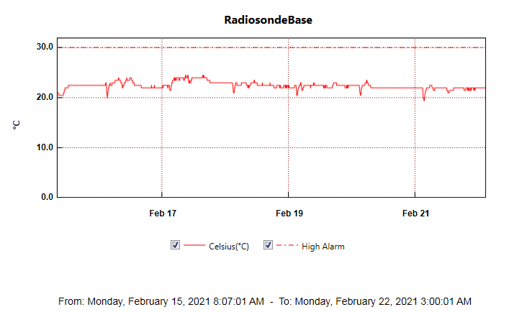

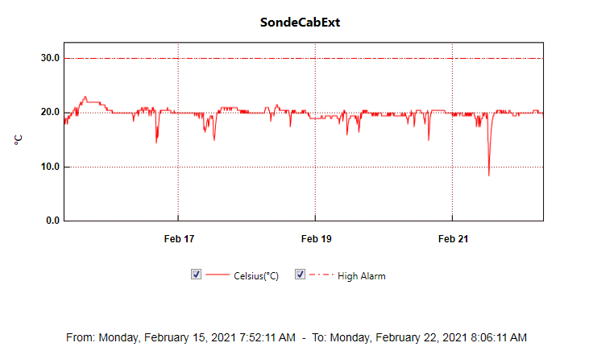

**MWR:**

* RPG-150-90 operating normally.

**SODAR:**

* 2021-02-17 1647 to 1705Z: Cleaned and levelled sodar.
* 2021-02-20 1810 to 1835Z: Cleaned and levelled sodar.
* Operating normally.

**POSS:**

* Operating normally.

**MASC:**

* Offline for winter season.

**MMCR:**

* 2021-02-16: Cleared ‘LabView error 7’ error.
* 2021-02-19: Cleared ‘LabView error 7’ error.
* Operating normally.

**CAPABL:**

* 2021-02-19: The CAPABL system experienced to hard reboots during the planned power outage (1330Z and 1344Z). After investigation we discovered that it was not connected to a UPS outlet. We powered the system down normally and transitioned it to a UPS outlet.
* 2021-02-19 1649Z: Restarted CAPABL data collection. We noticed and reported that the plot which cycles through different polarizations was irregular.
* 2021-02-19 1824Z: Restarted CAPABL data collection after a second reboot (including Meadow Lark power cycle), polarization plot is still showing irregular cycles.
* Operating normally.

**MPL:**

* 2021-02-19 2012 to 2034Z: Performed monthly after-pulse calibration.
* No change to MPL window condition.
* Operating normally.

**CEILOMETER:**

* 2021-02-18: The following errors were present: ‘Window contaminated’ and ‘Receiver optical cross-talk compensation poor’
* 2021-02-19 1853Z: Brushed snow from ceilometer mirror. Some ice remains and ‘Receiver optical cross-talk compensation poor’ errors persist.

**PAERI:**

* 2021-02-16 1354Z: Cleaned fan enclosure and scene mirror after blowing snow.
* 2021-02-19: Intermittent ‘HBB Max tamp diff’ yellow flags since 0900Z.
* Operating normally.

**IceCAM:**

* Operating normally.

**IcePIC:**

* 2021-02-17: Brought IcePICs set-up inside for defrost and optics cleaning.
* No IcePICs this week.

**CPC:**

* Offsite: Expected back at Summit on the final flight of February turnover.

**MSF - OPC:**

* Operating normally.

**TAWO - OPC:**

* Operating normally

**SKYOPC:**

* Returned to Kangerlussuaq for onward shipping and manufacturer repair in Germany.

**Fluxtower instrument suite:**

* 2021-02-15 1600 to 2200Z: Poor quality data from the 2 m 3D sonic anemometer during high winds.
* 2021-02-18 1100 to 2021-02-19 0200Z: Poor quality data from the 2 m 3D sonic anemometer during high winds.
* Operating normally.

**Radiometers:**

* Sun photometer cable disconnected – issue ongoing.
* Solar tracker misalignment persists, otherwise operating normally.