**ICECAPS-ACE Weekly Report**

February 22nd – February 28th, 2021

Dane Hansen

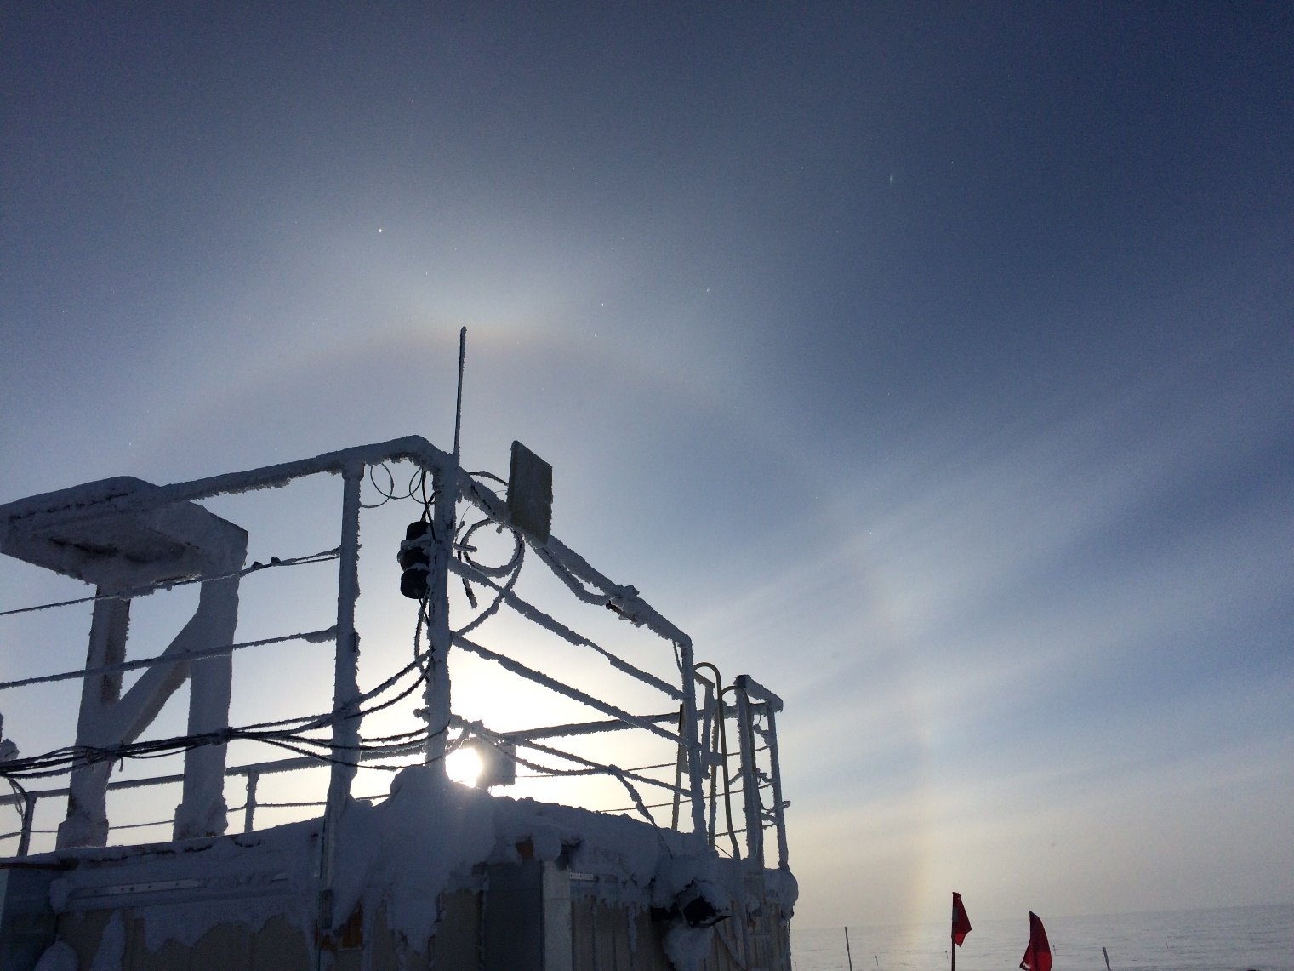

A 22°halo seen from behind the MSF

*Photo: Dane Hansen*

**General Notes:**

The week went well overall, and I am becoming more familiar with my duties with each passing day. The top priority this week was to get the CPC up and running. There is a lingering stink of butanol heavy in the air following the instruments homecoming, but it is now peacefully humming away in its corner. The need to clean snow and frost from instruments was limited given recent calm and cold weather, and the week was largely uneventful concerning instrument issues.

**General Weather Observations:**

|  |  |  |  |  |  |  |  |
| --- | --- | --- | --- | --- | --- | --- | --- |
| **Date** | **Time (Z)** | **Wind** | **Weather** | **Visibility** | **Sky** | **Temp (C)** | **Notes** |
| 02-22 | 12 | 15 kts at 161 | DRSN BR | 4800 | FEW180 | -34 |  |
| 02-23 | 12 | 5 kts at 182 | BR | 3200 | SCT | -41 |  |
| 02-24 | 12 | 13 kts at 155 | BR | 1600 | FEW | -42 |  |
| 02-25 | 12 | 15 kts at 141 | BR | 1600 | BKN080 | -40 |  |
| 02-26 | 12 | 14 kts at 132 | BR | 4800 | OVC015 | -39 |  |
| 02-27 | 12 | 12 kts at 152 | DRSN BR | 1600 | VV | -29 |  |
| 02-28 | 12 | 6 kts at 327 | BR | 3200 | OVC032 | -37 | 22°halo |

**Significant Weather Observations:**

* 2021-02-28 1300Z: 22-degree halo.

**MSF**

* Significant drifting continues to complicate building ingress after blowing snow events.
* Operating normally.

**ICECAPS-ACE Data Management:**

* 02-22: Data transfer completed at 0437Z.
* 02-23: Data transfer completed at 0443Z.
* 02-24: Data transfer completed at 0443Z.
* 02-25: Data transfer completed at 0434Z.
* 02-26: Data transfer completed at 0435Z.
* 02-27: Data transfer completed at 0443Z.
* 02-28: Data transfer completed at 0438Z.

**TSI:**

* Offline for the winter season.

**Radiosonde:**

* Once daily launches.
* See chart below for radiosonde cabinet temperatures over the last week.

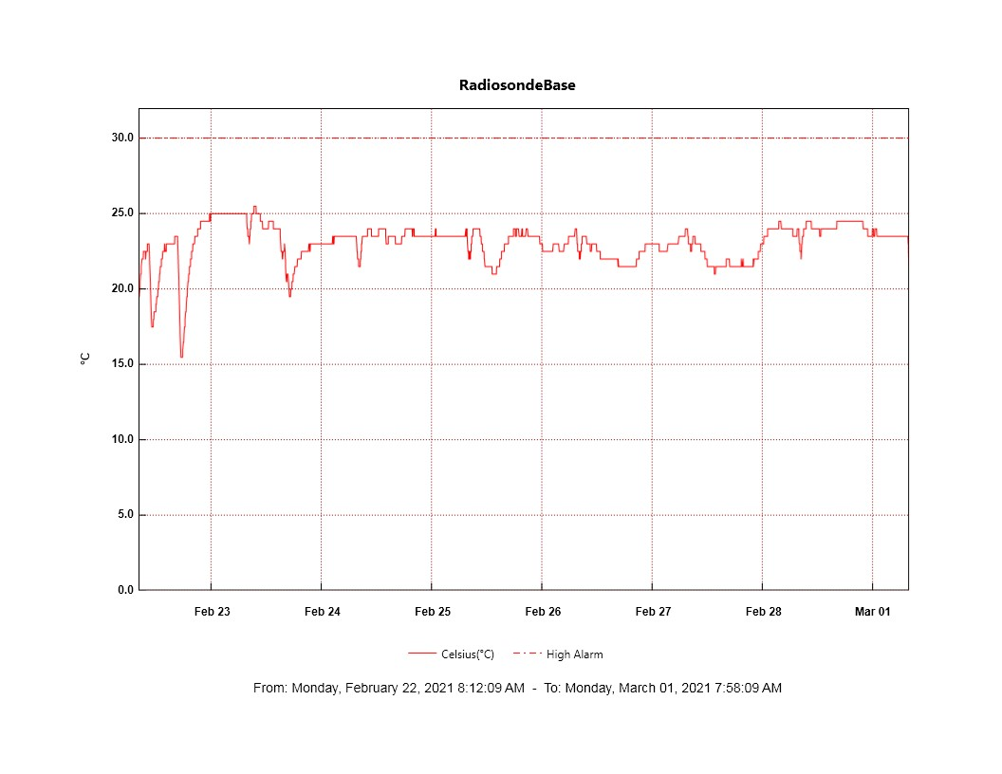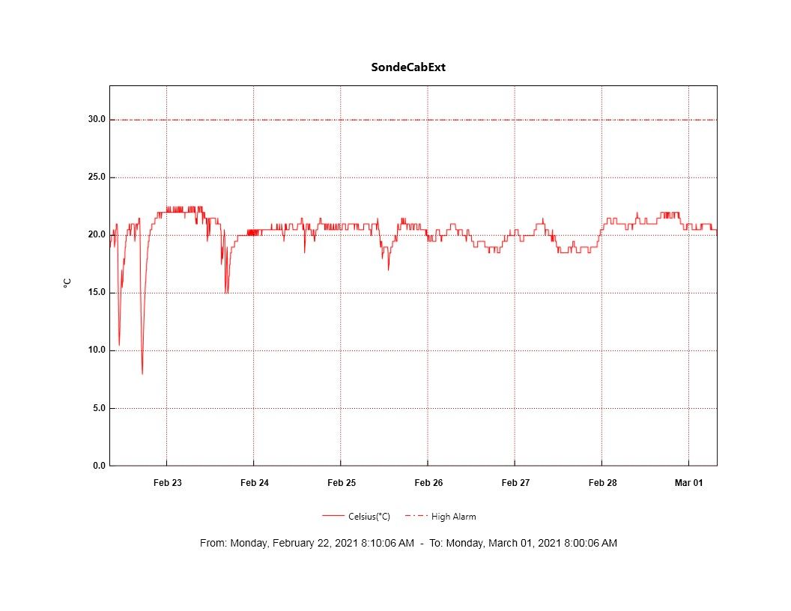

**MWR:**

* RPG-150-90 operating normally.

**SODAR:**

* Operating normally.

**POSS:**

* Dug out cables near MSF and raised cable run.
* Operating normally.

**MASC:**

* Offline for winter season.

**MMCR:**

* 2021-02-24: Cleared ‘LabView error 7’ error.
* 2021-02-28: Cleared ‘LabView error 7’ error.
* Operating normally.

**CAPABL:**

* 2021-02-28 1232Z: Briefly shut own CAPABL to clear snow from window. No abort file was written at the time of shut down.
* Operating normally.

**MPL:**

* No change to MPL window condition.
* Operating normally.

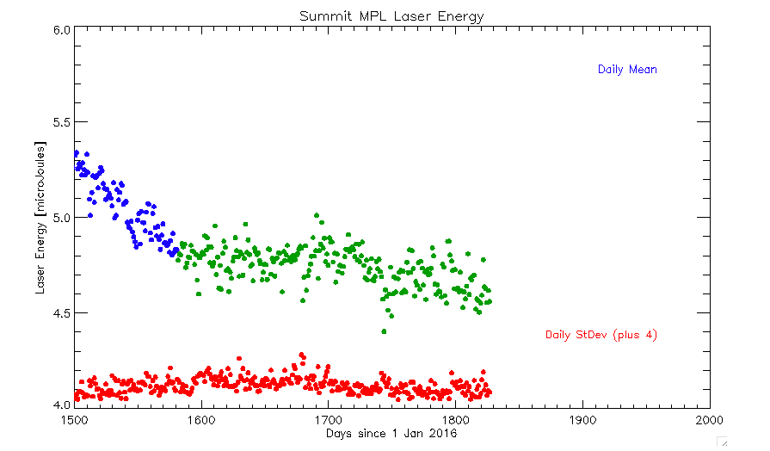

**CEILOMETER:**

* Operating normally.

**PAERI:**

* 2021-02-22: Intermittent ‘HBB Max tamp diff’ yellow flags.
* 2021-02-27: Brief ‘SW responsivity’ yellow flag.
* 2021-02-28: ‘Atmospheric Pressure’ yellow flag, ‘SW responsivity,’ and ‘LW responsivity’ red flags resolved themselves without intervention.
* Operating normally.

**IceCAM:**

* Operating normally.

**IcePIC:**

* Familiarized and tested IcePICs equipment.

**CPC:**

* 2021-02-24: CPC up and running on daily script.
* 2021-02-26: CPC script modified to restart measurement daily and filter changed.

**MSF - OPC:**

* Operating normally.

**TAWO - OPC:**

* Operating normally.

**SKYOPC:**

* Returned to Kangerlussuaq for onward shipping and manufacturer repair in Germany.

**Fluxtower instrument suite:**

* Operating normally.

**Radiometers:**

* Sun photometer cable disconnected – issue ongoing.
* Solar tracker misalignment persists, otherwise operating normally.