ICECAPS-ACE Weekly Report
March 1st – March 7th, 2021
Dane Hansen

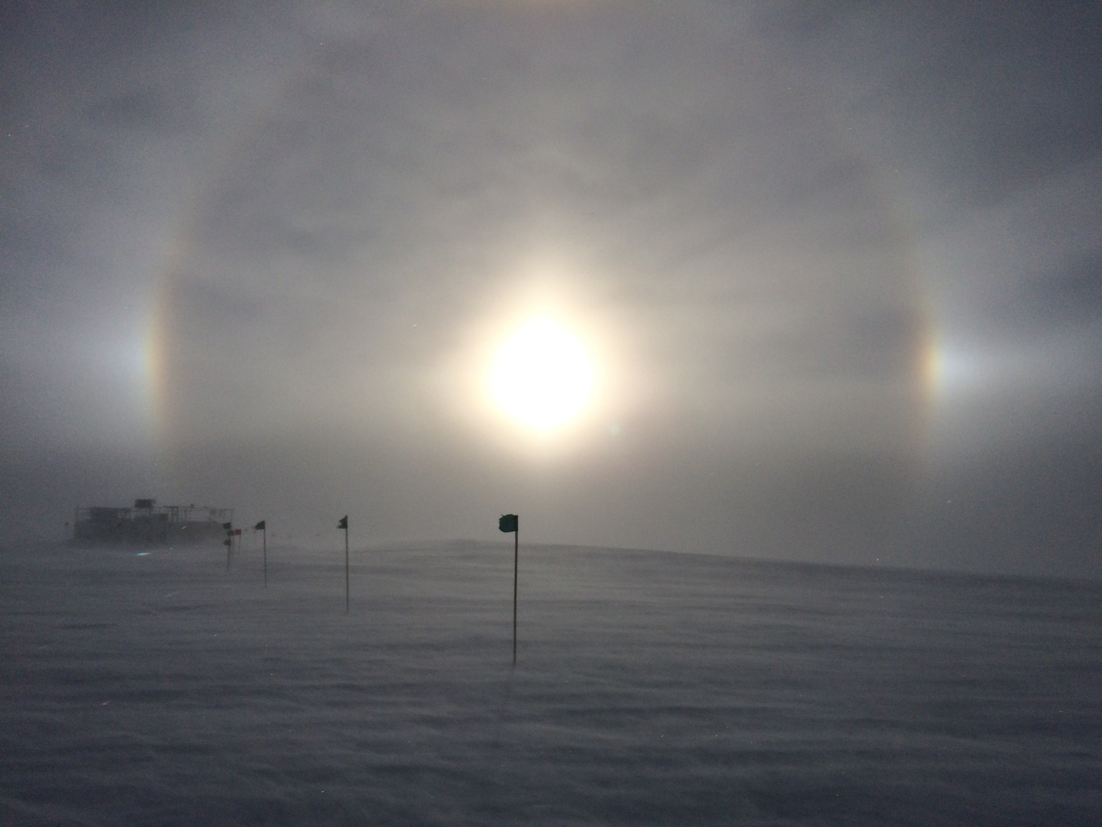

A sundog seen while enroute to the MSF
Photo: Dane Hansen

General Notes:
I stayed out of the MSF to some degree and monitored what I could from the big house. There were not too many instrument related events worth noting this week. I designed and built a negative pressure apparatus to evacuate the atmosphere surrounding the CPC and exhaust it directly outside of the building (which still stinks, but significantly less so).

Blowing snow slowed things appreciably this week, requiring a lot of digging to maintain normal function. Despite the weather, Nate and I were able to make some progress with the solar tracker and are anticipating more of the same next week.

General Weather Observations:
Date | Time (Z) | Wind | Weather | Visibility | Sky | Temp (C) | Notes
03-01 | 12 | 9 kts at 261 | BR | 4800 | OVC068 | -43
03-02 | 12 | 12 kts at 214 | BR DRSN | 1200 | SCT148 | -50 | aurora
03-03 | 12 | 15 kts at 227 | FZFG BLSN | 800 | VV016 | -27 | aurora
03-04 | 12 | 27 kts at 235 | FZFG BLSN | 200 | VV003 | -19
03-05 | 12 | 21 kts at 257 | FZFG BLSN | 400 | VV009 | -23
03-06 | 12 | 19 kts at 223 | FZFG BLSN | 400 | VV001 | -26 | sundog
03-07 | 12 | 16 kts at 207 | FZFG BLSN | 800 | SCT040 | -29 | sundog, aurora

Significant Weather Observations:
- 2021-03-05 1320Z: sundog.
- 2021-03-06 1125Z: sundog.

MSF
- Significant drifting continues to complicate building ingress after blowing snow events.
- Operating normally.

ICECAPS-ACE Data Management:
- 03-01: Data transfer completed at 0439Z.
- 03-02: Data transfer completed at 0444Z.
- 03-03: Data transfer completed at 0436Z.
- 03-04: Data transfer completed at 0454Z.
- 03-05: Data transfer completed at 0434Z.
- 03-06: Data transfer completed at 0438Z.
- 03-07: Data transfer completed at 0450Z.

TSI:
- Offline for the winter season.

Radiosonde:
- Once daily launches.
- See chart below for radiosonde cabinet temperatures over the last week.

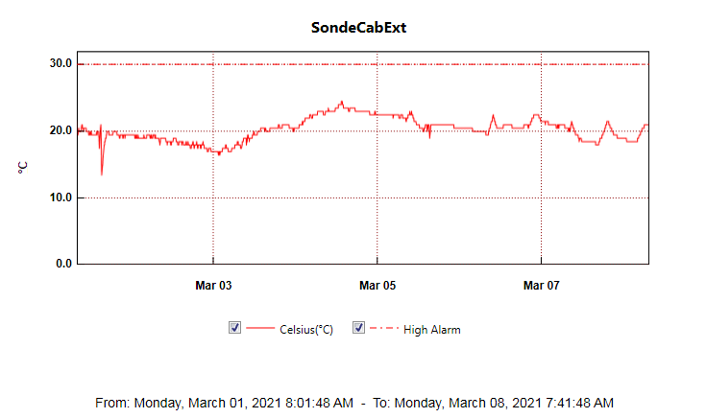

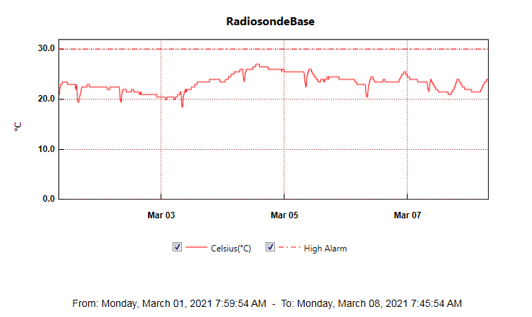

MWR:
- RPG-150-90 operating normally.

SODAR:
- 2021-03-01 1400 to 1434Z shut down to clean and level and raise cables.
- Operating normally.

POSS:
- Operating normally.

MASC:
- Offline for winter season.

MMCR:
- 2021-03-06: 0600Z and 1400Z ‘NetCDF.’
- 2021-03-07: 1500Z ‘NetCDF.’
- Tilt value is out of tolerance: mean = .23
- Operating normally.

CAPABL:
- Operating normally.

MPL:
- No change to MPL window condition.
- Operating normally.

CEILOMETER:
- Operating normally.

PAERI:
- 2021-03-03 1307Z: Cleared scene mirror after ‘SW responsivity’ and ‘LW responsivity” red flags.
- Operating normally.

IceCAM:
- Orientation to capture solar optics?
- Operating normally.

IcePIC:
- No IcePICs this week

CPC:
- 2021-03-04: CPC ventilation apparatus installed and turned on.
- Operating Normally

MSF - OPC:
- Operating normally.

TAWO - OPC:
- Operating normally.

SKYOPC:
- Returned to Kangerlussuaq for onward shipping and manufacturer repair in Germany.

Fluxtower instrument suite:
- Operating normally.

Radiometers:
- Sun photometer cable repaired in placed – issue ongoing.
- Solar tracker aligned initially and put in clock mode.
- Reworked dailies and weeklies log spreadsheet and want to move it t a new location.

