ICECAPS-ACE Weekly Report
March 8th – March 14th, 2021
Dane Hansen

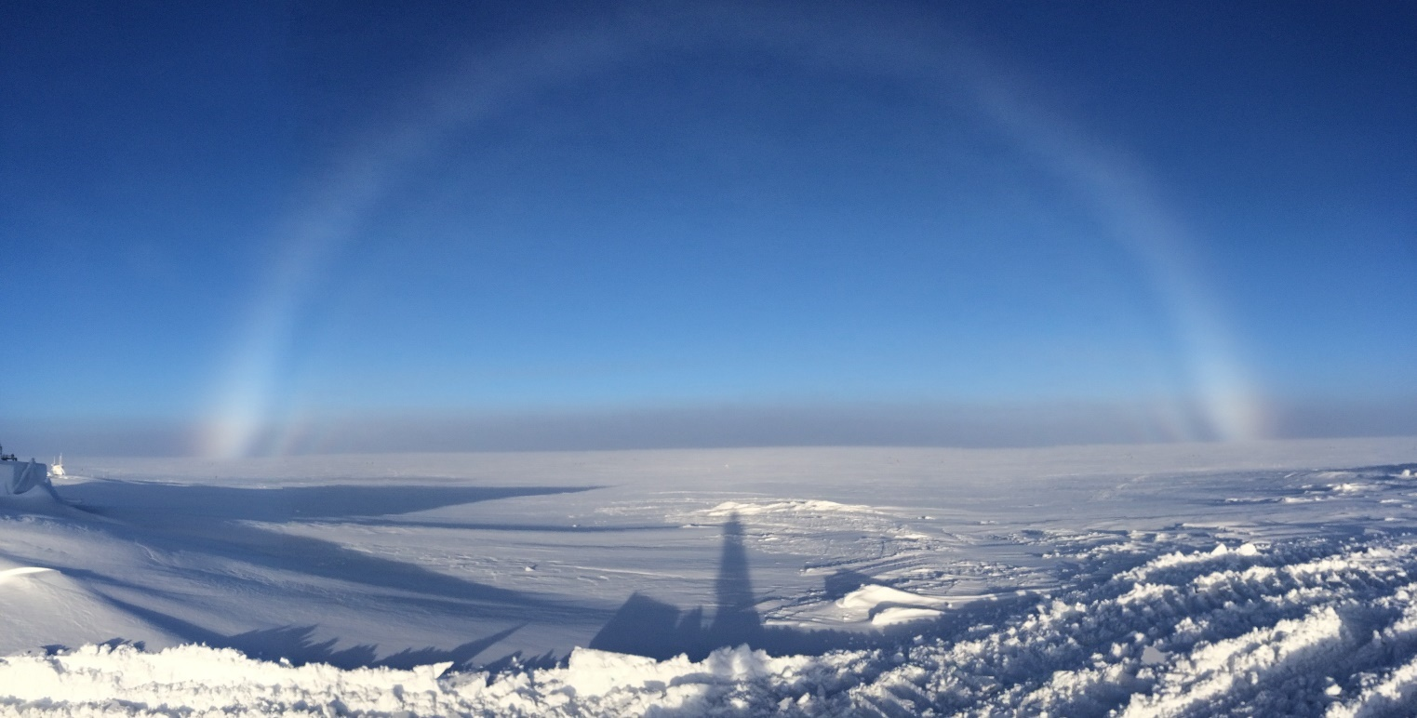

Morning fogbow taken during a radiosonde launch.
Photo: Dane Hansen

General Notes:
The big push this week was digging out from the previous weeks drifts. Once the main entrance of the berthing module was again accessible, I moved on to raising the POSS and MASC for the season. This included the two instruments and two associated power boxes. Both instruments look nice in their new places, and the MASC will be ready to return to service when the weather allows.

Additional efforts were made to mitigate drifting at the MSF. We brought the snowbeast out one day and made considerable progress improving access to the main entrance of the building, power connections, and ventilation ducting on the north side.

General Weather Observations:
Date | Time (Z) | Wind | Weather | Visibility | Sky | Temp (C) | Notes
03-08 | 12 | 12 kts at 186 |  | 9999 | SCT049 | -34
03-09 | 12 | 4 kts at 37 | BR | 4800 | SKC | -38 | Fogbow
03-10 | 12 | 14 kts at 65 | BR | 1600 | SKC | -42
03-11 | 12 | 16 kts at 133 | BR | 3200 | SKC | -44
03-12 | 12 | 11 kts at 253 |  | 9999 | FEW | -42
03-13 | 12 | 2 kts at 287 | BR | 1600 | SKC | -43 | Fogbow
03-14 | 12 | 12 kts at 203 | FZFG | 800 | VV006 | -43 | Sundog

Significant Weather Observations:
- 2021-03-09 1054 to 1540Z: Fogbow.
- 2021-03-09 1040Z: Fogbow.
- 2021-03-13 1917Z: Sundog.

MSF
- 2021-03-12 1700 to 1800Z: Snowbeast operating at MSF.
- A space heater was placed in the vestibule to help drive out remaining butanol.
- Operating normally.

ICECAPS-ACE Data Management:
- 03-08: Data transfer completed at 0430Z.
- 03-09: Data transfer completed at 0430Z.
- 03-10: Data transfer completed at 0455Z.
- 03-11: Data transfer completed at 0451Z.
- 03-12: Data transfer completed at 0445Z.
- 03-13: Data transfer completed at 0501Z.
- 03-14: Data transfer completed at 0449Z.

TSI:
- Offline for the winter season.

Radiosonde:
- Once daily launches.
- 2021-03-13: Failed launch requiring reboot for the following day (waiting for telemetry).
- See chart below for radiosonde cabinet temperatures over the last week.

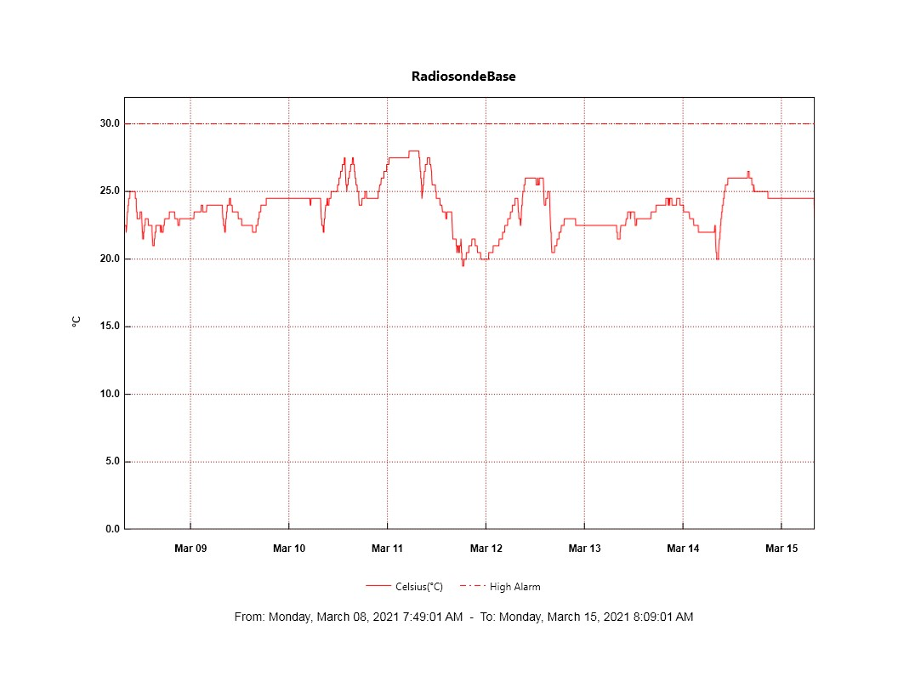

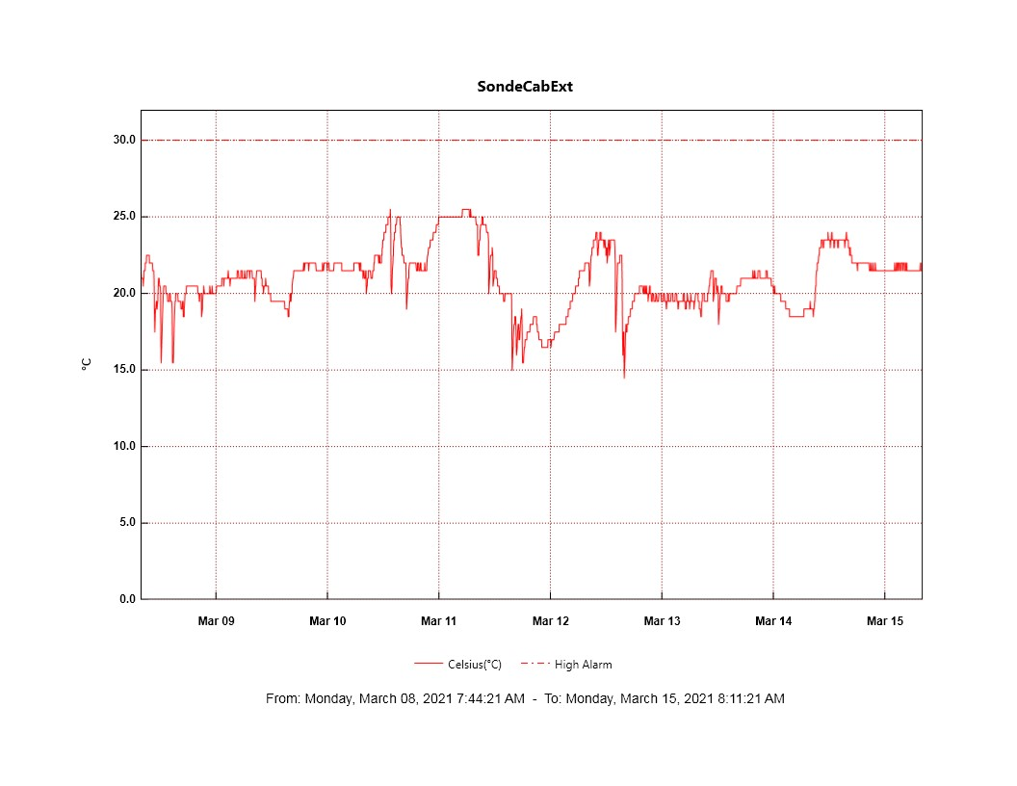
MWR:
- RPG-150-90 operating normally.

SODAR:
- 2021-03-09 1345 to 1407Z shut down to clean and level.
- Operating normally.

POSS:
- 2021-03-09: Digging around instrument.
- 2021-03-09 1700 to 1845Z: Raised instrument.
- Operating normally.

MASC:
- 2021-03-10: Digging around instrument.
- 2021-03-11: Raised instrument.
- Offline for winter season.

MMCR:
- 2021-03-09: Net_CDF errors persistent.
- 2021-03-11 1726Z: Shutdown command on LabView not responding.
- 2021-03-12 1249Z: Shutdown LabView and restarted in order to reboot instrument. Back up at 1310Z.
- Tilt value is out of tolerance: mean = .22
- Operating normally.

CAPABL:
- Operating normally.

MPL:
- No change to MPL window condition.
- Operating normally.

CEILOMETER:
- Operating normally.

PAERI:
- 2021-03-09 1307Z: Cleared scene mirror after ‘SW responsivity’ and ‘LW responsivity” red flags.
- Operating normally.

IceCAM:
- Operating normally.

IcePIC:
- No IcePICs this week.

CPC:
- 2021-03-11: Drained condensate pooling in outlet line.
- 2021-03-12 1345Z: Changed outlet filter.
- Operating normally.

MSF - OPC:
- Operating normally.

TAWO - OPC:
- 2021-03-09 1430Z: Inlet removed and brought inside to thaw.
- 2021-03-10 1318Z: Inlet reinstalled.
- Operating normally.

SKYOPC:
- Returned to Kangerlussuaq for onward shipping and manufacturer repair in Germany.

Fluxtower instrument suite:
- Operating normally.

Radiometers:
- 2021-03-13: Sun photometer cable failed during cold temps – issue ongoing.
- Reworked dailies and weeklies log spreadsheet and want to move it to a new location.

