**ICECAPS-ACE Weekly Report**

March 15th – March 21st, 2021

Dane Hansen

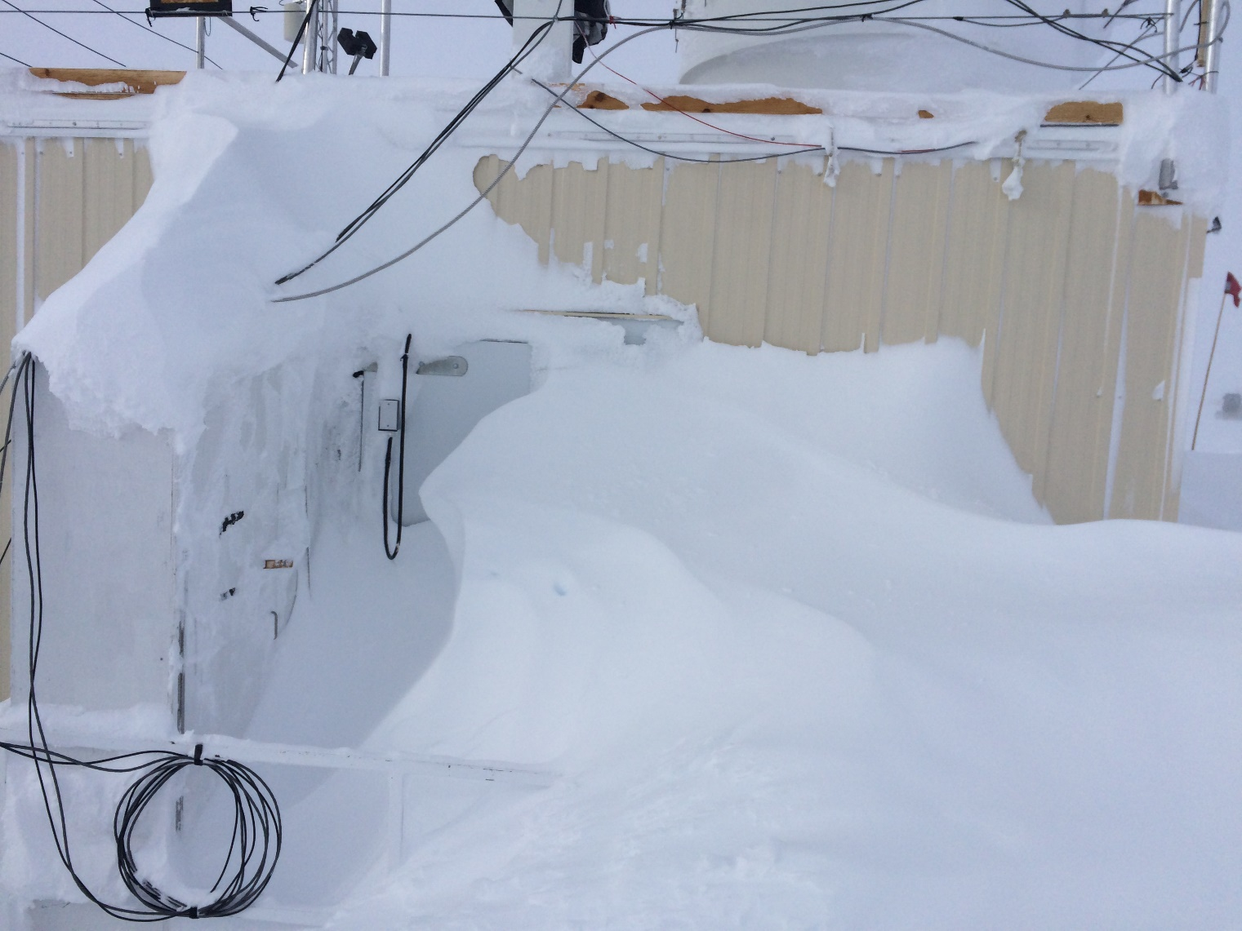

The backdoor of the MSF following the most recent wind event.

*Photo: Dane Hansen*

**General Notes:**

A busy week was punctuated by a significant storm on 2021-03-17 and 18 with wind gusts reaching speeds over 50 knots. This event corresponded with several instrument and facilities issues which were addressed that evening and the following day.

On 2021-03-18 at 1719Z the station experienced a primary generator failure which was later traced to a faulty transformer in the fuel pits. The MSF instruments were unaffected and ran off the UPS until emergency power was provided at 1802Z. The power was restored to the main generator 2021-03-19 between 1638 and 1639Z.

**General Weather Observations:**

|  |  |  |  |  |  |  |  |
| --- | --- | --- | --- | --- | --- | --- | --- |
| **Date** | **Time (Z)** | **Wind** | **Weather** | **Visibility** | **Sky** | **Temp (C)** | **Notes** |
| 03-15 | 12 | 17 kts at 186 | FZFG DRSN | 400 | VV020 | -33 |  |
| 03-16 | 12 | 14 kts at 193 | BR DRSN | 3200 | VV012 | -27 |  |
| 03-17 | 12 | 21 kts at 194 | FZFG DRSN | 400 | BKN049 | -26 | sundog |
| 03-18 | 12 | 32 kts at 205 | FZFG BLSN | 100 | VV002 | -18 | Gusts over 35 kts |
| 03-19 | 12 | 6 kts at 258 |  | 9999 | BKN049 | -37 | 22-degree halo |
| 03-20 | 12 | 14 kts at 157 | FZFG | 400 | VV015 | -38 |  |
| 03-21 | 12 | 14 kts at 175 | FZFG DRSN | 800 | SCT049 BKN098 | -30 | 22-degree halo |

**Significant Weather Observations:**

* 2021-03-17 1042Z: Sundog.
* 2021-03-19 1423Z: 22-degree halo.
* 2021-03-20 1123Z: 22-degree halo.

**MSF**

* Drifting snow accumulating on north and east sides.
* Operating normally.

**ICECAPS-ACE Data Management:**

* 03-15: Data transfer completed at 0636Z.
* 03-16: Data transfer completed at 0551Z.
* 03-17: Data transfer completed at 0451Z.
* 03-18: Data transfer completed at 0451Z.
* 03-19: Data transfer completed at 0431Z.
* 03-20: Data transfer completed at 0448Z.
* 03-21: Data transfer completed at 0448Z.

**TSI:**

* Offline for the winter season.

**Radiosonde:**

* Once daily launches.
* 2021-03-16: SMG experienced abnormally high temps causing SPS errors requiring reboot and cooling. Mechanics addresses problems in SMG HVAC system.
* 2021-03-18: Unplanned power outage caused hard shutdown of SPS and Radiosonde computer
* See chart below for radiosonde cabinet temperatures over the last week.

**MWR:**

* RPG-150-90 operating normally.

**SODAR:**

* 2021-03-16 1821 to 1844Z shut down to clean and level.
* 2021-03-20 1317 to 1333Z shut down to clean and level.
* Operating normally.

**POSS:**

* Operating normally.

**MASC:**

* Offline for winter season.

**MMCR:**

* 2021-03-18: Spikes in transmitter power (~120w) had occurred within prior 24 hours.
* Operating normally.

**CAPABL:**

* 2021-03-17 2237Z to 2021-03-18 1838Z: Internal errors in LabView.
* 2021-03-18 1958Z: LabView was terminated and the laser e-stopped.
* 2021-03-19 1306Z: System rebooted included motor controllers and cycled voltage scan and running normally (protocol update).
* Operating normally.

**MPL:**

* 2021-03-15 1501 to 1522Z: Performed calibration.
* No change to MPL window condition.
* Operating normally.

**CEILOMETER:**

* 2021-03-18 1923Z: Showing “optical cross-talk compensation poor” and “Window contaminated” error messages - cleaned instrument.
* 2021-03-19 1254Z: Errors clear.
* Operating normally.

**PAERI:**

* 2021-03-15 1437Z: Cleared scene mirror after ‘SW responsivity’ and ‘LW responsivity” red flags.
* 2021-03-16 1056Z: Cleared scene mirror after ‘SW responsivity’ and ‘LW responsivity” red flags.
* 2021-03-17 1549 and 2000Z: Cleared scene mirror after ‘SW responsivity’ and ‘LW responsivity” red flags.
* 2021-03-18 1920Z: Cleared scene mirror after ‘SW responsivity’ and ‘LW responsivity” red flags.
* 2021-03-20 1355Z: Cleared scene mirror after ‘SW responsivity’ and ‘LW responsivity” red flags.
* Operating normally.

**IceCAM:**

* Operating normally.

**IcePIC:**

* No IcePICs this week.

**CPC:**

* Operating normally.

**MSF - OPC:**

* 2021-03-18 1846Z: Instrument found not running and restarted data collection.
* Operating normally.

**TAWO - OPC:**

* 2021-03-18 1345Z Instrument found not running and restarted data collection.
* Operating normally.

**SKYOPC:**

* Returned to Kangerlussuaq for onward shipping and manufacturer repair in Germany.

**Fluxtower instrument suite:**

* Operating normally.

**Radiometers:**

* 2021-03-13: Sun photometer cable failed during cold temps – still disconnected.
* Dailies log and archiving old data.