ICECAPS-ACE Weekly Report
March 22nd – March 29th, 2021
Dane Hansen

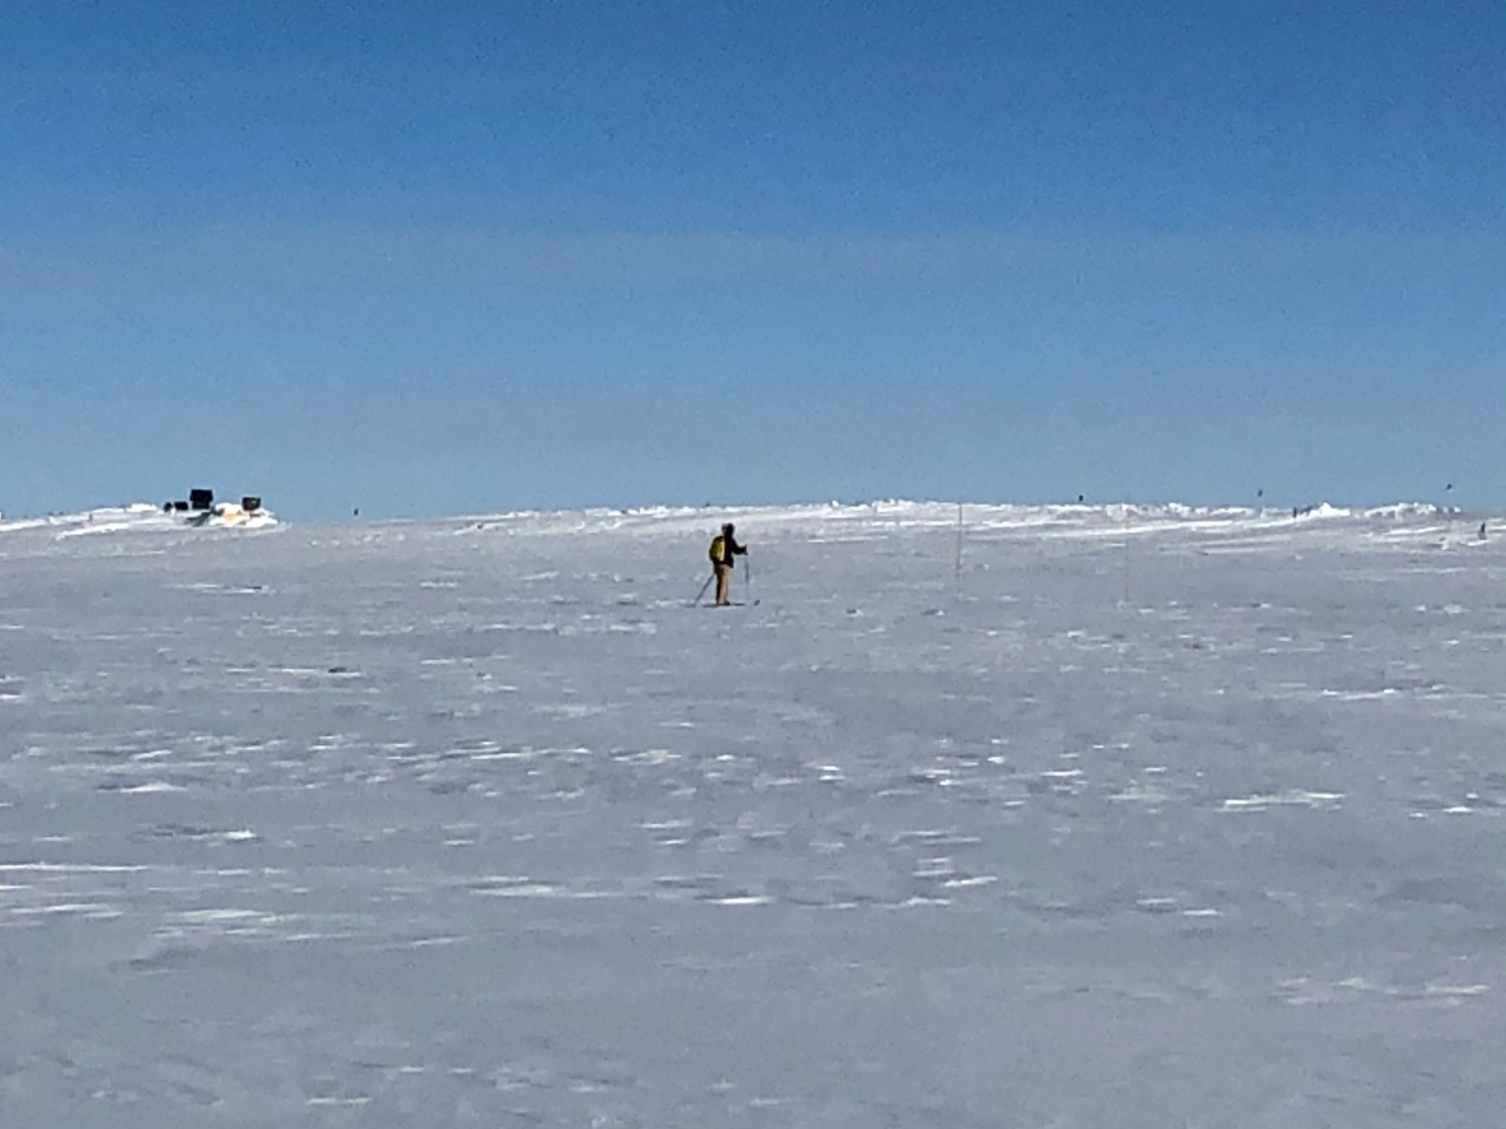

This weeks effort to complete the station accumulation survey.
Photo: Nathan Bowker

General Notes:
Spring weather kept everyone on their toes with low temps falling below -60 C on several occasions. Fortunately, there was minimal impact to instruments and facilities.

On 2021-03-24 the MSF experienced low temperatures around 9 C causing multiple alarms in the early morning. Nate found the northwest wall heater was not cycling and made an adjustment to the setting. The adjustment was adequate, and the MSF temperatures stabilized around 16 C.

General Weather Observations:
Date | Time (Z) | Wind | Weather | Visibility | Sky | Temp (C) | Notes
03-22 | 12 | 8 kts at 186 | BR | 4800 | SKC | -50
03-23 | 12 | 12 kts at 193 |  | 4800 | SKC | -53
03-24 | 12 | 8 kts at 194 |  | 9999 | FEW058 | -57
03-25 | 12 | 5 kts at 205 |  | 9999 | SKC | -54 | Low temp -64 C
03-26 | 12 | 14 kts at 258 | FZFG DLSN | 800 | SKC | -53 | Low temp -63 C
03-27 | 12 | 14 kts at 157 | BR | 4800 | OVC | -40
03-28 | 12 | 14 kts at 175 | BR | 1600 | BKN066 BKN124 | -41

Significant Weather Observations:
- None Observed.

MSF
- 2021-03-24: Heaters required adjustment due to low temps.
- Operating normally.

ICECAPS-ACE Data Management:
- 03-22: Data transfer completed at 0449Z.
- 03-23: Data transfer completed at 0438Z.
- 03-24: Data transfer completed at 0525Z.
- 03-25: Data transfer completed at 0457Z.
- 03-26: Data transfer completed at 0456Z.
- 03-27: Data transfer completed at 0449Z.
- 03-28: Data transfer completed at 0457Z.

TSI:
- Offline for the winter season.

Radiosonde:
- Once daily launches.
- Intermittent “SPS connection lost’ and ‘Telemetry received from wrong radiosonde’ messages.
- 2021-03-25: 111552Z Incorrect RH surface value entered due to low temps. The value was corrected and timestamped: 153142Z.
- See chart below for radiosonde cabinet temperatures over the last week.

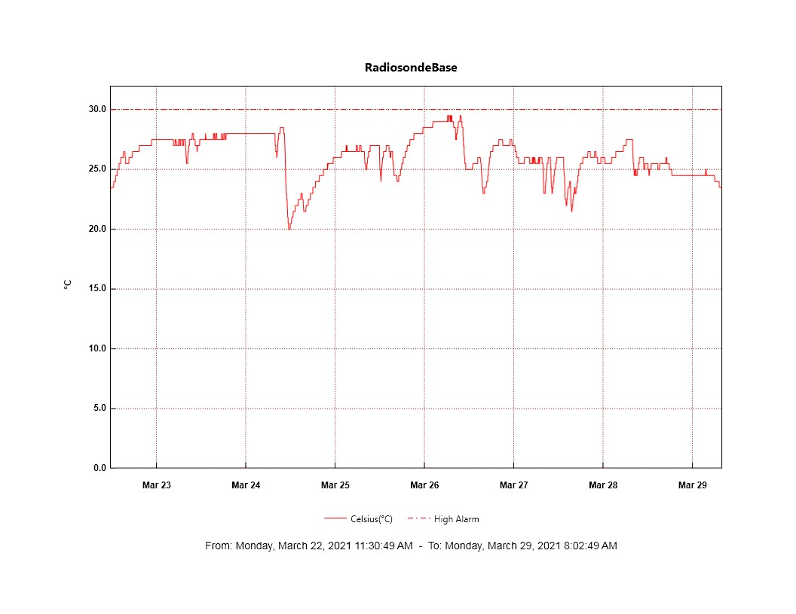

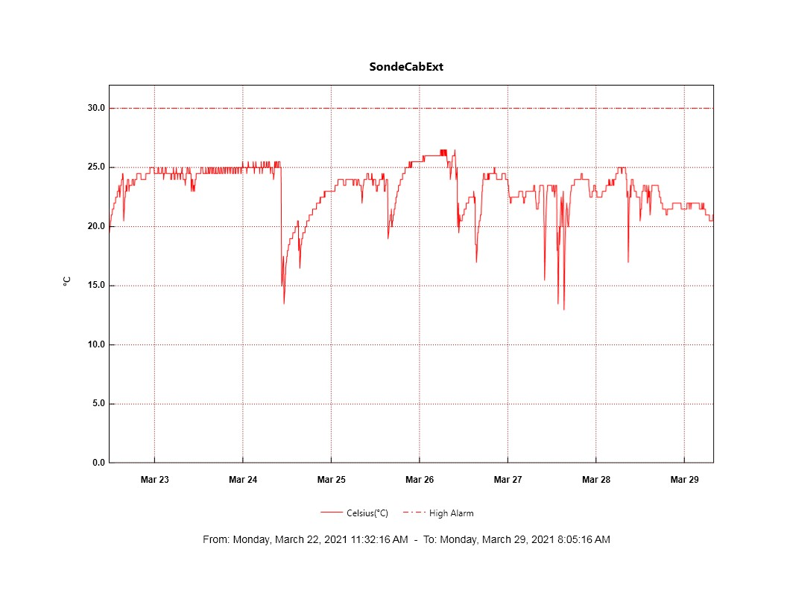
MWR:
- HatPro board slated to arrive 2021-03-30.
- RPG-150-90 operating normally.

SODAR:
- Operating normally.

POSS:
- Operating normally.

MASC:
- Offline for winter season.

MMCR:
- Operating normally.

CAPABL:
- Operating normally.

MPL:
- No change to MPL window condition.
- Operating normally.

CEILOMETER:
- Operating normally.

PAERI:
- 2021-03-25 600 to 900Z: ‘maxSampleStdDev’ flags
- 2021-03-26 200 to 1100Z: “mirrorMotorTemp’ and ‘maxSampleStdDev’ red flags.
- 2021-03-27 1600 to 1700Z: ‘SW responsivity’ and ‘LW responsivity” red flags.
- Operating normally.

IceCAM:
- Operating normally.

IcePIC:
- No IcePICs this week.

CPC:
- 2021-03-26 1416Z: Changed outlet filter.
- 2021-03-28 1100 to 1335Z: CPC not running due to ‘Air pump current too high.’ Cleared outlet line and restarted.
- Operating normally.

MSF - OPC:
- Operating normally.

TAWO - OPC:
- Operating normally.

SKYOPC:
- Returned to Kangerlussuaq for onward shipping and manufacturer repair in Germany.

Fluxtower instrument suite:
- Operating normally.

Radiometers:
- 2021-03-13: Sun photometer cable failed during cold temps – still disconnected.
- 2021-03-25: Switched tracker to sun mode. Power cable failed for logger.
- Dailies log and archiving old data.

