ICECAPS-ACE Weekly Report
March 30th – April 4th, 2021
Dane Hansen

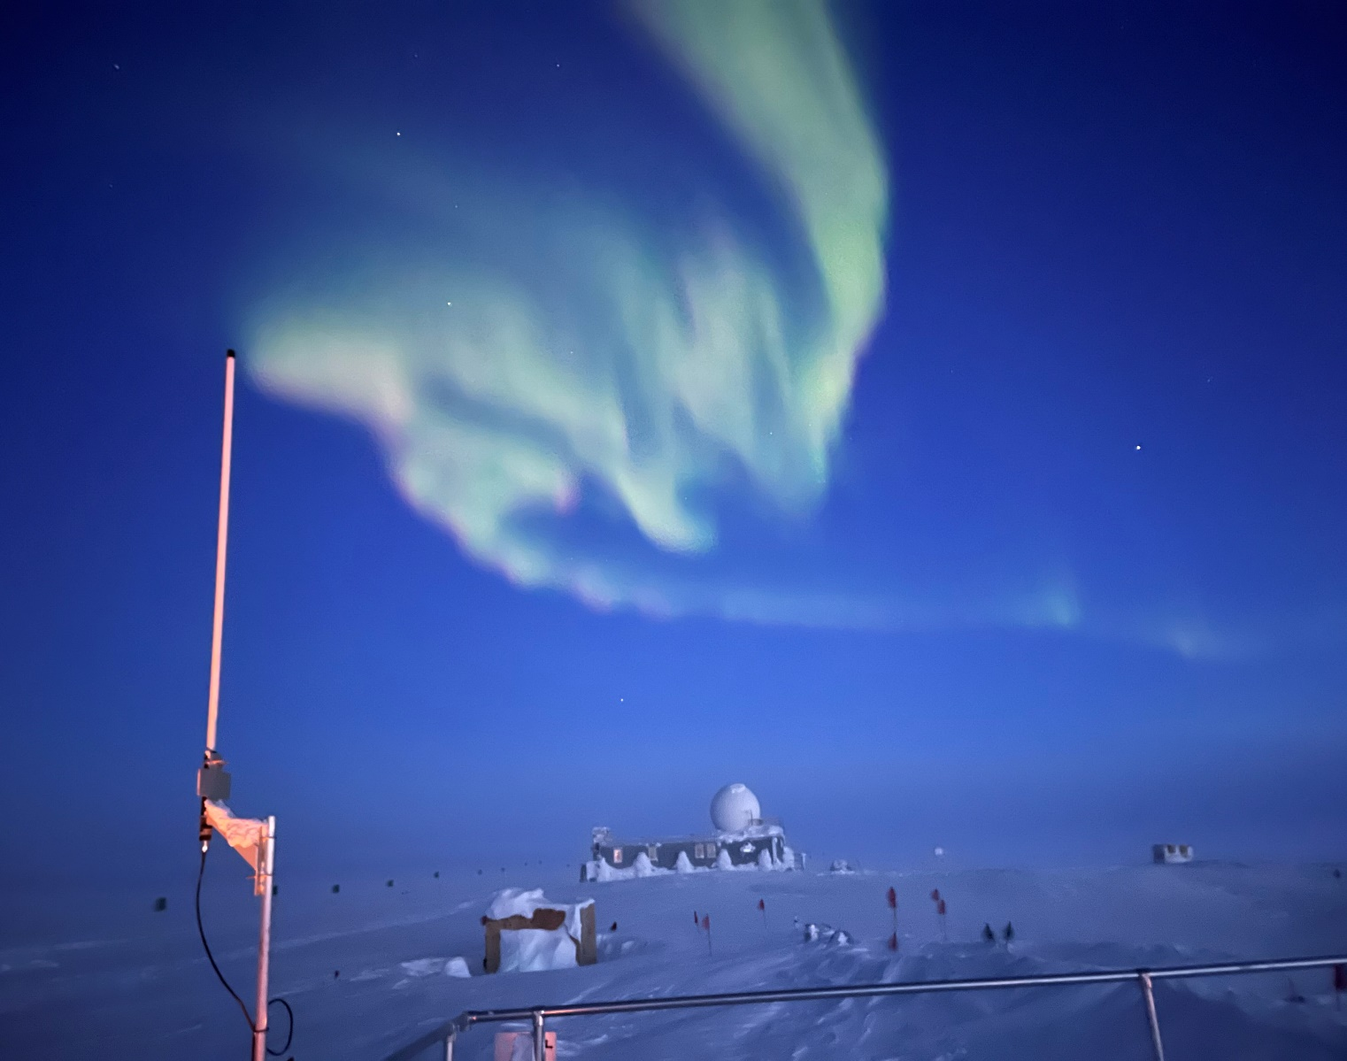

Some of the last aurora while night still offers enough darkness for clear viewing.
Photo: Gene Kornman

General Notes:
We received a LC-130 flight on Monday which brought up six new faces to join us at Summit. They spent the week acclimating and orienting to the station. The weather was quite windy with low visibility which limited our tasking and caused several instrument issues at the MSF.

I spent a portion of my time this week cleaning out the MSF and getting ready to dive into the HatPro repair. It looks much improved, but there is still a way to go. I expect to finish with the reorganization next week if all goes to plan.

General Weather Observations:
Date | Time (Z) | Wind | Weather | Visibility | Sky | Temp (C) | Notes
03-29 | 12 | 5 kts at 178 |  | 9999 | FEW040 | -43
03-30 | 12 | 18 kts at 173 | FZFG BLSN | 400 | VV | -37
03-31 | 12 | 32 kts at 226 | FZFG BLSN | 50 | VV004 | -22
04-01 | 12 | 21 kts at 220 | BLSN | 800 | SKC | -31
04-02 | 12 | 40 kts at 230 | BLSN FZFG | 20 | VV005 | -23 | Gusts over 45 kts
04-03 | 12 | 20 kts at 273 | DRSN | 400 | VV004 | -45
04-04 | 12 | 6 kts at 359 |  | 9999 | SKC | -50

Significant Weather Observations:
- None Observed.

MSF
- Reorganization begun.
- Operating normally.

ICECAPS-ACE Data Management:
- 03-29: Data transfer completed at 0451Z.
- 03-30: Data transfer completed at 0657Z.
- 03-31: Data transfer completed at 0521Z.
- 04-01: Data transfer completed at 0506Z.
- 04-02: Data transfer completed at 0524Z.
- 04-03: Data transfer completed at 0551Z.
- 04-04: Data transfer completed at 0608Z.
- 03-31: Swapped HD#3 for HD#4.
- Files not sent daily.

TSI:
- Offline for the winter season.

Radiosonde:
- Once daily launches.
- Periodic ‘wrong telemetry received’ and ‘SPS signal lost errors.’
- See chart below for radiosonde cabinet temperatures over the last week.

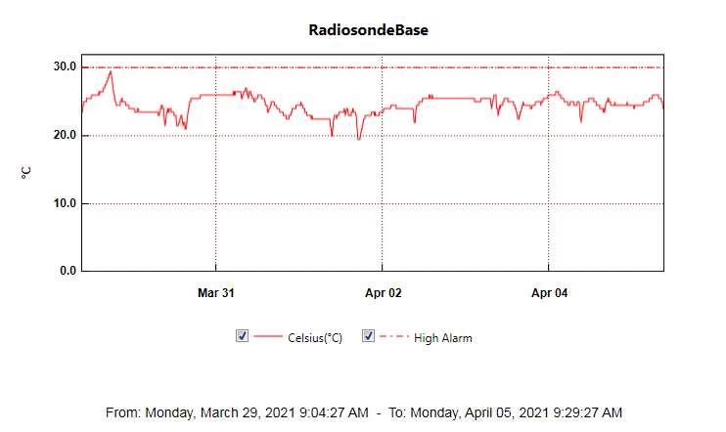

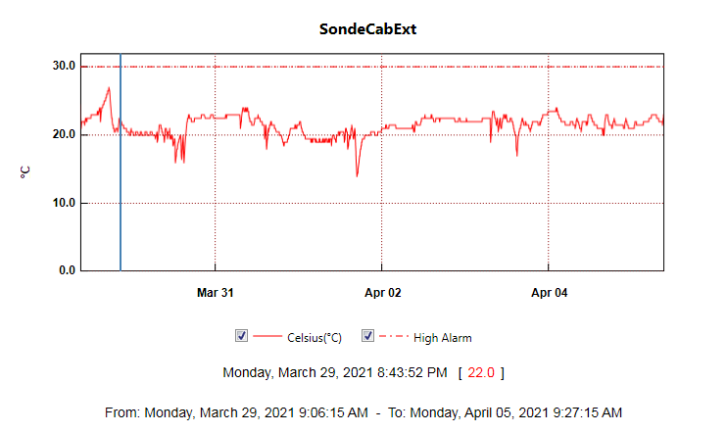
MWR:
- HatPro disassembly begun.
- RPG-150-90 operating normally.

SODAR:
- 2021-03-29 1445 to 1456Z: Cleaned and levelled – did not switch amplifier back on.
- 2021-03-30 1739Z: Noticed that amplifier was still off and corrected – left log open.
- 2021-03-31 1130Z: Minimized log so quicklooks could be captured.
- Operating normally.

POSS:
- 2021-03-02: ‘no good POSS packets in X (3 to 5) minutes’ errors.
- Operating normally.

MASC:
- Offline for winter season.

MMCR:
- Operating normally.

CAPABL:
- 2021-03-29 1407 to 1428Z: Licel found reading 005v. Licel and meadowlark power cycled and came back up normally.
- 20-03-31 1510 to 1518Z: LabView aborted due to internal errors. Power cycled, licel, meadowlark, laser, motor controllers, and restarted computer.
- 2021-04-02 1130 to 1838Z: Disk boot failure requiring power cycled, licel, meadowlark, laser, motor controllers, and computer restart to restore to operation.
- 2021-04-03 1325 to 1331Z: Shut down laser to clean window (no abort file was written).
- Operating normally.

MPL:
- No change to MPL window condition.
- Operating normally.

CEILOMETER:
- 2021-03-31 1537Z: ‘Optical receiver cross talk compensation poor’ error - cleaned instrument.
- 2021-04-01 1245Z: Error cleared.
- Operating normally.

PAERI:
- 2021-03-31 1546Z: Cleaned mirror due to ‘SW responsivity’ and ‘LW responsivity” red flags.
- 2021-04-02 1911Z: Cleaned mirror due to ‘SW responsivity’ and ‘LW responsivity” red flags.
- 2021-04-03 1317Z: Cleaned mirror due to ‘SW responsivity’ and ‘LW responsivity” red flags.
- 2021-04-04 1133, 1208, and 2120Z: Cleaned mirror due to ‘SW responsivity’ and ‘LW responsivity” red flags.
- Operating normally.

IceCAM:
- Operating normally.

IcePIC:
- No IcePICs this week.

CPC:
- 2021-03-29 1506Z: Refilled reservoir with butanol.
- 2021-04-02 1142Z: CPC found not running due to ‘Air pump current too high.’ Cleared outlet line and restarted.
- Operating normally.

MSF - OPC:
- 2021-03-30 2010Z to 2021-03-31 1441Z: OPC offline due to high winds.
- 2021-04-02 2132Z to 2021-04-03 1744Z: OPC offline due to high winds.
- Operating normally.

TAWO - OPC:
- 2021-03-31: OPC restarted after high winds.
- 2021-04-03: OPC restarted after high winds.
- Operating normally.

SKYOPC:
- Returned to Kangerlussuaq for onward shipping and manufacturer repair in Germany.

Fluxtower instrument suite:
- Operating normally.

Radiometers:
- 2021-03-29: Sun photometer, power, and data cables were repaired and reconnected. Hard anchors were added for strain relief to the umbilical and sun photometer cables. The umbilical was rerouted to reduce damage due to movement of the tracker. Power is still off to the tracker.
- Dailies log and archiving old data.

