**ICECAPS-ACE Weekly Report**

April 19th – April 25th, 2021

Dane Hansen

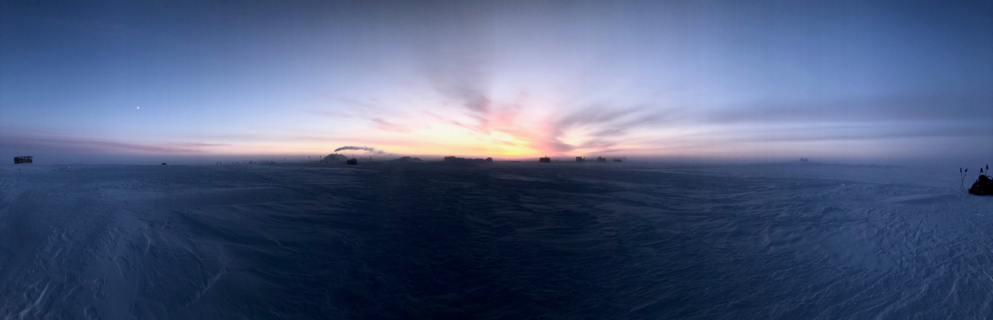

Sunrise over Summit Station 2021-04-19.

*Photo: Nate Bowker*

**General Notes:**

The week started out with clear skies and light winds and warmed up considerably by the weekend. Two new personnel arrived on the 21st with a load of cargo, both of which have been helpful to have at station. The second flight was cancelled due to unfavorable skiway conditions.

Progress is still being made troubleshooting the HatPro. I am hopeful that progress will accelerate, and I look forward to getting it put back together and on the roof.

**General Weather Observations:**

|  |  |  |  |  |  |  |  |
| --- | --- | --- | --- | --- | --- | --- | --- |
| **Date** | **Time (Z)** | **Wind** | **Weather** | **Visibility** | **Sky** | **Temp (C)** | **Notes** |
| 04-19 | 12 | 8 kts at 264 |  | 9999 | FEW032 | -40 |  |
| 04-20 | 12 | 9 kts at 266 | BR | 4800 | FEW058 | -40 | 22-degree halo |
| 04-21 | 12 | 9 kts at 265 | BR | 4800 | SKC | -40 |  |
| 04-22 | 12 | 10 kts at 202 |  | 9999 | FEW032 | -36 |  |
| 04-23 | 12 | 8 kts at 201 | BR | 4800 | VV005 | -23 |  |
| 04-24 | 12 | 11 kts at 153 |  | 9999 | SCT132 | -27 |  |
| 04-25 | 12 | 10 kts at 185 | FZFG | 600 | SKC | -26 |  |

**Significant Weather Observations:**

* 2021-04-20: 22-degree halo.

**MSF**

* Operating normally.

**ICECAPS-ACE Data Management:**

* 04-19: Data transfer completed at 0527Z.
* 04-20: Data transfer completed at 0453Z.
* 04-21: Data transfer completed at 0512Z.
* 04-22: Data transfer completed at 0854Z. No files transferred.
* 04-23: Data transfer completed at 0302Z. No files transferred.
* 04-24: Data transfer completed at 0556Z. No files transferred.
* 04-25: Data transfer completed at 0715Z. No files transferred.

**TSI:**

* Offline for the winter season.

**Radiosonde:**

* Once daily launches.
* Moved “S” serial numbers into radiosonde cabinet until further notice.
* See chart below for radiosonde cabinet temperatures over the last week.

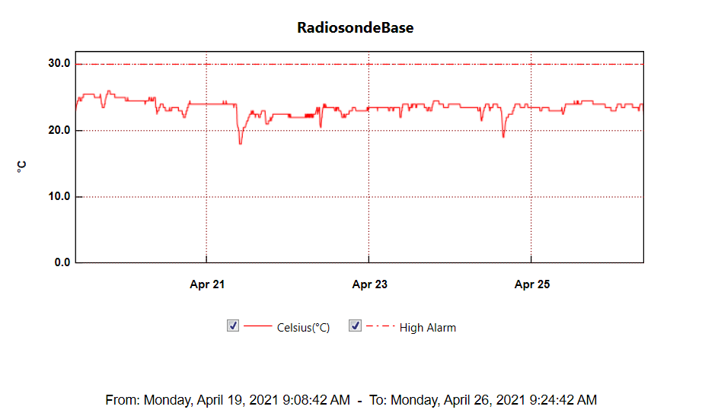

**MWR:**

* HatPro boots and connects to software but shows ‘Master stepper error’ message. Troubleshooting in progress.
* RPG-150-90 operating normally.

**SODAR:**

* Operating normally.

**POSS:**

* Operating normally.

**MASC:**

* Offline for winter season.

**MMCR:**

* 2021-04-25 1245Z: Cleared ‘Net CDF’ message.
* Operating normally.

**CAPABL:**

* 2021-04-24 1612Z: Restarted software and cycled peripherals due to ‘Disk boot failure’ message.
* 2021-04-25 1242 to 1258Z: Shut down laser to clean window.
* Operating normally.

**MPL:**

* No change to MPL window condition.
* Operating normally.

**CEILOMETER:**

* Operating normally.

**PAERI:**

* Operating normally.

**IceCAM:**

* Operating normally.

**IcePIC:**

* No IcePICs this week.

**CPC:**

* 2021-04-23 1148Z: Replaced outlet filter.
* Operating normally.

**MSF - OPC:**

* Operating normally.

**TAWO - OPC:**

* Operating normally.

**SKYOPC:**

* Scheduled for return to summit at some point.

**Fluxtower instrument suite:**

* Operating normally.

**Radiometers:**

* 2021-04-07: Ongoing troubleshooting. Suspected faulty DC power supply to logger box.