**ICECAPS-ACE Weekly Report**

April 26thth – May 2nd, 2021

Dane Hansen

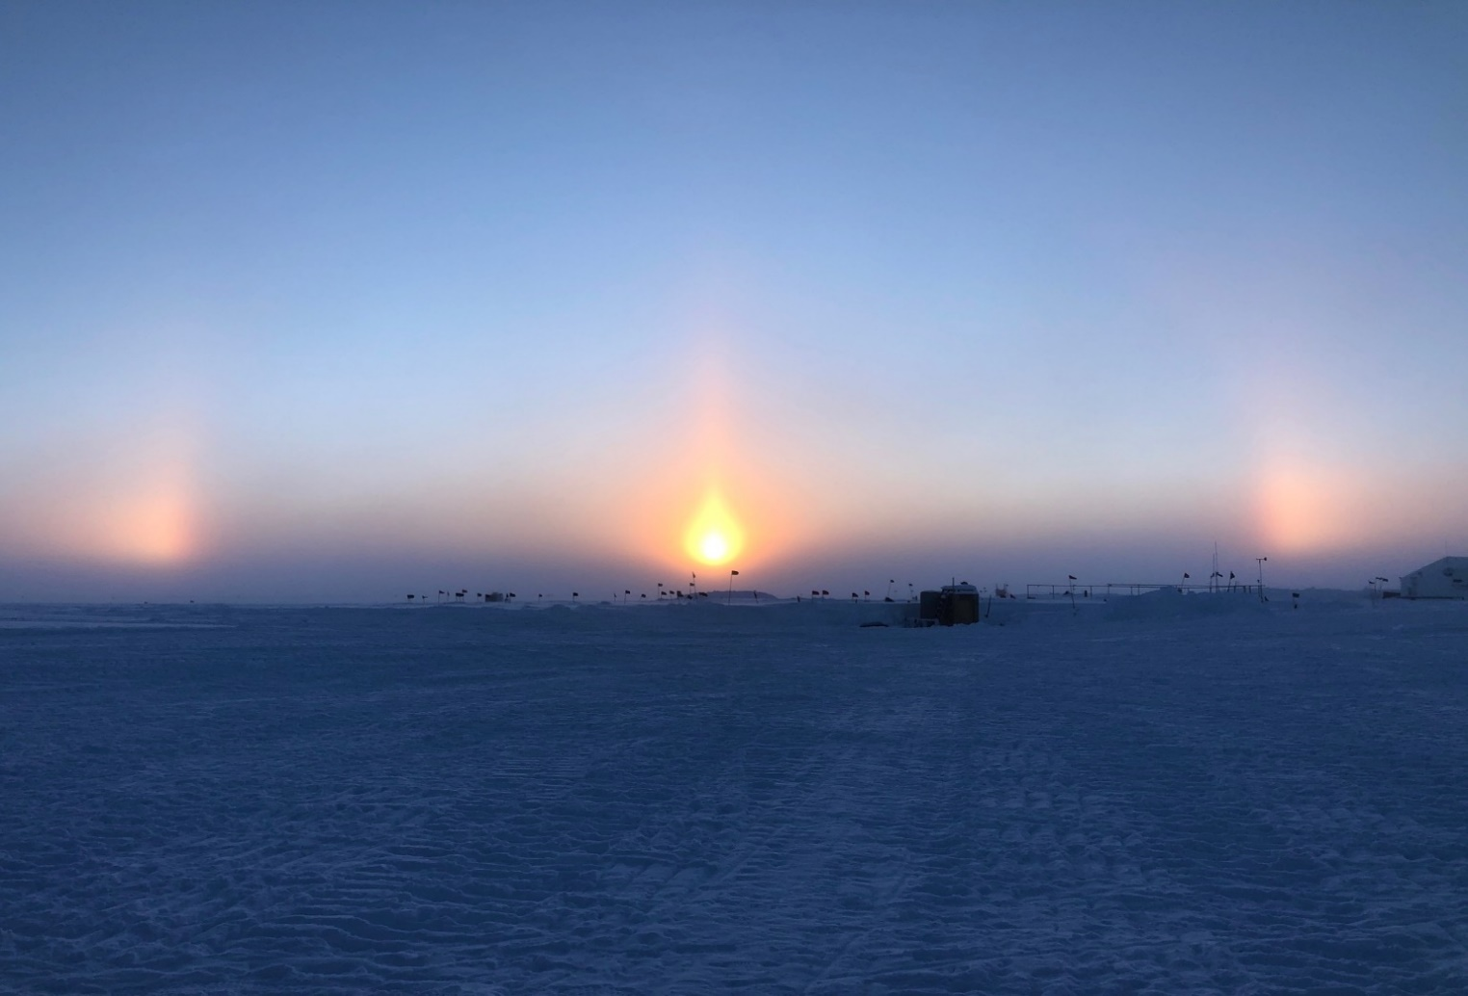

Sunset over Summit Station 2021-04-28.

*Photo: Derek Pickell*

**General Notes:**

The week brought warmer weather and clear skies. Fifteen crewmembers arrived on Tuesday which consisted mostly of carpenters, and also a replacement science technician for the TAWO facility. I spent several days training with the new science technician.

The HatPro status has not changed. The SkyOPC arrived on Tuesday and was installed mid-week. The TSI was also brought back online toward the end of the week and is capturing images.

**General Weather Observations:**

|  |  |  |  |  |  |  |  |
| --- | --- | --- | --- | --- | --- | --- | --- |
| **Date** | **Time (Z)** | **Wind** | **Weather** | **Visibility** | **Sky** | **Temp (C)** | **Notes** |
| 04-26 | 12 | 9 kts at 185 |  | 9999 | FEW066 FEW099 | -24 |  |
| 04-27 | 12 | 6 kts at 181 |  | 4800 | BKN047 | -15 |  |
| 04-28 | 12 | 10 kts at 250 |  | 9999 | FEW | -21 |  |
| 04-29 | 12 | 7 kts at 287 | FZFG | 1000 | SKC | -27 |  |
| 04-30 | 12 | 8 kts at 118 |  | 9999 | SKC | -32 |  |
| 05-01 | 12 | 10 kts at 123 |  | 9999 | SKC | -29 |  |
| 05-02 | 12 | 4 kts at 257 |  | 9999 | SKC | -26 |  |

**Significant Weather Observations:**

* None

**MSF**

* Operating normally.

**ICECAPS-ACE Data Management:**

* 04-19: Data transfer completed at 0736Z.
* 04-20: Data transfer completed at 0538Z.
* 04-21: Data transfer completed at 0538Z.
* 04-22: Data transfer completed at 0444Z.
* 04-23: Data transfer completed at 0429Z.
* 04-24: Data transfer completed at 0444Z.
* 04-25: Data transfer completed at 0516Z.

**TSI:**

* Offline for the winter season.

**Radiosonde:**

* Once daily launches.
* 2021-05-01: Launch failed due to excessive missing data frames.
* See chart below for radiosonde cabinet temperatures over the last week.

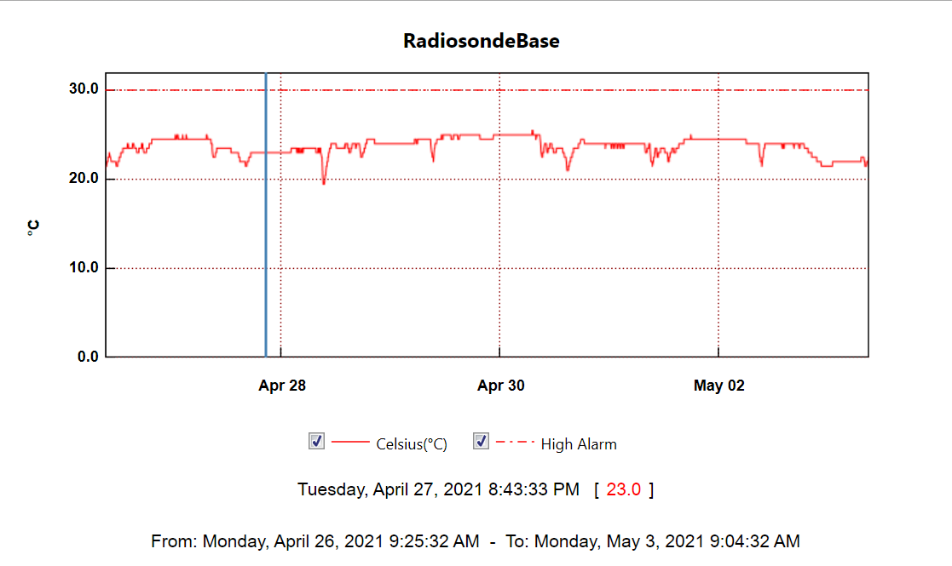

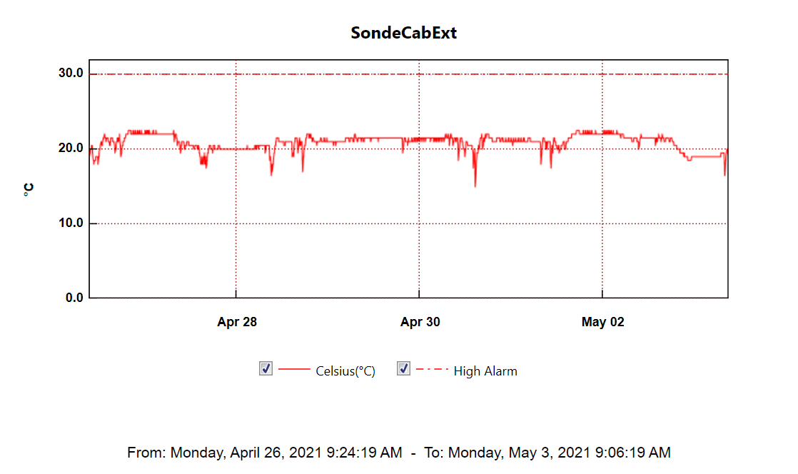

**MWR:**

* HatPro boots and connects to software but shows ‘Master stepper error’ message. Troubleshooting in progress.
* RPG-150-90 operating normally.

**SODAR:**

* 2021-04-26 1455Z: Cleaned and levelled.
* Operating normally.

**POSS:**

* Operating normally.

**MASC:**

* Offline for winter season.

**MMCR:**

* 2021-04-26 1413Z: Cleared ‘Net CDF’ message.
* 2021-04-27 1216Z: Cleared ‘Net CDF’ message.
* 2021-04-28 1655Z: Cleared ‘Net CDF’ message.
* 2021-04-29 1647Z: Cleared ‘Net CDF’ message.
* 2021-04-30 1330Z: Cleared ‘Net CDF’ message.
* 2021-05-02 1208Z: Cleared ‘Net CDF’ message.
* Operating normally.

**CAPABL:**

* 2021-05-01 1212 to 1219Z: Shut down laser to clean window and failed to restart data saving.
* 2021-05-02 1206Z: Restarted data saving.
* Operating normally.

**MPL:**

* No change to MPL window condition.
* 2021-04-29 2020Z: System froze.
* 2021-04-30 1348Z: Restarted computer and restarted software.
* Operating normally.

**CEILOMETER:**

* Operating normally.

**PAERI:**

* System has shown intermittent ‘SW responsivity’ yellow flags for most of the week.
* Operating normally.

**IceCAM:**

* Operating normally.

**IcePIC:**

* No IcePICs this week.

**CPC:**

* 2021-04-27 1326 to 1336Z: Knocked data cable out of instrument.
* Operating normally.

**MSF - OPC:**

* Operating normally.

**TAWO - OPC:**

* Operating normally.

**SKYOPC:**

* 2021-04-27 1635Z: Reinstalled and brought online.
* 2021-04-28 1628 to 1659Z: Tested new diaphragm pump.

**Fluxtower instrument suite:**

* 2021-05-02: Quicklooks lost communication with the fluxtower and is being addressed currently.
* Operating normally.

**Radiometers:**

* 2021-04-07: Ongoing troubleshooting. Suspected faulty DC power supply to logger box.