**ICECAPS-ACE Weekly Report**

May 3rd – May 9th, 2021

Dane Hansen

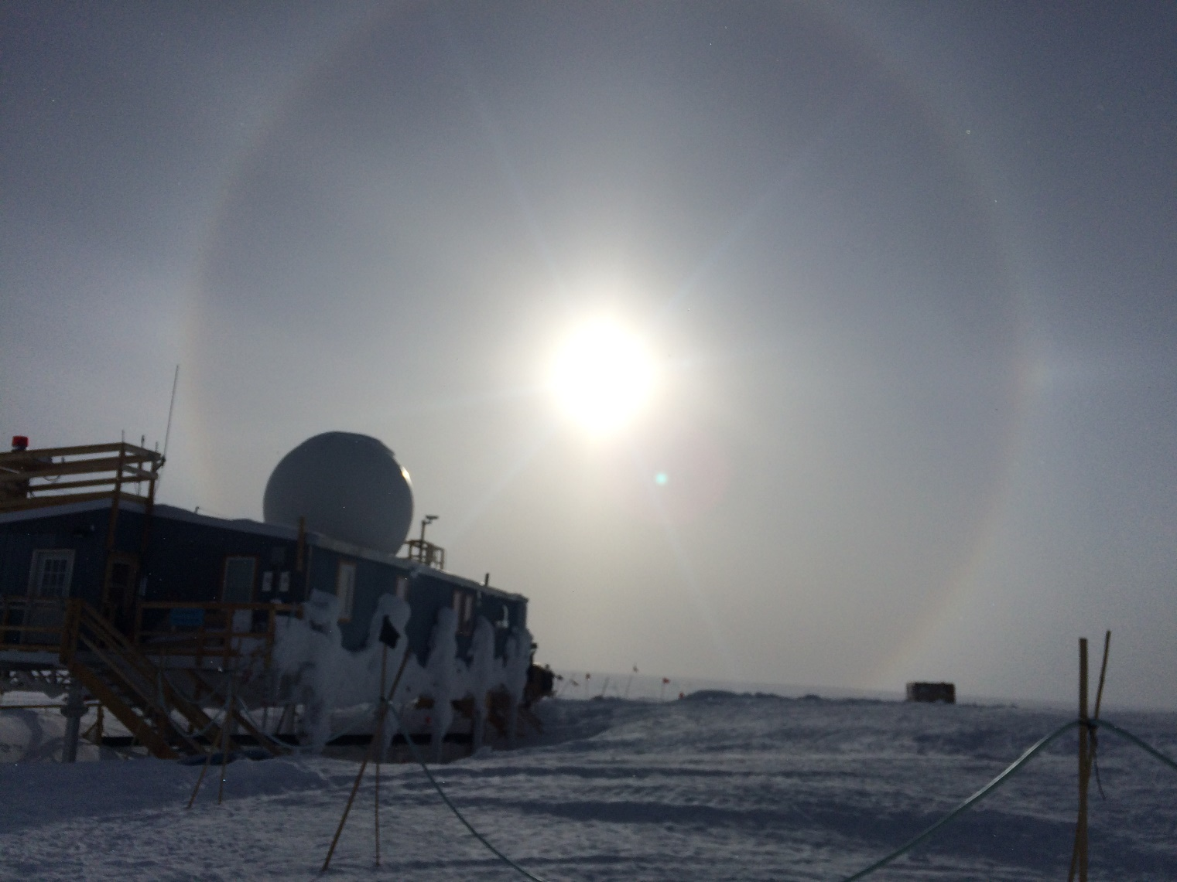

22-degree halo over Summit Station 2021-05-09.

*Photo: Dane Hansen*

**General Notes:**

The warming trend continued this week bringing clear skies and calm weather. The carpenters have been making progress on station addressing items of concern. The MSF main door has been adjusted and now seal properly. DNF cargo from a TAWO instrument is temporarily being stored in the MSF vestibule until the flight period next week.

The HatPro status has not changed and still shows a malfunction in the mirror drive system. The MASC was brought online Friday and came back up without too much trouble.

**General Weather Observations:**

|  |  |  |  |  |  |  |  |
| --- | --- | --- | --- | --- | --- | --- | --- |
| **Date** | **Time (Z)** | **Wind** | **Weather** | **Visibility** | **Sky** | **Temp (C)** | **Notes** |
| 05-03 | 12 | 7 kts at 296 |  | 9999 | SCK | -25 |  |
| 05-04 | 12 | 10 kts at 290 |  | 9999 | FEW120 | -24 | diamond dust |
| 05-05 | 12 | 9 kts at 258 |  | 9999 | FEW | -28 |  |
| 05-06 | 12 | 3 kts at 330 |  | 9999 | SCT020 | -26 |  |
| 05-07 | 12 | .5 kts at 118 |  | 9999 | FEW | -24 |  |
| 05-08 | 12 | 7 kts at 224 |  | 9999 | SCT020 | -25 |  |
| 05-09 | 12 | 6 kts at 227 |  | 9999 | SKC | -28 | 22-degree arc, parahelia, etc |

**Significant Weather Observations:**

* 2021-05-09: 22-degree arc, parahelia, upper tangential arc, sundog, etc.

**MSF**

* Operating normally.

**ICECAPS-ACE Data Management:**

* 05-03: Data transfer completed at 0440Z.
* 05-04: Data transfer completed at 0504Z.
* 05-05: Data transfer completed at 0457Z.
* 05-06: Data transfer completed at 0446Z.
* 05-07: Data transfer completed at 0444Z.
* 05-08: Data transfer completed at 0457Z.
* 05-09: Data transfer completed at 0501Z.

**TSI:**

* 2021-04-30 1925Z: Brought back online.
* Analysis of cloud cover accuracy is questionable.
* Operating normally.

**Radiosonde:**

* Once daily launches.
* 2021-05-04: Launch failed due to temperature sensor failure. Second launch failed due to excessive missing GPS data at 14,670ft.
* See chart below for radiosonde cabinet temperatures over the last week. Internal temps graph missing due to old battery in the logger.

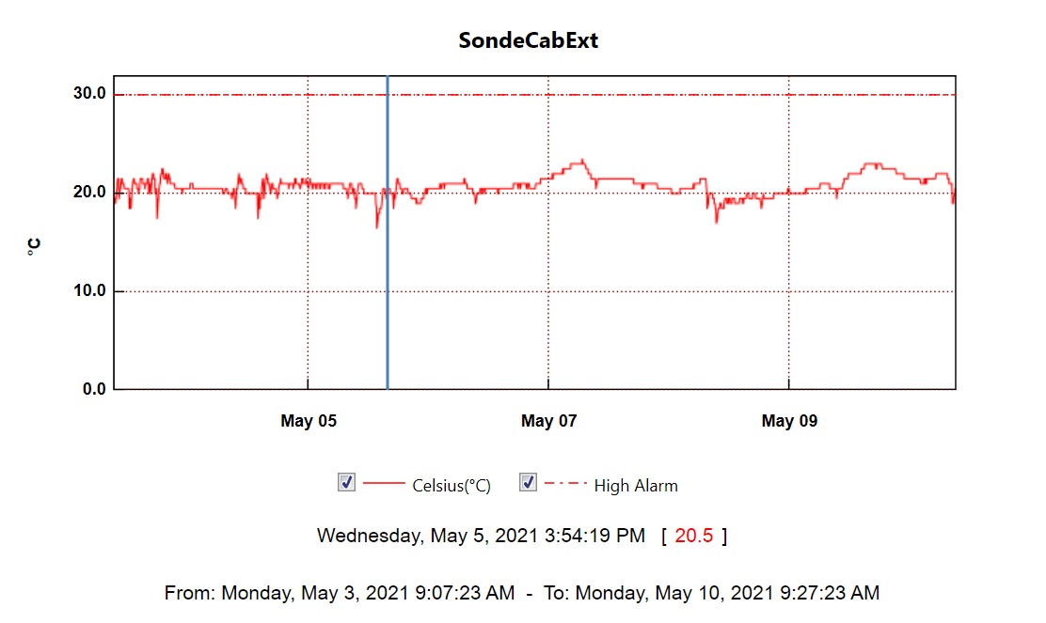

**MWR:**

* HatPro boots and connects to software but shows ‘Master stepper error’ message. Troubleshooting in progress.
* RPG-150-90 operating normally.

**SODAR:**

* 2021-05-04 1700Z: Cleaned and levelled.
* Operating normally.

**POSS:**

* Operating normally.

**MASC:**

* 2021-05-04: Changed desiccant in instrument body.
* 2021-05-07 1600Z: Brought back online.
* Operating normally.

**MMCR:**

* 2021-05-03 1627Z: Cleared ‘Net CDF’ message.
* 2021-05-04 1204, 1745, and 1912Z: Cleared ‘Net CDF’ message.
* 2021-05-05 ~1131 and 1537Z: Cleared ‘Net CDF’ message.
* 2021-05-06 1135 and 1230Z: Cleared ‘Net CDF’ message.
* 2021-05-07 1226 and 1545Z: Cleared ‘Net CDF’ message.
* 2021-05-08 1209Z: Cleared ‘Net CDF’ message.
* 2021-05-09 1209Z: Cleared ‘Net CDF’ message.
* Operating normally.

**CAPABL:**

* Operating normally.

**MPL:**

* 2021-05-03 1605 to 1957Z: Instrument was powered down to replace the window.
* Operating normally.

**CEILOMETER:**

* Operating normally.

**PAERI:**

* Still showing intermittent ‘SW responsivity’ yellow flags for most of the week.
* Operating normally.

**IceCAM:**

* Operating normally.

**IcePIC:**

* No IcePICs this week.

**CPC:**

* 2021-05-09 1215Z: Outlet filter replaced.
* Operating normally.

**MSF - OPC:**

* Operating normally.

**TAWO - OPC:**

* Operating normally.

**SKYOPC:**

* Operating normally.

**Fluxtower instrument suite:**

* 2021-05-05: Quicklooks brought back online after power cycling a switch in the Fluxtower enclosure.
* Operating normally.

**Radiometers:**

* 2021-04-07: Ongoing troubleshooting. Suspected faulty DC power supply to logger box.