**ICECAPS-ACE Weekly Report**

May 10th – May 16th, 2021

Dane Hansen

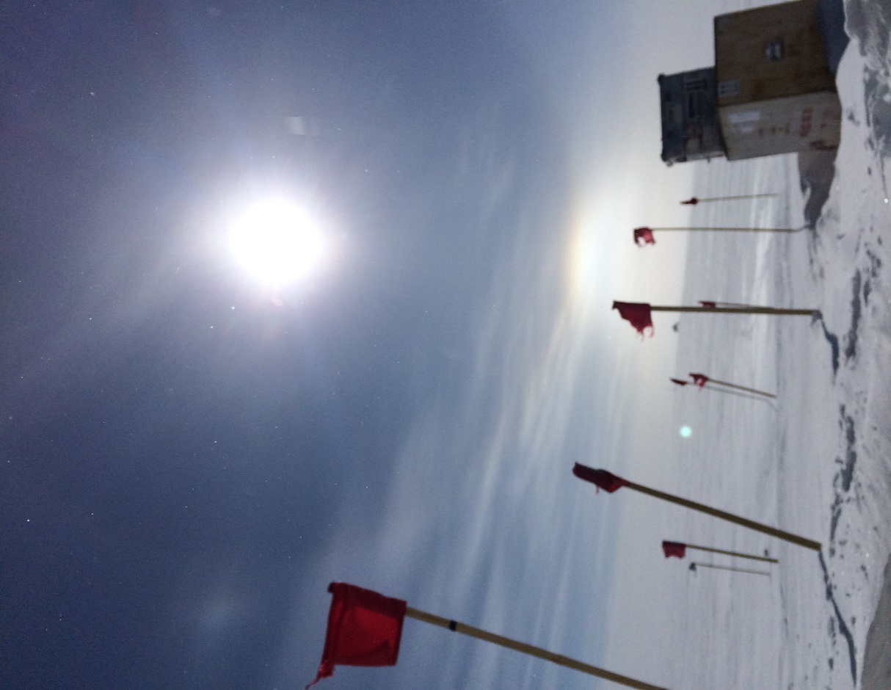

A lower tangent arc seen from outside the MSF entrance.

*Photo: Dane Hansen*

**General Notes:**

The weather is holding steady with clear skies and temperatures around -25C during the day. Efforts from equipment operators focus on digging out buried infrastructure and maintaining the skiway for a week of heavy activity. Carpenters continue to make improvements around station and prepare for incoming science groups.

The PAERI software stopped displaying new data early on Monday morning. After a reboot, the problem was not fixed, and the instrument stopped collecting data Monday at midnight. The problem is still under investigation.

**General Weather Observations:**

|  |  |  |  |  |  |  |  |
| --- | --- | --- | --- | --- | --- | --- | --- |
| **Date** | **Time (Z)** | **Wind** | **Weather** | **Visibility** | **Sky** | **Temp (C)** | **Notes** |
| 05-10 | 12 | 14 kts at 235 | BR | 9999 | BKN007 BKN033 | - 24 |  |
| 05-11 | 12 | 5 kts at 262 |  | 9999 | SKC | - 31 | tangent arc |
| 05-12 | 12 | 3 kts at 181 |  | 9999 | FEW | - 28 | sundog |
| 05-13 | 12 | 10 kts at 164 |  | 9999 | SKC | - 28 |  |
| 05-14 | 12 | 10 kts at 221 |  | 9999 | OVC066 | - 27 |  |
| 05-15 | 12 | 8 kts at 133 |  | 9999 | FEW | - 26 |  |
| 05-16 | 12 | 4 kts at 181 |  | 9999 | SKC | - 25 |  |

**Significant Weather Observations:**

* 2021-05-10: tangent arc
* 2021-05-11: sundog

**MSF**

* 2021-05-10 and 11: Equipment operators removed snow from north and west sides of building in preparation for relocation.
* Operating normally.

**ICECAPS-ACE Data Management:**

* 05-10: Data transfer completed at 0453Z.
* 05-11: Data transfer completed at 0512Z.
* 05-12: Data transfer completed at 0458Z.
* 05-13: Data transfer completed at 0450Z.
* 05-14: Data transfer completed at 0501Z.
* 05-15: Data transfer completed at 0506Z.
* 05-16: Data transfer completed at 0507Z.

**TSI:**

* Operating normally.

**Radiosonde:**

* Once daily launches.
* Intermittent SPS connection lost errors.
* See chart below for radiosonde cabinet temperatures over the last week.

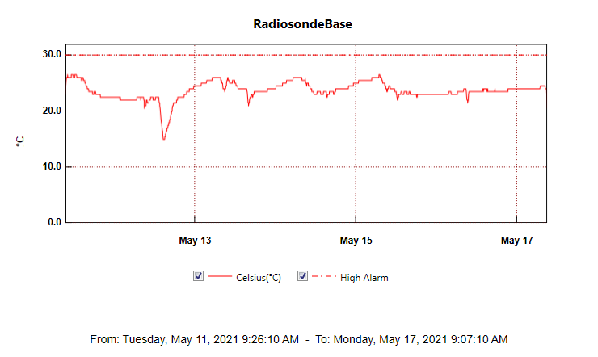

**MWR:**

* HatPro boots and connects to software but shows ‘Master stepper error’ message. Troubleshooting in progress.
* RPG-150-90 operating normally.

**SODAR:**

* 2021-05-11 1700Z: Cleaned and levelled.
* Operating normally.

**POSS:**

* Operating normally.

**MASC:**

* Operating normally.

**MMCR:**

* 2021-05-10 to 2021-05-13: Cleared error messages.
* 2021-05-13 1202 to 1335Z: Rebooted system.
* Operating normally.

**CAPABL:**

* Operating normally.

**MPL:**

* 2021-05-15 1426 to 1447Z: Performed afterpulse calibration.
* Operating normally.

**CEILOMETER:**

* Operating normally.

**PAERI:**

* 2021-05-10 0230Z: Software froze.
* 2021-05-10 1710Z: System rebooted.
* 2021-05-11 0000Z: System stopped acquiring data.
* Operating normally.

**IceCAM:**

* Operating normally.

**IcePIC:**

* No IcePICs this week.

**CPC:**

* 2021-05-11 1352Z: Refilled with butanol.
* Operating normally.

**MSF - OPC:**

* Operating normally.

**TAWO - OPC:**

* Operating normally.

**SKYOPC:**

* 2021-05-13: Pump failed and was replaced with new diaphragm pump.
* 2021-05-13 1244Z: Returned to service.
* Operating normally.

**Fluxtower instrument suite:**

* Operating normally.

**Radiometers:**

* 2021-04-07: Ongoing troubleshooting. Suspected faulty DC power supply to logger box.