**ICECAPS-ACE Weekly Report**

May 17th – May 23rd, 2021

Dane Hansen

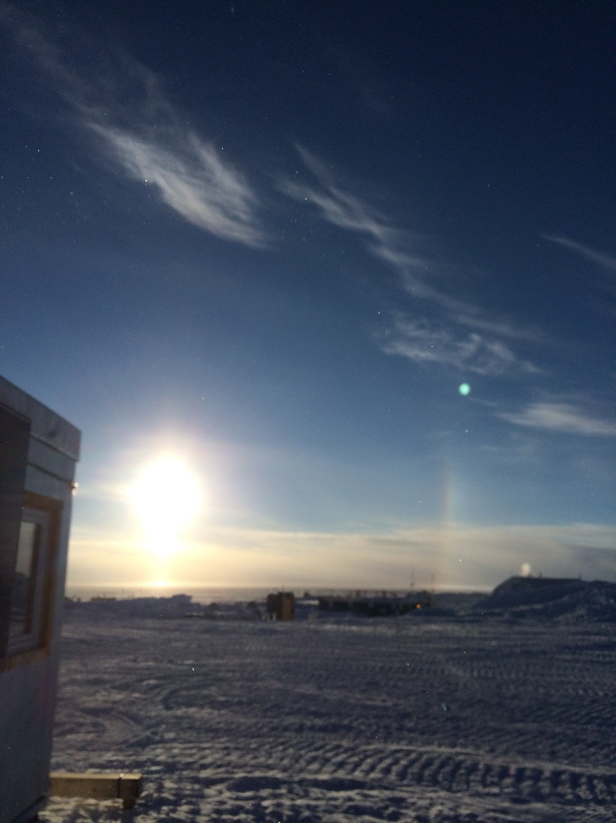

A late-night sundog taken from the summer berthing area.

*Photo: Dane Hansen*

**General Notes:**

Troubleshooting of the PAERI is ongoing after it stopped collecting data last week. The rest of instrument suite is operating normally. Nitrogen arrived midweek for the upcoming MWR calibration and was moved to the MSF.

The week was mostly uneventful and was highlighted with more warm and calm days.

**General Weather Observations:**

|  |  |  |  |  |  |  |  |
| --- | --- | --- | --- | --- | --- | --- | --- |
| **Date** | **Time (Z)** | **Wind** | **Weather** | **Visibility** | **Sky** | **Temp (C)** | **Notes** |
| 05-17 | 12 | 1 kts at 33 |  | 9999 | SKC | - 26 |  |
| 05-18 | 12 | 9 kts at 50 |  | 9999 | FEW198 | - 24 |  |
| 05-19 | 12 | 8 kts at 101 |  | 9999 | FEW | - 23 |  |
| 05-20 | 12 | 10 kts at 146 |  | 9999 | FEW | - 23 |  |
| 05-21 | 12 | 17 kts at 162 |  | 9999 | FEW | - 23 |  |
| 05-22 | 12 | 11 kts at 134 | BR | 1600 | SCT058 | - 24 | sundog |
| 05-23 | 12 | 14 kts at 132 |  | 9999 | OVC022 | - 21 | halo |

**Significant Weather Observations:**

* 2021-05-22: sundog
* 2021-05-23: halo

**MSF**

* 2021-05-17 1204 to 1205Z: Planned power outage.
* 2021-05-17 1858 to 1902Z: Planned power outage.
* 2021-05-23 1430 to 1436Z: Unplanned power outage.
* 2021-05-23 2310 to 2318Z: Unplanned power outage.
* Electrician installed thermostats on east wall heaters and updated building grounding.
* Operating normally.

**ICECAPS-ACE Data Management:**

* 05-17: Data transfer completed at 0441Z.
* 05-18: Data transfer completed at 0437Z.
* 05-19: Data transfer completed at 0500Z.
* 05-20: Data transfer completed at 0449Z.
* 05-21: Data transfer completed at 0448Z.
* 05-22: Data transfer completed at 0447Z.
* 05-23: Data transfer completed at 0457Z.
* MASC ‘file already exists’ error.

**TSI:**

* Operating normally.

**Radiosonde:**

* Once daily launches.
* See chart below for radiosonde cabinet temperatures over the last week.

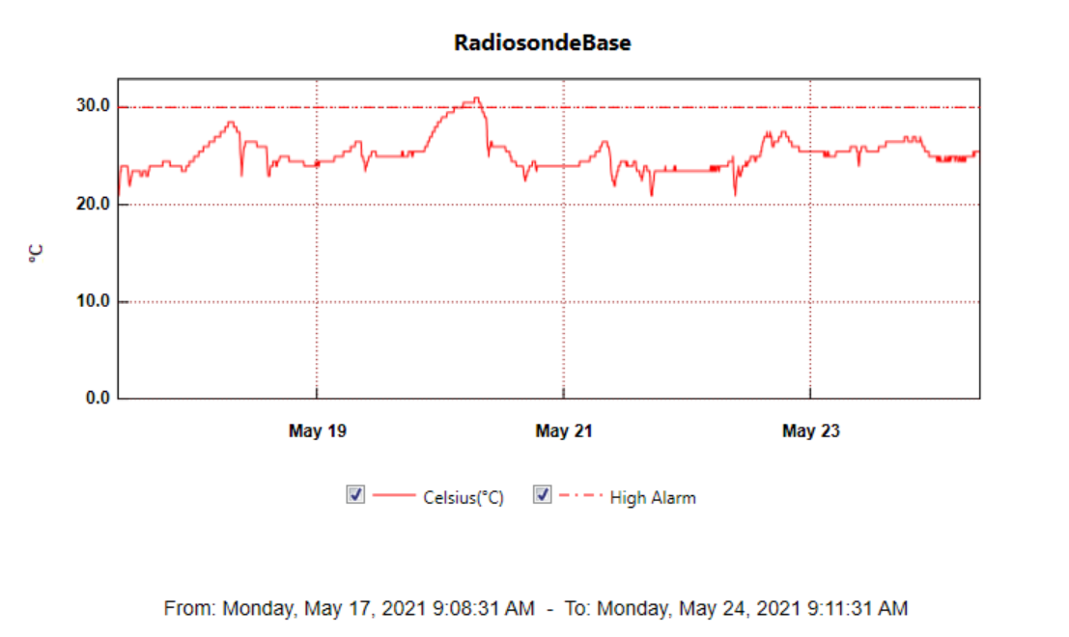

**MWR:**

* HatPro boots and connects to software but shows ‘Master stepper error’ message. Troubleshooting in progress.
* RPG-150-90 operating normally.

**SODAR:**

* 2021-05-19 1236 to 1242Z: Cleaned and levelled.
* Operating normally.

**POSS:**

* Operating normally.

**MASC:**

* Operating normally.

**MMCR:**

* Operating normally.

**CAPABL:**

* Operating normally.

**MPL:**

* Operating normally.

**CEILOMETER:**

* Operating normally.

**PAERI:**

* 2021-05-17 1231Z: Interferometer turned off.
* 2021-05-17 1918 to 1923Z: Copper disk removed to examine internal lights.
* Operating normally.

**IceCAM:**

* Operating normally.

**IcePIC:**

* No IcePICs this week.

**CPC:**

* Operating normally.

**MSF - OPC:**

* Operating normally.

**TAWO - OPC:**

* Operating normally.

**SKYOPC:**

* 2021-05-17 1209 to 1210Z: Turned off for outage.
* 2021-05-17 1902 to 1904Z: Turned off for outage.
* Operating normally.

**Fluxtower instrument suite:**

* Operating normally.

**Radiometers:**

* 2021-04-07: Ongoing troubleshooting. Power supply box overhaul planned to restore instrument function.