**ICECAPS-ACE Weekly Report**

May 24th – May 30th, 2021

Dane Hansen

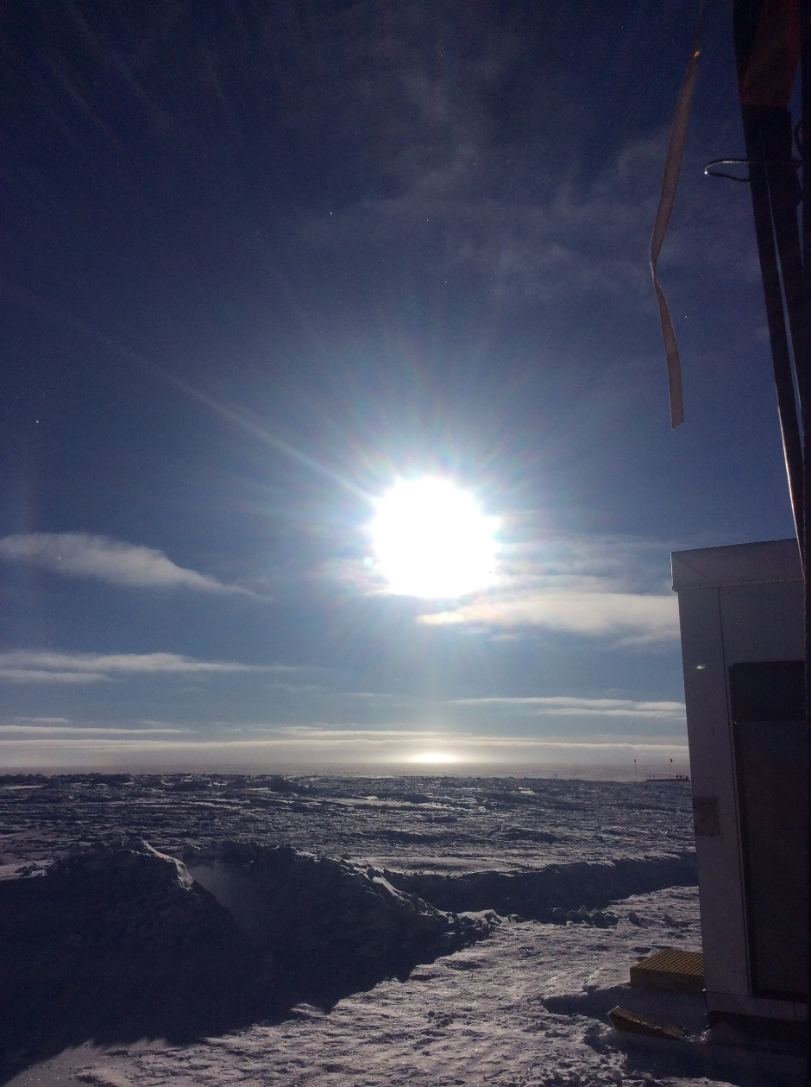

Another picture of the sun and the horizon.

*Photo: Dane Hansen*

**General Notes:**

This week we were visited by high winds and low visibility for the first time in close to a month. New science groups arrived and are getting settled into their projects and accommodations. General work at camp is focusing on digging out buried infrastructure in preparation for relocation later in the season. A new pad is being constructed for the relocation of the MSF as well.

**General Weather Observations:**

|  |  |  |  |  |  |  |  |
| --- | --- | --- | --- | --- | --- | --- | --- |
| **Date** | **Time (Z)** | **Wind** | **Weather** | **Visibility** | **Sky** | **Temp (C)** | **Notes** |
| 05-24 | 12 | 11 kts at 114 |  | 4800 | FEW033 | - 26 |  |
| 05-25 | 12 | 25 kts at 140 |  | 400 | VV010 | - 24 |  |
| 05-26 | 12 | 32 kts at 183 | FZFG BLSN | 300 | BKN022 | - 23 | Gusts to 35 kts |
| 05-27 | 12 | 10 kts at 180 | FZFG BLSN | 9999 | SCT | - 23 |  |
| 05-28 | 12 | 22 kts at 123 |  | 1600 | SCT | - 23 |  |
| 05-29 | 12 | 13 kts at 113 |  | 9999 | BKN045 BKN116 BKN168 | - 24 |  |
| 05-30 | 12 | 10 kts at 145 |  | 4800 | BKN020 | - 21 |  |

**Significant Weather Observations:**

* 2021-05-28: pillar
* 2021-05-30: 22-degree halo

**MSF**

* 2021-05-25 1224 to 1226Z: Planned power outage.
* 2021-05-25 1237 to 1243Z: Unplanned power outage.
* 2021-05-25 1623 to 1624Z: Planned power outage.
* 2021-05-28 2046 to 2047Z: Unplanned power outage.
* Operating normally.

**ICECAPS-ACE Data Management:**

* 05-24: Data transfer completed at 0501Z.
* 05-25: Data transfer completed at 0451Z.
* 05-26: Data transfer completed at 0454Z.
* 05-27: Data transfer completed at 0512Z.
* 05-28: Data transfer completed at 0453Z.
* 05-29: Data transfer completed at 0454Z.
* 05-30: Data transfer completed at 0455Z.

**TSI:**

* Operating normally.

**Radiosonde:**

* Once daily launches.
* See chart below for radiosonde cabinet temperatures over the last week.

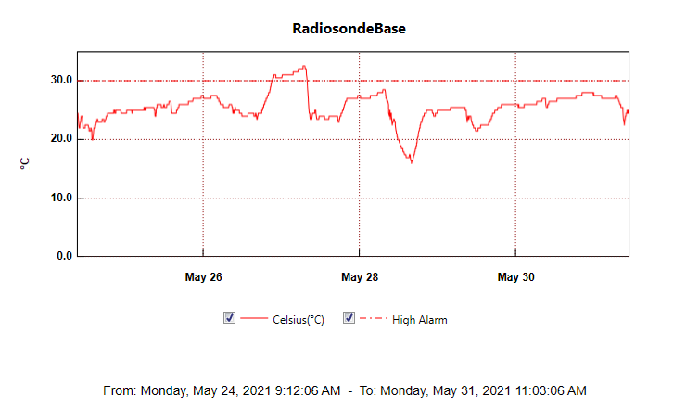

**MWR:**

* HatPro boots and connects to software but shows ‘Master stepper error’ message. Troubleshooting in progress.
* Reassembly and box up?
* RPG-150-90 operating normally.

**SODAR:**

* 2021-05-24 1550 to 1600Z: Cleaned and levelled.
* Operating normally.

**POSS:**

* Operating normally.

**MASC:**

* Operating normally.

**MMCR:**

* Operating normally.

**CAPABL:**

* 2021-05-29 1816Z: Laser not firing – cycled voltage scan.
* Operating normally.

**MPL:**

* Operating normally.

**CEILOMETER:**

* Operating normally.

**PAERI:**

* 2021-05-11 0000Z: Instrument down and troubleshooting in progress.
* 2021-05-26 1955Z: Cleaned snow from enclosure.
* Operating normally.

**IceCAM:**

* Operating normally.

**IcePIC:**

* No IcePICs this week.

**CPC:**

* 2021-05-24 1544Z: Outlet filter changed.
* Operating normally.

**MSF - OPC:**

* Operating normally.

**TAWO - OPC:**

* Operating normally.

**SKYOPC:**

* Operating normally.

**Fluxtower instrument suite:**

* Operating normally.

**Radiometers:**

* 2021-04-07: Ongoing troubleshooting. Power supply box removed - instrument is offline pending repair.