**ICECAPS-ACE Weekly Report**

May 31st – June 7th, 2021

Dane Hansen

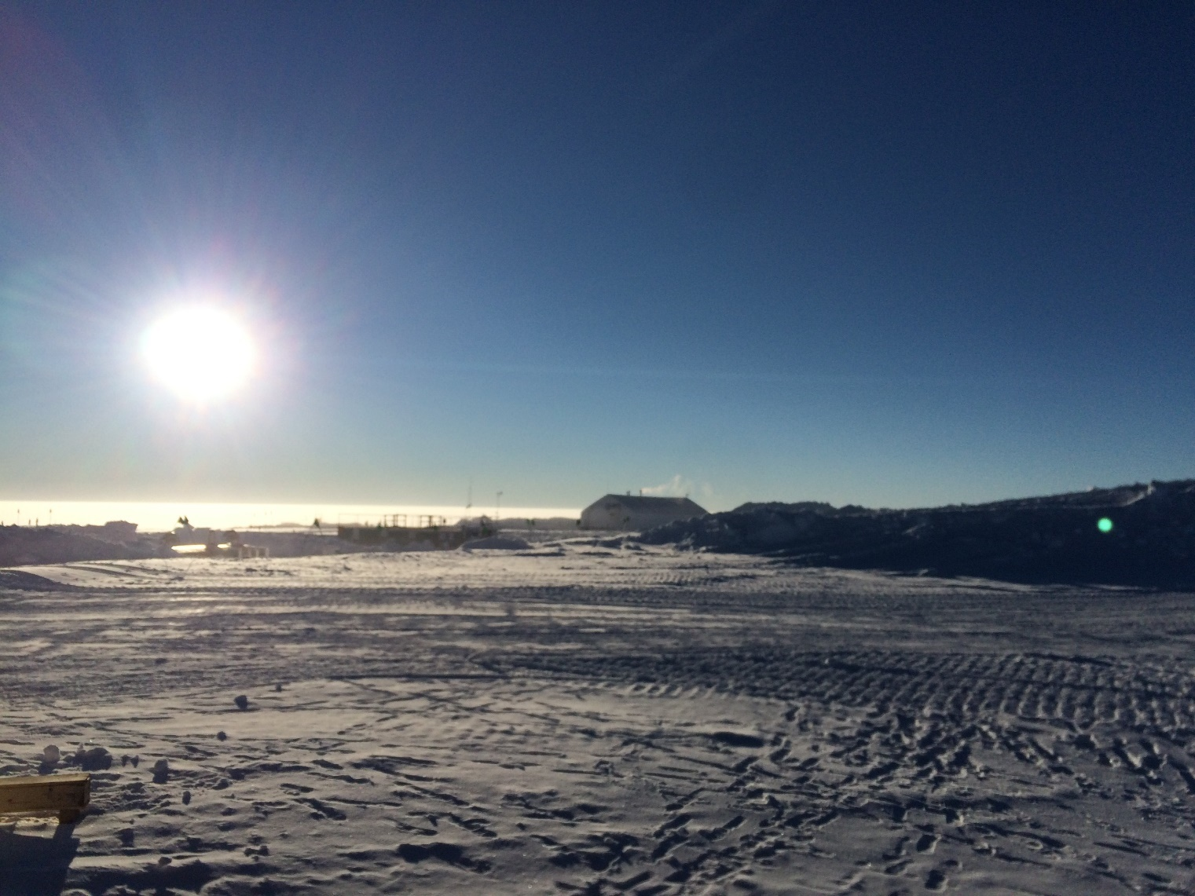

Another picture of the sun and the horizon, but slightly different than last week.

*Photo: Dane Hansen*

**General Notes:**

A busy week was concluded with the shutdown of many ICECAPS instruments. The RPG150-90 was successfully calibrated and returned to service on Monday. The overhaul of the solar tracker power box was completed midweek with the installation of a new 12VDC power supply. The box was reinstalled and the instrument successfully brought back online, though with some persisting communication errors. Toward the end of the week, the ICECAPS instrument suite shutdown has commenced and so far has not run into any significant obstacles.

**General Weather Observations:**

|  |  |  |  |  |  |  |  |
| --- | --- | --- | --- | --- | --- | --- | --- |
| **Date** | **Time (Z)** | **Wind** | **Weather** | **Visibility** | **Sky** | **Temp (C)** | **Notes** |
| 05-31 | 12 | 8 kts at 333 |  | 4800 | SCT052 | - 18 |  |
| 05-01 | 12 | 6 kts at 041 |  | 9999 | SCT082 | - 21 |  |
| 05-02 | 12 | 6 kts at 128 |  | 4800 | SCT049 | - 23 |  |
| 05-03 | 12 | kts at |  | 9999 | SKC | - | weather system down |
| 05-04 | 12 | 13 kts at 117 |  | 9999 | FEW | - 17 |  |
| 05-05 | 12 | 5 kts at 156 |  | 9999 | SCT | - 9 |  |
| 05-06 | 12 | 5 kts at 047 |  | 4800 | SCT033 | - 10 |  |

**Significant Weather Observations:**

* 2021-06-06: diamond dust, halo

**MSF**

* 2021-06-04 1200 to 1206Z: Planned power outage.
* Operating normally.

**ICECAPS-ACE Data Management:**

* 05-31: Data transfer completed at 0455Z.
* 05-01: Data transfer completed at 0527Z.
* 05-02: Data transfer completed at 0649Z.
* 05-03: Data transfer completed at 0508Z.
* 05-04: Data transfer completed at 0611Z.
* 05-05: Data transfer completed at 0510Z.
* 05-06: Data transfer completed at 0339Z.

**TSI:**

* 2021-06-04 1214Z: Shut down.
* Operating normally

**Radiosonde:**

* Once daily launches.
* 2021-06-04: ‘Excessive missing data frames’ and ‘PTU filtering stopped’ errors.
* 2021-06-05: ‘Signal lost’ errors.
* See chart below for radiosonde cabinet temperatures over the last week.

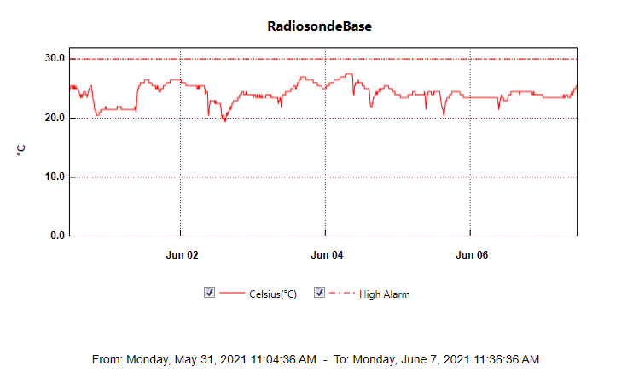

**MWR:**

* HatPro status unchanged - will reassemble for storage or retro.
* 2021-05-31 1604 to 1848Z: RPG-150-90 data collection stopped and calibrated.
* 2021-06-04 1655Z: RPG-150-90 shut down.
* RPG-150-90 operating normally.

**SODAR:**

* 2021-06-01 1240 1255Z: Cleaned and levelled.
* 2021-06-04 1210Z: Shut down. Cable run.
* Operating normally.

**POSS:**

* 2021-06-04 1243Z: Shut down. Cable run.
* Operating normally.

**MASC:**

* 2021-06-04 1300Z: Shut down. Cable run.
* Operating normally.

**MMCR:**

* 2021-06-05 1206Z: Shut down.
* Operating normally.

**CAPABL:**

* 2021-06-01 1223Z: Laser not firing – power cycled voltage scan.
* 2021-06-04 1726Z: Shut down.
* Operating normally.

**MPL:**

* Operating normally.

**CEILOMETER:**

* 2021-06-04 1709Z: Shut down.
* 2021-06-05 1114Z: Brought back online.
* Operating normally.

**PAERI:**

* 2021-05-11 0000Z: Instrument down and troubleshooting in progress.
* Operating normally.

**IceCAM:**

* Operating normally.

**IcePIC:**

* 2021-06-04: Optics brought inside.
* No IcePICs this week.

**CPC:**

* 2021-06-02 1235Z: Refilled butanol.
* 2021-06-04 1721Z: Shut down.
* Operating normally.

**MSF - OPC:**

* 2021-06-04 1859Z: Shut down.
* Operating normally.

**TAWO - OPC:**

* 2021-06-06 1339Z: Shut down.
* Operating normally.

**SKYOPC:**

* 2021-06-05 1140Z: Shut down.
* Operating normally.

**Fluxtower instrument suite:**

* Pending shutdown.
* Operating normally.

**Radiometers:**

* 2021-06-02: Power supply box reinstalled with new supply. Instrument does not allow access to position menu so an alignment cannot be performed.
* Shutdown schedule unknown.