**ICECAPS-ACE Weekly Report**

June 8th – June 13th, 2021

Dane Hansen

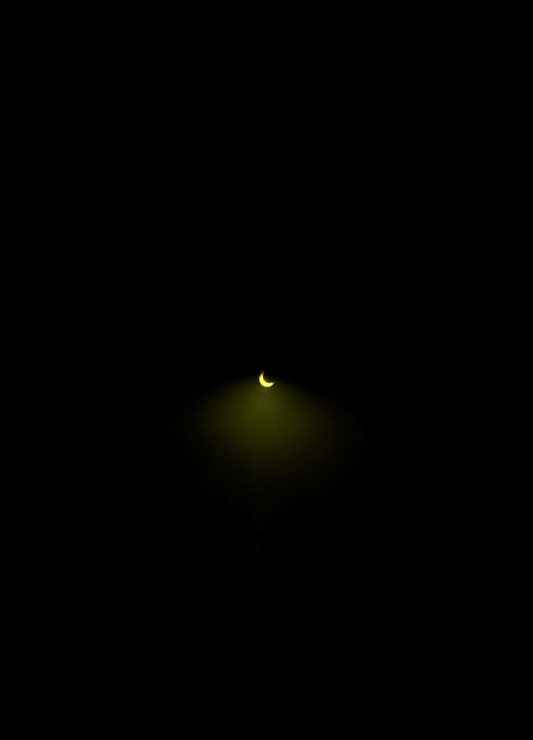

Annular eclipse that occurred on Thursday, June 10 was visible from Summit Station.

*Photo: Derek Pickell*

**General Notes:**

Shutdown activities continued along with preparation for the building move later in the season. Instruments have been secured and monitors have been placed face down. Wheels for mobile infrastructure have been chocked or locked. All instrument cable runs have been disconnected from instruments and fastened to the MSF railing. The PAERI hatch has been plugged and fastened closed.

The Ceilometer has been left on for flight operations. All other Icecaps instruments have been powered down and unplugged.

**General Weather Observations:**

|  |  |  |  |  |  |  |  |
| --- | --- | --- | --- | --- | --- | --- | --- |
| **Date** | **Time (Z)** | **Wind** | **Weather** | **Visibility** | **Sky** | **Temp (C)** | **Notes** |
| 06-07 | 12 | 7 kts at 112 |  | 9999 | SCT | - 11 |  |
| 06-08 | 12 | 10 kts at 055 |  | 9999 | OVC080 | - 16 |  |
| 06-09 | 12 |  |  | 4800 | OVC080 |  |  |
| 06-10 | 12 |  |  | 9999 | OVC049 |  |  |
| 06-11 | 12 |  |  | 9999 | SCT070 |  |  |
| 06-12 | 12 |  |  | 9999 | BKN016 |  |  |
| 06-13 | 12 |  |  | 4800 | SCT018 |  |  |

**Significant Weather Observations:**

* none

**MSF**

* Operating normally.

**ICECAPS-ACE Data Management:**

* 06-08: Data transfer completed at 0242Z.
* 06-13: Computer shut down.

**TSI:**

* 2021-06-04 1214Z: Shut down and brought inside for storage.
* Operating normally

**Radiosonde:**

* Once daily launches.
* 2021-06-07 1338Z: Sonde computer and SPS shut down and unplugged from wall.
* See chart below for radiosonde cabinet temperatures over the last week.

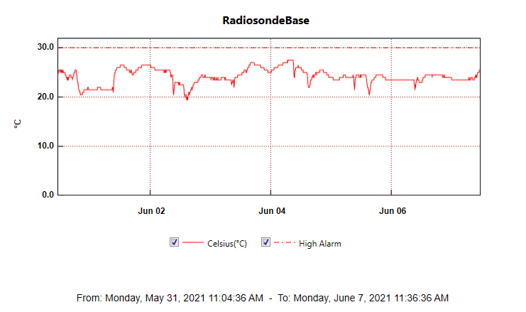

**MWR:**

* HatPro reassembled and packaged for storage on berm.
* 2021-06-04 1655Z: RPG-150-90, computer, and heater shut down.

**SODAR:**

* 2021-06-04 1210Z: Instrument shut down. Cable run removed and fastened to MSF railing.
* 2021-06-05: Computer shut down.
* 2021-06-10: Cable run removed and fastened to MSF railing.

**POSS:**

* 2021-06-04 1243Z: Shut down.
* 2021-06-05: Computer shut down and unplugged.
* 2021-06-10: Cable run removed and fastened to MSF railing.

**MASC:**

* 2021-06-04 1300Z: Shut down and brought inside for storage.
* 2021-06-05: Computer shut down, unplugged, and repeaters brought inside for storage.
* 2021-06-10: Cable run removed and fastened to MSF railing.

**MMCR:**

* 2021-06-05 1206Z: Shut down – waveguide removed and placed in grey container next to instrument.

**CAPABL:**

* 2021-06-04 1726Z: Instrument shut down and water drained from laser head and power source. Telescope and roof covers installed.
* 2021-06-05: Computer shutdown and unplugged.

**MPL:**

* 2021-06-07 1801Z: Instrument shut down and telescope capped.
* 2021-06-08: Computer shut down and unplugged.

**CEILOMETER:**

* Operating normally.

**PAERI:**

* 2021-06-10: Powered down and removed top-hat fan - loosened retaining ring on cold finger.
* 2021-06-13: Removed actuator from hatch, unthreaded arm from actuator, and installed plug in enclosure.

**IceCAM:**

* Operating normally.

**IcePIC:**

* 2021-06-04: Optics brought inside.
* No IcePICs this week.

**CPC:**

* 2021-06-04 1721Z: Shut down.
* 2021-06-08: Butanol and condensate drained. Bottle placed in flammable materials cabinet.

**MSF - OPC:**

* 2021-06-04 1859Z: Shut down and brought inside for storage.

**TAWO - OPC:**

* 2021-06-06 1339Z: Shut down and brought inside for storage.

**SKYOPC:**

* 2021-06-05 1140Z: Shut down.

**Fluxtower instrument suite:**

* Operating normally.

**Radiometers:**

* 2021-06-02: Power supply box reinstalled with new supply. Instrument does not allow access to position menu so an alignment cannot be performed.
* Troubleshooting to take place on cable connection for data transfer from logger.
* Shutdown delayed.