**ICECAPS-ACE Weekly Report**

May 9th – May 15th, 2022

Nicolette Ratz

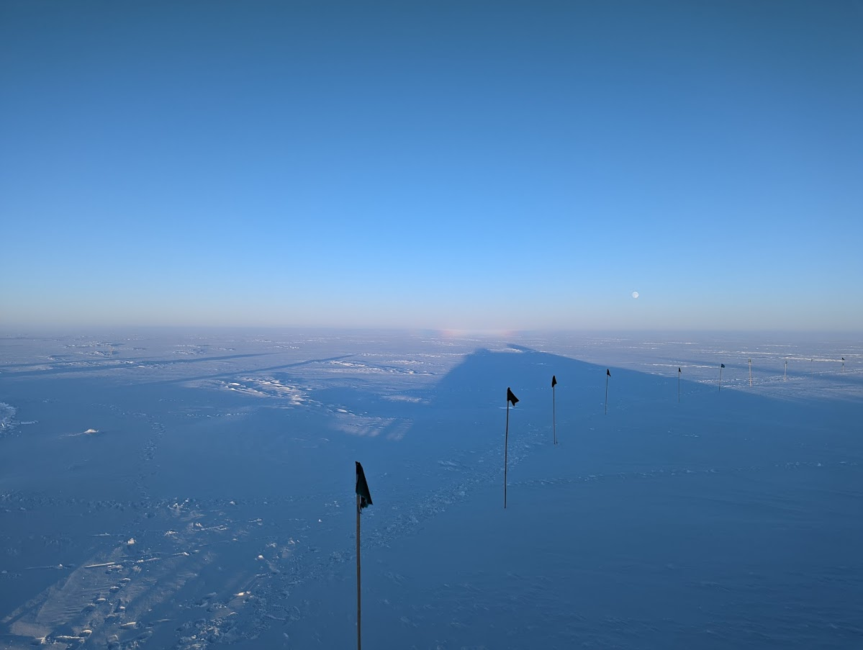

A faint rainbow was spotted below the moonrise on May 14th.

*Photo: Tom Pence*

**General Notes:**

The Mobile Science Facility (MSF) experienced many changes in relation to the startup, placement, and removal of various instruments. The Multi-Angle Snow Camera (MASC) mount and Precipitation Occurrence Sensor System (POSS) were placed outside the MSF 2022-05-11 with the intention of start-up during Flight Period 2. Von Walden arrived 2022-05-12 to remove the Polar Atmospheric Emitted Radiance Interferometer (PAERI) and has done so successfully. On 2022-05-13 the Micro-pulse Lidar (MPL) was turned on, the ceilometer and Total Sky Imager (TSI) were installed on the MSF roof, and all three instruments are taking data. Lastly, the Millimeter Cloud Radar (MMCR) was brought online 2022-05-14 and is also taking data. Several issues require troubleshooting and are listed individually below. Overnight internet outages are to be expected until 2022-05-21 for IT work.

In addition to the exciting start-up of many devices, the MSF went through a deep cleaning and organization overhaul—ready for incoming PIs.

**General Weather Observations:**

|  |  |  |  |  |  |  |  |
| --- | --- | --- | --- | --- | --- | --- | --- |
| **Date** | **Time (Z)** | **Wind** | **Weather** | **Visibility** | **Sky** | **Temp (C)** | **Notes** |
| 05-09 | 12 |  | IC | 9999 | FEW010 BKN060 |  | Cloud height estimated |
| 05-10 | 12 |  |  | 9999 | FEW060 BKN130 |  | Cloud height estimated |
| 05-11 | 12 |  | IC | 9999 | FEW00 FEW130 |  | Cloud height estimated |
| 05-12 | 12 |  | IC; FZFG | 900 | FEW090 |  | Cloud height estimated; FZFG obscuring horizon |
| 05-13 | 12 |  |  | 9999 | FE009 FEW090 |  | Cloud height estimated |
| 05-14 | 12 |  |  | 9999 | FEW090 SCT130 |  | Distant cloud height estimated |
| 05-15 | 12 |  |  | 9999 | FEW080 FEW180 |  | Cloud height estimated |

**Significant Weather Observations:**

* Rainbow spotted south of station 2022-05-15:150Z

**MSF**

* Operating normally

**ICECAPS-ACE Data Management:**

* USB and RAID drive are not mounted (resolved 2022-05-16)
* Ceilometer and TSI not mounted and not sending data to Data Management Computer (ceilometer mount resolved 2022-05-16)
* MPL, MMCR, and MWR are mounted and sending data to Data Management Computer
* “To Boulder/data” folders are not emptying (no outbound data); could be related to internet outages

**TSI:**

* Installed 2022-05-13:1700Z
* Aborted unexpectedly 2022-05-15:1155Z; manually restarted same day:1238Z
* Aborted unexpectedly 2022-05-17:0140Z; manually restarted same day:1049Z
* “Processed Images” missing 2022-05-17:0102Z-1049Z
* Operating normally, otherwise

**Radiosonde:**

* Not currently launching radiosondes; permits pending
* No MS Office license on Radiosonde Computer in SMG

**MWR:**

* Offline

**SODAR:**

* Offline

**POSS:**

* Installed and leveled outside MSF building 2022-05-12
* Offline

**MASC:**

* Installed and leveled mount outside MSF building 2022-05-11

**MMCR:**

* Brought online 2022-05-14:1945Z
* Pitch: 0.23 Roll: 9.28
* MSF leveling 2022-05-17
* Leveling was done with fine-tuned levels, however after leveling, instrument still shows Pitch:0.11 Roll:10.91

**MPL:**

* Brought online 2022-05-13:1200Z
* Unable to sync to GPS time server 192.168.1.170; potentially related to failing battery
* Collecting data normally

**CEILOMETER:**

* Installed on MSF roof and turned on 2022-05-13:1530Z
* Synced to GPS timer server 192.168.1.170
* Operating normally

**PAERI:**

* Uninstalled and removed 2022-05-14:1000Z
* Being packaged for shipment to US for repair
* Expected to return in August

**IceCAM:**

* Operating normally.

**IcePIC:**

* No images captured this week

**MAGIC CPC:**

* Operating normally

**MSF - OPC:**

* Is this OPC being brought to AWO as well?

**TAWO - OPC:**

* Where will this OPC be brought back online? Or is it being uninstalled?

**SKYOPC:**

* Offline
* Expected installation at AWO later this season

**Flux Tower instrument suite:**

* Operating normally.

**Radiometers:**

* Operating normally.