**ICECAPS-ACE Weekly Report**

May 18th – May 24th, 2022

Nicolette Ratz

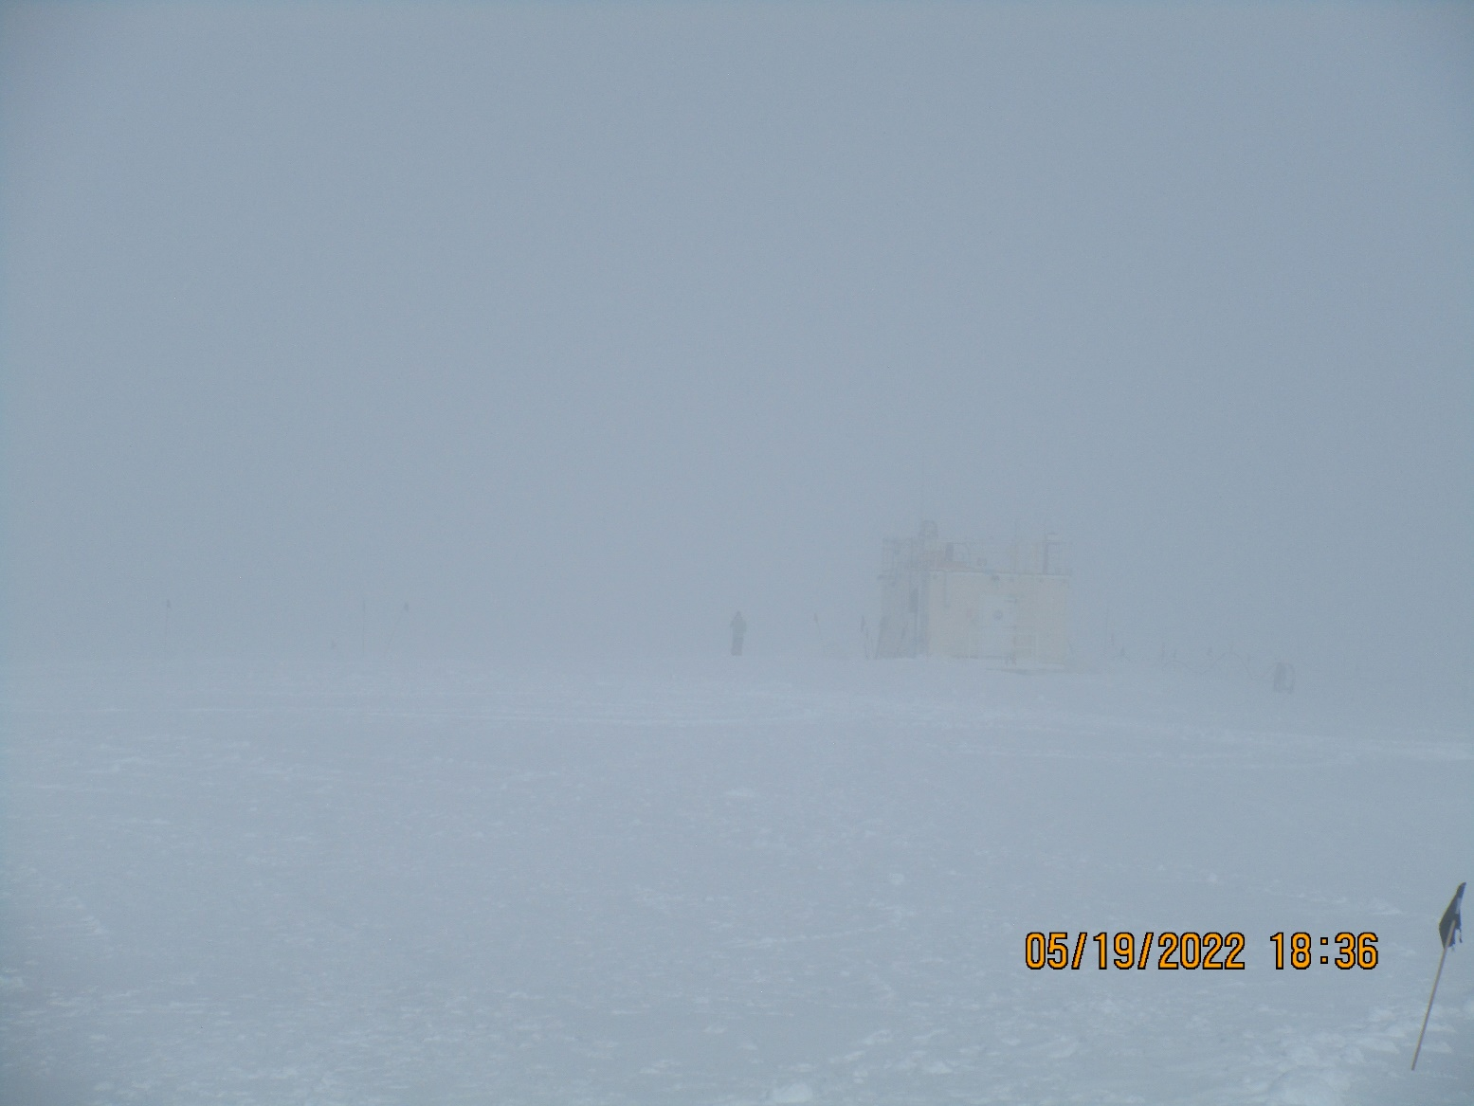

Science Project Manager, Sam Dorsi, outside of the MSF on a foggy day

*Photo: Nicolette Ratz*

**General Notes:**

The Mobile Science Facility (MSF) was leveled 2022-05-17 using fine-tune levels instead of the Millimeter Cloud Radar (MMCR)—as is usually the case. Future troubleshooting of the MMCR may lead to another leveling, but for now it is sufficient for the MMCR to collect useable data. Due to internet outages from 2022-05-15 to 2022-05-23, ICECAPS data files, transferring to Boulder, were regularly delayed; however as off 2022-05-23 all files are emptying each night as expected. Lastly, John Rausch and an ARO Battelle Science Technician are in conversation regarding the installation of the Multi-Angle Snow Camera (MASC).

**General Weather Observations:**

|  |  |  |  |  |  |  |  |
| --- | --- | --- | --- | --- | --- | --- | --- |
| **Date** | **Time (Z)** | **Wind**  **(m/s)** | **Weather** | **Visibility** | **Sky** | **Temp (C)** | **Notes** |
| 05-18 | 12 | 3.6 | FZFG | 650 | VV1400 | -17.8 | Cloud height estimated |
| 05-19 | 12 | 2.0 | FZFG | 400 | OVC700 | -25 | Cloud height estimated |
| 05-20 | 12 | 5.2 |  | 9999 | FEW009 FEW010 | -16.9 | Cloud height estimated |
| 05-21 | 12 | 5.3 | IC | 9999 | FEW100 SCT170 | -21.7 |  |
| 05-22 | 12 | 8.5 | DRSN | 9999 | SCT060 | -14.4 | Cloud height estimated |
| 05-23 | 12 | 6.2 | IC | 9999 | FEW010 SCT160 | -14.4 |  |
| 05-24 | 12 | 6.0 | IC | 9999 | FEW004 | -14.6 |  |

**Significant Weather Observations:**

* 22° Halo, 46° Halo, two parahelia, a parhelic circle and a rainbow observed 2022-05-16:1746z
* Corona observed through cirrus clouds 2022-05-23:1800

**MSF**

* Operating normally

**ICECAPS-ACE Data Management:**

* Due to internet outages for IT work 2022-05-15 through 2022-05-22, files “To Boulder” were delayed in emptying
* “To Boulder” files sending normally 2022-05-23
* One file remaining in “To Boulder”—ICECAPS.20220523.log
* Operating normally
* 05-18: data transfer incomplete due to IT internet outages 2022-05-15 through 2022-05-23
* 05-19: data transfer incomplete due to IT internet outages 2022-05-15 through 2022-05-23
* 05-20: data transfer incomplete due to IT internet outages 2022-05-15 through 2022-05-23
* 05-21: data transfer incomplete due to IT internet outages 2022-05-15 through 2022-05-23
* 05-22: data transfer incomplete due to IT internet outages 2022-05-15 through 2022-05-23
* 05-23: data transfer complete 0814z
* 05-24: data transfer complete 0358z

**TSI:**

* Installed 2022-05-13:1700Z
* Aborted unexpectedly 2022-05-15:1155z; manually restarted same day:1238z
* Aborted unexpectedly 2022-05-17:0140z; manually restarted same day:1049z
* “Processed Images” missing 2022-05-17:0102z-1049z
* “Processed Images” missing 2022-05-19:0121z-0338z
* “Processed Images” missing 2022-05-20:0132z-0327z
* “Processed Images” missing 2022-05-22:0204z-0256z
* Sending data to Data Management computer and Boulder without issue

**Radiosonde:**

* Not currently launching radiosondes; permits pending
* No MS Office license on Radiosonde Computer in SMG; this will be needed to log surface observations for radiosondes

**MWR:**

* Brought online 2022-05-12:1600z
* Rec. 1 and Rec. 2 Temperature Stability alarmed and stopped 2022-05-23:1120z
* 4 files per hour instead of 5 as per protocol

**SODAR:**

* Offline

**POSS:**

* Installed and leveled outside MSF building 2022-05-12
* Offline

**MASC:**

* Mount and enclosure installed outside MSF building 2022-05-11

**MMCR:**

* Brought online 2022-05-14:1945Z
* MSF leveling 2022-05-17
* Leveling done with fine-tuned levels, however after leveling, instrument still shows Pitch:0.11 Roll:10.91

**MPL:**

* Brought online 2022-05-13:1200Z
* Unable to sync to GPS time server 192.168.1.170; 3 minutes and 5 seconds ahead
* Operating normally, otherwise

**CEILOMETER:**

* Installed on MSF roof and turned on 2022-05-13:1530Z
* Operating normally

**PAERI:**

* Uninstalled and removed 2022-05-14:1000Z
* Expected to return in August

**IceCAM:**

* Operating normally.

**IcePIC:**

* No images captured this week

**MAGIC CPC:**

* Operating normally; bi-weekly water reservoir fill

**MSF - OPC:**

* Offline
* Expected installation in August

**AWO - OPC:**

* Offline
* Expected installation in August

**SKYOPC:**

* Offline
* Expected installation in August (AWO)

**Flux Tower instrument suite:**

* Operating normally.
* Uptime 70%; Evening IT network outages between 2022-05-15 – 2022-05-22
* 2022-02-01 V2 not communicating, found with snow accumulation indicating loss of function

**Radiometers:**

* Albedo Stand: A storm with strong winds in Mid-March caused the network connection to the albedo stand to fail; weekly data downloads
* Solar tracker powered down on 2021-11-01