**ICECAPS-ACE Weekly Report**

June 1st– June 7th, 2022

Nicolette Ratz

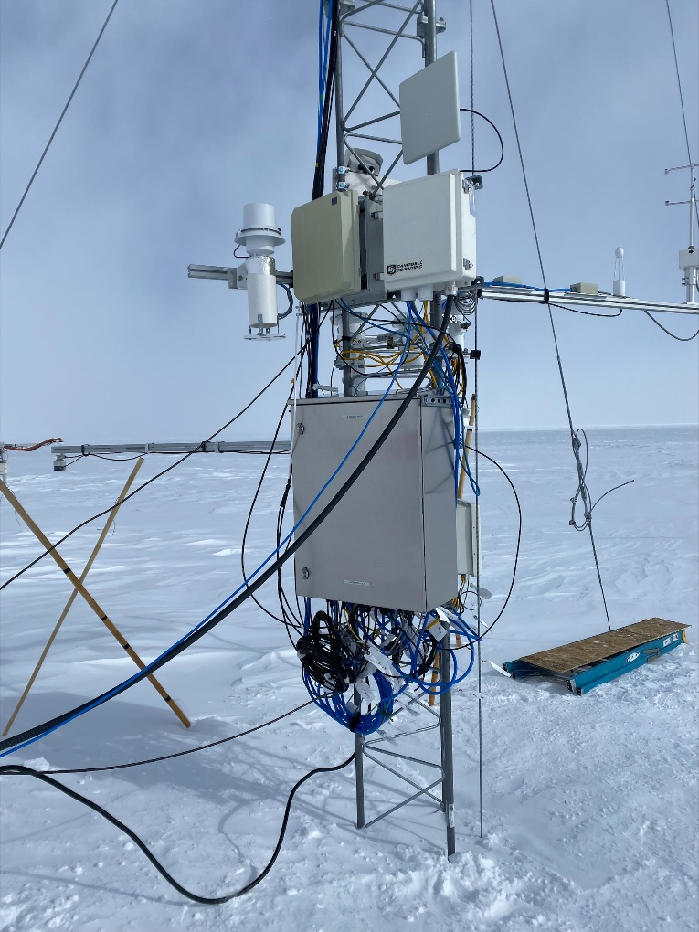

Finalization of Met Tower raise 2022-06-06

*Photo: Alicia Bradley*

**General Notes:**

This week the MSF experienced a power outage to raise the D-shack 2022-06-01:1230z-1330z. Afterward the UPS showed 81% battery capacity left. The MWR spontaneously powered down 2022-06-07 and was brought back online with a power cycle 2022-06-07:1140z. Construction took place on the MSF roof to remove the CAPBL railings 2022-06-01:1230z-1400z. At this time a drill and several screws were temporarily placed on the MMCR radome. The instrument and data were unaffected, however discussions covering MSF Roof orientation and the MSF Roof Activity Hazard Assessment (AHA) were had to ensure instrument sensitively is well understood before construction takes place. The Met Tower Raise was successfully completed 2022-06-06 with the help of FEMC crew members.

**General Weather Observations:**

|  |  |  |  |  |  |  |  |
| --- | --- | --- | --- | --- | --- | --- | --- |
| **Date** | **Time (Z)** | **Wind**  **(kt)** | **Weather** | **Visibility** | **Sky** | **Temp (C)** | **Notes** |
| 06-01 | 12 | 2 |  | 9999 | FEW009 FEW010 | -19 |  |
| 06-02 | 12 | 10 |  | 9999 | FEW010 FEW030 | -21 |  |
| 06-03 | 12 | 10 | IC | 9999 | SCT060 BKN150 | -16 |  |
| 06-04 | 12 | 35 | DRSN | 600 | OVR009 | -18 |  |
| 06-05 | 12 | 18 | DRSN, IC | 1500 | BKN060 | -23 |  |
| 06-06 | 12 |  | BLSN | 9999 | FEW060 SCT150 |  |  |
|  |  |  |  |  |  |  |  |

**Significant Weather Observations:**

* 22-degree halo, parhelic circle, parahelia, and upper tangential arc 2022-06-06:1200z-approx. 1430z

**MSF**

* A station-wide power outage for the D-shack’s routine raise occurred 2022-06-01:1030z-1128z
  + 81% of UPS battery capacity remained
* A station-wide power outage for the D-shack’s routine raise is scheduled for 2022-06-07:1200z-2000z

**ICECAPS-ACE Data Management:**

* Data transfer complete 2022-06-01:0350z
* Data transfer complete 2022-06-02:0324z
* Data transfer complete 2022-06-03:0340z
* Data transfer complete 2022-06-04:0345z
* Data transfer complete 2022-06-05:0402z
* Data transfer complete 2022-06-06:0351z
* Script “df -h” slow to complete due to unmounted devices
* Operating normally

**TSI:**

* Installed 2022-05-13:1700z
* Atypical photo found in TSI Manager 2022-06-03:0122z; photos taken at 0121z and 0123z were typical and with little cloud cover in the processed images, whereas the 0122z photo was entirely green and100% cloud cover in the processed image.
* Operating normally

**Radiosonde:**

* Not currently launching radiosondes—permits pending
* An attempt to download LibreOffice was unsuccessful due to incapability of the software and Windows operating system—will continue to troubleshoot this issue
* No MS Office license on Radiosonde Computer in SMG

**MWR:**

* Brought online 2022-05-12:1600z
* MWR computer found to have powered down 2022-06-02
* MWR computer rebooted 2022-06-02:1735z
* Last data files at the time of reboot were 2022-06-01:1140z; daily checks on 2022-06-03 show data transfer is operating normally
* 4 files per hour instead of 5 as per protocol

**SODAR:**

* One dish is free of ice and snow, the other has compacted ice
* Use of SMG cleared with lead heavy equipment operator to remove ice if needed
* Offline

**POSS:**

* Installed and leveled outside MSF building 2022-05-12
* Offline

**MASC:**

* MASC computer turned on 2022-05-31:1345z
* TeamViewer installed on MASC computer 2022-05-31:1400z
* Mount and enclosure relocated 2022-05-31
* USB and Firewire cables run from MSF to MASC enclosure 2022-05-31

**MMCR:**

* During construction activities to remove the CAPABL deck railings, the staff on the roof deck placed a drill and several screws on the south end of the radome. This took place at approx. 2022-06-01 12:30z to 14:00z
* Pitch:0.16 Roll:9.30—2022-06-06:1300z

**MPL:**

* Operating normally

**CEILOMETER:**

* Operating normally

**PAERI:**

* Expected to return in August

**IceCAM:**

* Operating normally.

**IcePIC:**

* No images captured this week

**MAGIC CPC:**

* Operating normally; bi-weekly water reservoir fill

**MSF - OPC:**

* Offline
* Expected installation in August

**AWO - OPC:**

* Offline
* Expected installation in August

**SKYOPC:**

* Offline
* Expected installation in August (AWO)

**Flux Tower instrument suite:**

* Met Tower raise 2022-06-06—instruments and enclosures at suitable heights for annual snow drifting. Exact measurements will be obtained and sent to Heather.
* 2022-02-01 V2 not communicating, found with snow accumulation indicating loss of function
* Operating normally.

**Radiometers:**

* Science technicians preparing for Albedo Stand raise through protocol.
* Albedo Stand: A storm with strong winds in Mid-March caused the network connection to the albedo stand to fail; weekly data downloads
* Solar tracker powered down on 2021-11-01