**ICECAPS-ACE Weekly Report**

June 8th– June 14th, 2022

Nicolette Ratz

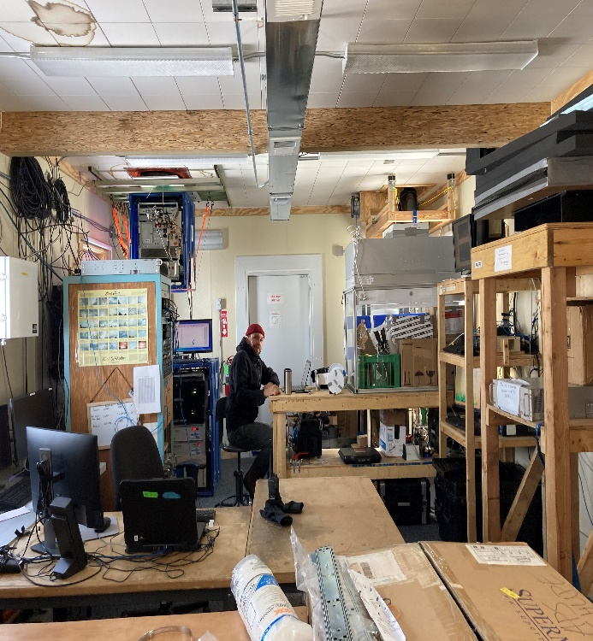 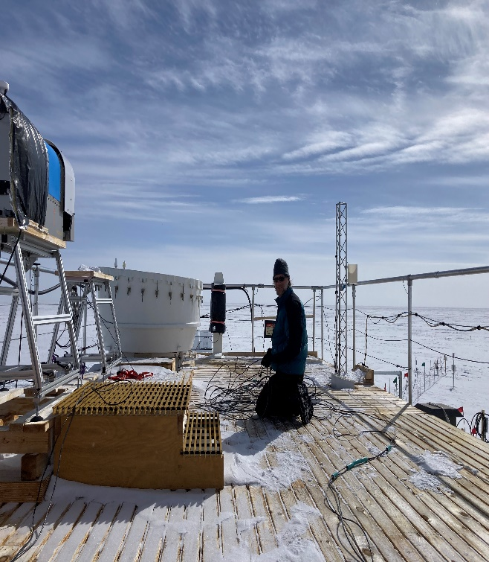

Left: Michael Gallagher working on the Dataman computer swap

Right: Matt Shupe untangling SoDAR cables on the MSF roof

*Photos: Nicolette Ratz*

**General Notes:**

This week was an exciting week for ICECAPS! Matt Shupe and Michael Gallagher arrived Wednesday (06-08) and got right to work on improvements. In the seven-day timespan they managed—with some science technician assistance—to exchange the Dataman computer (06-09); connect and turn on the SoDAR and POSS (06-10); raise the albedo stand (06-10); decommission and package the solar tracker (06-10); plumb Fluxtower data in the Dataman computer (06-11); and replace the MMCR UPS batteries (06-13). In addition to their hard work, Libre Office was successfully installed on the radiosonde computer (06-08) and a MPL Afterpulse Calibration was conducted 2022-06-14:1336z. Lastly, Nicolette and Alicia climbed the tower to finalize Met Tower Raise measurements, remove the V2 junction box, and assess the defective HMP4 aspirated shield (06-09).

**General Weather Observations:**

|  |  |  |  |  |  |  |  |
| --- | --- | --- | --- | --- | --- | --- | --- |
| **Date** | **Time (Z)** | **Wind**  **(kt)** | **Weather** | **Visibility** | **Sky** | **Temp (C)** | **Notes** |
| 06-08 | 12 | 2.0 |  | 9999 | FEW090 SCT160 | -17 |  |
| 06-09 | 12 | 9.0 |  | 9999 | FEW090 SCT160 | -14 |  |
| 06-10 | 12 | 9.0 | -SN | 9999 | FEW009 SCT030 | -13 |  |
| 06-11 | 12 | 2.0 |  | 9999 | FEW060 FEW130 | -12 |  |
| 06-12 | 12 | 12.0 |  | 9999 | OVR020 | -14 |  |
| 06-13 | 12 | 10.0 | IC | 9999 | FEW010 FEW160 FEW100 | -14 |  |
| 06-14 | 12 |  | DRSN; IC | 800 | SCT060 |  |  |

**Significant Weather Observations:**

* No significant weather observations made

**MSF**

* Selway workstation cleared and available for use

**ICECAPS-ACE Data Management:**

* Dataman computers exchanged 2022-06-12; operations for daily checks remain the same
* Data transfer complete 2022-06-08:0346z
* Data transfer complete 2022-06-09:0353z
* Data transfer complete 2022-06-10:0118z
* Data transfer complete 2022-06-11:0414z
* Data transfer completion unknown due to computer exchange 2022-06-12
* Data transfer complete 2022-06-13:0621z
* Data transfer complete 2022-06-14:0458z
* Operating normally

**TSI:**

* Atypical photo found in TSI Manager 2022-06-03:0122z; photos taken at 0121z and 0123z were typical and with little cloud cover in the processed images, whereas the 0122z photo was entirely green and 100% cloud cover in the processed image.
* Operating normally

**Radiosonde:**

* Libre Office (34-bit version) successfully downloaded to radiosonde computer 2022-06-08; plans to transfer Excel radiosonde data log
* Not currently launching radiosondes—permits pending

**MWR:**

* Operating normally

**SODAR:**

* Placed in new location (approx. 50m east of MSF) and leveled 2022-06-10
* Cables replaced and run to instrument 2022-06-10
* Turned on and collecting data 2022-06-10:1615z
* Amplifier turned off for weekly cleaning 2022-06-13:1103z-1107z

**POSS:**

* New cables run to instrument 2022-06-14
* Powered on and collecting data 2022-06-14

**MASC:**

* Remote access granted 2022-06-13; plans to configure instrument 2022-06-17
* Offline

**MMCR:**

* Roll parameter restored by Matt Shupe through cable management 2022-06-09; Pitch:0.12
* UPS batteries replaced 2022-06-13
* Powered down for battery replacement 2022-06-13:1103z-1107z
* Powered on 2022-06-13:1204z-approx.1245z; required three attempts to reboot due to helix cathode fault

**MPL:**

* Stopped data collection for MPL Afterpulse Calibration 2022-06-14:1336z; restored data collection 2022-06-14:1400z
* Operating normally

**CEILOMETER:**

* Operating normally

**PAERI:**

* Expected to return in August

**IceCAM:**

* Operating normally.

**IcePIC:**

* No images captured this week

**MAGIC CPC:**

* Operating normally

**MSF - OPC:**

* Offline
* Expected installation in August

**AWO - OPC:**

* Offline
* Expected installation in August

**SKYOPC:**

* Offline
* Expected installation in August (AWO)

**Flux Tower instrument suite:**

* HMP4 Aspirated shield found defective by Heather Guy 2022-06-09; plans to replace with HMP1 Aspirated shield
* Removal of V2 junction box (bagged and secured to tower) 2022-06-09; plans to conduct continuity testing and check soldering connections
* Measurements of Met Tower Raise 2022-06-09; plans to finish measurements of KT15 to lowest boom
* Fluxtower data plumbed through Dataman computer 2022-06-11
* V2 not communicating, found with snow accumulation indicating loss of function 2022-02-01

**Radiometers:**

* Albedo Stand Raise completed 2022-06-11:1400z
* Adjustments and leveling for the Albedo Stand made by Matt Shupe and Michael Gallagher 2022-06-11:1700z-2000z
* Solar tracker dismantled, removed, and packaged for retro shipment 2022-06-11
* Solar tracker replacement expected to arrive in August