**ICECAPS-ACE Weekly Report**

June 14th– June 20th, 2022

Nicolette Ratz

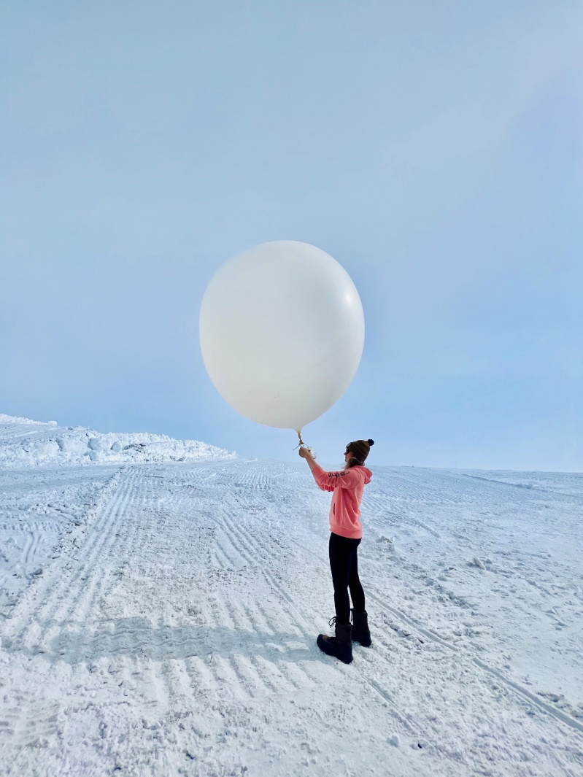

Science Technician, Nicolette, set to release a radiosonde balloon 2022-06-17

*Photo taken by: Andrew Chapman*

**General Notes:**

This week Science Technicians—Alicia and Nicolette—began launching radiosondes after obtaining a much-needed permit (06-15). The MWR and SoDAR experienced unexpected shutdowns (06-17); both restored with a power cycle (06-17). Continuity testing of the V2 junction box was completed (06-17), leading to plans for its replacement via the V1 junction box—so long as cable length allows. Lastly, Nicolette and John configured the MASC (06-20) and hope to deploy the instrument soon.

**General Weather Observations:**

|  |  |  |  |  |  |  |  |
| --- | --- | --- | --- | --- | --- | --- | --- |
| **Date** | **Time (Z)** | **Wind**  **(kt)** | **Weather** | **Visibility** | **Sky** | **Temp (C)** | **Notes** |
| 06-14 | 1200 | 26 | DRSN; IC | 800 | SCT060 | -10 |  |
| 06-15 | 1200 | 14 | BLSN | 1500 | BKN030 | -10 |  |
| 06-16 | 1200 | 17 | IC | 9999 | FEW060 BKN090 | -7 |  |
| 06-17 | 1200 | 15 |  | 9999 | SCT060 | -8 |  |
| 06-18 | 1200 | 27 | BLSN | 500 | OVR020 | -12 |  |
| 06-19 | 1200 | 29 | DRSN | 1200 | OVR020 | -15 |  |
| 06-20 | 1200 | 5 | FZFG | 750 | FEW000 | -16 | Horizon obscured by FZFG |

**Significant Weather Observations:**

* No significant weather observations made

**MSF**

* Unplanned power outage 2022-06-15
  + approx.1840z-1852z for switch to emergency generator
  + 1905z-1906z for switch back to main generator
* Planned power outage 2022-06-18:1530z-1532z for generator maintenance

**ICECAPS-ACE Data Management:**

* ‘To Boulder’ file not empty 2022-06-15 due to continued troubleshooting of Dataman computer—operating normally 2022-06-16
* Data transfer complete 2022-06-14:0402z
* Data transfer *did not* complete 2022-06-15
* Data transfer complete 2022-06-16:0402z
* Data transfer complete 2022-06-17:0344z
* Data transfer complete 2022-06-18:0418z
* Data transfer complete 2022-06-19:0429z
* Data transfer complete 2022-06-20:0459z

**TSI:**

* Anomalous behavior 2022-06-14; restored by disconnecting and reconnecting power cables 2022-06-15
* Operating normally

**Radiosonde:**

* Radiosonde launches started 2022-06-15:2315z; one balloon lost due to falling off the balloon table 2022-06-15
* Operating normally

**MWR:**

* Unexpectedly powered off 2022-06-17; restored with power cycle 2022-06-17:0934z
* R2CH.EXE program experienced window-sizing issue 2022-06-19; restored with computer reboot 2022-06-19:1713z

**SODAR:**

* Instrument unexpectedly powered down 2022-06-16:1401z; restored with power cycle 2022-06-17:1658z
* Amplifier turned off for weekly cleaning 2022-06-20:1139z-1152z

**POSS:**

* Operating normally

**MASC:**

* Instrument configured 2022-06-20; plans to finalize cable connections and power on with John later in the week
* Offline

**MMCR:**

* Operating normally

**MPL:**

* Operating normally

**CEILOMETER:**

* Operating normally

**PAERI:**

* Expected to return in August

**IceCAM:**

* Operating normally.

**IcePIC:**

* No images captured this week

**MAGIC CPC:**

* Operating normally

**MSF - OPC:**

* Offline
* Expected installation in August

**AWO - OPC:**

* Offline
* Expected installation in August

**SKYOPC:**

* Offline
* Expected installation in August (AWO)

**Flux Tower instrument suite:**

* V2 junction box continuity testing conducted 2022-06-17:1300z—found broken solder connection; plans to replace V2 junction box with V1 junction box if cable length allows
* HMP4 Aspirated shield found defective by Heather Guy 2022-06-09; plans to replace with HMP1 Aspirated shield
* V2 not communicating, found with snow accumulation indicating loss of function 2022-02-01

**Radiometers:**

* Albedo Stand operating normally
* Solar Tracker replacement expected in August