**ICECAPS-ACE Weekly Report**

June 21st– June 27th, 2022

Nicolette Ratz

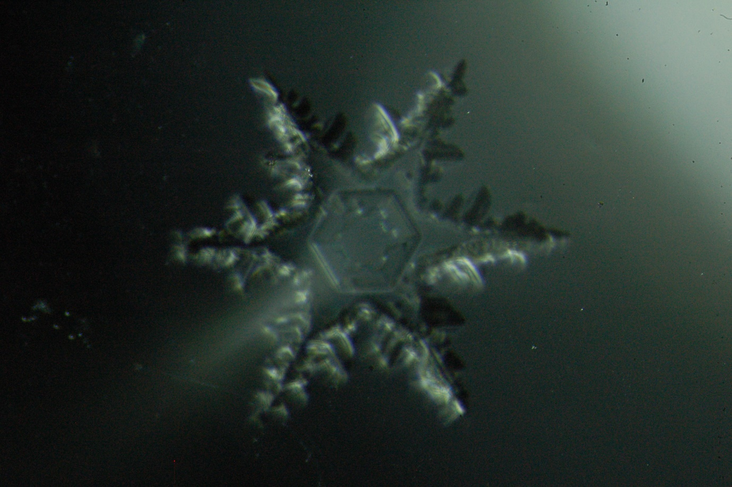

A plate crystal with dendrites, captured during light snow 2022-06-27

*Photo taken by: Nicolette Ratz*

**General Notes:**

This week the first Ice Pic images were captured (06/27) during a light snow. Technicians are continuing to troubleshoot Flux Tower instruments: V2, HMP4, and KT15 (06/18 to present) with plans to conduct tower work as soon as possible—weather permitting. Lastly, the SoDAR amplifier was powered off longer than acceptable due to a technician error (06/27); measures are in place to ensure this does not happen again.

**General Weather Observations:**

|  |  |  |  |  |  |  |  |
| --- | --- | --- | --- | --- | --- | --- | --- |
| **Date** | **Time (Z)** | **Wind**  **(kt)** | **Weather** | **Visibility** | **Sky** | **Temp (C)** | **Notes** |
| 06-21 | 1200 | 11 |  | 9999 | OVR009 | -20 |  |
| 06-22 | 1200 | 15 | IC | 9999 | FEW030 SCT120 | -15 |  |
| 06-23 | 1200 | 10 |  | 9999 | OVR080 | -16 |  |
| 06-24 | 1200 | 6 |  | 9999 | BKN090 | -16 |  |
| 06-25 | 1200 | 8 |  | 700 | OVR010 | -13 |  |
| 06-26 | 1200 | 9 |  | 9999 | FEW060 | -17 |  |
| 06-27 | 1200 | 15 |  | 9999 | FEW090 SCT130 | -12 |  |

**Significant Weather Observations:**

* 22-degree halo, parahelia, and parhelic circle 2022-06-22:1200
* 22-degree halo, and lower tangential arc 2022-06-22:1800

**MSF**

* Operating normally

**ICECAPS-ACE Data Management:**

* Data transfer complete 2022-06-21:0459z
* Data transfer complete 2022-06-22:0441z
* Data transfer complete 2022-06-23:0523z
* Data transfer complete 2022-06-24:0409z
* Data transfer complete 2022-06-25:0411z
* Data transfer complete 2022-06-26:0409z
* Data transfer complete 2022-06-27:0417z
* Operating normally

**TSI:**

* Operating normally

**Radiosonde:**

* Consistent discrepancies in RH between NOAA data and radiosonde calibration 2022-06-21 to 2022-06-27—email sent to Matt Shupe and Von Walden for input
* Operating normally

**MWR:**

* Operating normally

**SODAR:**

* Amplifier turned off for weekly cleaning 2022-06-27:1007z-2022-06-28:1043z; Science Technician error in leaving amplifier off longer than acceptable

**POSS:**

* Operating normally

**MASC:**

* Meeting with John to power on instrument 2022-06-28:1500z
* Offline

**MMCR:**

* Operating normally

**MPL:**

* Operating normally

**CEILOMETER:**

* Operating normally

**PAERI:**

* Expected to return in August

**IceCAM:**

* Operating normally.

**IcePIC:**

* Images captured 2022-06-27:1610z-1730z

**MAGIC CPC:**

* Operating normally

**MSF - OPC:**

* Offline
* Expected installation in August

**AWO - OPC:**

* Offline
* Expected installation in August

**SKYOPC:**

* Offline
* Expected installation in August (AWO)

**Flux Tower instrument suite:**

* 2022-06-28 located replacement connectors for KT15 and standing by to solder
* 2022-06-23 Not logging data; rebooted laptop
* 2022-06-22 Removed KT15 from tower and brough inside  
  2022-06-21 found unplugged cable at tower; reestablished connection; power cycled; found missing pin in female connector
* 2022-06-18 KT15 stopped communicating
* V2 junction box continuity testing conducted 2022-06-17:1300z—found broken solder connection; plans to replace V2 junction box with V1 junction box if cable length allows
* HMP4 Aspirated shield found defective by Heather Guy 2022-06-09; plans to replace with HMP1 Aspirated shield
* V2 not communicating, found with snow accumulation indicating loss of function 2022-02-01

**Radiometers:**

* Albedo Stand operating normally
* Solar Tracker replacement expected in August