**ICECAPS-ACE Weekly Report**

July 5th– July 11th, 2022

Nicolette Ratz

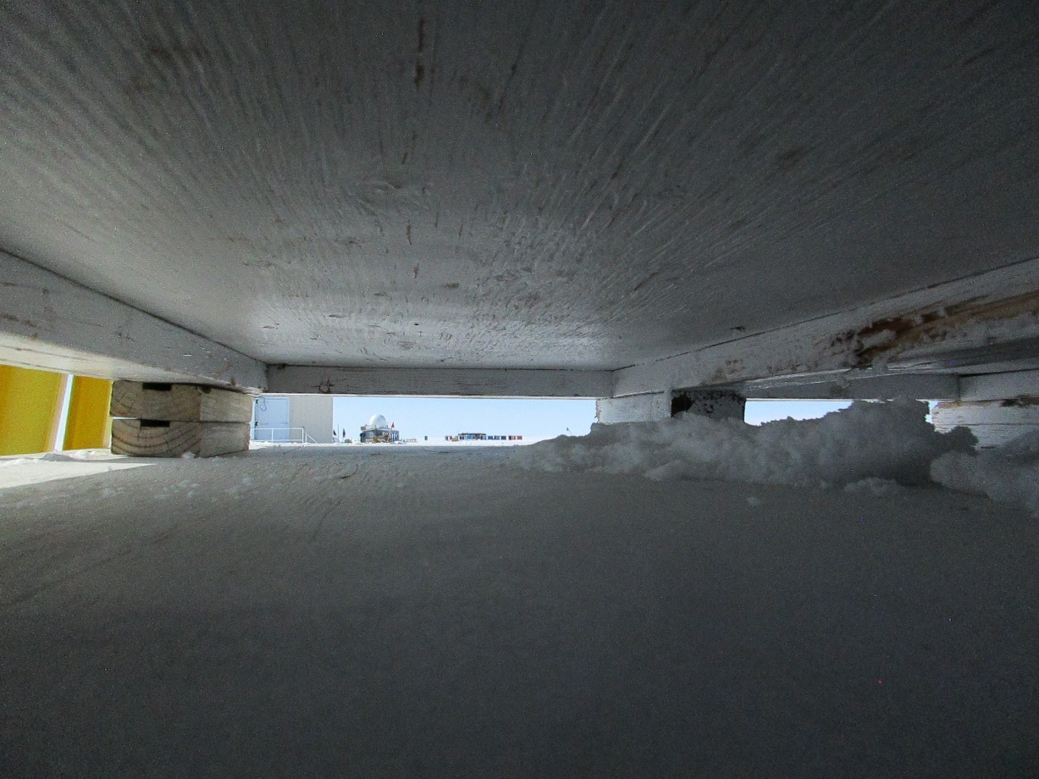

A view of the Big House as seen through the SoDAR 2022-07-12

*Photo taken by: Nicolette Ratz*

**General Notes:**

This week started with an early unplanned power outage (07/05) potentially powering off the MWR and SoDAR; both were restored with a power cycle once power was restored. Two more planned power outages were conducted to restore generator function later that day (07/05). The MSF building’s preferred temperatures were restored through HVAC manipulation (07/05), in addition to a deep clean of the facility. The POSS is currently experiencing continued faults beginning Friday (07/08). Lastly, Leeds hazardous cargo is packaged and ready to be palletized for shipment to Kangerlussuaq during Flight Period Three.

**General Weather Observations:**

|  |  |  |  |  |  |  |  |
| --- | --- | --- | --- | --- | --- | --- | --- |
| **Date** | **Time (Z)** | **Wind**  **(kt)** | **Weather** | **Visibility** | **Sky** | **Temp (C)** | **Notes** |
| 07/05 | 1200 | 10 | -SN | 9999 | OVR030 | -10 |  |
| 07/06 | 1200 | 2 |  | 9999 | OVR009 | -8 |  |
| 07/07 | 1200 | 3 | FZFG | 800 | FEW000 | -8 | Horizon obscured by FZFG |
| 07/08 | 1200 | 9 |  | 9999 | FEW010 FEW060 SCT130 | -11 |  |
| 07/09 | 1200 | 3 |  | 9999 | FEW050 FEW130 | -9 |  |
| 07/10 | 1200 | 4 |  | 9999 | FEW180 | -11 |  |
| 07/11 | 1200 | 3 |  | 9999 | FEW009 FEW060 SCT160 | -10 |  |

**Significant Weather Observations:**

* No significant weather observations made

**MSF**

* Unplanned power outage 2022-07-05:0311z-0345z
* Two planned power outages to restore generator function 2022-05-07 at 1304z-1306z and 1730z-1733z
* Preferred temperatures in building restored by changing SOLO regulator on HVAC system to 58 degrees 2022-07-05

**ICECAPS-ACE Data Management:**

* Data transfer incomplete due to unplanned power outage 2022-07-05
* Data transfer complete 2022-07-06:0516z
* Data transfer complete 2022-07-07:0541z
* Data transfer complete 2022-07-08:0421z
* Data transfer complete 2022-07-09:0506z
* Data transfer complete 2022-07-10:0547z
* Data transfer complete 2022-07-11:0636z
* Operating normally

**TSI:**

* Operating normally

**Radiosonde:**

* Consistent discrepancies in RH between NOAA data and radiosonde calibration; investigation of potential causes ongoing
* Operating normally

**MWR:**

* Erik was kicked out of Log Me In 2022-07-08; an unsuccessful attempt to restore remote connection was conducted 2022-07-11
* Powered down during unplanned power outage 2022-07-05:0311z; restored through power cycle 2022-07-05: 0419z
* Operating normally

**SODAR:**

* Operating normally

**POSS:**

* Instrument began exhibiting continuous fault ‘no good packets’ 2022-07-08 to present
* Rebooted 2022-07-10:1017z-1418z; reboot did not remedy fault
* Technician and PI continuing to troubleshoot instrument

**MASC:**

* Currently not connected to data management network; what needs to be done to get the MASC data script connected to ‘To Bolder’ transfers? A large back-up of data (>1G) is currently stored on the MASC computer and will need to be considered when transferring
* Operating normally

**MMCR:**

* Operating normally

**MPL:**

* Operating normally

**CEILOMETER:**

* Operating normally

**PAERI:**

* Expected to return in August

**IceCAM:**

* Operating normally.

**IcePIC:**

* How are Ice PIC images transferred from MSF laptop to data management computer ‘through network’ as suggested in the ICECAPS protocol?
* No images captured this week

**MAGIC CPC:**

* Operating normally

**MSF - OPC:**

* Offline
* Expected installation in August

**AWO - OPC:**

* Offline
* Expected installation in August

**SKYOPC:**

* Offline
* Expected installation in August (AWO)

**Flux Tower instrument suite:**

* Tower instruments did not log data after data download 2022-06-23 and 2022-06-28; function to flux laptop was restored after reboot 2022-07-04:1120z-1132z; Technician is in communication with Heather Guy regarding this issue
* KT15 awaiting Heather’s arrival; not currently responding post rebuilt cable
* V2 junction box continuity testing conducted 2022-06-17:1300z—found broken solder connection; plans to replace V2 junction box with V1 junction box if cable length allows
* HMP4 Aspirated shield found defective by Heather Guy 2022-06-09; plans to replace with HMP1 Aspirated shield

**Radiometers:**

* Albedo Stand operating normally
* Solar Tracker replacement expected in August