**ICECAPS-ACE Weekly Report**

August 2nd – August 8th, 2022

Nicolette Ratz

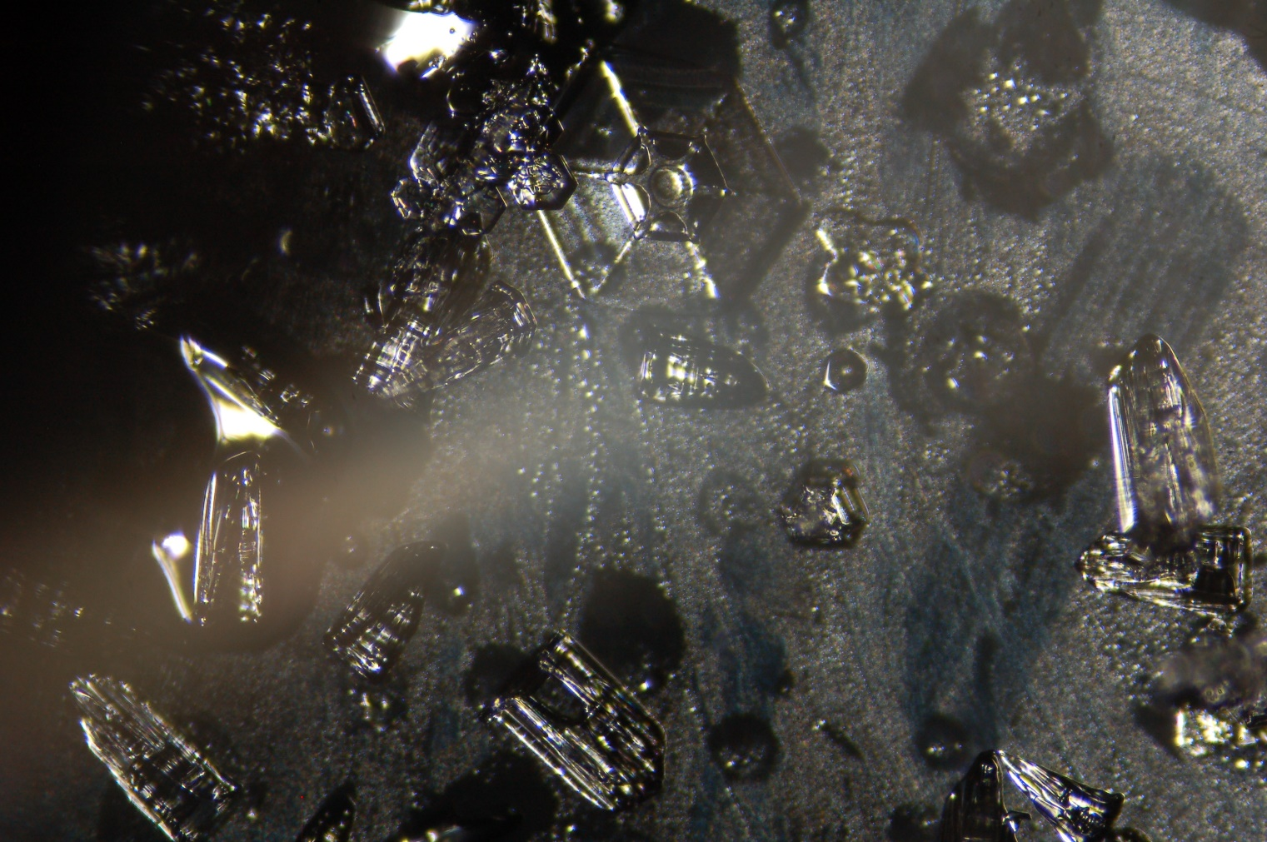

Ice PIC image captured during snowfall 2022-07-22

*Photo taken by: Nicolette Ratz*

**General Notes:**

This week, Summit Station continued to experience a prolonged network outage, ending Monday (08/02). During that time communication was primarily through the ARO Site Supervisor email account and Iridium Satellite phones. As of Monday, normal communication has been restored. A continuity of the POSS data cable (08/04) showed the cable to be functioning properly; after reconnecting the data cable and a full reboot of the instrument, the POSS is now collecting data again (08/07). The TSI Manager is still failing to process images (08/08). Flux Tower data was manually transferred due to the prolonged outage (08/04).

**General Weather Observations:**

General Weather data unavailable due to prolonged network outage 20220725 through 20220809

|  |  |  |  |  |  |  |  |
| --- | --- | --- | --- | --- | --- | --- | --- |
| **Date** | **Time (Z)** | **Wind**  **(kt)** | **Weather** | **Visibility** | **Sky** | **Temp (C)** | **Notes** |
|  |  |  |  |  |  |  |  |
|  |  |  |  |  |  |  |  |
|  |  |  |  |  |  |  |  |
|  |  |  |  |  |  |  |  |
|  |  |  |  |  |  |  |  |
|  |  |  |  |  |  |  |  |
|  |  |  |  |  |  |  |  |

**Significant Weather Observations:**

* 22-degree Halo 2022-08-08:1342z
* Partial 22-degree Halo 2022-08-08:1129z
* Partial Fog Bow W of station 2022-08-05:1030z
* 46-degree Halo 2022-08-04:2320z
* Full Fog Bow 20220802:2300z-2350z

**MSF**

* Preparing workspace for incoming PIs
* Operating normally

**ICECAPS-ACE Data Management:**

* Radiosonde and MASC mounts were not present 20220802; MASC remounted when network was restored 20220808; radiosonde mount is still not present
* Flux tower data still not present in data transfers 20220808
* As of this report, “To Boulder” folder still transferring data from 20220803—manually start script in the evening?
* Data transfer did not complete 2022-08-02
* Data transfer did not complete 2022-08-03
* Data transfer did not complete 2022-08-04
* Data transfer did not complete 2022-08-05
* Data transfer did not complete 2022-08-06
* Data transfer did not complete 2022-08-07
* Data transfer did not complete 2022-08-08
* Operating normally

**TSI:**

* TSI Manager continuing to fail processing images 20220808
* Checked disk space, memory, CPU, and other Ceilometer computer processes 20220805; report did not indicate reason for TSI Manager malfunction

**Radiosonde:**

* Computer failed to connect to network after prolonged outage 20220808
* Davis weather data used for Radiosonde Log 20220802 through 20220808
* Operating normally

**MWR:**

* Operating normally

**SODAR:**

* Amplifier turned off for cleaning 2022-08-08:1839z-1850z
* Operating normally

**POSS:**

* Instrument collecting usable data 20220808—commonality between this successful reboot and one previous reboot, is the resecuring of the data cable at POSS—potentially ill-fit connection?
* Reconnection data cable and reboot of instrument conducted 22020808:1849z
* Continuity testing of data cable conducted 20220804; found nothing malfunctioning with data cable

**MASC:**

* Computer rebooted to remedy computer mousepad malfunction 20220804:1152z
* Operating normally

**MMCR:**

* Error in reading MMCRSpecMom files (present in ICECAPS Log on Data Management computer during prolonged network outage) no longer present 20220808
* MMCR-RADAR and MMCR-DM computers rebooted to remedy error in reading MMCRSpecMom files 20220804; did not change status of errors
* Operating normally

**MPL:**

* Operating normally

**CEILOMETER:**

* Operating normally

**PAERI:**

* Expected to return in August

**IceCAM:**

* Operating normally.

**IcePIC:**

* No images taken

**MAGIC CPC:**

* Operating normally

**MSF - OPC:**

* Offline
* Expected installation in August

**AWO - OPC:**

* Offline
* Expected installation in August

**SKYOPC:**

* Offline
* Expected installation in August (AWO)

**Flux Tower instrument suite:**

* Manual transfer of data (due to prolonged network outage) 20220804:1204z
* KT15 awaiting Heather’s arrival; not currently responding post rebuilt cable
* V2 junction box continuity testing conducted 2022-06-17:1300z—found broken solder connection; plans to replace V2 junction box with V1 junction box if cable length allows
* HMP4 Aspirated shield found defective by Heather Guy 2022-06-09; plans to replace with HMP1 Aspirated shield

**Radiometers:**

* Albedo Stand operating normally
  + Orange light present with memory card insertion 20220802
* Solar Tracker replacement expected in August