**ICECAPS-ACE Weekly Report**

August 9th – August 22nd, 2022

Nicolette Ratz and Molly Peek

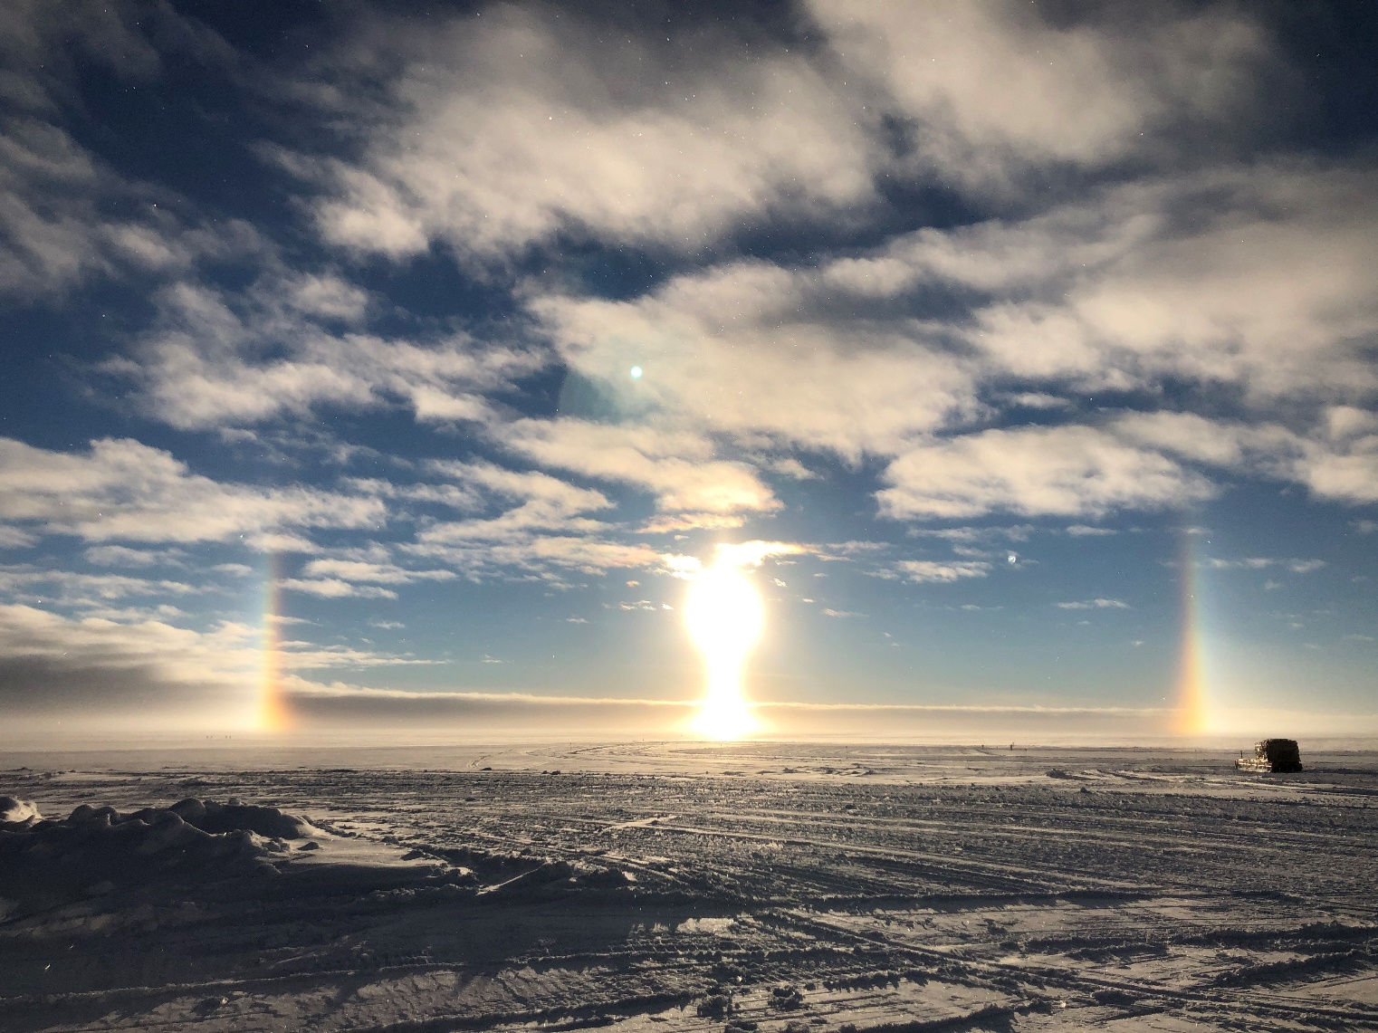

Atmospheric optics 2022-08-13

*Photo taken by: Molly Peek*

**General Notes:**

This week, operations were running normally as PIs arrived and started work on new installations and projects. The new 14-channel HAT-PRO MWR was installed and calibrated on the MSF roof, adding to the current MWR installation. The CAPABL window and equipment was removed, and the hole in the MSF roof is currently being repaired. The Walden team worked on installing a Solar Tracker, Optical Particle Counters, and a Sea Ice Mass Balance Array on the AWO roof. Additionally, there was an Optical Particle Counter and a Present Weather Sensor installed on the MSF roof. The albedo stand also received maintenance, with new radiometers installed. Overall, it was a very busy week of work for our visiting PIs! Intermittent internet issues persisted as IT repairs continued, but regular connections were restored by Saturday (08/20). Flux tower data was manually transferred due to connectivity issues. This was Nicolette’s last week as a (superbly fantastic) science tech, and Molly will be taking over for the last month of the season.

**General Weather Observations:**

|  |  |  |  |  |  |  |  |
| --- | --- | --- | --- | --- | --- | --- | --- |
| **Date** | **Time (Z)** | **Wind**  **(kt)** | **Weather** | **Visibility** | **Sky** | **Temp (C)** | **Notes** |
| 2022-08-16 | 1200 | 10.0 |  | 9999 | FEW009  FEW050  FEW160 | -14.0 |  |
| 2022-08-17 | 1200 | 7.0 |  | 9999 | FEW030  FEW130 | -16.0 |  |
| 2022-08-18 | 1200 | 6.0 |  | 9999 | FEW040  FEW070  SCT110 | -18.0 |  |
| 2022-08-19 | 1200 | 7.0 | DISTANT FRZ FOG | 9999 | FEW004  FEW007  FEW010 | -19.0 |  |
| 2022-08-20 | 1200 | 12.0 |  | 9999 | OVC007 | -17.0 |  |
| 2022-08-21 | 1200 | 6.0 |  | 9999 | FEW030  FEW 070 | -19.0 |  |
| 2022-08-22 | 1200 | 8.0 |  | 9999 | SCT007  SCT020  SCT060 | -20.0 |  |

**Significant Weather Observations:**

* Partial 22-degree halo 2022-08-10:2328z
* Halo 2022-08-11:1050z
* Corona 2022-08-11:1309z
* 22-degree halo; circumzenithal arc; full parhelic circle; two parhelia; diamond dust 2022-08-13: approx.1045z- 1300z
* Partial halo; sun pillar; diamond dust 2022-08-13: approx. 2230z
* Partial 22-degree halo 2022-08-17:1700z0
* Iridescence; corona 2022-08-19:1030z-1035z
* Corona; iridescence 2022-08-22:1200-1230z
* Two parhelia 2022-08-22:1755z

**MSF**

* New HAT-PRO installed by Erik
* Walden group set up in MSF for work
* CAPABL removed from MSF, the hole in the roof is currently being repaired
* Intermittent internet and connectivity outages 2022-08-15 through 2022-08-18
* Operating normally

**ICECAPS-ACE Data Management:**

* Flux tower data manually transferred 2022-08-18
* Data transfer did not complete 2022-08-09
* Data transfer completed 2022-08-16:0505z
* Data transfer completed 2022-08-17:0429z
* Data transfer completed 2022-08-18:0501z
* ‘To Boulder’ folder did not empty 2022-08-19
* Data transfer completed 2022-08-20:0450z
* Data transfer did not complete due to a lost connection 2022-08-21 and 2022-08-22. This issue was investigated by IT and as of 2022-08-23 the data is being processed but data transfer is not completed
* Operating normally

**TSI:**

* TSI Manager closed out and ceilometer computer rebooted 2022-08-12:1327z
* Status “Idle” on TSI window; 17703 unprocessed images 2022-08-19: approx. 1100z
* “Java image capture error” displayed 2022-08-20:1045z
* New script by Michael Gallagher installed to successfully process image backlog on the TSI 2022-08-21. The script was turned off when image processing caught up on 2022-08-22
* Temperatures at night are dropping, continued monitoring to decide when to bring the instrument inside

**Radiosonde:**

* Computer failed to connect to network after prolonged outage 2022-08-09 through 2022-08-10; radiosonde mount down on data management computer 2022-08-08 through 2022-08-09
* Radiosonde computer back on network 2022-08-10: approx. 1800z
* Davis weather data used for Radiosonde Log 2022-08-02 through 2022-08-08 through 2022-08-09
* Computer reboot 2022-08-16:1330z
* Radiosonde dropped from balloon, unsuccessful release 2022-08-17:2330z
* UPS accidentally shut off 2022-08-17:2300z
* Script errors displayed during radiosonde conditioning process 2022-08-19:2300z
* UPS shut off prior to planned power outage 2022-08-22:1030z. Operation resumed successfully when restarted after outage 2022-08-22:1115z
* Operating normally

**MWR:**

* The new 14-channel HAT-PRO was installed on the MSF roof
* Both the new and existing MWR instruments were calibrated on 2022-08-20
* Operating normally

**SODAR:**

* Amplifier turned off for cleaning 2022-08-15:1708z
* Amplifier turned off for cleaning 2022-08-22:1600-1615z
* Low LC-130 flyover 2022-08-19: approx. 1630z
* Operating normally

**POSS:**

* Regular transient noise errors, new DC offset error displayed 2022-08-19:1115z
* Operating normally

**MASC:**

* DEICE 120V cable found disconnected 2022-08-13 and reconnected 2022-08-13:1145z; did not appear to affect MASC function or data acquisition
* MASC computer rebooted to fix nonoperational mousepad 2022-08-16:1207z
* Increasing amounts of rime and frost on the MASC setup, falling rime could contribute to photos taken on days without precipitation
* Operating normally

**MMCR:**

* Small amounts of snow and ice beginning to accumulate on MMCR
* Operating normally

**MPL:**

* Afterpulse calibration ended on 2022-08-15:1652z
* Operating normally

**CEILOMETER:**

* Computer rebooted 2022-08-12:1327z to troubleshoot TSI Manager
* Operating normally

**PAERI:**

* Expected to return in August

**IceCAM:**

* Operating normally.

**IcePIC:**

* Images taken during storm 2022-08-23

**MAGIC CPC:**

* Operating normally
* Spare received

**MSF - OPC:**

* Offline
* Expected installation in August

**AWO - OPC:**

* Online!
* Expected data through QuickLooks

**SKYOPC:**

* Online
* Expected data through QuickLooks

**Flux Tower instrument suite:**

* + Fluxtower laptop replaced with raspberry pi as new data logging platform
  + Utilizing TeraTerm for daily instantaneous data check
    - Will also refer to QuickLooks once updated
  + Upgraded: aspirated shields on temperature and humidity sensors
  + Installed: Optical Particle Counter inlet /Sea Ice Mass Balance Array / Portable Optical Particle Spectrometers
  + Repaired and remounted: Sonic Distance Sensor / Infrared Radiation Thermometer / Ventus 1 anemometer / HMP 155 (1)
  + Received and stored: Moderate Aerosol Growth and Internal water Cycling CPC
  + Collected microplastic samples

**Radiometers:**

* Albedo Stand: continued normal operations
  + Data download upgraded and weekly downloads no longer necessary
  + Access to data via Logger Net
* Solar Tracker installed and is absolutely beautiful
  + Have been cleaning **heavy frost** off fans daily (!)
    - concerned about their resilience over winter