**ICECAPS-ACE Weekly Report**

August 23rd – August 29th, 2022

Molly Peek

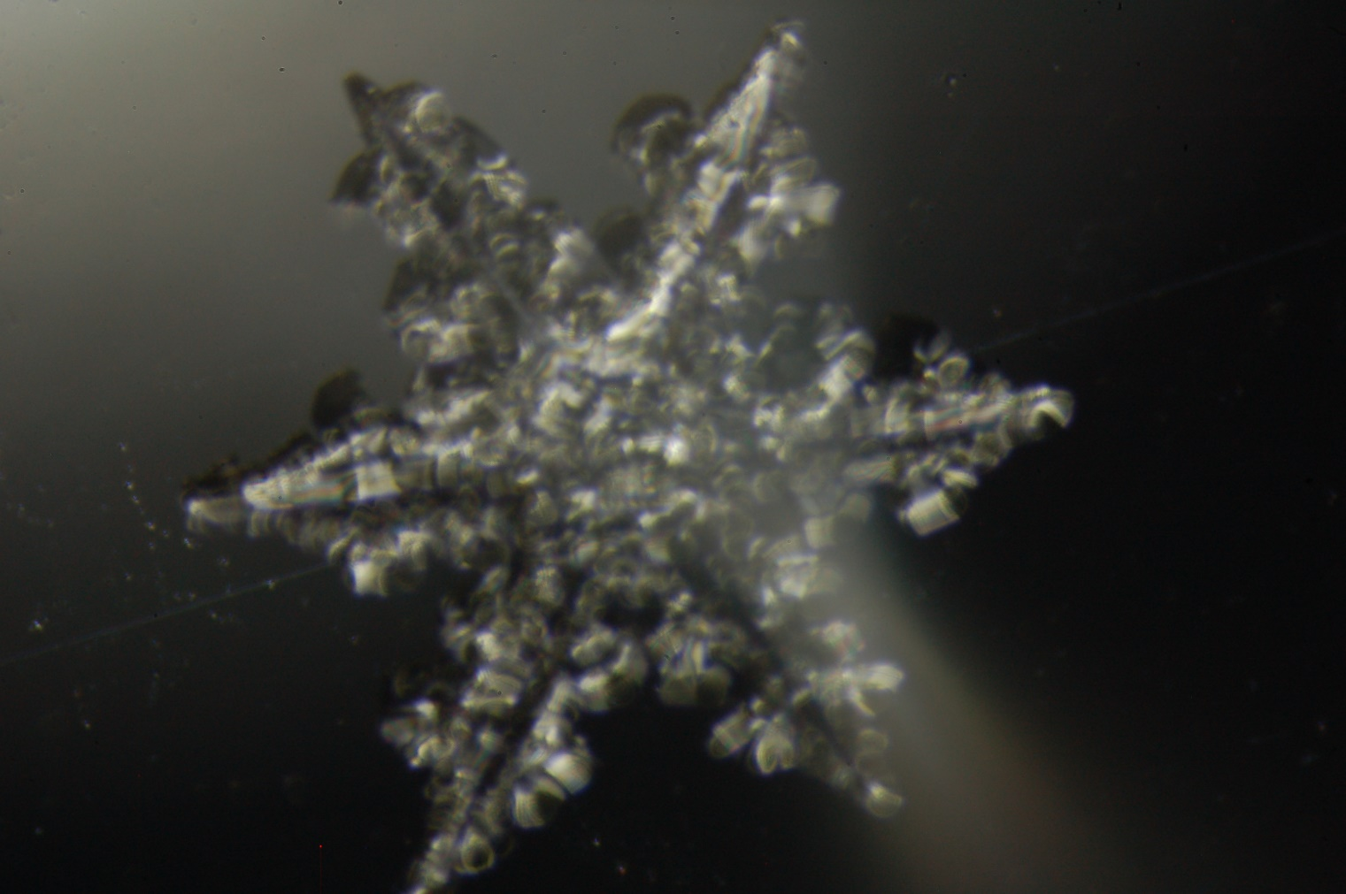

ICEPic image captured 2022-08-24

*Photo taken by: Molly Peek*

**General Notes:**

This week, priority was placed on monitoring new instruments and catching up on small projects as we close out the summer season. The new Humidity and Temperature Profiler (HAT-PRO) Microwave Radiometer (MWR), Optical Particle Counter (OPC), and Biral Present Weather Sensor have now been operational for a week and are running smoothly. With new IT updates, data transfer is now smoother and previous backlogs on the Total Sky Imager (TSI) and the Dataman data transfer system have been successfully processed. With more snow coming to Summit, the Ice Particle Image Camera (ICEPic) project was more active, capturing images of snow particles from 3 different events. Image capture from the TSI was temporarily down between 2022-08-23 to 2022-08-24 but is now fully operational. We are continuing to prepare the MSF for winter as the entire camp starts to consolidate and say goodbye to the summer season.

**General Weather Observations:**

|  |  |  |  |  |  |  |  |
| --- | --- | --- | --- | --- | --- | --- | --- |
| **Date** | **Time (Z)** | **Wind**  **(kt)** | **Weather** | **Visibility** | **Sky** | **Temp (C)** | **Notes** |
| 2022-08-23 | 12:00 | 16 | DRSN; -SN | 750 | OVC | -10 |  |
| 2022-08-24 | 12:00 | 15 | BLSN; -SN | 9999 | OVC | -10 |  |
| 2022-08-25 | 12:00 | 11 |  | 9999 | SCT | -16 |  |
| 2022-08-26 | 12:00 | 5 |  | 9999 | BKN | -16 |  |
| 2022-08-27 | 12:00 | 13 | FRZ FOG; BLSN | 1500 | OVC | -14 |  |
| 2022-08-28 | 12:00 | 10 | FRZ FOG | 1200 | SCT | -17 |  |
| 2022-08-29 | 12:00 | 20 | BLSN; DRSN; -SN | 750 | OVC | -11 |  |

**Significant Weather Observations:**

* Diamond dust 2022-08-27:1200z
* Partial 22-degree halo; diamond dust 2022-08-27:1930z
* Partial 22-degree halo 2022-08-28:1130z-1200z
* Full 22-degree halo 2022-08-28:1415z

**MSF**

* Operating normally

**ICECAPS-ACE Data Management:**

* Data transfer did not complete 20220823
* Data transfer completed 2022-08-24:0735z
* Data transfer completed 2022-08-25:0459z
* Data transfer completed 2022-08-26:0352z
* Data transfer completed 2022-08-27:0407z
* Data transfer completed 2022-08-28:0447z
* Data transfer completed 2022-08-29:0401z
* Operating normally

**TSI:**

* TSI Manager did not collect data on 2022-08-23, was successfully restarted on 2022-08-24
* Operating normally

**Radiosonde:**

* Failed sonde the morning of 2022-08-29 due to a lost connection to the SPS.
* Several Java script errors continue to pop up, does not appear to affect launch or data collection.
* Operating normally

**MWR:**

* Older MWR is not directing data to the correct place
* Operating normally

**SODAR:**

* Amplifier turned off for cleaning 2022-08-29:1055-1105z
* Operating normally

**POSS:**

* Regular transient noise errors
* Operating normally

**MASC:**

* Operating normally

**MMCR:**

* Operating normally

**MPL:**

* Operating normally

**CEILOMETER:**

* Operating normally

**PAERI:**

* Expected to return in August

**IceCAM:**

* Operating normally.

**IcePIC:**

* Images taken 2022-08-23
* Images taken 2022-08-24
* Images taken 2022-08-29
* Image transfer is delayed due to a network error at Summit- will be manually transferred this week

**MAGIC CPC:**

* Operating normally

**MSF - OPC:**

* Operating normally

**AWO - OPC:**

* Offline
* Expected installation in August

**SKYOPC:**

* Offline
* Expected installation in August (AWO)

**Biral PWS :**

* Bad self-check 2022-08-26 :2200z – 2022-08-27 :0200z
* Bad self-check 2022-08-29:0045-0115z and 0130-0200z
* Operating normally

**Flux Tower instrument suite:**

* One wind sensor repaired and replaced on the tower
* Second wind sensor requires more work/replacement next season
* Operating normally

**Radiometers:**

* Operating normally