**ICECAPS-ACE Weekly Report**

August 30th – September 5, 2022

Molly Peek

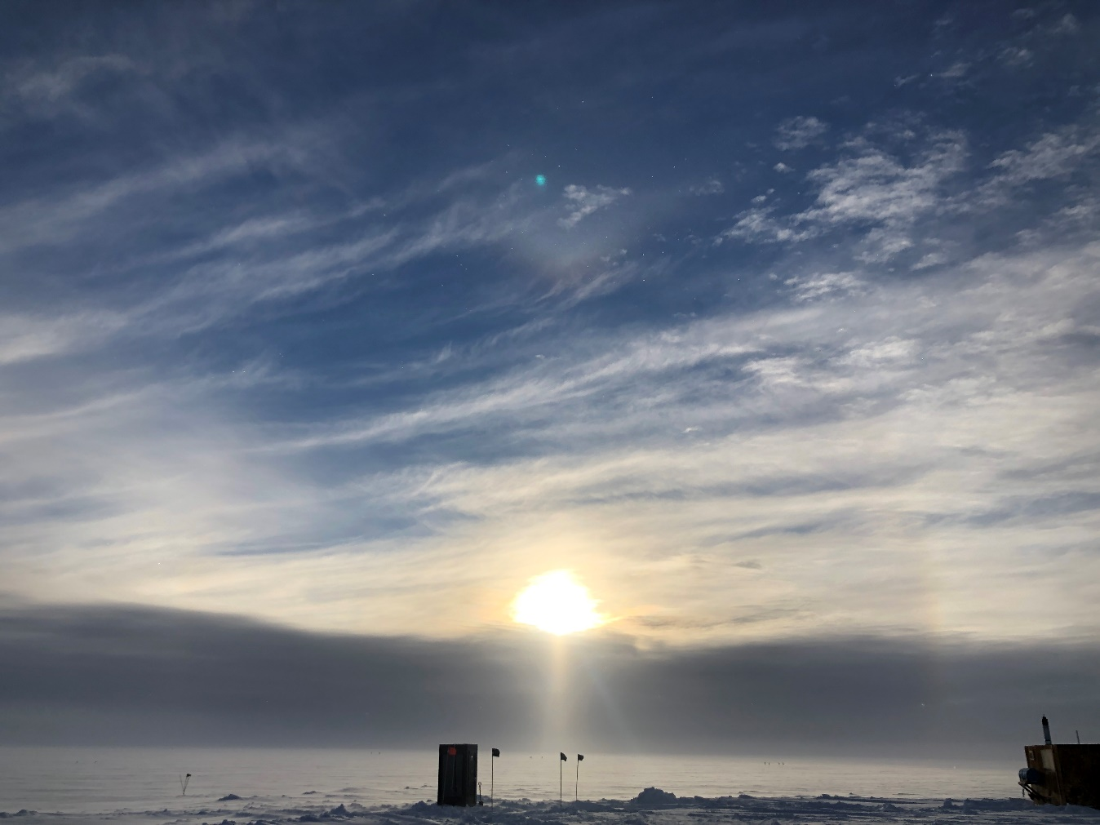

Gull-winged upper tangent arc, partial 22-degree halo, and sun pillar on the evening of 2022-09-04.

*Photo taken by: Molly Peek*

**General Notes:**

This week at the Mobile Science Facility (MSF), work was focused on fixing bugs and instrument errors. The Millimeter Cloud Radar (MMCR) experienced issues with the MMCR-DM computer, and there was no MMCR data transfer after 2022-09-01. The Raspberry Pi also had issues processing data and troubleshooting continues. After some small operating issues on 2022-09-03, the Dataman computer is successfully working and processing data. Summit has experienced anomalously warm temperatures since 2022-09-03, with temperatures intermittently above 0 degrees Celsius throughout the day on 2022-09-03, and hovering closely below freezing since then. All regular instrument checks and the twice-daily radiosonde balloon launches continued successfully.

**General Weather Observations:**

|  |  |  |  |  |  |  |  |
| --- | --- | --- | --- | --- | --- | --- | --- |
| **Date** | **Time (Z)** | **Wind**  **(kt)** | **Weather** | **Visibility** | **Sky** | **Temp (C)** | **Notes** |
| 2022-08-30 | 12:00 | 25 | BLSN, DRSN, +SN | 750 | OVC | -5 |  |
| 2022-08-31 | 12:00 | 12 |  | 1200 | FEW | -12 |  |
| 2022-09-01 | 12:00 | 5 | FZFG | 400 | OVC | -18 |  |
| 2022-09-02 | 12:00 | 11 |  | 9999 | SCT | -14 |  |
| 2022-09-03 | 12:00 | 17 | FZFG | 3000 | BKN | -1 |  |
| 2022-09-04 | 12:00 | 14 |  | 9999 | BKN | -2 |  |
| 2022-09-05 | 12:00 | 9 |  | 9999 | BKN | -3 | Unverified freezing rain in the night leading into 2022-09-06 |

**Significant Weather Observations:**

* Partial 44-degree halo; diamond dust 20220831:1106z
* Diamond dust 20220831:1200z
* Iridescence 20220831:1300z
* Fogbow 20220901:1900z
* Iridescence 20220902:0845z
* Partial rainbow 20220903:1127z
* Lower tangent arc 20220903:1240z
* Gull-winged upper tangent arc; partial 22-degree halo; sun pillar 20220904:2015z

**MSF**

* Operating normally

**ICECAPS-ACE Data Management:**

* Data transfer completed 2022-08-30:0400z
* Data transfer did not complete 2022-08-31
* Data transfer completed 2022-09-01:0447z
* Data transfer completed 2022-09-02:0419z
* Data transfer completed 2022-09-03:0558z
* Data transfer did not complete 2022-09-04
* Data transfer completed 2022-09-05:0427z
* Issue opening desktop folders and completing commands in the Terminal Emulator 20220903

**TSI:**

* Was partially iced during warm and cold weather fluctuations
* Operating normally

**Radiosonde:**

* Several Java script errors continue to pop up, does not appear to affect launch or data collection.
* Operating normally

**MWR:**

* Operating normally

**SODAR:**

* Amplifier turned off for cleaning 2022-09-05:1138z-1153z
* Operating normally

**POSS:**

* Regular transient noise errors
* Operating normally

**MASC:**

* Frayed power cord to MASC mount, notes have been made for repairs
* Operating normally

**MMCR:**

* MMCR-DM computer experiencing issues, the radar seems to be operating normally
* MMCR does not appear to be transferring data

**MPL:**

* Operating normally

**CEILOMETER:**

* Operating normally

**PAERI:**

* Expected to return in September

**IceCAM:**

* Operating normally.

**IcePIC:**

* Images taken 2022-09-04
* Camera issues affected photo quality 2022-08-31, resolved same day

**MAGIC CPC:**

* Operating normally

**MSF - OPC:**

* Raspberry Pi experiencing issues, Quicklooks pages are not accessible
* Operating normally

**AWO - OPC:**

* Offline

**SKYOPC:**

* Offline

**Biral PWS :**

* Bad self-check 2022-08-26 :2200z – 2022-08-27 :0200z
* Bad self-check 2022-08-29:0045-0115z and 0130-0200z
* Raspberry Pi experiencing issues, Quicklooks pages are not accessible
* Operating normally

**Flux Tower instrument suite:**

* Upgrades underway
* Operating normally

**Radiometers:**

* Upgrades underway, resulting in some down time
* Operating normally