**ICECAPS-ACE Weekly Report**

September 6th – September 12th, 2022

Molly Peek

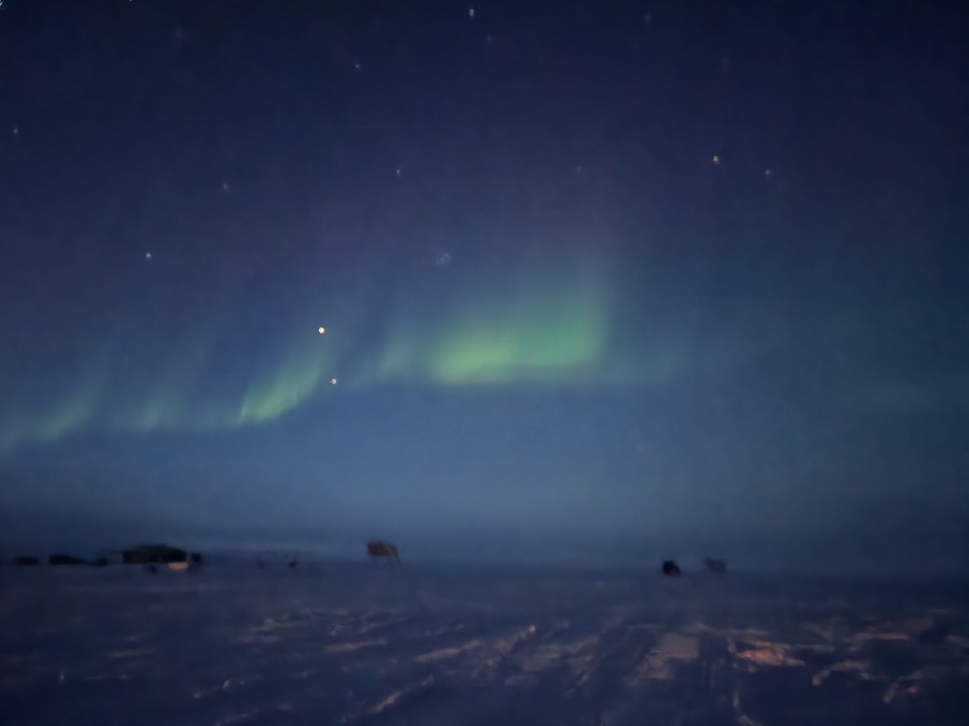

The first aurora of the season at Summit.

*Photo taken by: Cody Spillane*

**General Notes:**

This week at the Mobile Science Facility (MSF), all regular checks and projects continued as the facility is prepared for the winter crew. Daily radiosonde balloon launches and instrument checks were all successful. The MMCR-DM computer issue was resolved, and the instrument is once again fully operational. Network issues persisted, interrupting daily data transfers and offsite access to instruments. This issue is currently being resolved with IT. The MASC was taken offline due to a frayed wire, until a fix can be arranged. After abnormally warm temperatures last week, Summit Station saw gradual cooling and several fog and snow events.

**General Weather Observations:**

|  |  |  |  |  |  |  |  |
| --- | --- | --- | --- | --- | --- | --- | --- |
| **Date** | **Time (Z)** | **Wind**  **(kt)** | **Weather** | **Visibility** | **Sky** | **Temp (C)** | **Notes** |
| 2022-09-06 | 12:00 |  |  | 1000 | OVC |  |  |
| 2022-09-07 | 12:00 |  |  | 9999 | OVC |  |  |
| 2022-09-08 | 12:00 |  | -SN | 800 | OVC |  |  |
| 2022-09-09 | 12:00 |  | BLSN, DRSN | 1000 | OVC |  |  |
| 2022-09-10 | 12:00 |  | DST FZFG | 9999 | SCT |  |  |
| 2022-09-11 | 12:00 |  |  | 9999 | SCT |  |  |
| 2022-09-12 | 12:00 |  |  |  |  |  |  |

**Significant Weather Observations:**

* Partial 22-degree corona 2022-09-08:1600z
* Full 22-degree corona 2022-09-10:1000z
* Full 22-degree corona 2022-09-11:1345z

**MSF**

* Operating normally

**ICECAPS-ACE Data Management:**

* Data transfer did not complete 2022-09-06
* Data transfer did not complete 2022-09-07
* Data transfer did not complete 2022-09-08
* Data transfer completed 2022-09-09:0453z
* Data transfer completed 2022-09-10:0516z
* Data transfer completed 2022-09-11:0358z
* Data transfer completed 2022-09-12:0346z
* Persistent data transfer issues are being resolved with Battelle IT

**TSI:**

* Operating normally

**Radiosonde:**

* Operating normally

**MWR:**

* Brightness temperatures logging irregularly starting 20220912
* Operating normally

**SODAR:**

* Amplifier turned off for cleaning 2022-09-11:1404-1415z
* Operating normally

**POSS:**

* POSACQ window found closed 20220912. Power cord found loose and reattached, and the software was restarted the same day.
* Operating normally

**MASC:**

* Taken offline until further notice because of frayed power cord. The de-ice is still connected to limit snow accumulation.

**MMCR:**

* MMCR-DM computer issues resolved
* Slightly low transmitter power
* MMCR- RADAR computer error 20220911. Resolved same day.
* Operating normally

**MPL:**

* Operating normally

**CEILOMETER:**

* Operating normally

**PAERI:**

* Expected to return in September

**IceCAM:**

* Operating normally.

**IcePIC:**

* No images captured

**MAGIC CPC:**

* Operating normally

**MSF - OPC:**

* Quicklooks pages are not accessible.
* Operating normally

**AWO - OPC:**

* Operating normally

**SKYOPC:**

* Offline

**Biral PWS :**

* Quicklooks pages accessible, data updating
* Operating normally

**Flux Tower instrument suite:**

* Operating normally

**Radiometers:**

* Operating normally