**ICECAPS-ACE Weekly Report**

September 13th – September 19th, 2022

Rachel Cook, Sam Dorsi

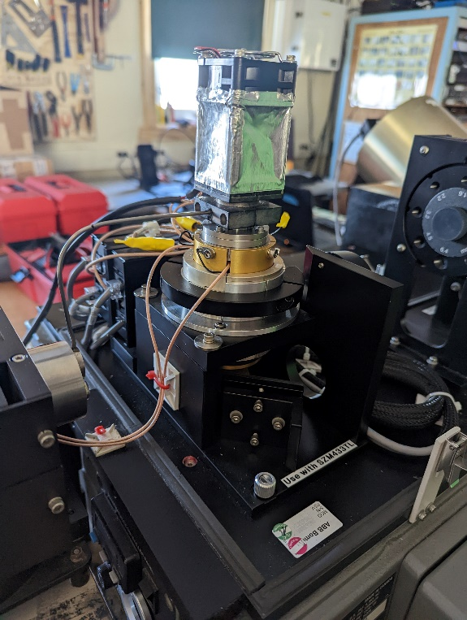

PAERI Instrument – The infamous Stirling cooler and infrared detector

*Photo taken by: Rachel Cook*

**General Notes:**

This week at the Mobile Science Facility (MSF), turnover occurred. The new winter science technician was trained on regular instrument checks. The MASC remains offline due to a frayed wire. The PAERI instrument was repaired and reinstalled.

**General Weather Observations:**

|  |  |  |  |  |  |  |  |
| --- | --- | --- | --- | --- | --- | --- | --- |
| **Date** | **Time (Z)** | **Wind**  **(kt)** | **Weather** | **Visibility** | **Sky** | **Temp (C)** | **Notes** |
| 2022-09-13 | 12:00 | 9.0 | 4800 | FZFG | OVC010 | -14.0 |  |
| 2022-09-14 | 12:00 | 10.0 | 2800 | FZFG | FEW006, SCT010 | -18.0 |  |
| 2022-09-15 | 12:00 | 23.0 | 2000 | DRSN -SN | FEW008, BKN090, OVC120 | -11.0 |  |
| 2022-09-16 | 12:00 | 4.0 | 9999 | -SN | BKN040 | -17.0 |  |
| 2022-09-17 | 12:00 | 17.0 | 9999 | -SN DRSN | OVC005 | -7.0 |  |
| 2022-09-18 | 12:00 | 22.0 | 2400 | SN BL | OVC027 | -7.0 |  |
| 2022-09-19 | 12:00 |  |  |  |  |  |  |

**Significant Weather Observations:**

* Fog Bow 2022-09-19:0943z
* Sun Dog 2022-09-19:1126z

**MSF**

* Operating normally

**ICECAPS-ACE Data Management:**

* Data transfer completed 2022-09-14:0418z
* Data transfer completed 2022-09-15:0400z
* Data transfer completed 2022-09-16:0409z
* Data transfer completed 2022-09-17:0410z
* Data transfer completed 2022-09-18:0451z
* Data transfer completed 2022-09-19:0401z
* Data transfer

**TSI:**

* Operating normally

**Radiosonde:**

* Operating normally

**MWR:**

* Data logs stopped 2022-09-15 on RPG-150-90.
* Setup continues on RPG-HATPRO, waiting for updated protocols for daily checks.

**SODAR:**

* Amplifier turned off for cleaning 2022-09-19:1310-1324z.
* Operating normally.

**POSS:**

* Operating normally.

**MASC:**

* Taken offline until further notice because of frayed power cord. The de-ice is still connected to limit snow accumulation.

**MMCR:**

* NetCDF errors started 2022-09-16 and continued daily until 2022-09-19. MMCR rebooted to resolve.

**MPL:**

* Operating normally.

**CEILOMETER:**

* Operating normally.

**PAERI:**

* Repaired and reinstalled.

**IceCAM:**

* Operating normally.

**IcePIC:**

* No images captured.

**MAGIC CPC:**

* Operating normally.

**MSF - OPC:**

* Operating normally.

**AWO - OPC:**

* Offline

**SKYOPC:**

* Operating normally

**Biral PWS :**

* Operating normally.

**Flux Tower instrument suite:**

* Operating normally.

**Radiometers:**

* Operating normally.