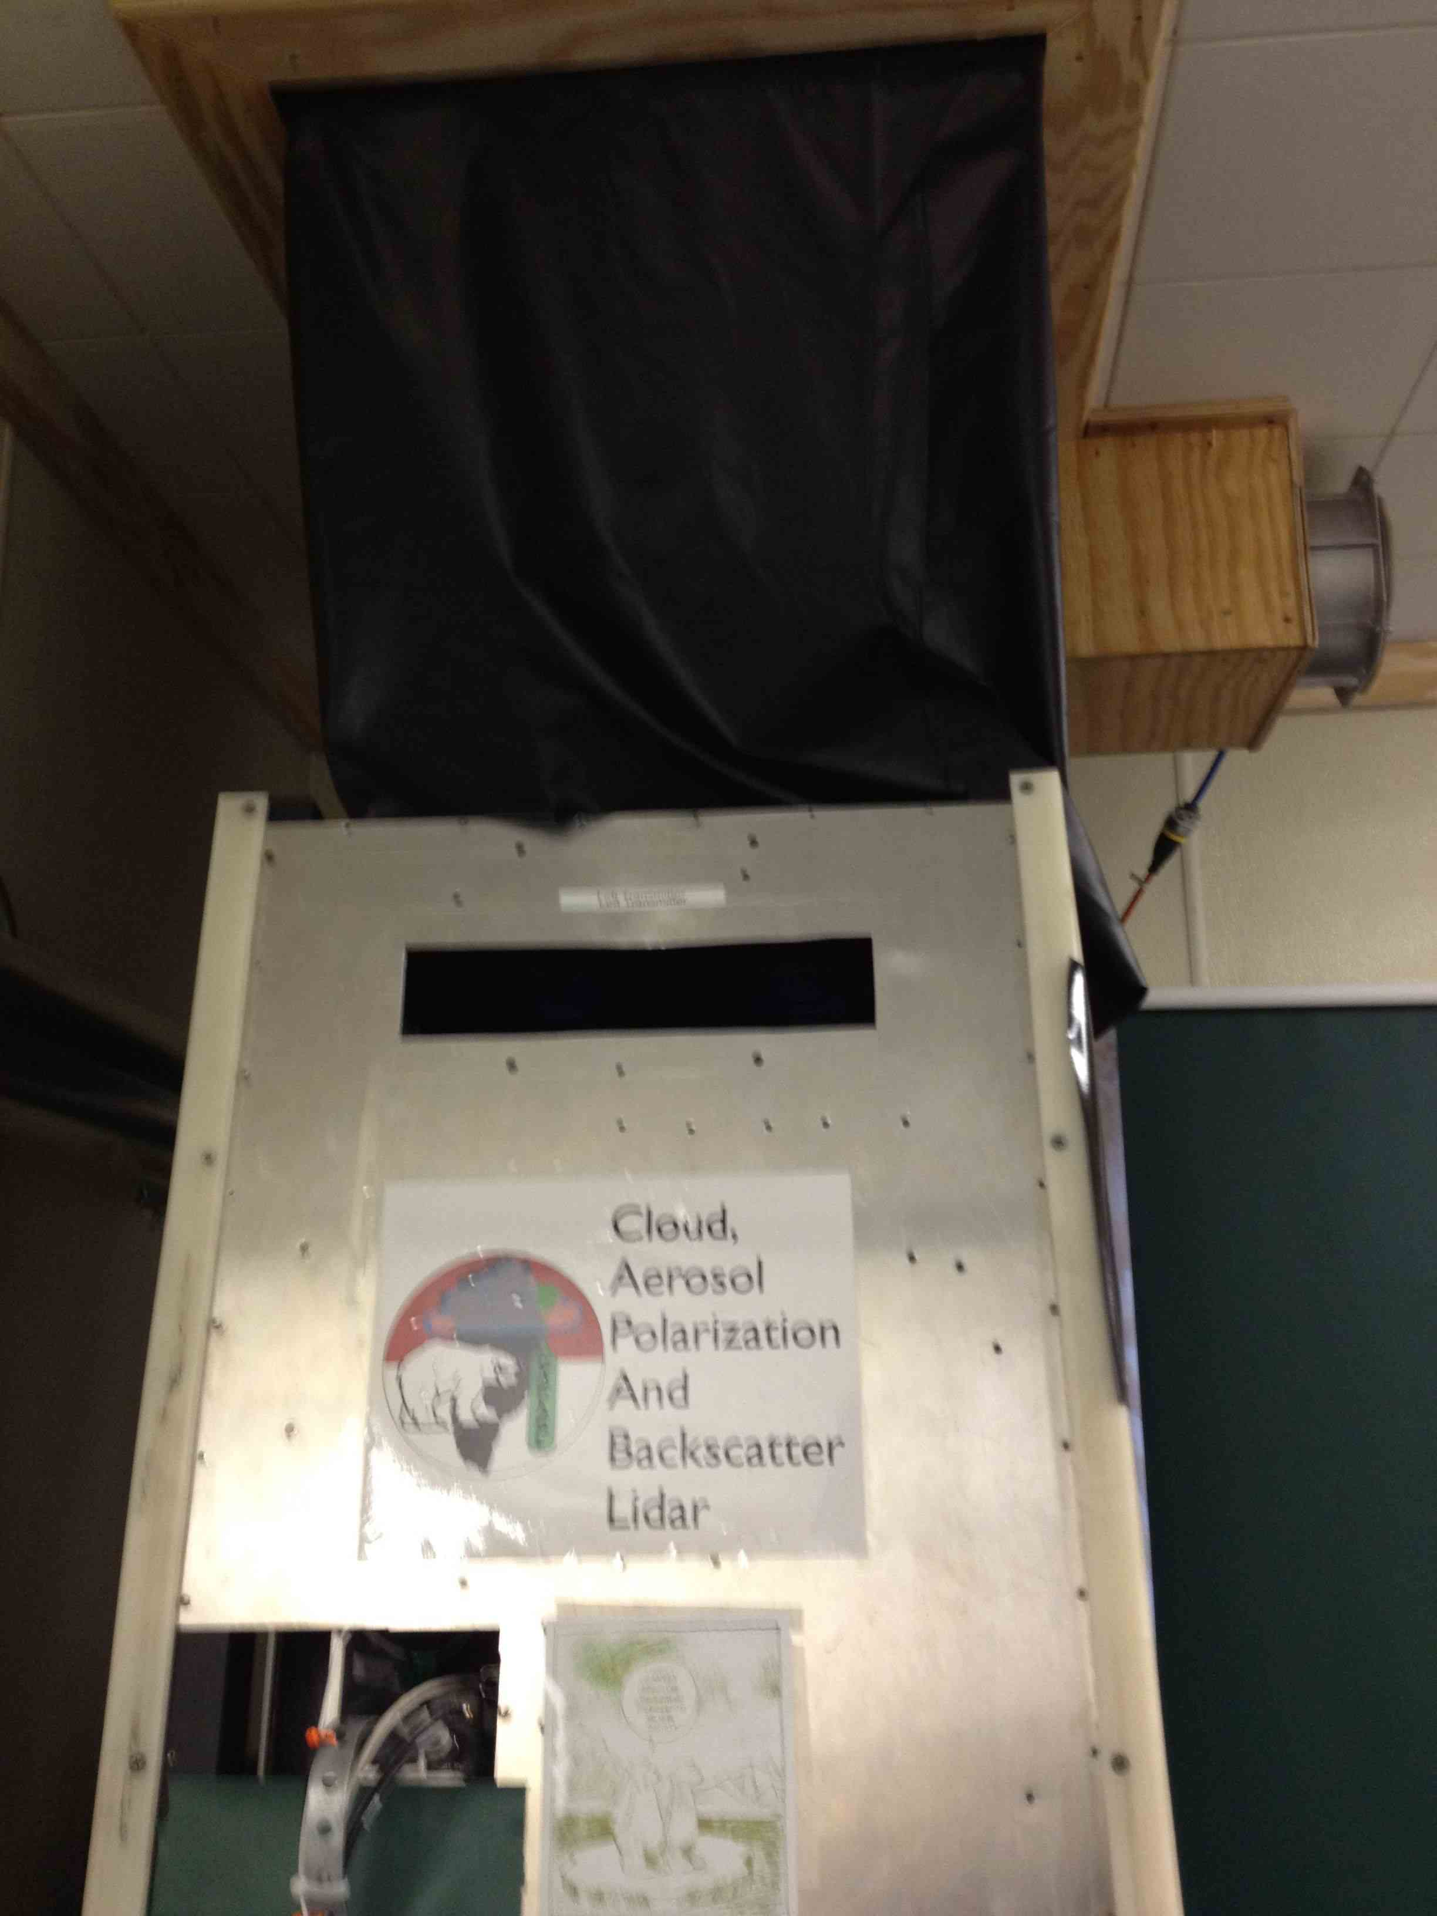
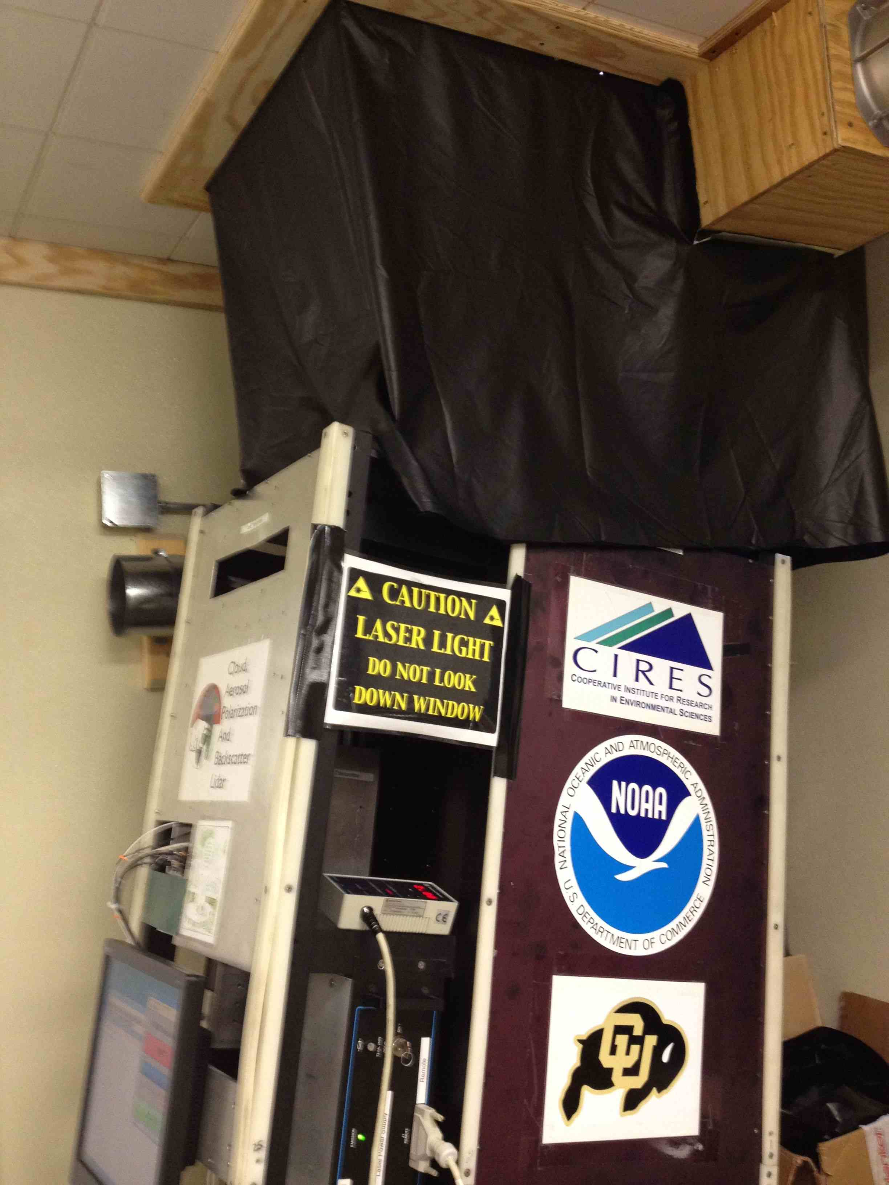
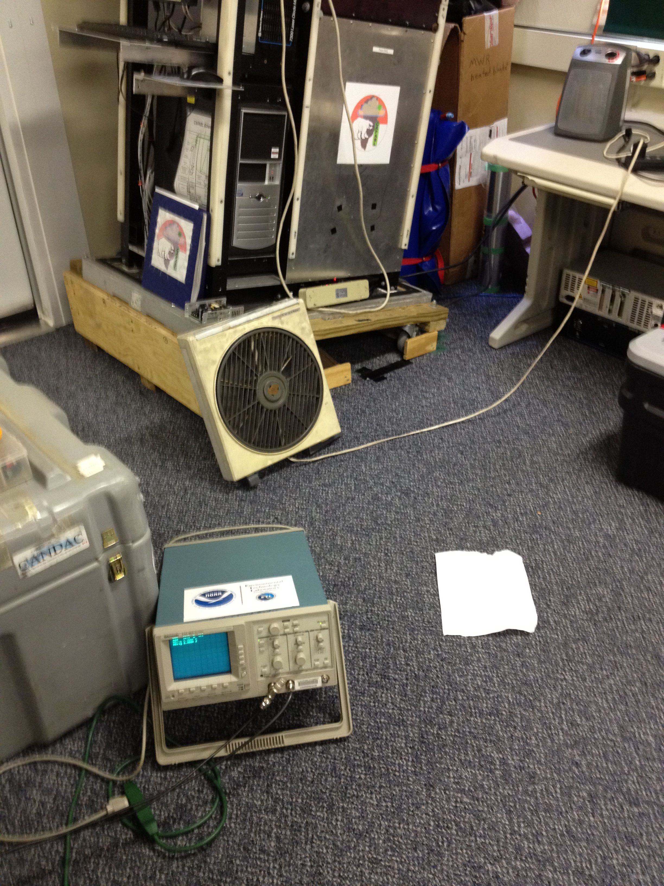
Hey Ryan – here are some rough illustrations of the beam I saw. I could be quite a bit off, it is hard to remember or tell without recreating. Let me know if I can give you more information.

