Radar Update
Claire Pettersen
April 4th, 2012

March 19th - 24th :

From March 19th to 22nd, the old Up Down Converter was removed and the new Up Down Converter was installed. An extra attenuator was added to the back of the Radian box at the Transmitter Output (51-10dBZ) and the UDC was tuned using the power output of the TWTA. The “I” signal from the Radian Box was low – 20mV peak to peak. You can see the results did not look good from the NOAA radar browser images below (March 23rd and March 24th). Black flexguide piece was replaced as well. No change:
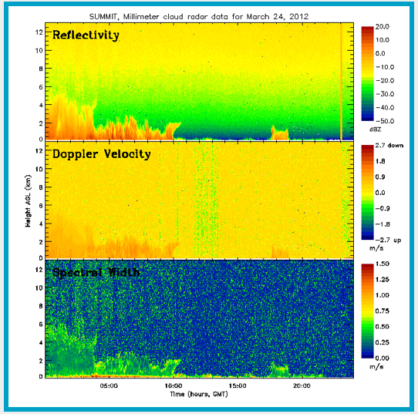
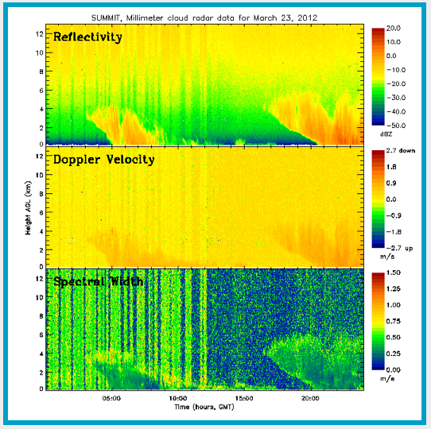

March 25th – March 30th :

Waveguide setup was rebuilt in the old configuration and each waveguide piece was inspected and cleaned. There were 5 junctions missing screws and 7 junctions with loose screws. There was little to no change in the radar performance as seen in the March 30th browser:
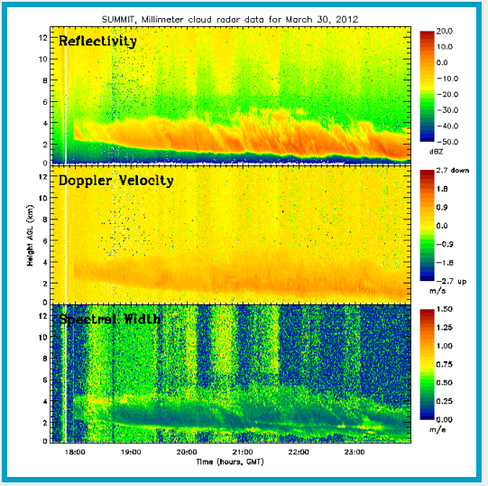

March 31st:

See the figure below for the correlating timing. During the day I first: a) turned off radar, replaced the black flex guide from the RF Input of the UDC with a piece of gold flex guide, turned on the radar - no change, b) turned off radar, replaced the gold flex guide with a piece of bran new bubble-wrap protected black flex guide, turned on the radar - no change, c) shut down the radar, went to lunch, did work on the roof and PAERI fan (nothing related to radar), d) started radar back up – high reflectivity but no background scattering and the noise floor is about 38dBZ – which is where it should be (the only thing I saw change at this point was that the “Circulation Temperature” was above 0C), e) at about 2230 UTC, Duane does some type of calibration – the noise floor drops to 20 dBZ (thus we have background scattering again, but is much improved). Since the following day is the first of the month, we will wait for the Full Calibration to run on April 1st:
a)
e)
b)
c)
d)
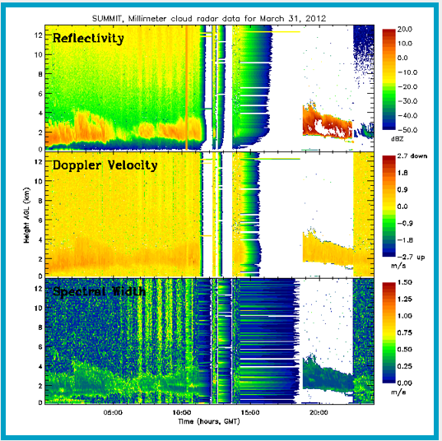
Just FYI – here are pictures of the waveguides before and after:

This is a picture of the waveguide setup when I arrived:
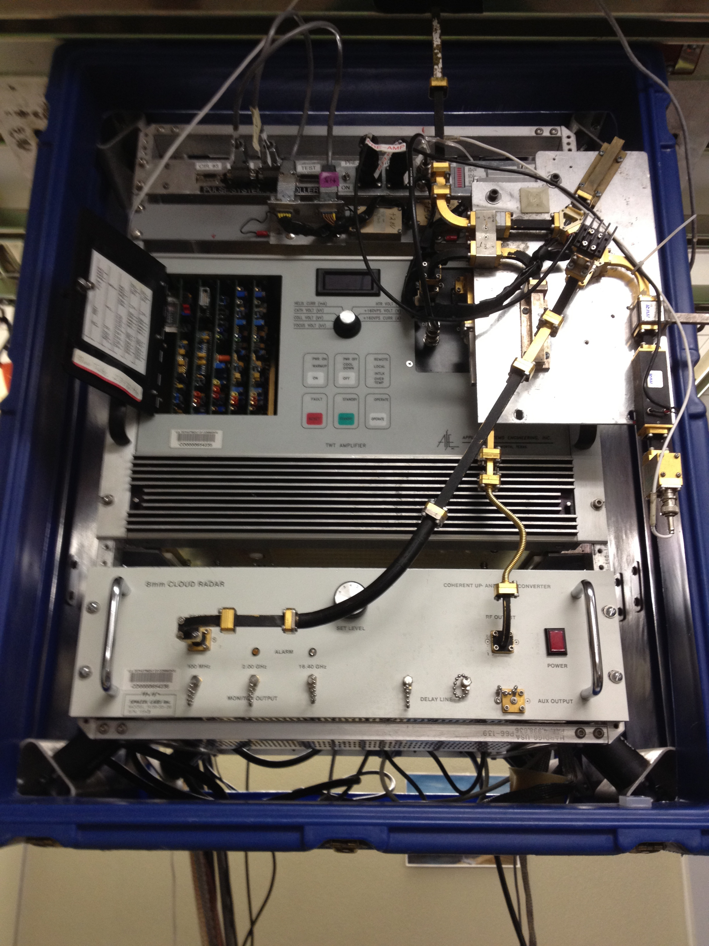
And this picture below is the CURRENT waveguide setup (copied the old setup from last Summer):
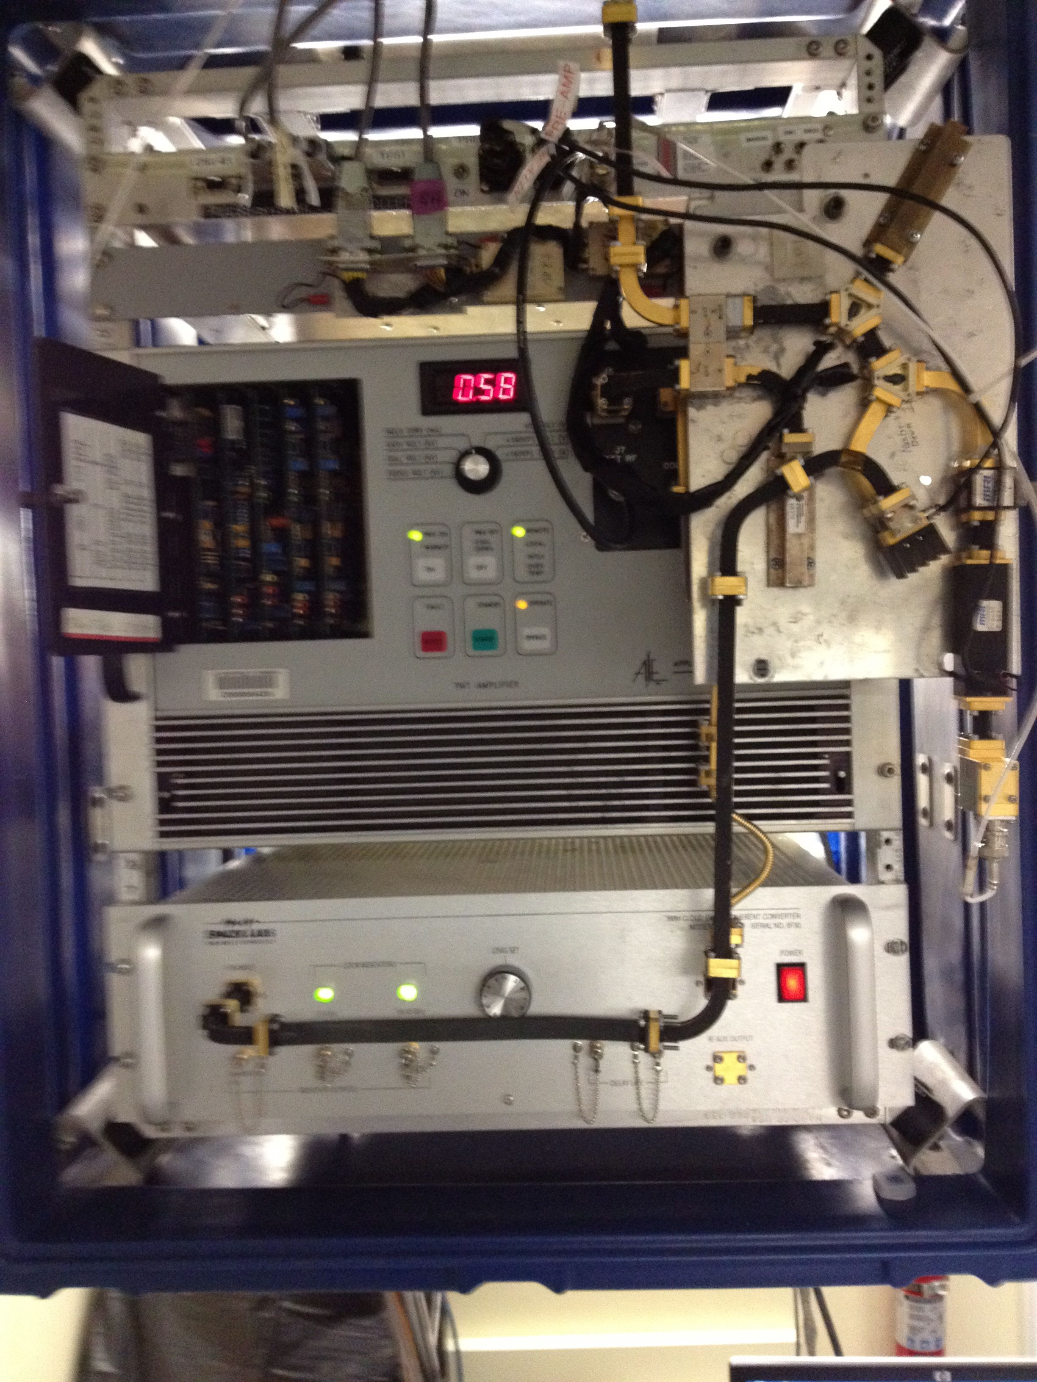
April 1st :

Duane calibrated the radar the previous day (at 2230 UTC March 31st). I woke up at 8am local (1000 UTC) to a severe clear sky (clearest we have had since I arrived. I checked the radar and it only had the scattering – no clouds at 1000UTC. The big Monthly Calibration at the first of the month was automatically run at 1230 UTC (A in the figure below). At this point (A), one can see the scattering has disappeared. Also, the noise floor is back to 38 dBZ on the spectrographs on mmcr-radar, which is close to where it should be, and the signal from radian box BNC “I” is about 200mV peak to peak, which is also where it should be. However, the big calibration FAILED. But, some settings must have been changes by the Monthly Calibration even though it failed because the noise floor changed and the “I” changed to close to their correct values, 38 dBZ and 200mV, respectively. Since there was no cloud cover, we let it run all Monday as well in the current state.
A

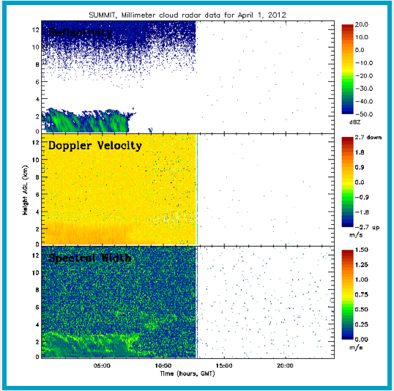

April 2nd :

We had an overcast and snowy day on April 2nd – the data looks great on the browser. Whatever changes from the big calibration – even though it failed – made the data look the best it has been since last last fall. The reflectivity seems to match the outside conditions. However, the big calibration did fail but the changes it made seem good:

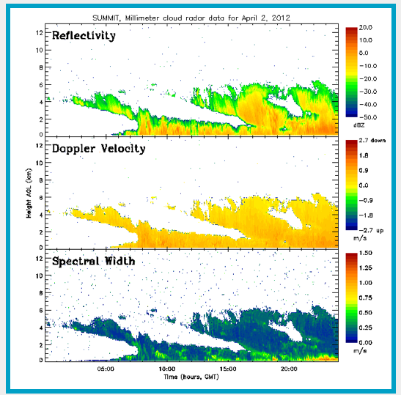

April 3rd :

Duane ran a calibration (different from the Monthly Calibration) in the morning April 3rd at about 1030 UTC (point A). This calibration again lowered the noise floor to about 20 dBZ and the signal from “I” is a order of magnitude lower, about 10mV (it should be 200mV as it was after the big calibration failed). We again have background scattering. The weather on both April 2nd and 3rd was exceptionally snowy and overcast for the entire day (the heaviest snow I have seen here).

A

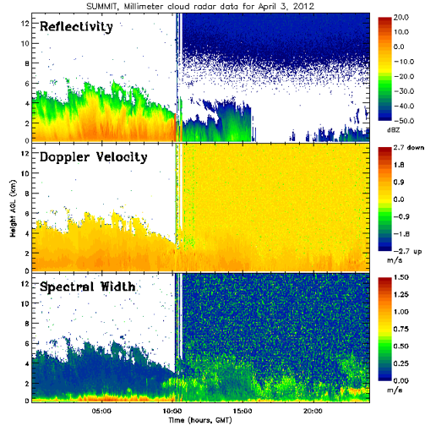

April 4th:

Duane and the radar design engineer concluded that the calibrations were not working due to a bad switch in the radian box that is used during the calibration. I removed the switch from the radian box and bypassed it completely as per their instructions. The radar was shut down at 1600 UTC on the 4th and brought back up at 2030 UTC the same day. The switch is illustrated below:
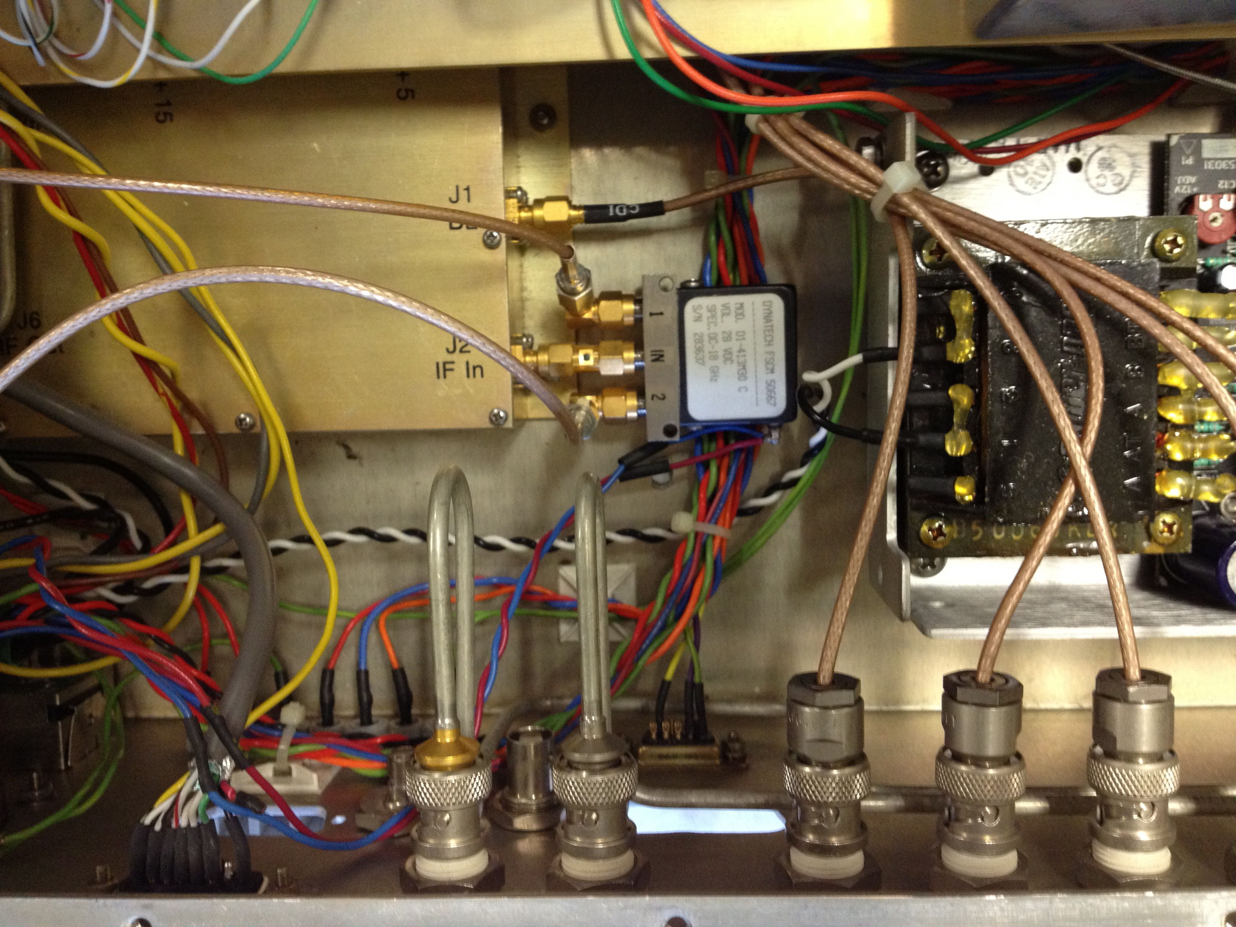
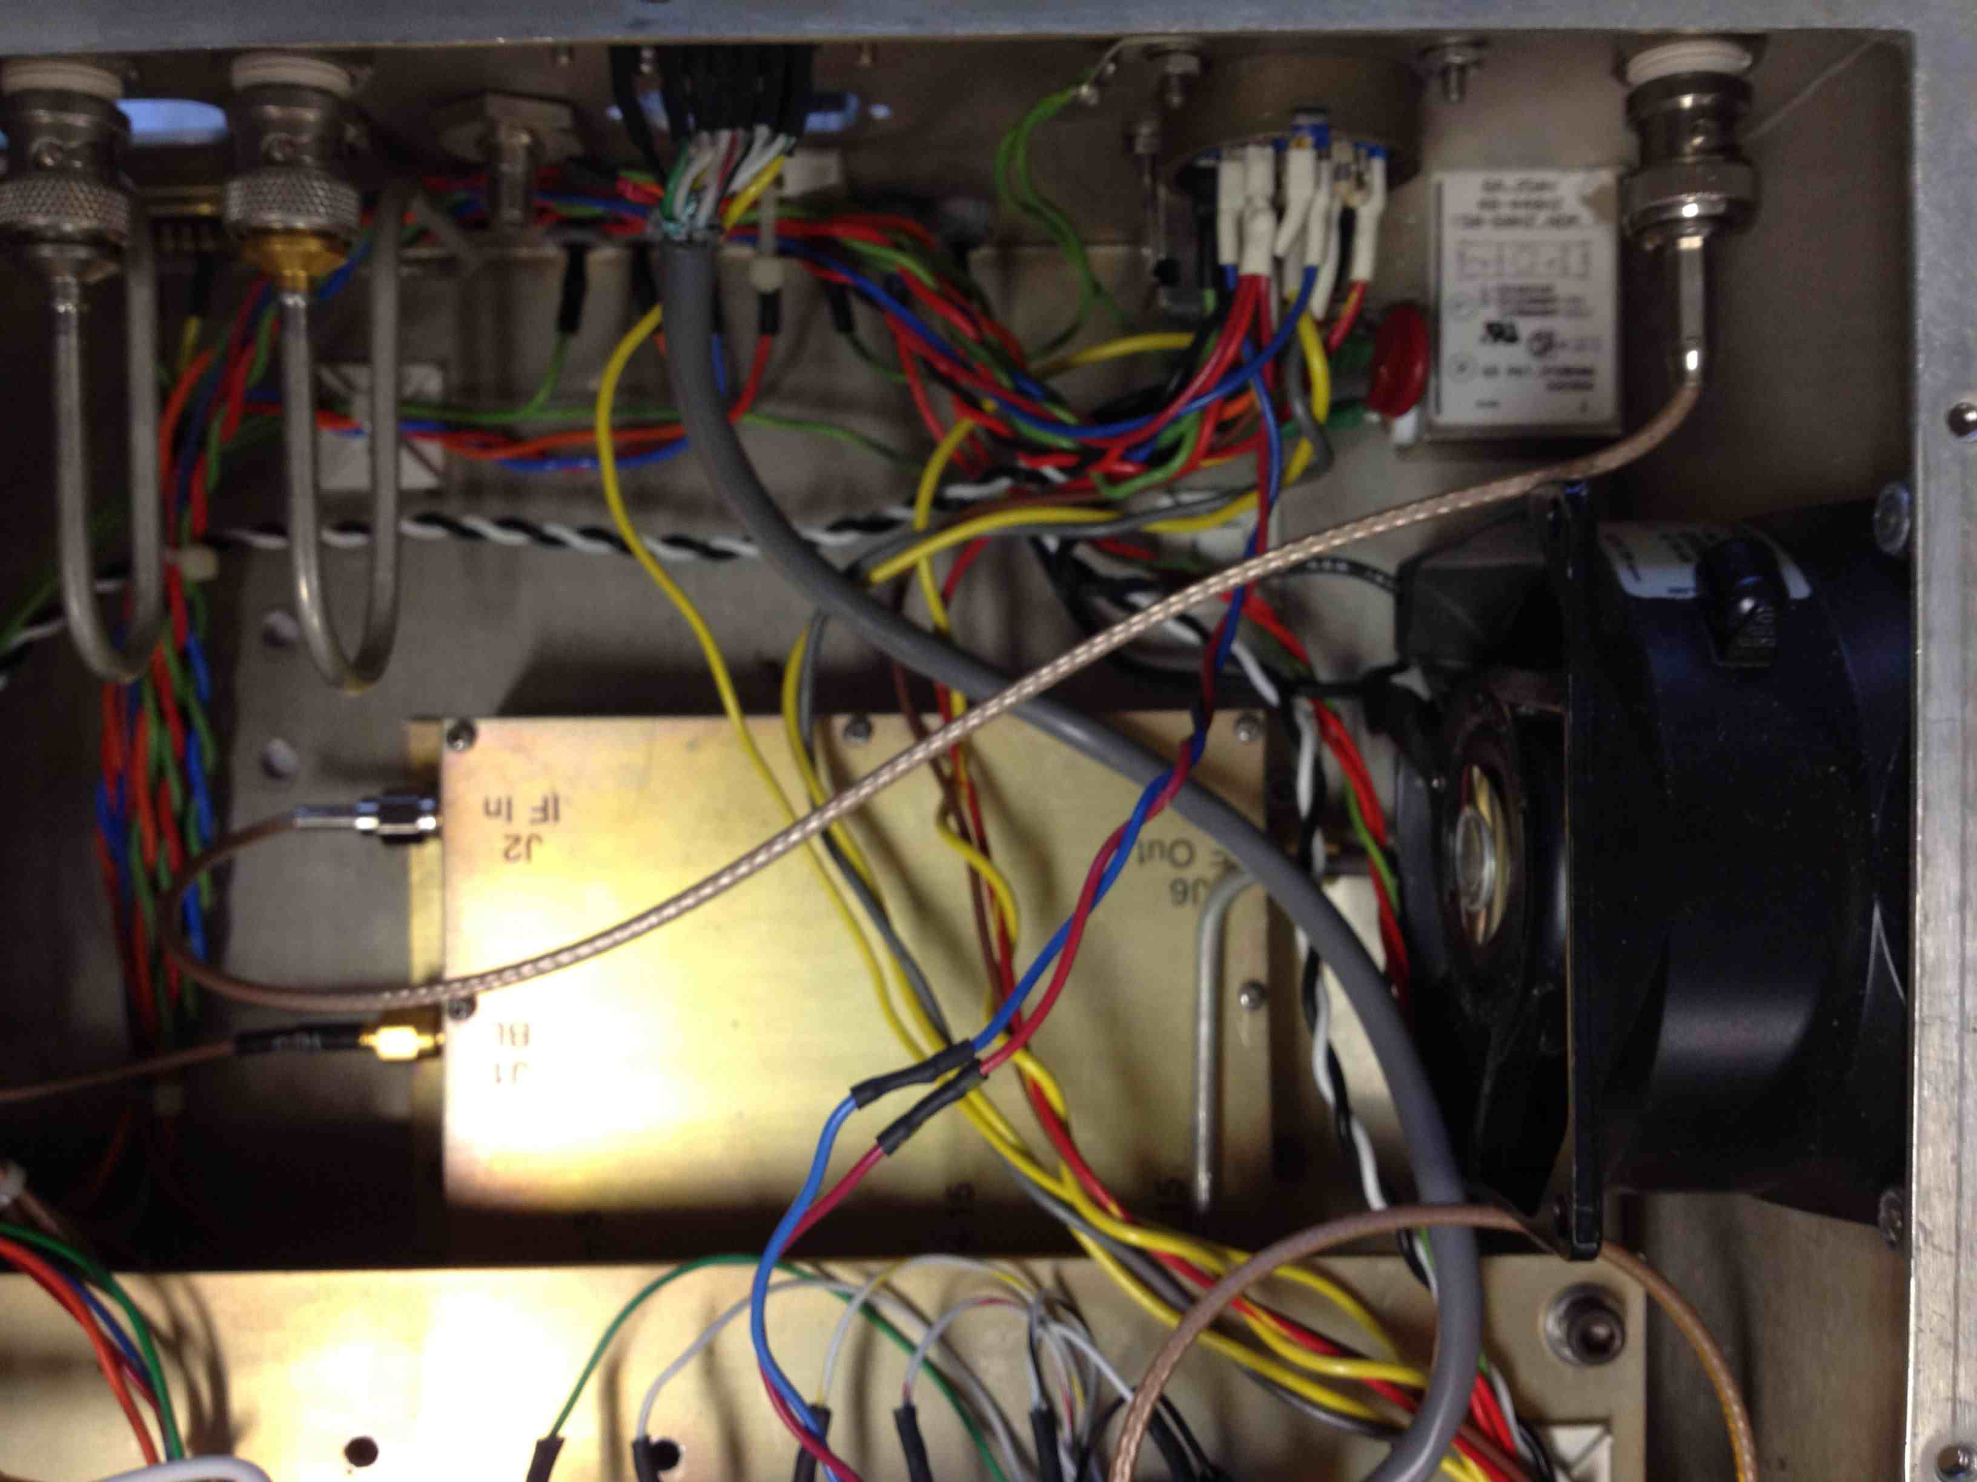
Before: With switch After: No Switch

NOAA browser MMCR data for April 4th:
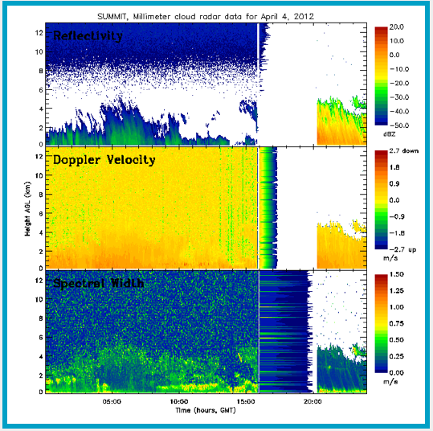
April 5th:

On April 5th at 1035 UTC, the Up Down Converter was switched to “3”. And the cal-table was changed on 0000 UTC April 5th to accommodate the new setup without the switch:

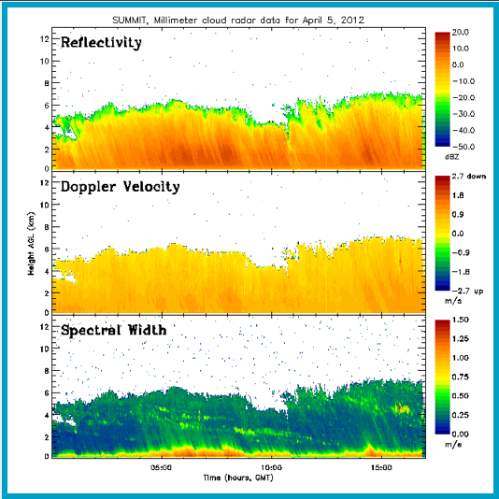

April 6th:

On April 6th, the calibration hung at 1230 UTC because of a communication issue. Duane was able to get the radar back online at about 1400 UTC. Also, it was determined by Matt on the evening of April 6th that:
while we have made some good progress on the radar, we are not yet where I want to be with it. I've been looking at some of the Doppler spectra today in more detail and there are some serious images in the data. I won't go into the details of these (in part because I don't understand everything about them!) but the images used to be about 36 dB down from the primary signal and now they are more like 20 dB down. This leads to incorrect moment calculations. I could write some code to correct the spectra and then re-compute the moments, but ideally I'd like to get these images back down where they should be.
So, Duane and the radar design engineer asked that a 10dB Attenuator be installed in the Input into the radian box as well as the UDC be changed to “2”. This was done at 2230 UTC:

10dB attenuator added and UDC to “2”
Hung Calibration
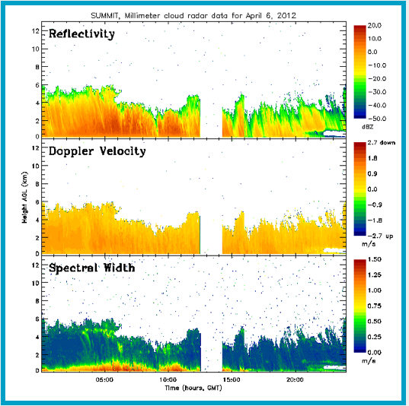

April 7th – 9th:

At this point the data has remained the same. The data looks good, but the mirror images on the radar are still only 20dBZ lower than the primary signal. This is still a problem for Matt's program that calculates the moments and is a problem because these images could mask some of the behaviors in mixed phase clouds and interesting data.

On April 8th (Easter Sunday), we had a Helix Current fault in the TWTA after the calibration check at 1230 UTC. This led to a loss of data for a few hours. We now have a procedure for correcting this fault in the Daily Checks – common problems section.
Helix Current Fault TWTA

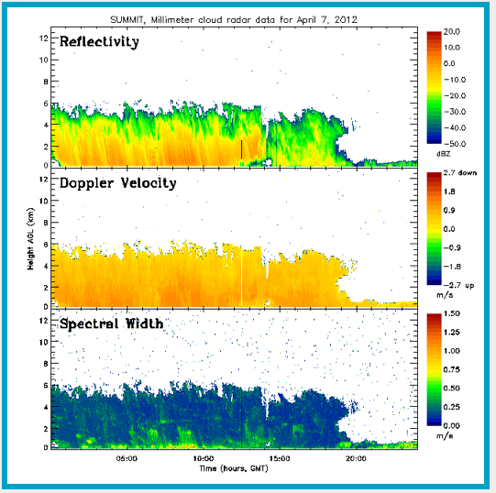
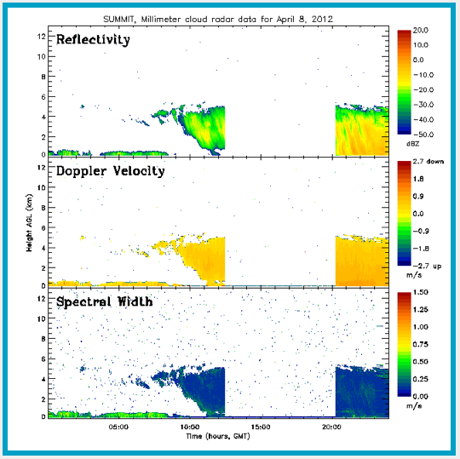
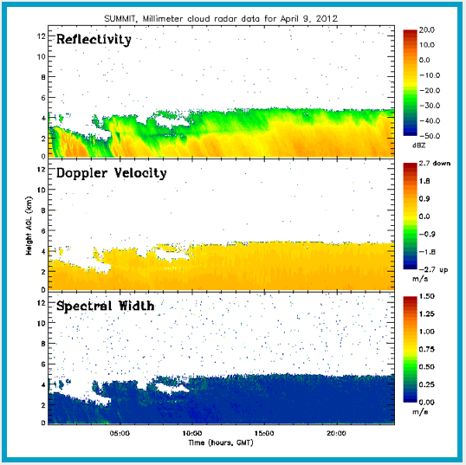

April 10th:

On April 10th, Duane asked for some debugging work. First, from 1536 to 1540 UTC, I watched the “I” and “Q” signals on the scope while I removed the 10dB attenuator from the Receiver Input line and then placed it back in the line. Second, from 1540 to 1542 UTC, I removed “I” and “Q” BNC cables from the back of the radian box and observed the change in the noise floor. The noise floor went from 27 to 36dBZ to 6 to 14dBZ (when “I” and “Q” were unplugged).

After finishing this, I noticed on the spectrographs that the mirror images seemed lower dBZ than before. Again, nothing was changed, but my suspicion was that the BNC carrying the receiver signal (in braided aluminum ground sheild outside the BNC), was either a bad cable or that the shield was not properly grounded. I emailed Matt and Duane with my observations, however, there was not a lot of cloud/moisture action on April 10th, so it was hard to tell if the images were actually lower. Matt would need to do some more analysis.

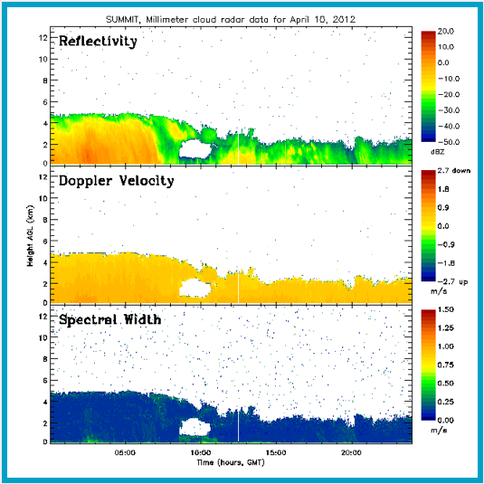
Approximate time of debugging work

April 11th:

On April 11th, Matt verified during the call (and again on the 12th), that the images were back to being about 31dBZ lower than the primary signal. And that the radar data looks really good. Duane will continue to work with the calibration to get it to a point where the daily cal checks are not failing (however, the calibration on the radar looks good, there are errors due to removing the switch in the Radian Box).

GOOD DATA!

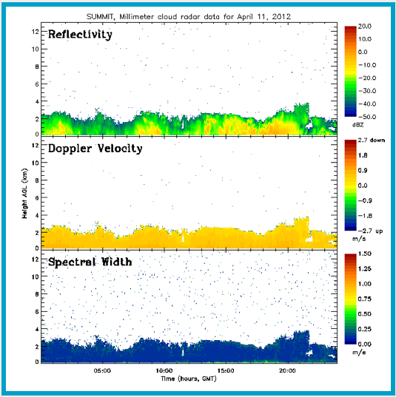

Comments:

- The only correlating factor that I found with the signal looking better is the fact that it is warmer. The day I started seeing the clean signal, the “Circulator Temperature” alarm was no longer red and was above 0C. I have talked to Matt and Duane both about this – and it is very likely that it is not the issue, but I wanted to make note of it.
- The Monthly Calibration, though failed, seemed to bring about the correct parameters for the radar. For example, the resulting data on April 2nd, the noise floor of 38dBZ, and the “I” signal of 200mV peak to peak. You can see the data looks good after the failed Monthly Calibration in the graph from April 2nd.
- For some reason, the current calibration that Duane has been running succeeds, but lowers the noise level to 20dBZ and the “I” to 10mV peak to peak. You can see this effect in the graph from April 3rd at 1030 UTC (A).
- The mirror images' drop in dBZ (fromonly 20dBZ lower to down to 31dBZ below primary signal), seems to be tied to the BNC cable for the Receiver Input. This cable is shielded with a aluminum braid and it is possible it is not properly grounded. If the mirror images get high again, I would recommend checking that cable and grounding the strap.

