NASA – ICESat Transect

Primary contacts: Bob Hawley, Dartmouth, 603-646-1425, robert.l.hawley@dartmouth.edu
Secondary contacts: Thomas Neumann, NASA, thomas.neumann@nasa.gov
Derek Pickell, Dartmouth, derek.j.pickell.gr@dartmouth.edu

How often: Monthly – Standard Traverse
Every 3 Months – Reverse Traverse
(Dates can be found in Tech Drive>Supporting documents>ICESat)
Clean requirements: Annual Raise

Supplies needed: Yellow SICK SLIVER Box
PolyPod survival sled
Snow machines (2)
Equipment for the accumulation survey (see ICESat Accumulation Protocol)
Safety gear for off-station travel – see seasonally appropriate travel policy

Location:
The ICESat transect is located across the Skiway from the main station. A flag line extends from the southern end of the Skiway to the start of the transect.

Introduction:
The purpose of the ICESat Traverse survey is to maintain an accurate ground-truth measurement for spaceborne and airborne laser and radar altimetry systems. It was established to run directly along and across the ground track of NASA’s Ice, Cloud and land Elevation Satellite (ICESat), which was operational between 2003 and 2009. The main instrument onboard ICESat was the Geoscience Laser Altimeter System (GLAS), which was designed to measure ice-sheet surface elevation and elevation change. ICESat-2, successfully launched in September 2018, has a similar mission requirement over the Earth’s ice sheets. In the intervening years between ICESat and ICESat-2 (2009-2018), NASA undertook an airborne campaign known as Operation IceBridge, which aimed to “bridge the gap” between the 2 satellites, using airborne laser altimetry in both Greenland and the Antarctic. Additionally, the European Space Agency has launched CryoSat-2, which carries as its primary payload a radar altimetry system with the parallel goal of measuring changes in the Earth's ice cover.
With these disparate past and present systems contributing to the altimetry record, it is more important than ever to maintain our ground measurements. Inter-comparison between different measurement platforms (i.e., what changes took place on the ice sheet between ICESat and ICESat-2) can only be meaningful if they are both cross-calibrated to the same “truth”, and we have established Summit's ICESat transect as that truth for operations in Greenland. Having a continuous set of measurements will allow meaningful comparisons between ICESat, the instruments on IceBridge aircraft, CryoSat-2, and ICESat-2. In addition, the time-series of elevation change provided by these measurements is invaluable to researchers, as it can provide completely independent rate-of-change estimates.
In 2016, the original ICESat traverse route was augmented with the ‘ICESat-2 extension’. The value of the original ICESat section of the traverse (the southern end of the traverse line) lies in the 10-year time-series. Ten years of data provide an unprecedented time series of surface change and help to fill in the information that can’t be obtained from quarterly satellite assessments or semi-annual airborne campaigns. The value of the ICESat-2 extension (the northern end of the traverse line) is that it consists of a series of waypoints intended to optimize the ground sampling specific to ICESat-2 track placement; the extension will hit a region where 2 of the ICESat-2 tracks cross one another, providing better statistics for ICESat-2 validation.
As of 2025, the ICESat GNSS survey uses a new GNSS logging instrument (the “SICK SLIVER Box”). This instrument will hopefully make the GNSS portion of the traverse simpler. As this is a new instrument, we are open to suggestions for modifications to make it easier to work with, especially in the cold and dark.
Given that the value of the ICESat section of the traverse is in the time series, do not make changes to this protocol without contacting all of the Primary and Secondary contacts.
A Note on Safety:
The ICESat traverse can be an incredible experience but can also be one of the most dangerous regarding exposure to the elements. Safety is the most important factor when planning a traverse as the time spent outside could range from 3-6 hours depending on the season, lighting, and current conditions. The temperature cutoff for equipment usage is -50F, but it’s important to factor in the human element as well. Wind speed, visibility, and ambient temperature should all be considered when evaluating the timing for the traverse. Windchill, while important and does, in part, set what weather condition the station is in, is only one temperature figure to consider. A 5-degree drop in windchill temperature is not the same as a 5-degree drop in ambient temperature and is experienced very differently. Ambient temperatures have a way of sneaking up on you as your gear gets more and more cold soaked while out there. For example, you will usually notice quickly a cold wind hitting an exposed piece of skin, but your foot completely covered by your boot may slowly get colder and you don’t notice it until it’s very cold. Do not underestimate how quickly your body (as a whole or an extremity) can go from ‘a little chilly’ to dangerously cold in this extreme environment. If conditions change on the day of the planned traverse and have become dangerous, do not hesitate to cancel and re-evaluate for another day. It is also okay to cancel in the middle of a traverse if the conditions change or a person gets too cold. While we always shoot to be within a ±3-day period of the scheduled date, safety can push the date further or even cause for a cancellation all together. Just be sure to be in contact with the PIs and the science PM beforehand (or immediately after if you aborted an ongoing traverse). You will receive no pushback; it is more just for notification of this change. The power in this dataset comes from its longevity and if a traverse differs by a few extra days or is canceled completely it will not invalidate the rest of the data. Be safe, stay warm, and have fun!
Procedures: When to Conduct the Survey
NOTE: It is necessary that participants review and follow ‘CP423 Summit ICESat Traverse, Operational’ (found in the OneDrive), which covers safety and communication preparations in advance of the traverse, and pre-planned responses in the event of issues. Given the time spent away from the station and the demanding ice sheet environment, these preparations are a crucial part of all ICESat Traverses.

Every three months, the ICESat-2 satellite performs a sequence of two overpasses of the Summit traverse route, with the two overpasses separated by ~8.6 days. The technicians should perform an overpass-coordinated traverse, followed by a second special traverse (Reverse Traverse) ~8.6 days later, in which only GPS measurements are made (no ICESat Accumulation). In the GPS-only traverse, no manual accumulation measurements are made at the bamboo stakes; however, the track depth measurements must still be made. (Proceed below to the “ICESat Reverse Traverse” section for the transect protocol).

These two overpass-coordinated traverses should be timed to coincide as closely with the overpasses as safe conditions allow. The best data quality is achieved when the traverse date is closest to the overpass date (before or after), so if a good weather window appears in the days leading up to the overpass date, take advantage! Target traverses for +/- three days from scheduled overpass date, but that may not always be possible. Crew safety absolutely prevails. The desire for close timing increases the importance of prior coordination between the technicians, manager and mechanic, as well as off-site staff when needed. Technicians should initiate a discussion between these parties about one week before each overpass date.

If the survey cannot be performed on the day of the overpass, technicians should record conditions on the intervening days and communicate these conditions when the post-survey notice is sent to the PIs. The PIs are particularly interested in snowfall, drifting, wind scouring, and rime build-up. This information is valuable as it suggests how the snow surface may have changed between the time the satellite measures the surface height and the time that the technicians with the PolyPod measure the surface height.

In between these tri-monthly overpasses, we still perform monthly traverses for temporal consistency. To see which months correspond to the ICEsat-2 overpasses (normal and reverse traverse) and which dates correspond to the monthly non-overpass traverses, a calendar can be found at following link:

https://docs.google.com/spreadsheets/d/1D09MtjVyRGainFbOn1u6WPxd6_R2yPSuukBeDrMyebc

Setting Up the PolyPod: Ensure that all safety and support equipment is present, as described in ‘CP423 Summit ICESat Traverse, Operational’. This includes, but is not limited to, adequate ECW gear and spares, a survival bag, food, a thermos of hot water, and appropriate communications equipment. A typical survey requires about 4 hours but bring sufficient supplies for flexibility and safety in case of issues.

Setting Up the SLIVER Box: The instruments are contained in a yellow Nanuk case located in the MSF. On the exterior of the box you will see the GNSS antenna, the LED status indicators for the OGRE and the SICK laser, and the dust shield for the SICK laser.

On opening the box, you will see 3 main components: the OGRE on the right, the SICK laser in the middle with two 7 Ah SLA batteries on either side, and the SICK data logger on the left. There may also be a charger loose within the box and a slot in the packing foam containing a MicroSD adapter.

To power on or off, simply plug or unplug the power cables, one for the SICK laser and data logger and one for the OGRE (cables are labelled accordingly). For charging, connect the batteries to the charger. This has been constructed so that it is impossible to connect the batteries to anything but the charger or to the OGRE and SICK data logger. For storage, disconnect the battery cables from both the instruments and the charger.

Prior to the survey (the day before), ensure that the microSD cards are properly inserted into the OGRE and the SICK data logger, and that the batteries are charged.

- The night before the survey, open the box and plug in the chargers. Upon first plugging in, the charger will display an amber light, indicating a less-than-full charge on the two batteries. When the batteries are fully charged, the light will turn green.
- Ensure the microSD cards (2 total) are inserted into each datalogger.
  - Do not delete/move the CONFIG.txt file from the main directory on the OGRE microSD card (labeled with the label maker).
- The following morning, ready the box for logging:
  - When the batteries are fully charged, disconnect the charger from both the wall and batteries.
  - Connect the batteries to the OGRE, SICK laser, and SICK data logger.
    - It does not matter which battery goes to which connector.
  - On the side of the box, observe the red OGRE LED begin to flash, 1 second on, 1 second off, and observe the yellow SICK laser LED hold steadily on.
  - Close the lid of the box, being careful to avoid pinching any wires.

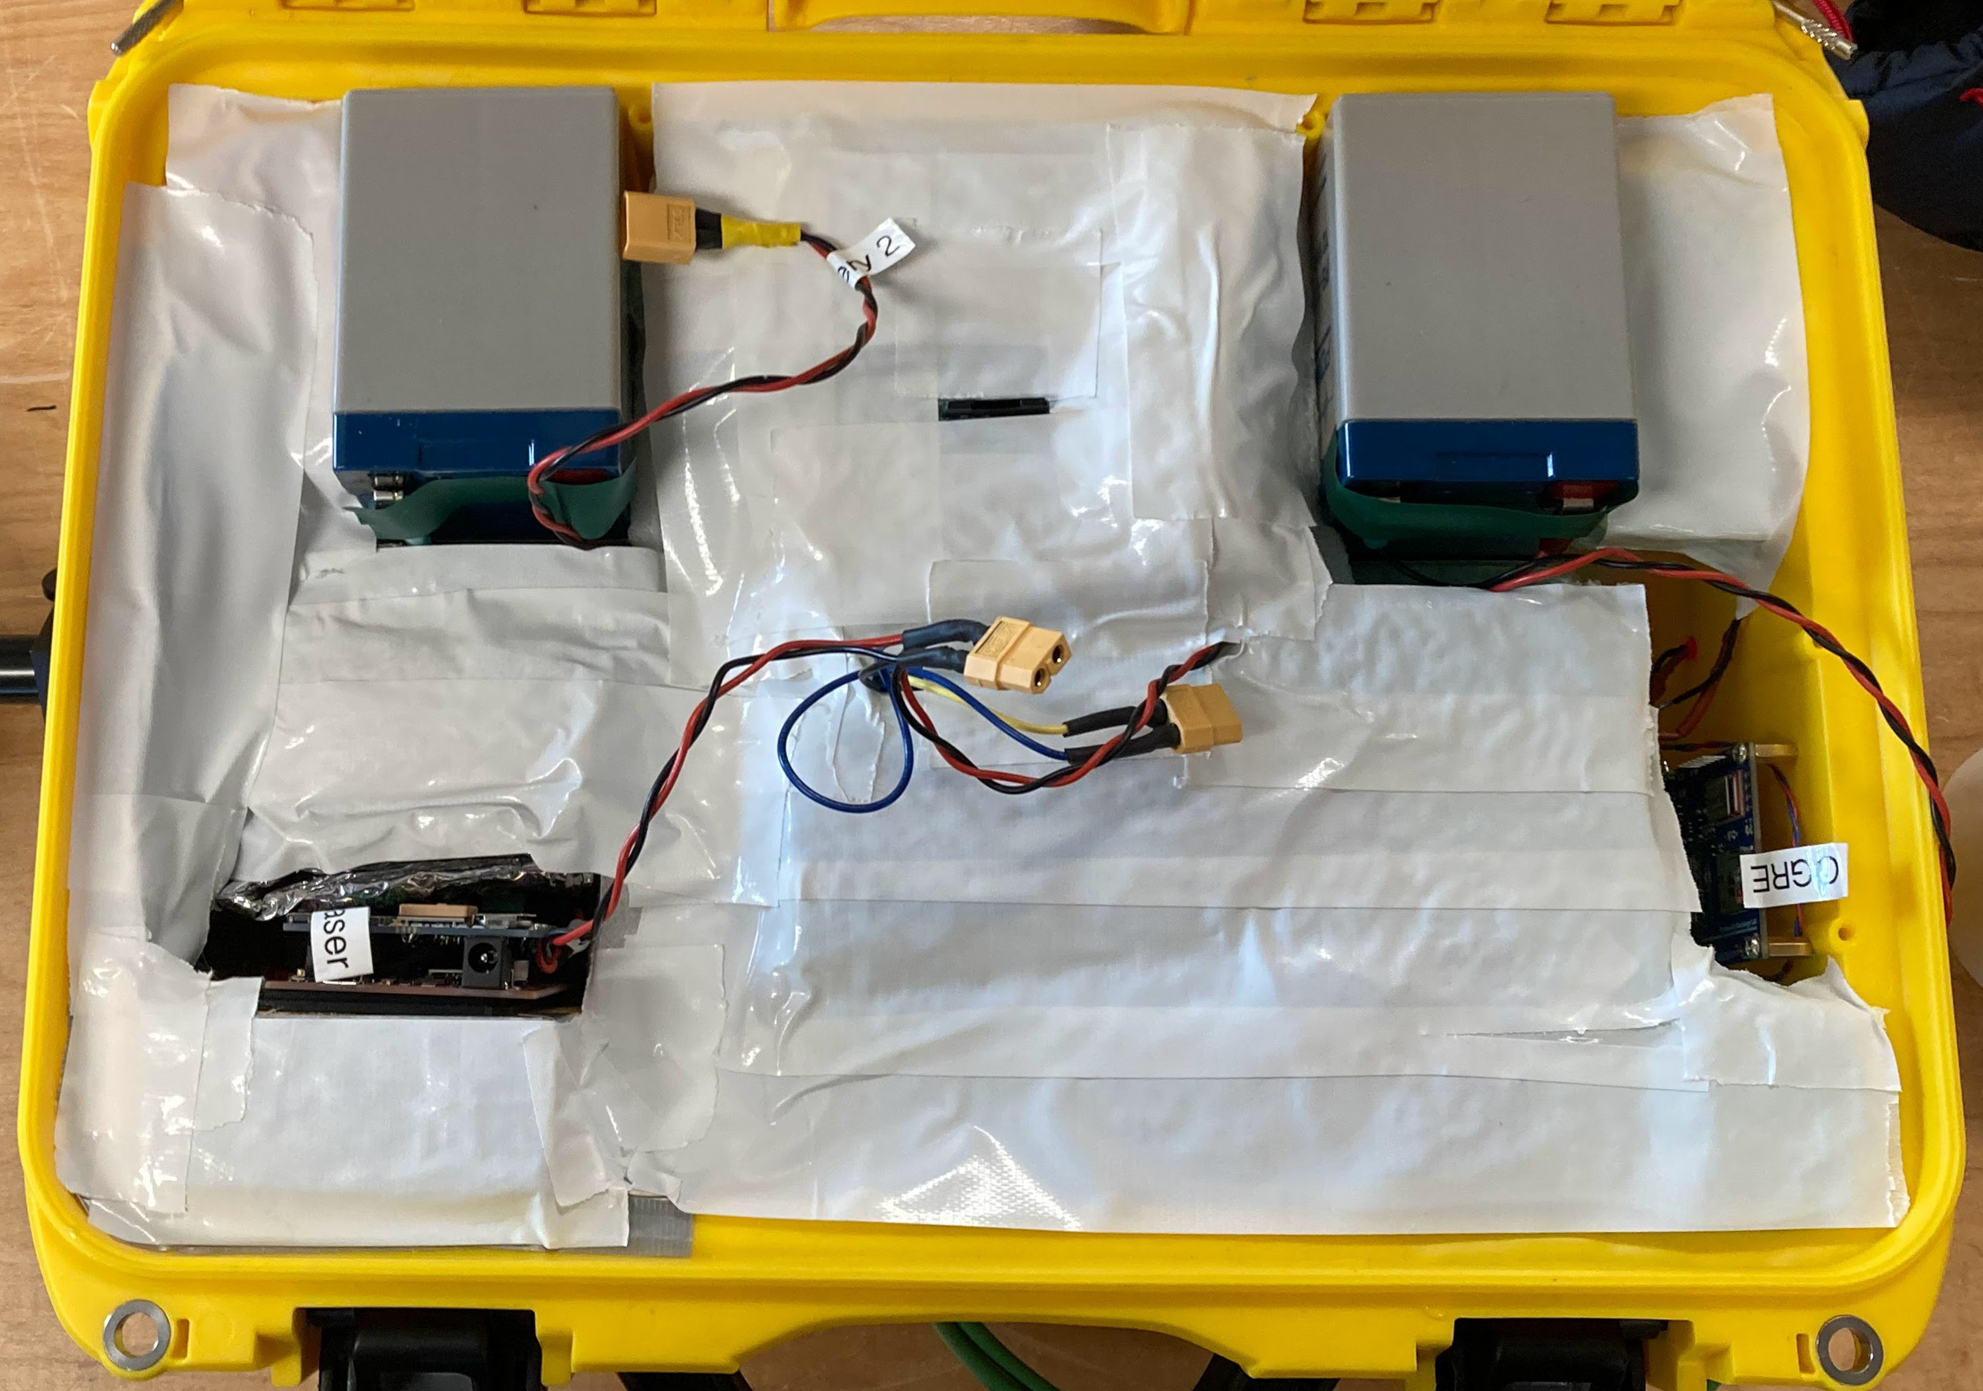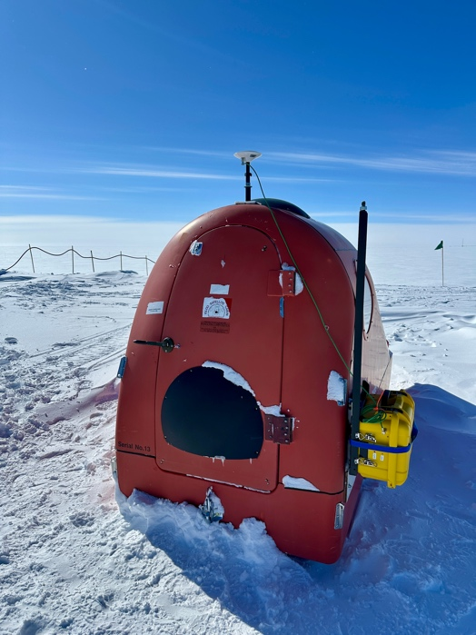
Figure 1: (a) Interior of the SLIVER box and (b) SLIVER box attached to the PolyPod.

Inside the Nanuk case, filled with close-cell foam. The SICK laser (not visible, but between the two 7 Ah SLA batteries) looks out through a hole in the back side of the box (top). The laser communicates with the SICK laser logger (bottom left). On the right is the OGRE. The batteries and instruments connect via the yellow XT60 connectors. In the top middle is a slot that contains a MicroSD adapter.
SLIVER box clasped to the framework and antenna attached to the framework’s mast. The box is further secured with an NRS strap. The external LEDs are on the left side of the box. Note that the handle is facing up.

- Bring the box out to the PolyPod and slide it into the framework, with the handle facing up. The draw latches holding the box to the frame can be adjusted for a snug fit. Use an NRS strap to further secure the SLIVER box to the framework.
- Press the button on the antenna mount to detach the antenna from the SLIVER box. Extend the antenna to the top of the PolyPod antenna bracket and press the button again to attach the antenna to the mast.
  - Do not use the side bracket-attached mast for the antenna. This may be used in the future for a different experiment.
- Go back about your business preparing for the survey, while the GNSS units start acquiring satellites.
- When you return to the PolyPod, verify that data is logging by observing the LEDs.
  - The yellow SICK laser will blink once every 5 seconds.
  - The OGRE will have an irregular, fast flicker – this is intentional as the light illuminates when data is being written to memory.
  - If you encounter a specific, regular flashing pattern for either LED, see the LED Flash Pattern Codes below.
- On the traverse, check occasionally to verify that the SLIVER box is still logging (i.e., LED flashes are as described above). If one or the other is not, take note, continue with the accumulation portion, and notify the PI after return. The only thing you can reasonably check in the field is that the antenna and antenna cable are properly secured.
- After completing the traverse and returning to the MSF, detach the antenna from the framework mount and reattach it to the side of the SLIVER box. Remove the strap and unclasp the SLIVER box from the framework and bring the box inside.
- Open the box and disconnect the batteries from the instruments, making sure not to get snow on the electronics.
- Proceed to ‘Download data from SICK and Ogre loggers’ under the ‘after ICESat traverse’ section below.

LED Flash Pattern Codes:
OGRE:
- 1 blink pattern: system initializing; finished with 10 blinks (below).
- 10 rapid blinks: RTC synced and system configuration complete (after initial power on or reset only).
- 5 rapid blinks: CONFIG file failed to read.
- 2 blink repeating pattern: MicroSD failed; waiting for reset. Try ejecting and reinserting the MicroSD card.
- 5 blink repeating pattern: RTC sync failed; waiting for RESET (bring box outside).
- Random rapid blinks (roughly 1 Hz): system logging data
- No blinks: system deep sleep due to low battery or battery dead.
- 3 blink repeating pattern: Antenna cable not attached properly or broken.
- 1 blink every 12 seconds: sleeping. This shouldn’t happen.

You should normally only notice codes 1, 2, and 5 (and only if you wait around to look for the 10 blinks, which isn’t necessary). Pattern 3 is not really a concern as the default CONFIG is hard-coded. If you see pattern 4, try ejecting the MicroSD and re-inserting. Pattern 5 is only a problem if it persists after you bring the box outside and wait 5 minutes. With patterns 7-9, there is not much you can do, except for rebooting the system and making sure the battery is fully charged.

SICK Laser:
- Steadily on: system initializing and waiting for GPS fix (bring box outside). Fishing with 10 blinks (below).
- 10 rapid blinks: RTC synced and system configuration completer (after initial power on or reset only).
- 2 blink repeating pattern: MicroSD failed; waiting for reset. Try ejecting and re-inserting the MicroSD card.
- 1 blink every 5 seconds: system logging data.
- No LED: power supply issue; check if batteries are charged.

You should normally only notice codes 1, 2, and 4 (and, again, only if you wait around to look for the 10 blinks, which isn’t necessary). If you see pattern 3, try ejecting the MicroSD card and re-inserting it. With pattern 5, there is not much you can do except for power-cycling the system and making sure the batteries are fully charged.

Performing the ICESat Traverse
- Radio yourselves out of station.
- Drive to the start of the ICESat flag line using the approach flag line.
  - At the start of the ICESat flag line, the halfway point (roughly flag 66), and the junction for the ICESat extension route, and more frequently if any issues are suspected, stop to inspect the status lights on the SICK SLIVER receivers and confirm that the lights indicate 1) good power connection, 2) good satellite signals, and 3) writing to file as normal. This is to avoid extended data outages if cable-related or other issues develop during the traverse travel.
    - These are also great times to give a safety radio check-in to station to notify that you are okay and what your current location is.
- At the start of the ICESat flag line, measure the depth to which the PolyPod's deepest runner sinks into the snow (which will vary with snow conditions) using the following procedure (see photo below):
  - Take the ICESat field book or clipboard and lay it on the snow at the edge of the PolyPod's track, approximating the actual surface
  - Measure and record the distance between the bottom edge of the book/clipboard and the deepest part of the PolyPod's track.
  - This distance will be used by the PIs to subtract from the fixed distance between the bottom of the antenna mount and the bottom runner of the PolyPod (indicated inside the PolyPod).
- Radio to station that you are starting the traverse.
- Record the start time in UTC.

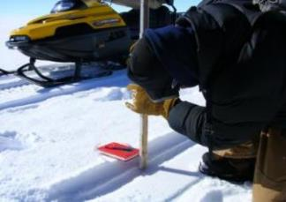
Example of how to measure PolyPod track depth.

- Drive the accumulation line, stopping to measure the stakes (see ICESat Accumulation Protocol). The PolyPod should be towed on the right side of the bamboo stakes.
  - The survey sled must be towed slowly. Maximum speed during the survey is 12 mph or 20 km/h. Confirm whether the snowmobile in use has km/h or mph speedometer units. This speed will result in position coordinates with 5-meter spacing, which is the science team requirement.
  - Ensure the polypod pauses at each accumulation point/flag for a few seconds (the time to make the accumulation measurement is long enough).
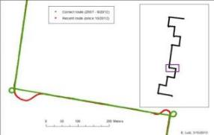
  - There is no need to align the GNSS antenna (at the back of the PolyPod) with the bamboo flags when stopping. Measuring accumulation with the snow machines stopped adjacent the flag (allowing one person to measure and the other to record) is the preferred procedure.
- A visual of the outside, donut shaped turns for each corner (in green)

- Drive the entire distance of each line of bamboo and then make an outside, donut shaped turn to line up on the next line (as shown below in green; do not make sweeping turns as shown in red).
  - This is to keep each turn as close to a 90-degree angle as possible.
- Each section will alternate colors (red or black), and a turn will be indicated by the changing of color, the log sheet will also indicate each turn, and which way, with either an L or R next to the flag number associated with that turn.

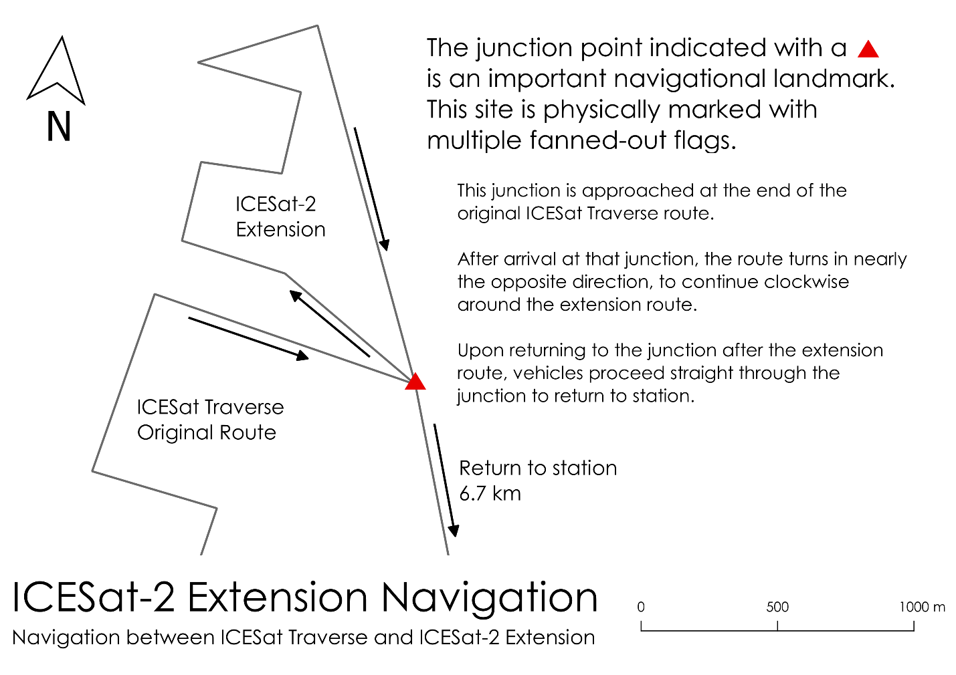

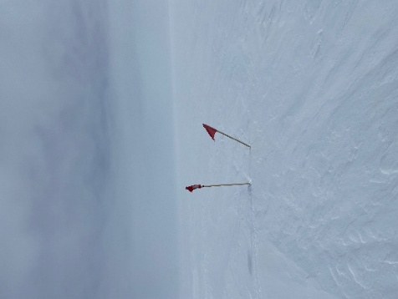
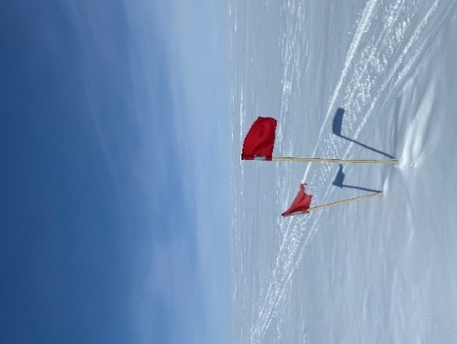
Left turn Right turn
Examples of turns along the ICESat extension loop.

The ICESat-2 Extension
- The survey track was extended in 2016 for ICESat-2; this additional ‘ICESat-2 Extension’ segment is shown above. At the junction, marked by several splayed flags (not the first smaller set you will come upon) marking the end of the original accumulation survey. Perform another outside turn but turn around 180 degrees and head back towards the smaller set of splayed flags you passed. Go to the right of these slayed flags and follow the ICESat-2 Extension flag line in a clockwise direction, with the receivers still collecting data. Drive with the PolyPod still to the right of the red flags and keeping under 12mph or 20km/h. Several things are done differently for the extension:
  - There is no need to turn the PolyPod in a loop at these corner flags, as these waypoints are outside of the intersection of the ICESat-2 tracks
  - There is no need to pause at any of the flags.
  - Accumulation is not measured at the ICESat-2 Extension flags: there is no need to stop and measure bamboo height along the extension.
  - Each turn is indicated by a double flag rather than color changes (pictured below), where the second, shorter, flag is angled in the direction of the turn, alternatively, the direction of the turns are noted in order on the log sheet.
- At the end of the ICESat-2 extension (back at the splayed flags junction), measure and record the depth to which the PolyPod's deepest runner sinks into the snow like at the beginning.
- Record the finish time in UTC.
- Ensure the LED lights for all systems are still on and appropriately flashing or solid.
- Radio to station to inform you have finished and are heading back to station.
- Return to the MSF.
- Radio in to inform that you are back at the station.
- At the MSF, bring the box inside. The data record should start and stop at the MSF. It is not necessary to bring the logging box inside immediately. When ready, open the box and disconnect the battery from the GNSS. If convenient, you can plug the battery in to charge while you download the data (It will likely finish charging by the time you are done downloading and ready to put the box away for the next traverse)
- Take a break, relax, get a cup of hot chocolate. Come back and resume the process when you are ready, it’s okay if it’s the next day.

ICESat “Reverse Traverse”:
- As mentioned above, every three months the ICESat-2 satellite makes two passes directly over the ICESat traverse transect line. With these two passes, two different traverses are performed for data collection. The first is a normal traverse with accumulation data collected. The second is a ‘reverse traverse’ with no accumulation data, only GPS data is collected. This traverse also has a slightly different protocol from the regular traverse. Other than the lack of accumulation data, the other large difference is rerunning the transect in reverse after you have completed it normally. Below is a protocol for the differences in this traverse:
- Prepare everything as you would for the normal traverse (PolyPod, SICK SLIVER, safety equipment, etc.)
- Radio yourselves out from station.
- Drive out to the beginning of the ICESat flag line and measure the PolyPod track depth and record it on the log sheet.
- Check the status of the lights on the SICK SLIVER box.
- Radio into station that you are starting the traverse.
- Record the start time in UTC.
- Drive along the flag line with the PolyPod on the right and stay below 10mph or 12km/h.
  - The support sled should stay back further from the flags and not be immediately next to the flags, on either side.
- Since accumulation data will not be taken, there is no need to stop/pause at any of the flags. Just like with the extension loop, you can just keep slowly driving.
- Continue to make outside turns to keep corners at 90 degrees.
  - The support sled can help scout turns by driving ahead and pointing in the direction of the turn to help the PolyPod driver.
- Drive through the transect, including the extension loop, until you reach the ending junction (when you would normally begin your drive back to station).
- During this traverse, this is your halfway point.
  - This is a great time to perform a radio check-in to station.
- Check the status lights.
- At this point you will turn around and drive the transect in reverse, this time keeping the PolyPod on the left of the flag line. (see photo below)
  - Take care to not drive over the outbound tracks, instead drive a little further out from the flags.
- This reverse section has an extra crossover maneuver that needs to be performed
  - Once during each section, the polypod needs to weave around the right of one of the flags. (shown in below photo)
  - The photo shows it as the second flag after a turn, but if it is performed once anywhere along the section, that will suffice.
- During this, the support sled should take care not to be too close to the flags so the PolyPod does not drive over its tracks during its crossover maneuver.
- Continue driving this way until you have reached your original starting point and drive past it a little way.
- Record the ending PolyPod track depth.
- Check the status lights.
- Record the end time in UTC.
- Radio into the station that you have finished the traverse and are heading back to station.
- Return to the MSF, radio yourselves back on station, and complete the same steps you would for the normal traverse.

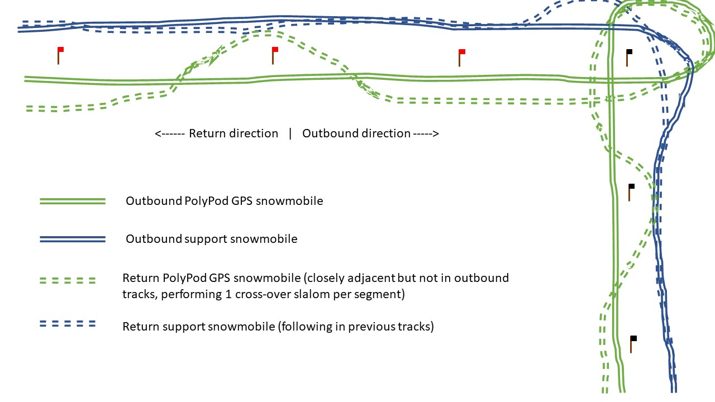
Reverse Traverse: How to drive it, with an example of the “crossover” maneuver.

After the ICESat Traverse:
Download the data from SICK and Ogre Logger:
- To remove the MicroSD from the OGRE and SICK data loggers, gently press inwards on the MicroSDs. You will hear a click, and they will spring out enough for you to grasp them and pull them out.
- For each MicroSD, place them into the SD adapter (included in a slot in the foam) and plug into your PC. Note that the MicroSDs are tagged with their corresponding instrument.
- For each MicroSD, locate the day’s file. The file naming conventions are as follows for the OGRE and SICK laser, respectively: 0006 YYYYMMDD HHMM.ubx and DDMMYYXX.SCK, which iterates on the last two characters if multiple files are generated on the same day. Note that if the system was power cycled, there may be more than one file with today’s date for both instruments. Feel free to transfer all files with the current date, or if you are confident that the whole survey is on a single file, it will be the largest.
- Transfer the file(s) to the FTP.
- There should be ample space on both MicroSDs for at least a year’s worth of traverses, but if they are full or feel cluttered, email Bob for permission to erase previous surveys from the cards.
- After downloading, return the MicroSDs to the logging box, gently pressing them into their respective instruments until there is a click, and they stay in place.
- Store the box with the lid closed and power cables unplugged until the next traverse.

Add Traverse Metadata Details:
Previously, a unique polypod_depth file was created for each survey. Now, we use a single file to track the start and end times of the survey, the track depths, and any notes such as weather between the traverse and the satellite overpass time. This format is more machine-readable.
- Open TraverseMetadata.xlsx from the FTP.
- Add a new line to reflect to reflect the (1) .ubx file name (2) survey date (3) start and end times UTC, and the PolyPod track depth measurements made at the start and end of the survey.
  - Note the next column: “Distance between Antenna Base Plane and Bottom of the Runners”. This distance should remain consistent as long as there are no changes to the antenna or polypod mounting configuration. With the current configuration, this distance is 1.897 m. This was measured from the track runner to the antenna reference point (flat, bottom surface of antenna), and includes the quick release mount setup. Previously with the old Trimble GPS + GPS antenna, it was 1.797 m. If for some reason the antenna setup changes, make your best attempt to measure the antenna height and notify the PIs.
  - If this was an overpass-coordinated survey, note relevant weather conditions (e.g., snowfall, drifting, scouring, rime) between the date of the overpass and the date the survey was performed. Do this in the Notes Column
- All the files should now be saved to the FTP directory: \ftp\science\ICESat\ICESat_Data\YYYY. The new folder should be named: ICESATYYMMDD where YYMMDD is the year, month, day. The TraverseMetadata.xlsx should be kept in the main ICESat\ICESat_Data\ directory.
- Please notify Tom (thomas.neumann@nasa.gov), Bob (robert.l.hawley@dartmouth.edu), and Derek (derek.j.pickell.gr@dartmouth.edu) when all files have been uploaded. And you're done! Thanks for collecting these data for us!

Raising ICESat:
- Should be completed over the course of one day in July or August, when it is warm and poles are still easy to remove from the snow, but before they become too low ergonomically.
- Complete the ICESat transect once as usual, then go through and raise all bamboo poles. Contact the PI regarding which way to move the poles (e.g. 15cm forward). Then repeat ICESat.

Caution: Remember that safety is the over-riding issue for measuring the ICESat Array. Venture out when conditions are favorable and minimize risks due to weather and other factors. Ride snowmobiles conservatively. Postpone measurements if conditions are questionable.
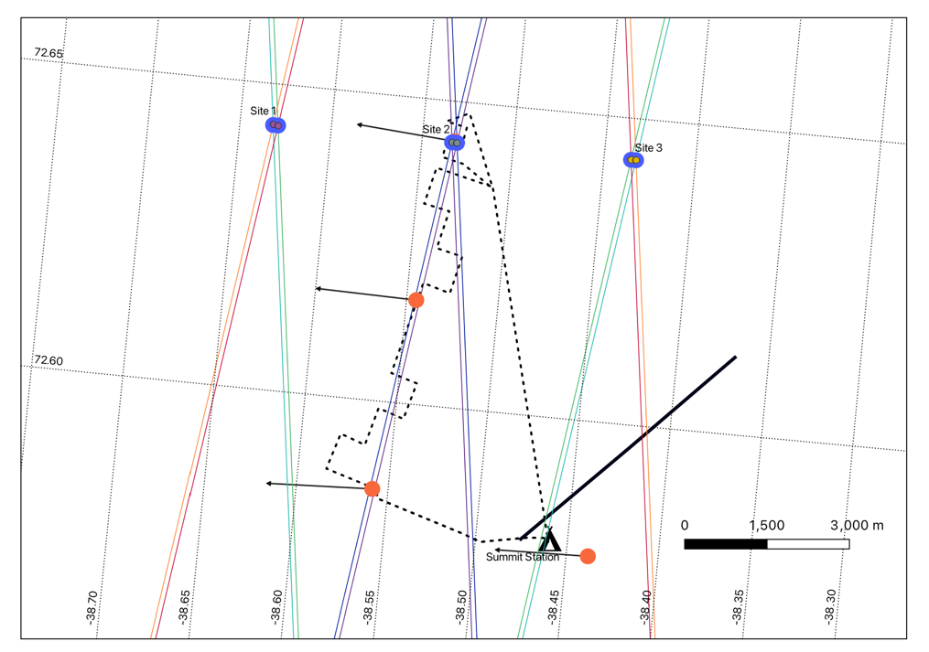
Map showing how the ICESat-2 6-beam configuration intersects with the ICESat traverse. The right-leaning 6 beam pairs (red-purple-green from left to right) is the Reverse Traverse overpass, the left-leaning (green-purple-red from left to right) is the normal GPS Traverse overpass track.

Day-Of Quick Guide:

Before you leave for ICESat:
- Connect SICK SLIVER to batteries, insert MicroSD cards, and connect box/antenna to Polypod
- Verify LEDS are as follows:
  - Ogre LED: random rapid blinks
  - Laser LED: blinking 1x/5 seconds

When you arrive at the ICESat traverse:

- Verify LEDs are as above.
- Measure depth of Polypod track at start of the ICESat traverse, record depth and start time (in UTC) on accumulation log sheet.
- Drive the transect at <12mph or 20km/hr on right side of flags.
- Stop ~10 seconds at each pole and take accumulation measurement.

When you finish the ICESat-2 extension:

- Measure depth of Polypod track at the end of the ICESat-2 extension, record depth and end time (in UTC) on accumulation log sheet.
- Verify LEDs are same as at the beginning of traverse.

When you return to the MSF:
- Bring the SICK SLIVER inside
- Unplug SICK SLIVER from batteries
- Warm up, take a break, etc. When ready, upload files to FTP.

