1. Download the data from the R7 receiver and convert file type:
   1. Remove the Compact Flash (CF) card from the R7 via the hinged yellow door on the bottom.
   2. Connect it to a Science Tech laptop computer running Windows 10 with a USB card reader and locate the CF card drive.
   3. Drag and drop the .T01 file(s) for your recent survey from the flash card into the desktop folder called “runpkr00”.
   4. The files are all named with the following file naming scheme: 9876xxxy.T01 where xxx is the Julian Day and y is a sequence number of files within the day. Select the “Details” button in the upper right corner to view the creation date of the files, to help you figure out which one is the one you want. Be sure to select the current day's files.
   5. Note that the receiver logs data whenever it is powered on. If the R7 has lost and then regained power over the course of your survey (this has historically been an issue) then multiple files will have been created. Look at the file size for guidance: Larger files indicate longer data recording times. Select all files from the time you left the MSF to the time you returned to the MSF. You can select multiple files by hitting shift-click.
   6. Eject and remove the CF card from the reader and return to the R7.
   7. Open a PowerShell command prompt window.

**C:\Users\ARO-Summit-Technicia> dir**

**C:\Users\ARO-Summit-Technicia>cd Onedrive – “Polar Field Services”**

**C:\Users\ARO-Summit-Technicia\OneDrive – Polar Field Services> dir**

**C:\Users\ARO-Summit-Technicia\OneDrive – Polar Field Services> cd Desktop**

**C:\Users\ARO-Summit-Technicia\OneDrive – Polar Field Services\Desktop> cd runpkr00.exe**

**C:\Users\ARO-Summit-Technicia\OneDrive – Polar Field Services\Desktop\runpkr00.exe>**

**C:\Users\ARO-Summit-Technicia\OneDrive – Polar Field Services\Desktop\runpkr00.exe>runpkr**

**C:\Users\ARO-Summit-Technicia\OneDrive – Polar Field Services\Desktop\runpkr00.exe>runpkr00 -d 98762230.t01**

Replace 98762230.t01 with the name of your .t01 file

In order for this code to work, your .t01 file needs to be dragged into the runpkr folder

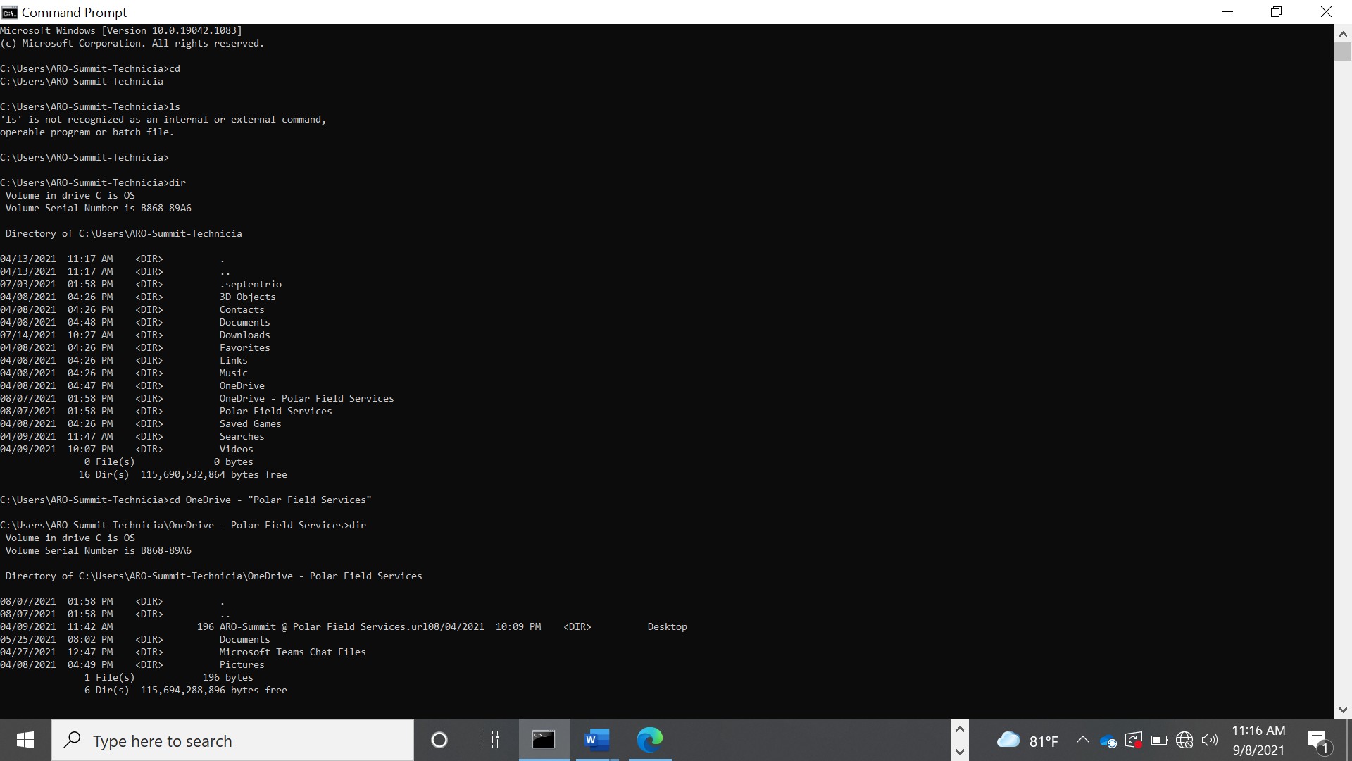

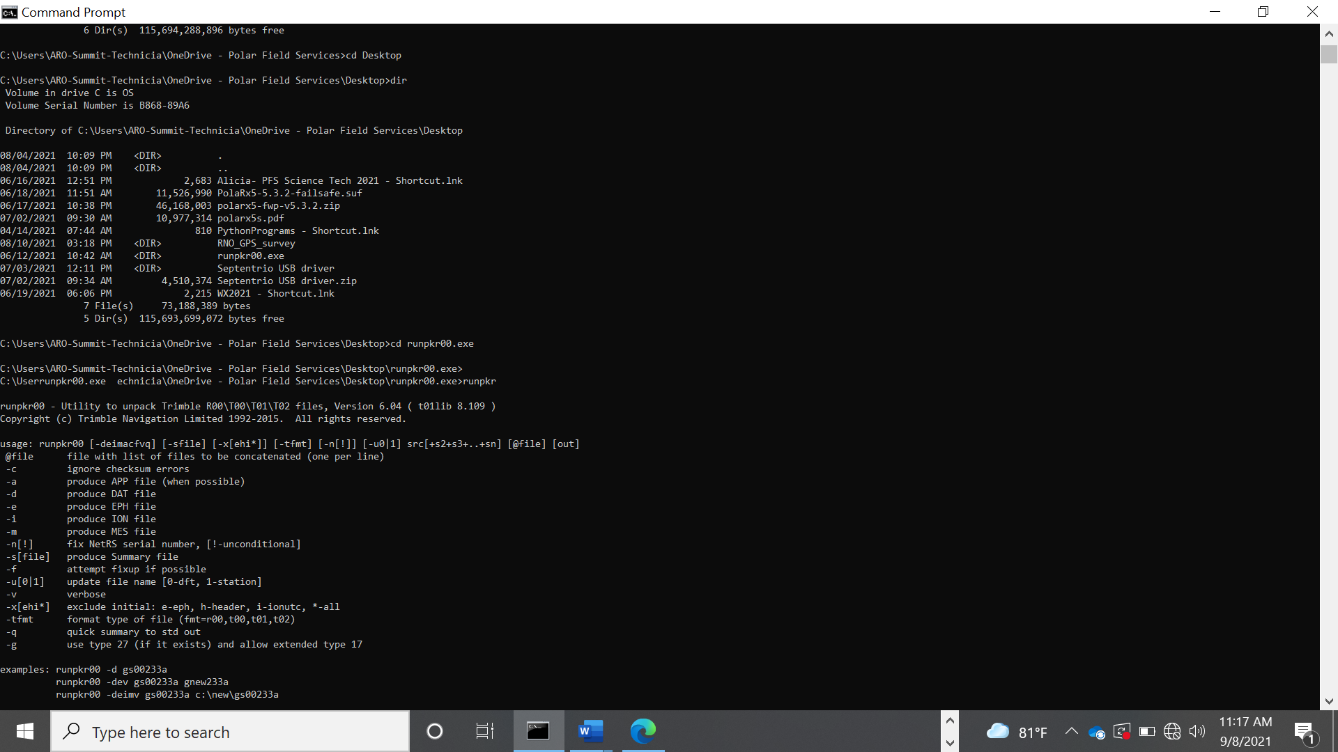

* 1. 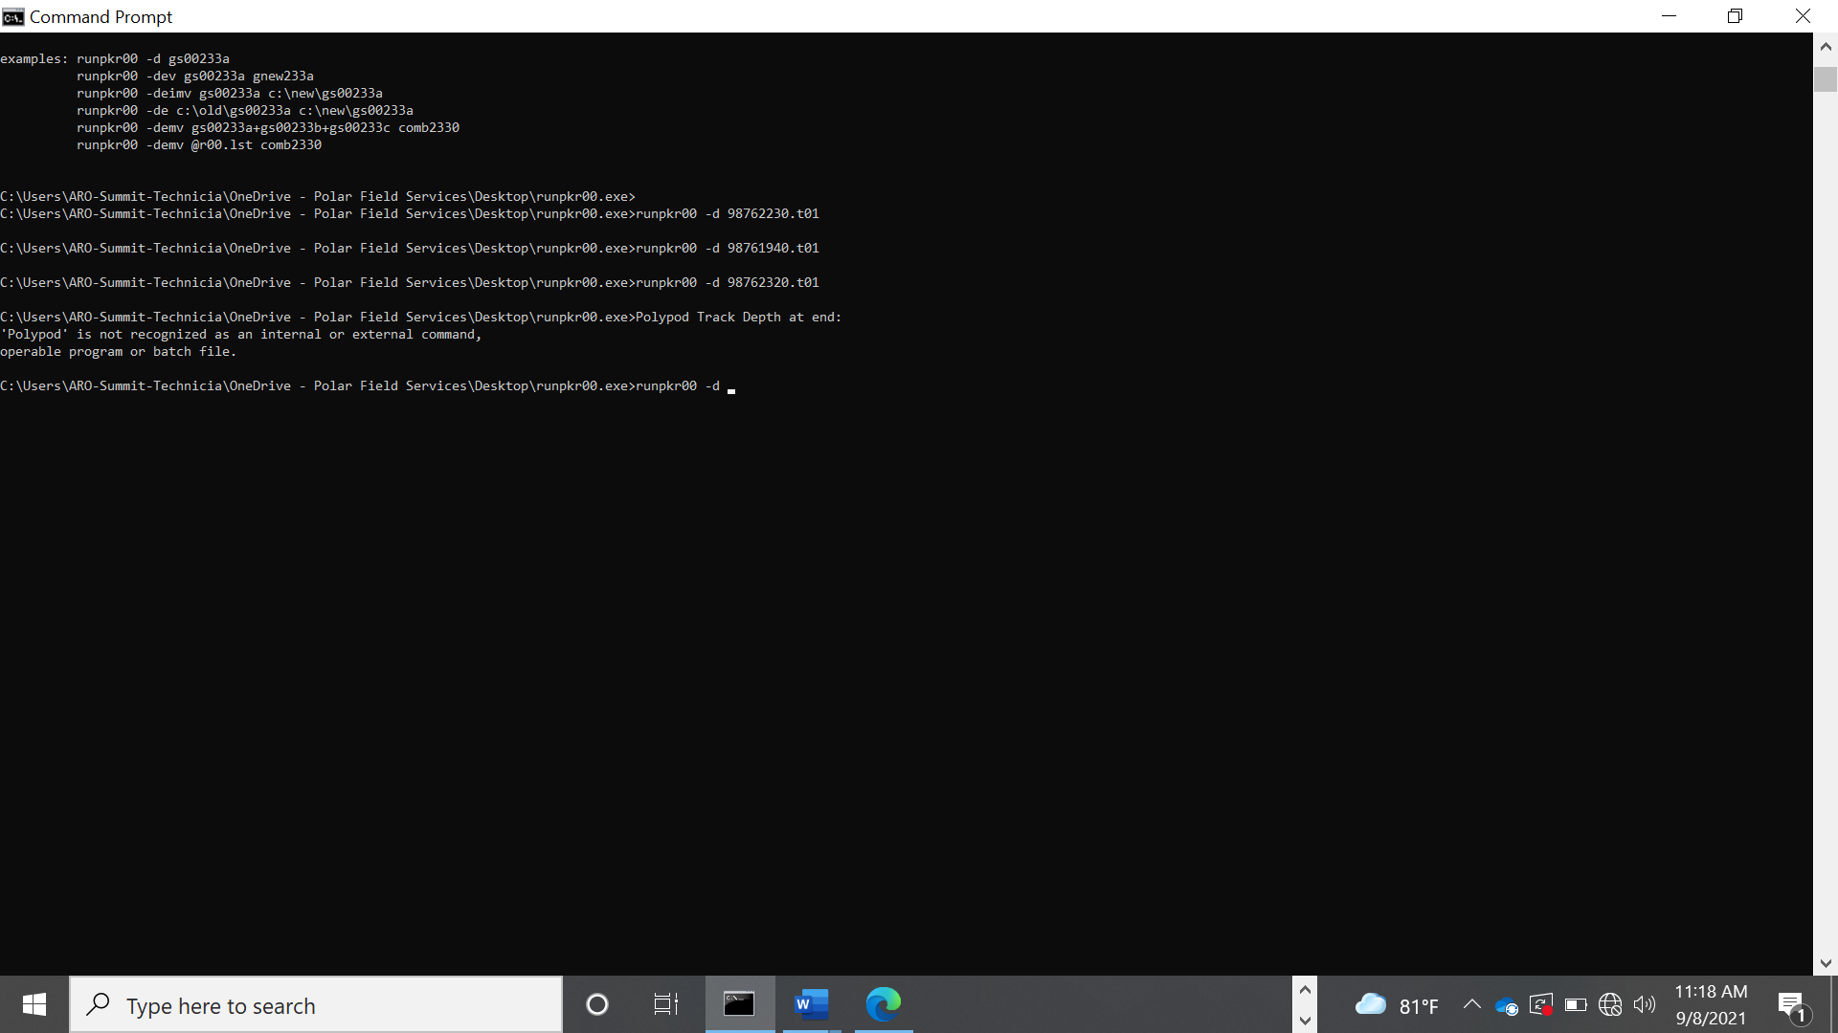Navigate to runpkr00 directory: ‘cd Desktop’ [Enter] ‘cd runpkr00’ [Enter]
  2. Confirm presence of *t.01 file: ‘ls’ [Enter], and inspect directory contents
  3. Convert file: ‘.\runpkr00 -d [filename].t01’ [Enter]
  4. Confirm presence of new [filename].dat file: ‘ls’ [Enter]
  5. Move your new *.dat and original *.t01 roving data file(s) to the survey directory created on the FTP. All data files should be removed from the runpkr00 directory.