NOAA – Coastal Environmental Meteorology Suite

***Primary contact*:** Michael O’Neill

GMD Met – NOAA Service Account

303-497-4294, _oar.esrl.gmd.met@noaa.gov

***Secondary contact*:** Brian Vasel, NOAA ESRL GMD, Boulder, CO

303-497-6655, Brian.Vasel@noaa.gov

How Often: Daily check

Weekly ZENO clock update

Yearly calibration

Clean Requirements: None

Supplies Needed: None

**Introduction:** NOAA/ESRL/GMD has a full suite of meteorological instruments to support the data set of the other measurements done on site. Temperature inversions, wind speeds, and wind directions can be useful in understanding the dynamics of the atmosphere and tell investigators about the meteorological conditions when samples are collected. This system should be simple to maintain with only minimal daily checks for snow accumulation, it is designed to run remotely and hands free.

**Instruments and Software:** The met system was initially supplied by Coastal Environmental Systems. The Zeno data logger and Intercept software are both Coastal products. There is a Vaisala temperature and humidity probe in an aspirated housing on the shorter arm at 2 meters. There is also a platinum resistance probe (RTD) in a Cambridge aspirator housing on the longer arm at 2 meters (this is the measurement that displays the temperature on the NOAA weather display). There is a RTD temperature-only probe in an aspirated housing at 10 meters. The 10m anemometer is from RM Young. There are two pressure sensors (one made by Setra and the other by Honeywell) and both are located inside the datalogger enclosure in the instrument rack inside TAWO. The Setra sensor is considered the primary pressure reading and the Honeywell sensor should be used as the backup. There is an unaspirated RTD probe that comes out of the bottom of the data logger enclosure. This probe is currently being used to measure the temperature inside TAWO. A laptop (“Bunting”) in the rack should be connected directly to the Zeno data logger. The combination temperature and RH sensor and RTD probe should be 2m above the surface snow and the third temperature at 10m. The wind bird should also be at 10m. These heights should be adjusted as needed to ensure that the sensors remain as close to 2m and 10m as possible as the drifting accumulates throughout the year. A diagram of the tower and the met instruments is below.

NOTE: To recover lost Met data look in the Zeno-3200 user Manual on page 55.

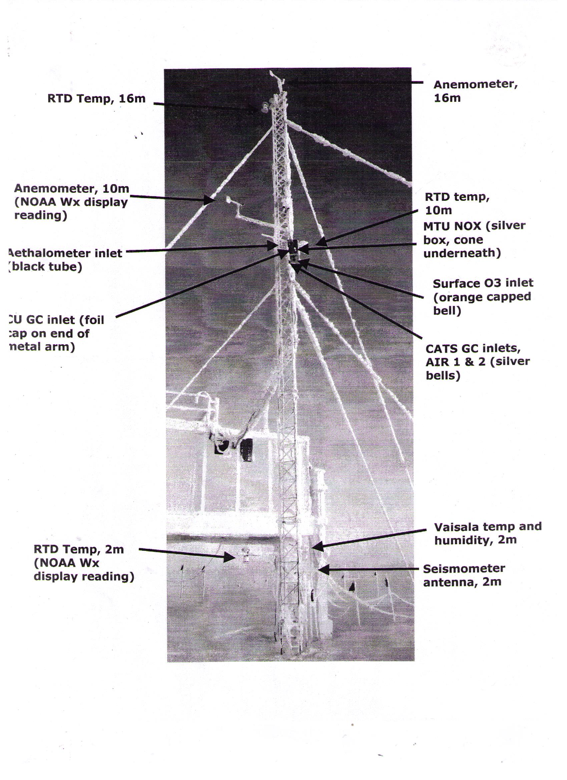

There is also software called "Virtual Weather Station" (VWS) that enables the user to view the meteorological data in graphical displays on the Met Laptop. This software is capable of creating plots of each met variable on 12 and 24 hour scales to visually see changes in temp, pressure, etc. VWS can also create and save a JPEG image of each of these plots to display the weather at Summit on any computer. A simple HTML file can be viewed from any Summit computer by browsing [//Server/ftp/data/GEOSummit/NOAA/MetData/Root/noaawx.html](http://us.mg1.mail.yahoo.com/dc/launch?.gx=1&.rand=e65ep03hrfp5t). Any software questions for the Intercept program should be addressed in the manual that is found with the laptop in TAWO.

**Procedure:**

***Daily Checks:***

The anemometer and all aspirator housings should be checked daily for snow or rime accumulation. Any snow or rime buildup should be removed. The aspirator fans should be checked to be working and free of snow.

Data should be visually checked daily on Intercept and Virtual Weather Station to look acceptable and ensure all of the sensors are online. The current day's file is stored in the directory C:\Intercept\wxdata and the previous day’s files should be saved into the directory C:\Intercept\archive, both of which are on the Met Laptop (Bunting). The data is sent to Boulder on a daily basis via an automated script named "reorg" that runs as a windows service on the Met Laptop. Check the VWS-generated html file, most conveniently done using a web browser, to make sure data is transferring, updating and looks acceptable. The file is located at //Server/ftp/data/GEOSummit/NOAA/MetData/Root/noaawx.html.

If the ARyymmdd.001 file is updating but station weather displays are not updating, check to see if the “reorg” service needs to be restarted. This can be done by going to the Control Panel->Administrative Tools -> Services -> choose Reorg Service from list of services -> Press Start -> press Okay. If reorg is found to need to be restarted often or in an automated way, there is a batch file, Reorg_Restart.bat, located at \\Bunting\Intrcept, that can be used with the Windows Scheduler to restart reorg on a schedule that is convenient.

The log file for the Met system is located at the following location on the FTP server and should be filled out when alignments and calibrations are done, when frost is cleaned off the wind bird and temp sensors, when a fan is found to be dead, etc.: //Server/ftp/data/GEOSummit/NOAA/NOAA Housekeeping/Active Logs/

***Daily Checks:***

There are three sources of time errors in this system. All three must be updated to maintain the met suite:

(1) The computer time drifts and is updated automatically multiple times per day to a network time server through the Clockwise software. This ensures that the computer time is accurate.

(2) The internal clock of the Zeno data logger drifts and must be set manually to match the computer time. The Zeno time is displayed in the Intercept Instrument Panel or Summary as “System Time”.

(3) The Intercept logging software keeps time based on the computer internal clock frequency, not the computer time as displayed by Clockwise or Windows. The Intercept time is displayed in the Intercept Instrument Panel or Summary as “Last Sample Time (Local)”. As the computer time drifts, Intercept time drifts, but is not corrected until shut down and restarted.

Check the Zeno and Intercept time by doing the following:

1. Check the computer time using RJ Clockwise, which is always running. You can check to see if the scheduled time syncs are working through “Options” –“Tools” – “Read Activity Log.”
2. Watch data update in the Intercept Instrument Panel while also watching Clockwise. Record the offset in the TAWO log on the tech computer.
3. Compare the “System Time” to the “Last Sample Time” in the Intercept Instrument Panel.

When the difference between the computer time and the Zeno time (located in the field named “System time” in Intercept) is greater than 5 seconds, the Zeno data logger time will need to be corrected (see directions below). The time will likely need to be reset once or twice per week. If after setting the Zeno time, the difference between the “System Time” and “Last Sample Time” is greater than 5 seconds, restart Intercept. Note - the one minute data updates based on the System (Zeno) time and will always display the top of the minute (17:13:00 for example).

*To correct the Zeno data logger time through Intercept*:

* On Intercept Toolbar, select Utilities 🡪 Terminal Window

* Choose a time approximately one minute ahead. You will use this time to align the Intercept software with the laptop clock. In the command field, enter the chosen time using the following format: #TMYYMMDDhhmmss

Where: YY is the year

MM is the month

DD is the day

hh is the hour

mm in the minute

ss is the second

* Next, watch the laptop clock or RJ Clockwise output; when it approaches your pre-set time, hit ‘send’ and ‘ok’.

* Wait a second or two

**If System Time is within five seconds of “Last Sample Time” there is no need to restart Intercept (will result in ~3 minute loss of data). So only perform the next two steps if the times are way off**.

* Exit the Intercept program.

* After another second or two, restart Intercept.

* Data will begin displaying again in about 3-4 minutes.

**\* Double check that the Intercept time is now aligned with the laptop clock and is on UTC time (not local time).**