**NOAA 50m Tower Configuration and Instruments**

Updated July 10, 2016

Background

In Summer 2016 the new suite of Met instruments was installed on the 50m tower near MSF. The purpose of this additional installation was twofold:

* to move the Met instruments far away enough from TAWO to mitigate the influence of building turbulence
* to upgrade the data acquisition, wind measurements, and cable connections

The plan as of Summer 2016 is to have the two instrument suites (TAWO tower and 50m tower) run in parallel until Summer 2017. When NOAA Observatories staff are satisfied that the 50m tower does not show significant offsets, the official station weather feed will be switched to the 50m tower. At this point, all aircraft operations and official weather will be reported from the 50m tower. During Summer 2017 the Met instruments will be removed from TAWO.

Tower Layout

There are NOAA Met instruments at two levels: 2m and 10m. These are the two standard World Meteorological Organization (WMO) standard heights. The 2m temperature is standard, 10m wind is standard.

At 2m:

* Aspirated Logan RTD temperature sensor in Cambridge housing (shorter white housing) – *to be* *official station temp*
* Aspirated Vaisala HMP155 humidity (dewpoint) sensor in Cambridge housing (white housing with aluminum extension)
* Lufft sonic anemometer
* Instrument enclosure with: Setra pressure sensor, power supplies, network gear, Campbell Scientific CR1000 data logger – *to be* *official station pressure*

At 10:

* Aspirated Logan RTD temperature sensor in Cambridge housing (shorter white housing)
* Lufft sonic anemometer - *to be official station wind sensor*
* RM Young anemometer (“windbird”) – for comparison with sonic anemometer

Mounting to Tower

* Instruments are mounted to the tower using 80/20 slotted aluminum bars to make it as easy as possible to install and remove instruments. 80/20 bars have T-slots machined into their sides to allow different brackets and other compatible pieces to be slid in and locked.
* The 80/20 bars are attached to the tower via U-bolts and 80/20-specific mounts. The longer bars hold anemometers, shorter bars hold temperature and humidity sensors.
* Each bar has a locking ‘stopper’ at its end, so the bar cannot be slid too far out. Short bars need to be locked into place with a wrench, but longer bars have a red brake that locks when its turned.
* 80/20 bars can be slid in and out to work on instruments, remove them, and reposition as necessary. More info about each instrument’s mount follows.

80/20 U-bolt mounting and red-handled brake:

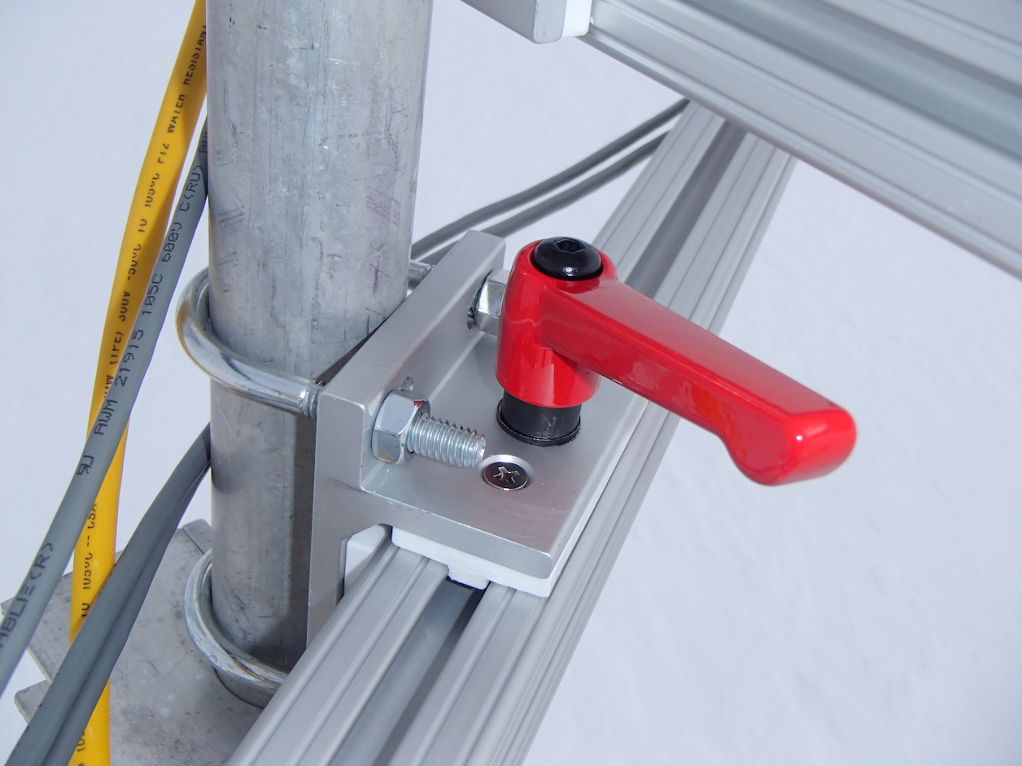

Stopper bolt blocking the 80/20 bar from sliding:

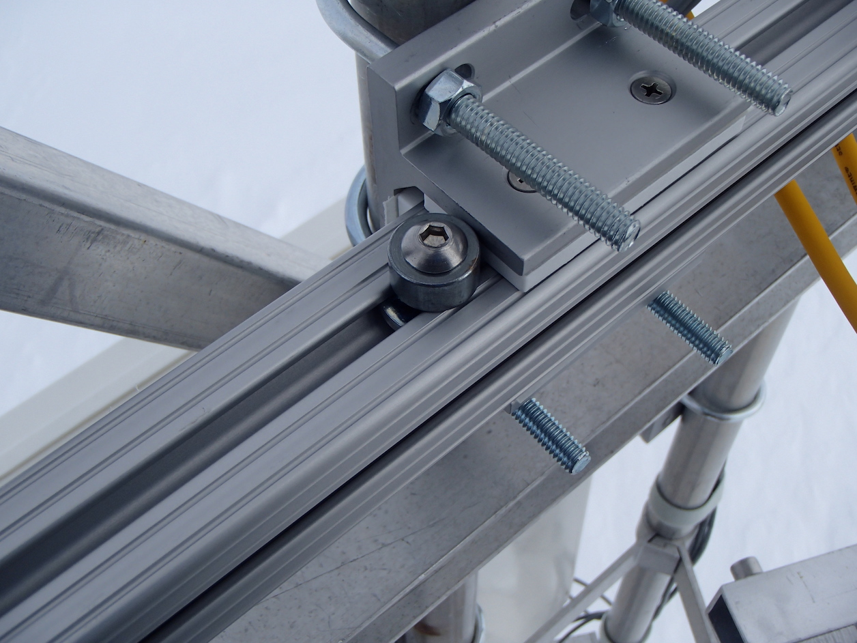

Instrument Mounting

* RTD:
  + RTD’s are mounted with locking nuts and carriage bolts. The carriage bolts are slid into the 80/20 slots, instrument fit onto the bolts, and nuts put on/tightened.
  + To remove:
    - Unplug RTD.
    - Slightly loosen the nuts, slide instrument with bolts still attached away from tower and off of 80/20 bar.
  + To mount:
    - Slide bolts into the 80/20 slots so the head of the bolt is caught by the 80/20. The threaded end should be facing outward.
    - Space the two bolts so the ends line up with the holes on the Cambridge housing mount.
    - Place Cambridge housing mount onto bolts and tighten locking nuts onto bolts.
  + Tools needed: size 13 wrench
  + Pictures:

2m RTD mounted on tower:

* + 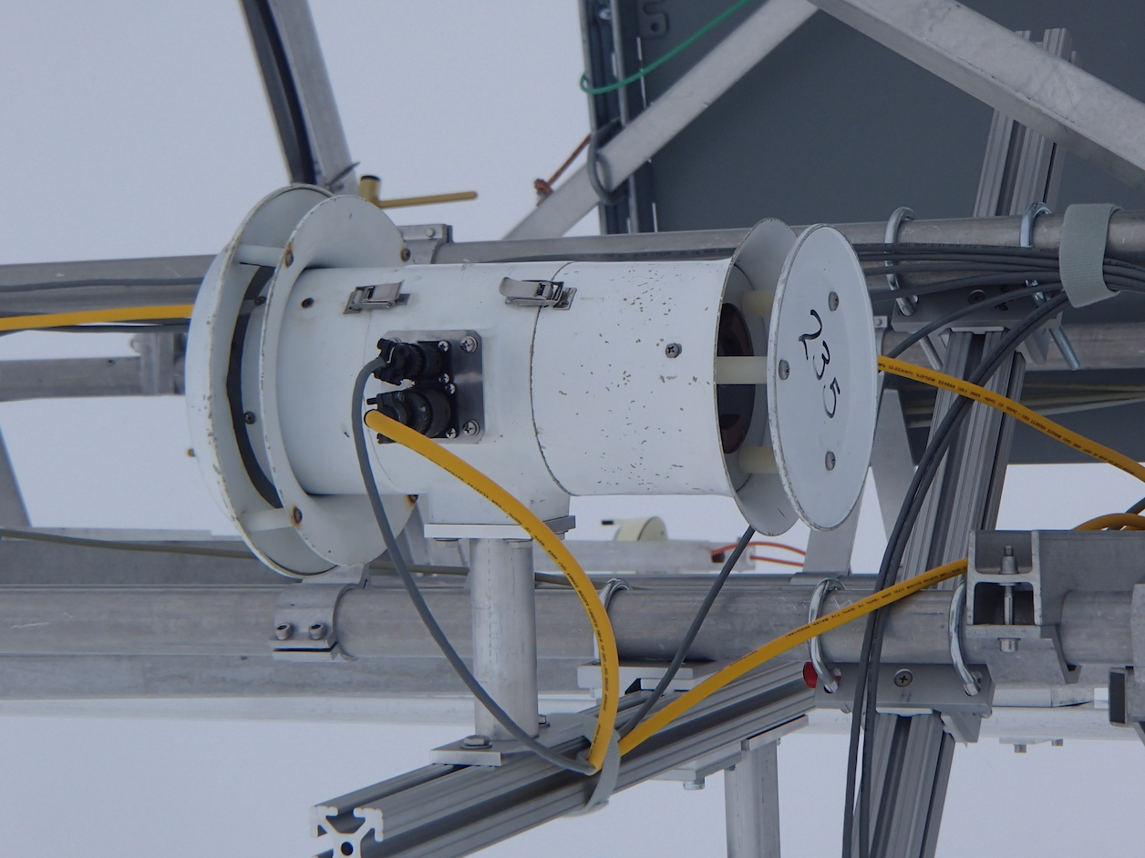

80/20 mounting with carriage bolts, washers, locking nuts:

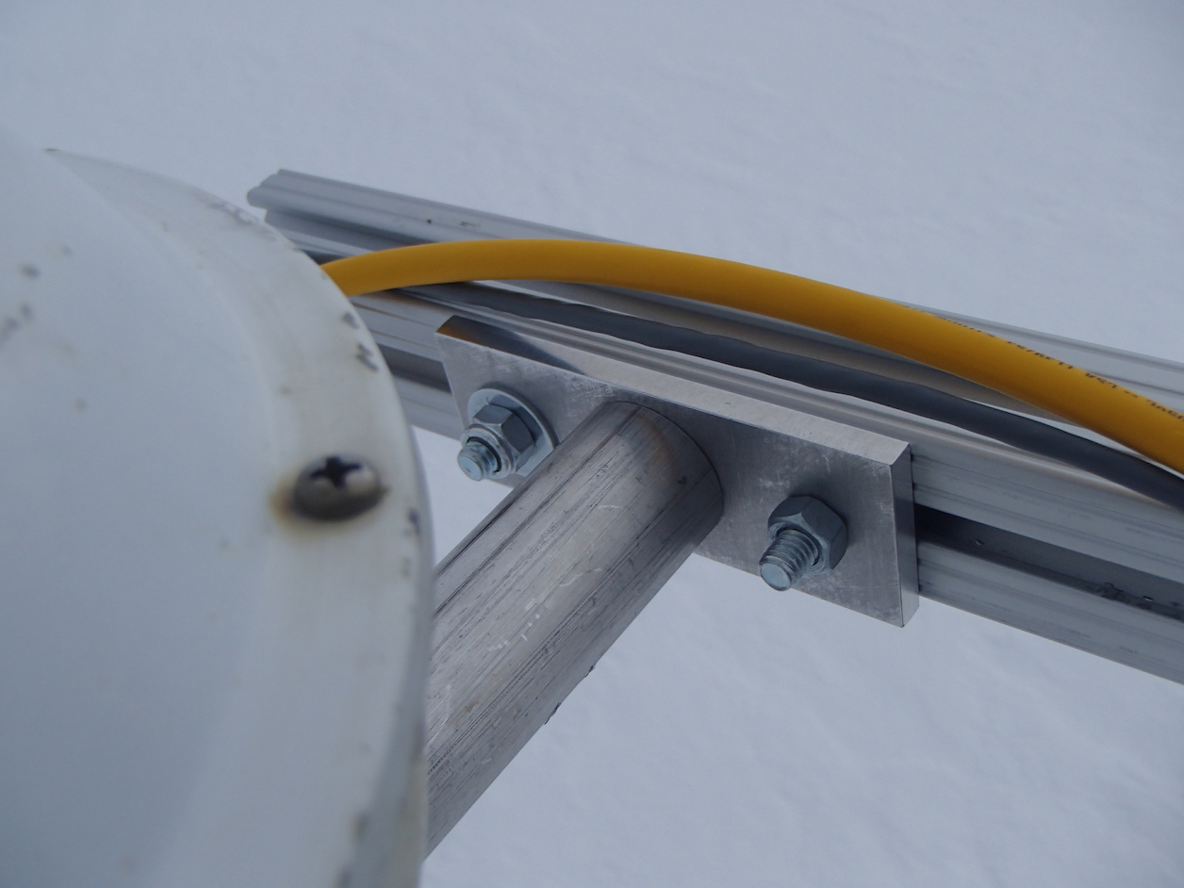

* Vaisala HMP155:
  + Mounted with locking nuts and carriage bolts. The carriage bolts are slid into the 80/20 slots, instrument fit onto the bolts, and nuts put on/tightened.
  + To remove:
    - Unplug the instrument.
    - Slightly loosen the nuts, slide instrument with bolts still attached away from tower and off of 80/20 bar.
  + To mount:
    - Slide bolts into the 80/20 slots so the head of the bolt is caught by the 80/20. The threaded end should be facing outward.
    - Space the two bolts so the ends line up with the holes on the Cambridge housing mount.
    - Place Cambridge housing mount onto bolts and tighten locking nuts onto bolts.
  + Tools needed: size 13 wrench
  + Pictures:

HMP155 mounted on same 80/20 bar as 2m RTD:

* 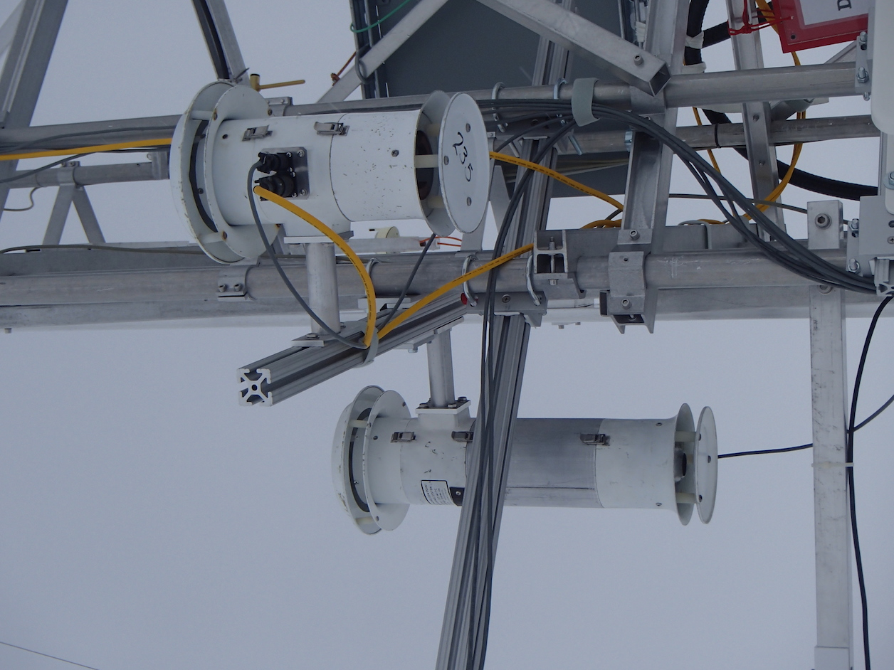

HMP155 mounted to 80/20:

* 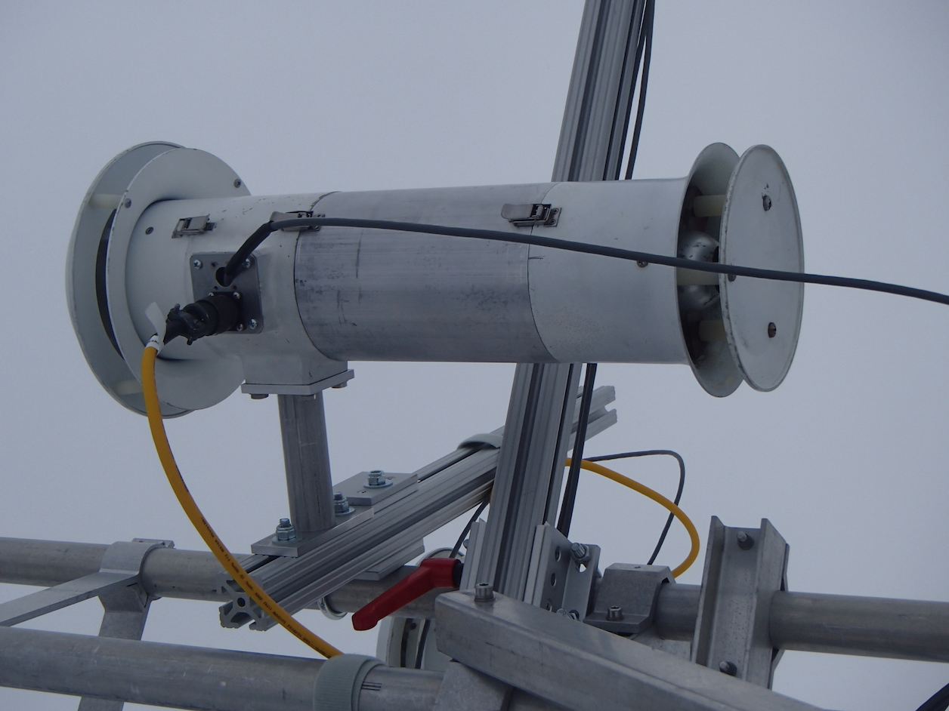

HMP155’s mounting hardware: carriage bolt, washers, locking nuts:

* 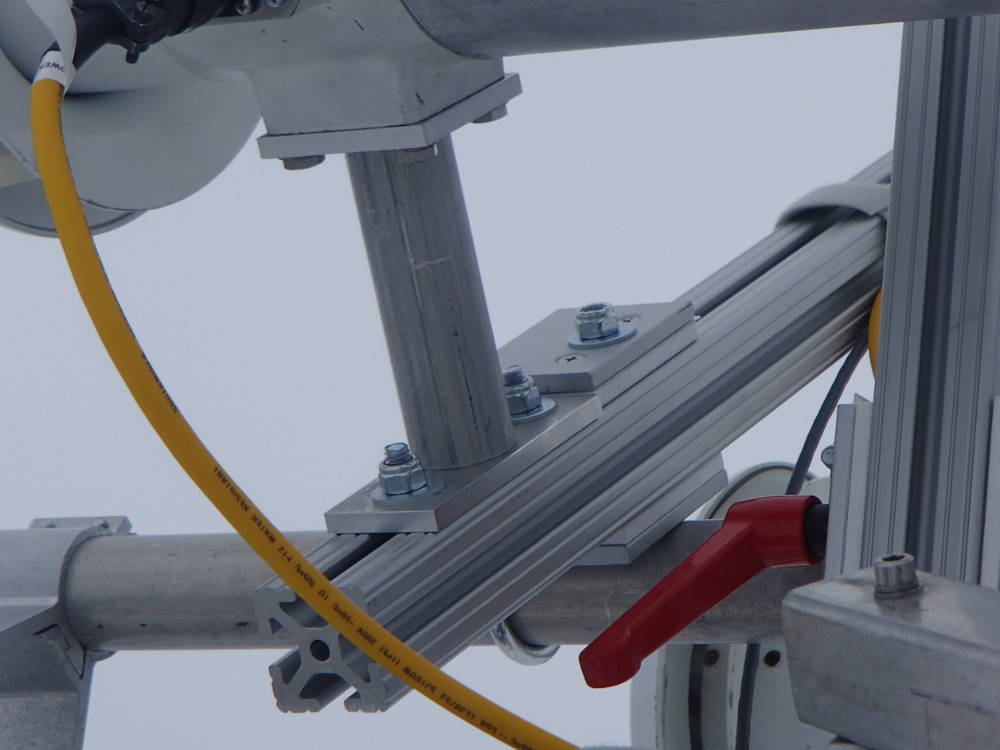
* Sonic Anemometers:
  + Mounted with a sliding bracket that clamps around the sonic anemometer cylindrical mount.
  + To remove:
    - Loosen red brake handle and slide 80/20 bar toward tower
    - Unplug cables from sonic anemometer
    - Loosen sliding mount screws with an allen wrench – size …
    - Slide bracket with instrument off of 80/20 bar
  + To mount:
    - Loosen red brake handle and slide 80/20 bar toward tower
    - Loosen 80/20 T-nuts on bolts to allow sliding bracket to fit on 80/20.
    - Align 80/20 T-nuts horizontally and slide loosened bolts on bracket into the 80/20 channel.
    - Slide to desired location on 80/20 bar and tighten nuts to hold in place.
    - Slide 80/20 bar back out to its extended position. Lock in place with red handle.
  + To adjust alignment:
  + Tools needed:
    - To remove sliding bracket:
    - To remove cylindrical mount:
  + Pictures:

Sonic anemometer mounted at it’s fullest extent from tower:

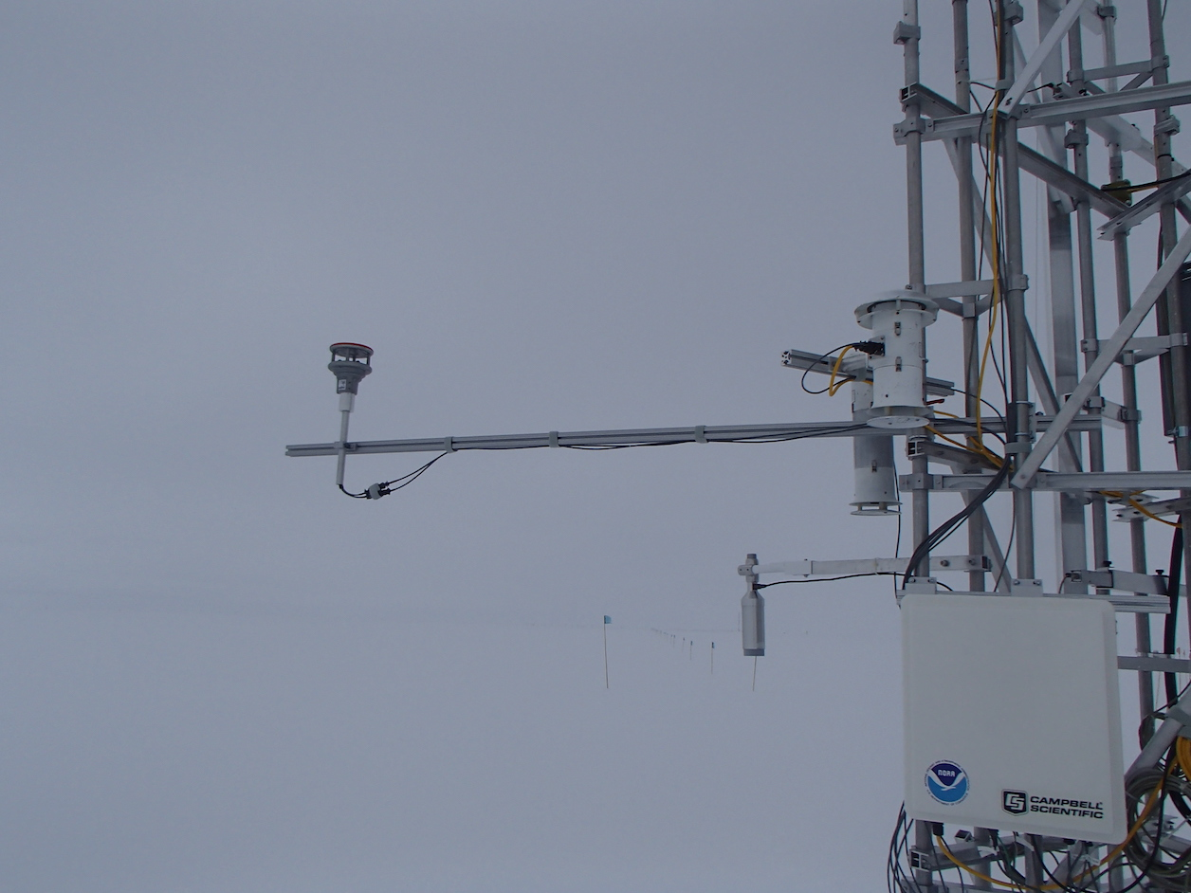

Sonic mounting on 80/20:

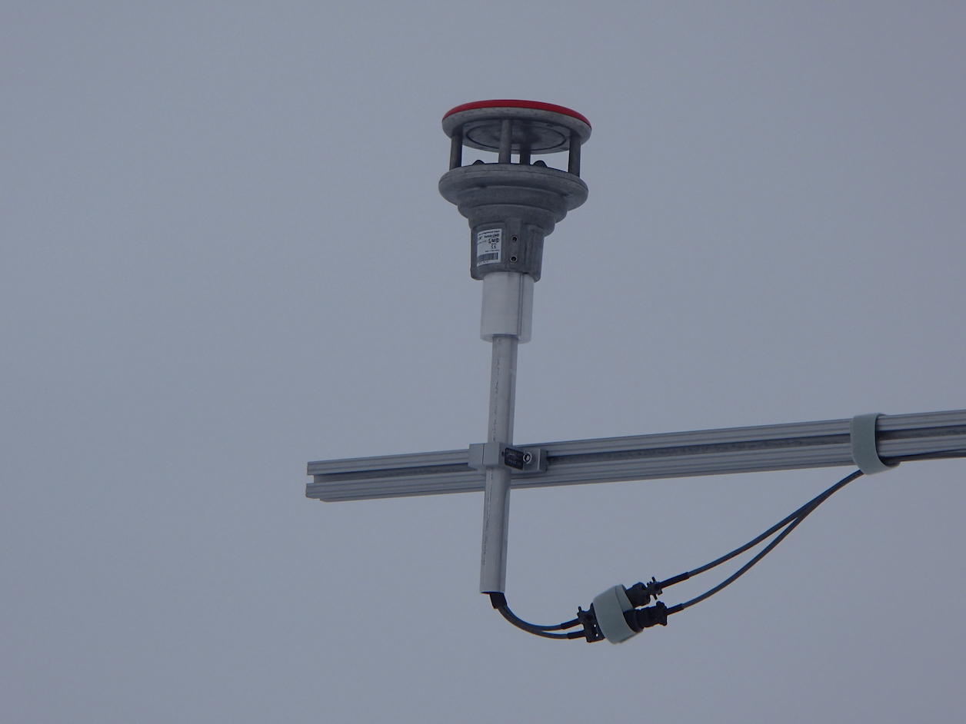

Close-up of sonic mount and cables:

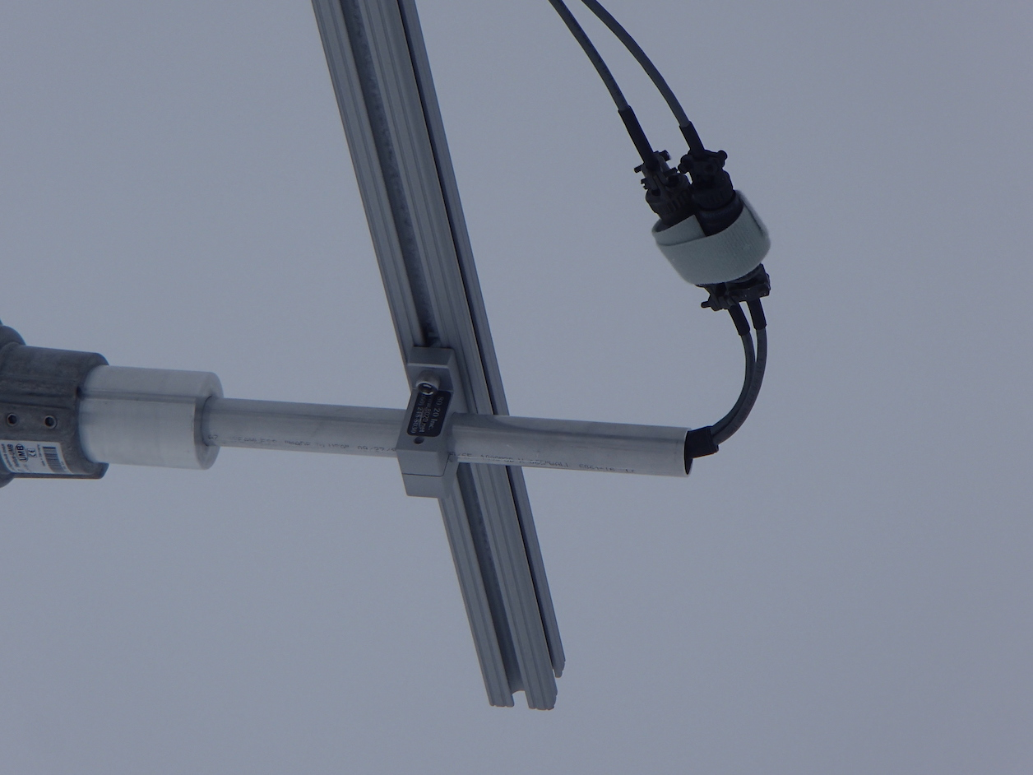

* RM Young Anemometer “Wind Bird”:
  + Mounted with a sliding bracket that fits into the 80/20 grooves, U-bolts connecting RM Young and mounting pipe (see photo).
  + To remove entire unit:
    - Unlock bar with red handle and slide instrument toward tower.
    - Unplug the cables.
    - Unlock the bolt on the RM Young 80/20 slider bracket, slide entire instrument off the end of the 80/20 bar.
  + To remove bird, leaving mount:
    - Unlock bar with red handle and slide instrument toward tower.
    - Unplug the cables.
    - Unscrew TOP hose clamp. LEAVE THE BOTTOM HOSE CLAMP UNTOUCHED (this preserves alignment).
    - Slide bird off top of copper pipe, leaving bottom black fitting tight on the pipe.
  + To mount:
    - With 80/20 bar slid toward the tower, slide RM Young 80/20 slider bracket onto bar.
    - Lock down slider bracket with bolt when in place. Connect cables.
    - Slide 80/20 bar out to full extent, lock into place with red handle.
  + To adjust alignment: using flat screwdriver, loosen bottom hose clamp. Turn entire RM Young unit as necessary (bottom black mounts included), tighten hose clamps in new orientation.
  + Tools needed: flat screwdriver, size 13 wrench
  + Pictures:

RM Young attached to 80/20:

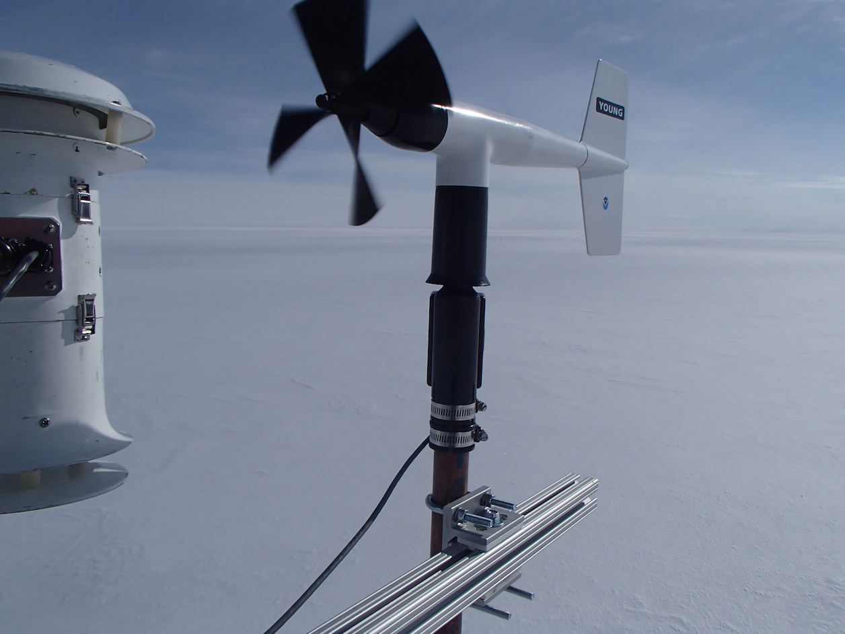

RM Young sliding mount, with U-bolts:

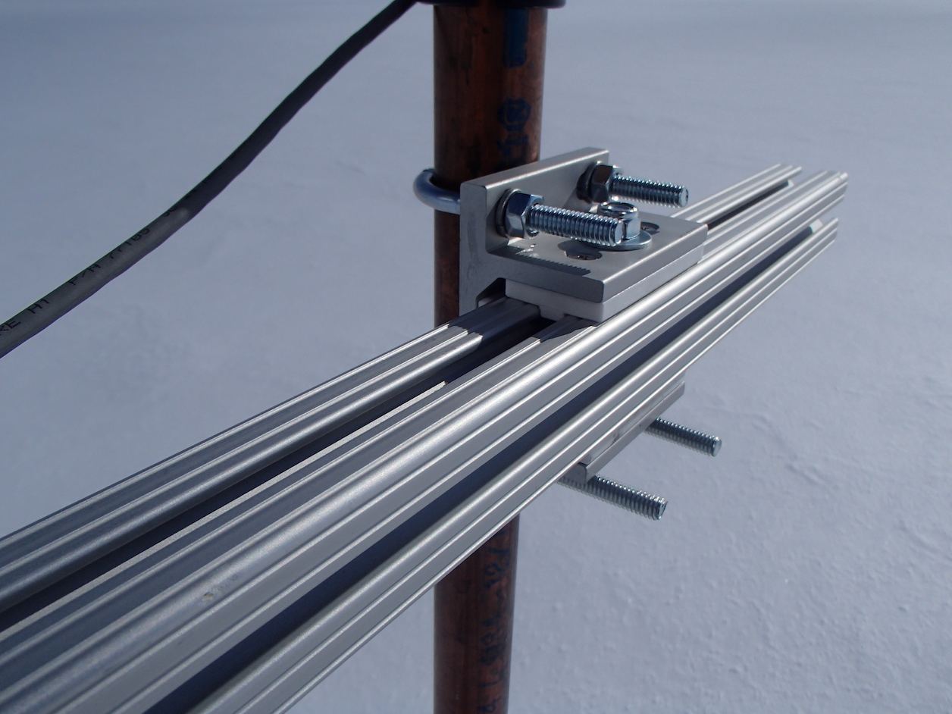

RM Young fully extended:

