*Updated 2022-02-23*

**SMM3 Transfer Procedure**

1. Ensure that you are connected to the PolaRx5 network “SMM3_UNAVCO”. Verify you are online with it by going to 192.168.20.1 and you should see the following screen:

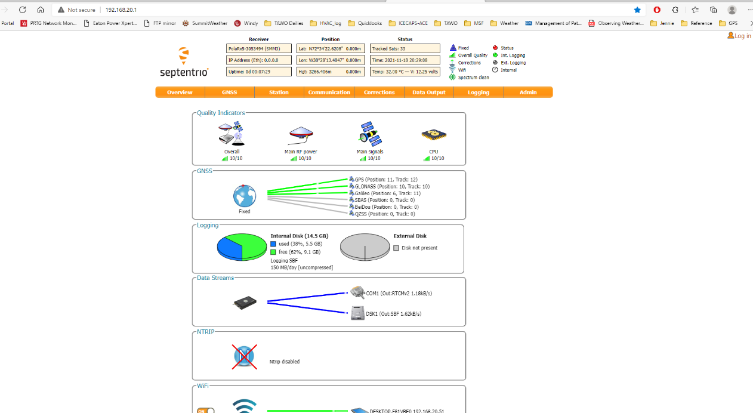

1. Open Filezilla and enter the following- Host: sftp://192.168.20.1 (should not require any other username or password info). If successful, you should see the device pop up in the right hand side of the lower windows.

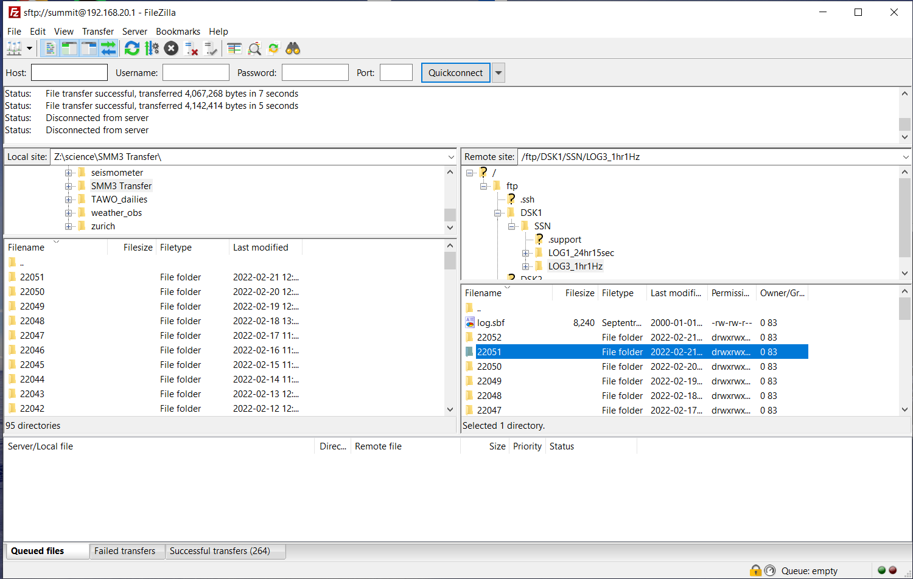

1. From there select: DSK1 > SSN> LOG3_1hr1Hz.
2. After that you should see a list of each day’s files, listed as YYJJJ.
3. On the left hand side window, navigate to Z:\science\SMM3 Transfer\
4. You should see previous days worth of files folders.
5. From that point, click on the previous complete day’s file folder on the right hand side, and drag it over to the left hand side. In the window at the very bottom you should see the progress of the files transferring.