**b • r • u • s • a • g**

sensorik & messtechnische entwicklungen ag

Chapfwiesenstrasse 25  
  
**CH-8712 Stäfa (Switzerland)**

**Changing**

**the**

**Belts**

Technical Note

BRUSAG Ref: INTRA/TN/2394-BRU Version 1.00 of 04-Apr-2017

Change Record

|  |  |  |  |
| --- | --- | --- | --- |
| **Date** | **Version** | **Who** | **Description** |
| 03-Apr-2017 | 0.00 | RB | Draft |
| 04-Apr-2017 | 1.00 | RB | Document finalized |
| 06-Apr-2017 | 1.50 | HJ | Questions in ‘comments’ and Figure markups |

Contents

1 Introduction 1

2 Step by Step 1

2.1 Tools required (metric) 1

2.2 Preparation for and Setting up the Improvised Platform 1

2.3 Changing the Belt of a Gear Unit 3

2.4 Resuming Operation 5

# Introduction

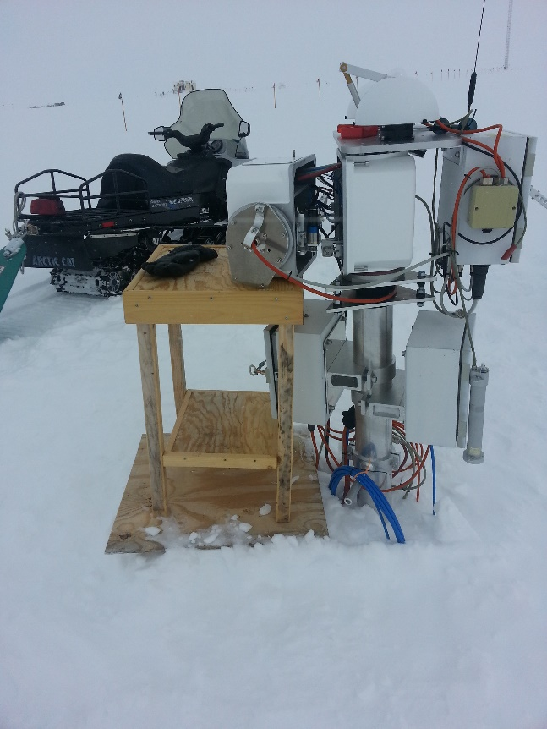This document is a step by step instruction on how to exchange the toothed belt(s) of INTRAs drive(s). Normally, such an exchange would be done in the lab. However, in many cases, it is quite an exercise to remove a tracker from its site, because many cables are fed through it and more things are attached to it. This is especially true for the Summit site and hence we propose an alternative approach:

* Set up an improvised platform as shown below in Fig. 1
* Open the tracker – also as shown in Fig. 1
* Remove the gear(s) from the tracker and take it (or them) into the lab.
* Exchange the belts.
* Re-install the gears into the tracker, close the case and check if everything works fine again.

Fig. 1 Example of an improvised platform for the "intermediate storage" of the "elevation half" of the tracker. We cannot give much advice here, because it depends on the situation you find at the station. The important points are: The platform should be at level with the "elevation half" of the tracker and should be large enough to allow for a sufficient separation of the two halves of the tracker.

# Step by Step

## Tools required (metric)

In the field

* Allen wrenches 6, 5 and 3 mm (for allen screws M8, M6 and M4)
* Side cutter (small) to cut cable ties

In the lab

* Allen wrenches 3, 2.5 mm

## Preparation for and Setting up the Improvised Platform

Dismount the shader arm from the west-flange of INTRA. Carefully store away the two M6-allen screws. Eventually fix the now loose arm with an adhesive tape or a cable tie such that it does not longer protrude in your working area.

Dismount the instruments from the interfaces attached to the flanges of the tracker.

Install the improvised platform. Because the belt(s) are broken, you will not be able to position the tracker in a position that is as well suited for the installation of an improvised platform as shown in Fig. 1. We rely on your genius to handle this.

The two halves of the tracker are hold together by 4 M8 allen screws. When loosening these screws, rotate them until you can hear that the end of the thread has been reached. You still are not yet able to remove such a screw from the case, but you can withdraw it that it no longer sticks out from its bore. In other word: The screws remain in their hole – see the screw on the top of the case in Fig. 2. Now start by completely loosen the two lower M8 allen screws that hold the two halves of INTRA together. S

While a second person presses the two halves of the tracker together, now also remove the two upper M8 allen screws. When sufficiently pressed, the two halves will not move, because two of the four threaded holes of the PA-halve of the tracker include a tube that stick out a few millimeters into the opposite halve of INTRA. It is essential not to damage these tubes when separating or assembling the two halves of the case.

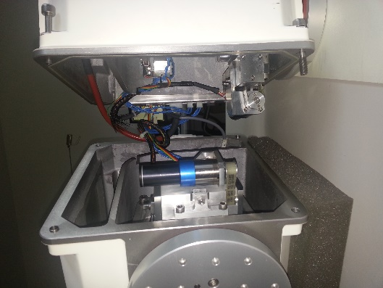Once all four screws are loose, hold the SA-halve at the flanges and pull it horizontally for a few millimeters from the other halve. Now you can put the SA-halve onto the improvised platform. The situation should now look as depicted in Fig. 2.

Fig. 2 The two halves of the tracker separated. The SA-part to the left, the PA-part to the right. Also note the slightly protruding tube in the threaded hole top left of the SA-part.

You may want to replace the belts of the PA, the SA-drive or both. Remove the corresponding motor cable(s) from the electronics board. Hint: The connector can easily be removed from its socked if you pull slightly away from the near rim of the case while also pulling on the cable.

Next then is two remove the two M6 allen screws that hold a gear block in its place. Having done this, you can carry the gear block to the lab for further work.

Prior to leaving the tracker, you should think about the fact, that now those axis without gear block are no longer self-locking. Wind loads might move the axis.

## Changing the Belt of a Gear Unit

This work can be done in the lab. Fig 3

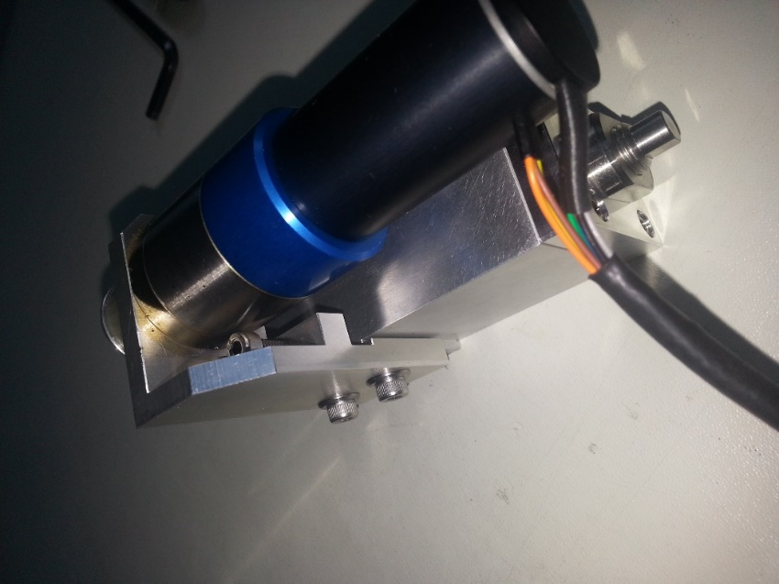Fig. 3 The gear unit. The motor sits on a kind of a sled that allows to trim the tension of the belt. The two M4 allen screws to the left form this sled while the upper M4-allen screw allows to apply tension to the belt in a controlled way.

Loosen the two M4 allen screws that form the sled (see Fig. 3). Do not yet remove these two screws, just loosen them a little bit such that the two pieces can slide against each other.

Then remove tension from the belt by rotating the 3rd M4-screw visible in Fig. 3 by a few full turns.

Once the belt is without tension, completely remove the two lower screws. Now you are able to separate the motor assembly from the worm-drive housing. The belt however cannot yet be removed or replace.

Remove the 3 M3-allen screws that hold the cover of the worm-drive housing in place. Press the cover against the housing (see also Fig. 4) while removing the screws. Then remove the cover. Take care that the axial ball bearing remains at its place at the inside of the cover.

Now the belt can be removed. Do so and put the new belt at the place of the old one.

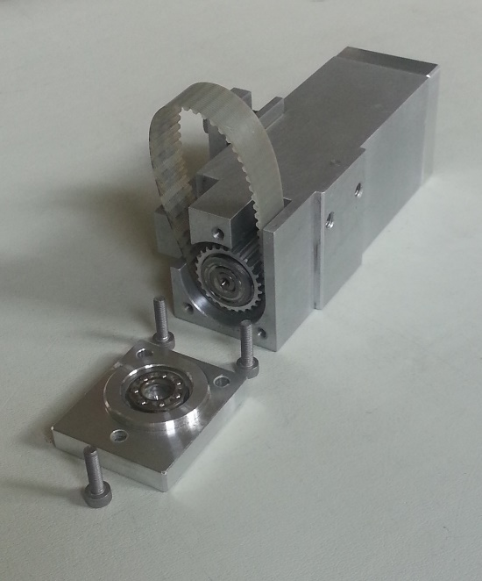Fig. 4 The worm-drive housing. The worm inside the housing is spring loaded. Hence be careful when removing the 3 M3 allen screws that hold the worm in place.

Put the cover back at its place and fasten it with the 3 screws. Then verify that the belt can easily be moved and the worm rotates accordingly.

Next is to attach the motor sled. Feed the toothed wheel of the motor into the belt and press the sled against its seat. Then put the two M3-allen screws (with washers) into their resp. threaded holes. But do not yet apply much torque. The sled should work as such but have (almost) no play.

Use the top M3 allen screw to apply some tension to the belt. Tension is ok when pressing the belt with two fingers (see Fig. 5) the belt moves 1 to 2 mm. Once tension is ok, tighten the two screws of the sled.

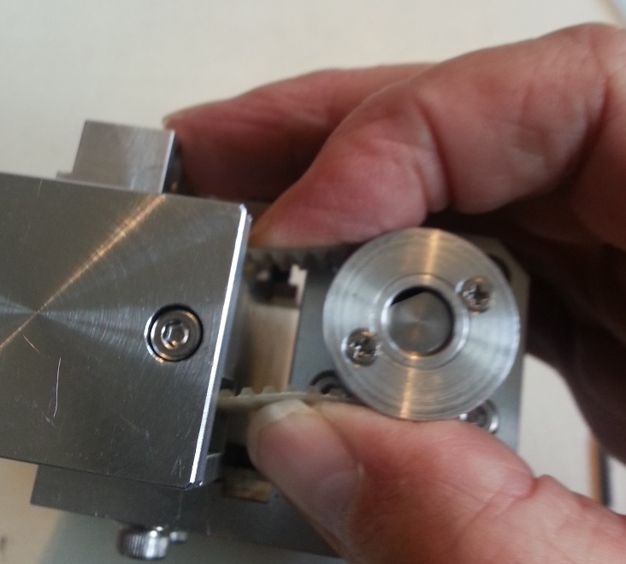Fig. 5 Checking the tension of the belt. The picture illustrates, that one should not overstretch the belt, but adjust its tension such that it will not slip over the teeth of the wheels.

The gear block now is ready to be installed into the tracker. Put it back onto its position in INTRA and use the two M6-allen screw to attach it. Prior to tightening these screws, make sure the worm-drive block is positioned correctly – meaning without any gap – at its correct position. Tighten these two M6 screws very strongly.

Finally, put the connector of the motor back into its socket at the electronics – see Fig. 6.

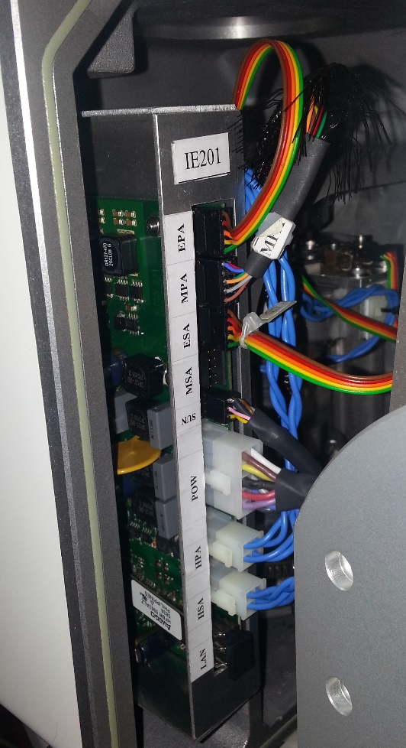Fig. 6 Position of the sockets of the controller board. Motor sockets are labeled MPA (Motor Primary Axis) and MSA (Motor Secondary Axis). In this picture, the MSA-socket is empty and will accept the corresponding connector of the motor of the gear block on the SA.

Push all the cables of a half-unit into the corresponding slit and bind the cables together with a cable tie – as shown in Fig. 7.

Now you should remove the service cover, because next is to bring the units together and while doing this, you must make sure that the cables remain in their corresponding slit. Otherwise they might be squeezed between the two half-cases and thereby be damaged.

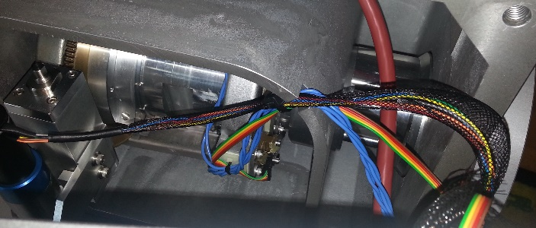Fig 7 Positioning the cables in their slit.

Check that the 4 M8-screws do no protrude from the contact surface of the half-case. Then grab the SA-half at the flanges, bring it up to level with the PA-half and put them together. Do not apply force, until it's clear that the two guide tubes previously mentioned have snapped into their proper place. Then keep pressing the two halves together while person two screw in one of the top M8 screws. Do not tighten it yet. Apply a second M8 – diagonally opposite the first one. Then check cables through the service opening. If everything looks ok, also put the other two M8 screws in place and then tighten them strongly. We typically used an extension to the allen wrench, because this allows to apply more torque. These screws can take it.

## Resuming Operation

INTRA is now ready to resume operation, but because the current firmware has a problem, it should get an update of the firmware. But prior to doing this, use the current firmware to check if both axis work properly – and for this, you can still use the old firmware. For further advice, please check the [document found under this link.](http://www.owel-swiss.ch/Files/Files_Brusag/140908_INTRA_update_guide_103.pdf) This document includes information on how to move both axis, find both zero marks etc. Do not command the tracker in sun- or clock mode while it still runs on its current firmware.

If you have convinced yourself, that both axis work properly, put INTRA in Halt-mode and wait for the new firmware. Currently, this new firmware is still under test at OWELs test site. Once these tests are completed, you will receive a mail with a link to the new firmware. Download and install it. Then INTRA will be ready to go – or almost: Then you should finally attach the shader arm at the west-flange and command the tracker again into sun mode.

* End of the Story -