Troubleshooting the INTRA at Summit

After reading the mails and their attachment, there are some puzzling questions left – or in short: We still do not yet understand what exactly the problem of the Summit-INTRA is. According to the log-file Tracker_log_10_31_16.docx, it worked normal until 21.09.2016. Then it produced “near zero timed out errors” until 25.10.2016. On this day, the rewind operation was executed correctly and this continued until 30.10.2016 when a “zero-0 timed out” message came up. But it recovered and completed the “search flag run” less than 2 minutes later. However, with a unsettling value of 9380 for the parameter eposo. Now let’s first discuss what these messages tell us and then which questions the current set of data leaves open. But firstly a few words about basics of the tracker:

The tracker has an encoder disc on each axis. These two disks are firmly attached to the resp. axis – no gears in between. The encoder disc produces 9380 counts per full revolution of the axis. So far, it’s an incremental sensor only, but he encoder disk has an additional track with one mark only – the so called zero mark – and with this, the system works as an absolute position encoder.

INTRAs firmware also uses the hall counts produced by the motors to deduce an alternative, less accurate (gears!) position indicator. This allows it to detect possible failures of an encoder circuit and stop the tracker. Otherwise, the thing could go wild….

During a day of 24 hours, the primary (vertical) axis (PA) of the tracker rotates from -180° to app. +180°. The secondary axis (SA) follows the elevation of the sun, until it goes 3 degrees below the horizon. Then it stops at this angle. At local midnight – currently at Summit near 02:30 UT – the tracker initiates a rewind. During this rewind, it also attempts to check the position of the zero mark. It firstly moves either axis to a position app. 5° clockwise (+) of its zero mark. The tracker schedules an interval of time during which this position should be reached. If this interval elapses while the position is still not reached, it produces a “near zero timed out” error. This is what we have in the log files as of 21.09.2016 until 25.10.2016 when it resumed normal operation.

Q1:  
Do you have observations of the tracker during its down time 21.09. to 24.10.? What did you observe? Please describe (e. g. approximate position of PA and SA, moving or totally blocked?)

On 21.09, after a routine cleaning of the solar alignment opening, the tracker attempted to point the arm straight up. This movement was outside of its normal movement range, and it caused one of the mounted instruments (the PFR) to strike the radiometer mounting plate. This mechanical interference forced the motion of the tracker to stop, with the azimuth near south or south-east, and the elevation near zenith. The PFR was removed. The tracker remained motionless in this position until 24.10.

Q2:  
When it resumed normal operation on 25.10, was there an intervention? Which kind of intervention?

On 25.10, there was an intervention. On Dany’s request, we connected a laptop to the DB9 port in the lower power supply box of the tracker. Using IntraCfg, we re-sent the EEPROM flash settings specified by Dany, used the ‘Run Motors’ mode to confirm that the unit could move in both axes, and selected the ‘Sun’ mode. The tracker appeared to resume operation, pointing at a location near the point where the sun had set (near the horizon and to the south). When we checked the tracker the next morning (12z), the tracker arm pointed about 165 degrees behind the sun in azimuth, and at roughly the correct elevation. The EEPROM settings sent on 25.10 were as follows:

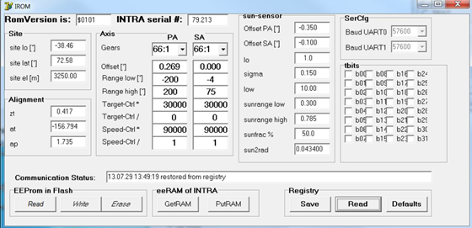

When the tracker reaches the 5° positions, its submode is changed to WAITZERO and a “search zero run” is triggered. As previously, an interval is scheduled during which these flags should be detected. If this does not happen in due time, an “zero-0 or zero-1 timed out” error is reported. Zero-0 for the PA and zero-1 for the SA. This message popped up on 30.10. But less than 2 minutes later, the PA found its zero mark. And it issued the message:  
16-10-30 02:36:07 chat,zero-0 found, eposo,9380, eerrs,0, hposo,59605, herrs,0  
eposo = 9380 is the value of the position of the PA at the moment of detection of the zero mark. The strange thing is that 9380 counts correspond to exactly 360°, hence one full turn. The value of hposo=59605 corroborates this, because this as well corresponds app. to one full turn. This means, that the tracker was far above PA=360° when it started its zero search (which moves ccw). Note that positions above 200° are “illegal”, because the settings in the eeprom limit the movement of the PA to the range (-200,+200). It looks as if the values in the eeprom were garbage to allow this to happen.

Q3:  
What values did you find in the eeprom when you connected to the tracker on 31.10.?

When we connected to the tracker on 31.10, we found that the EEPROM values were unchanged since the time that we input them on 25.10. That is, they still matched Dany’s values.

Q4:  
Following the fix of the eeprom values when you switched to sun mode: What was the time of the day and what did the tracker do?

The switch to Sun mode has had different effects during different attempts. In the attempt on 25.10, the sun had recently set, and the tracker moved to a position near the location of the sunset (near the horizon and to the south), but was shown to be 165 degrees behind the sun at sunrise the next morning. On later attempts, e.g., 31.10 at about 13:00z or 14:00z, the sun was visible in the sky to the south, but the tracker pointed to a location near the horizon and to the north. We had input a new set of EEPROM parameters from Dany for this attempt. These new settings are as follows:

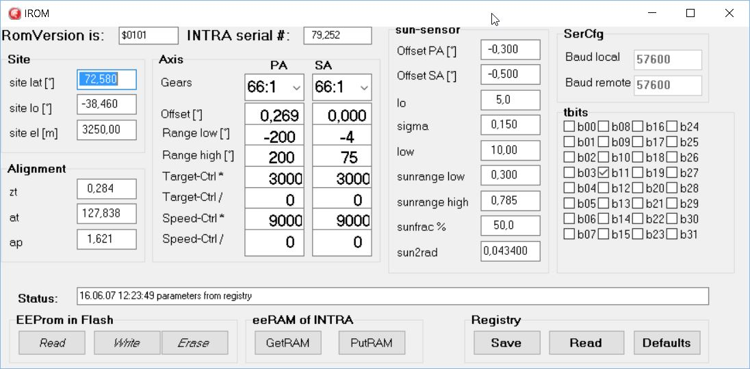

The final attempt to switch to Sun mode is described below. I should note that the sun is low during the entire day, given our high latitude at this time of year.

Q5:  
Is the tracker now up and running or what is its current status?

On the final time that we switched to Sun mode (31.10, 18:54z), the tracker completed a full 360 rotation in azimuth (moving ccw), and then continued to rotate. We were concerned that further rotation could damage the instrument, so we hit the ‘reset’ button in the ‘position window’ to stop motion. We used the “Run Motor” function to reverse this motion by 90 degrees, then hit ‘reset’ to stop. We left the instrument in this state.

Thank you for your help with the diagnosis of this issue!