Troubleshooting the INTRA at Summit

After reading the mails and their attachment, there are some puzzling questions left – or in short: We still do not yet understand what exactly the problem of the Summit-INTRA is. According to the log-file Tracker_log_10_31_16.docx, it worked normal until 21.09.2016. Then it produced “near zero timed out errors” until 25.10.2016. On this day, the rewind operation was executed correctly and this continued until 30.10.2016 when a “zero-0 timed out” message came up. But it recovered and completed the “search flag run” less than 2 minutes later. However, with a unsettling value of 9380 for the parameter eposo. Now let’s first discuss what these messages tell us and then which questions the current set of data leaves open. But firstly a few words about basics of the tracker:

The tracker has an encoder disc on each axis. These two disks are firmly attached to the resp. axis – no gears in between. The encoder disc produces 9380 counts per full revolution of the axis. So far, it’s an incremental sensor only, but he encoder disk has an additional track with one mark only – the so called zero mark – and with this, the system works as an absolute position encoder.

INTRAs firmware also uses the hall counts produced by the motors to deduce an alternative, less accurate (gears!) position indicator. This allows it to detect possible failures of an encoder circuit and stop the tracker. Otherwise, the thing could go wild….

During a day of 24 hours, the primary (vertical) axis (PA) of the tracker rotates from -180° to app. +180°. The secondary axis (SA) follows the elevation of the sun, until it goes 3 degrees below the horizon. Then it stops at this angle. At local midnight – currently at Summit near 02:30 UT – the tracker initiates a rewind. During this rewind, it also attempts to check the position of the zero mark. It firstly moves either axis to a position app. 5° clockwise (+) of its zero mark. The tracker schedules an interval of time during which this position should be reached. If this interval elapses while the position is still not reached, it produces a “near zero timed out” error. This is what we have in the log files as of 21.09.2016 until 25.10.2016 when it resumed normal operation.

Q1:  
Do you have observations of the tracker during its down time 21.09. to 24.10.? What did you observe? Please describe (e. g. approximate position of PA and SA, moving or totally blocked?)

On 21.09, after a routine cleaning of the solar alignment opening, the tracker attempted to point the arm straight up. This movement was outside of its normal movement range, and it caused one of the mounted instruments (the PFR) to strike the radiometer mounting plate. This mechanical interference forced the motion of the tracker to stop, with the azimuth near south or south-east, and the elevation near zenith. The PFR was removed. The tracker remained motionless in this position until 24.10.

rwb: Running in an obstacle usually damages the belt of the gear-assembly of the corresponding axis. In most cases it overstretches the toothed belt, causing it to slip in later movements. This slipping may stop the tracker but not in all cases. But the big question is: Why did the tracker move up to app. 90° of elevation? The settings in the eeprom should prevent it from moving above 75° - except of course, if it had completely lost its position and the firmware used an erroneous position below this limit. The following questions might help to shed some light on this issues.

Q6:  
Did you connect to the tracker with IntraCfg prior (or later) for the removal of the PFR? Any commands sent? Position observed? Did values reported for the position correspond to the real position of the tracker? Power on during removal? Did the tracker then move – after or during removal? Did you leave it with or without power after removal?

SWD #2: To my knowledge, no successful connection was made with IntraCfg between the time of the maintenance visit this summer until 25.10. I wanted to provide further description of the time of the impact on 21.9, this according to former tech Elissa:

“This morning when I went out to check on the PFR there was quite a bit of frost on the solar tracker window, which seemed to be preventing it from precisely locating the sun. It was pointed in the right general direction, but jerking back and fourth a couple centimeters trying to hone in. I cleaned the frost off, and it immediately rotated into an upright position, not pointed toward the sun at all. Elissa, 21.9”

We first learned of the location of the connector for INTRA communication on 24.10. As a result, no successful connection was made to INTRA before this time, no commands were sent to INTRA, and no position info was received. Throughout this time, the tracker continued to rotate in azimuth, but with the arm elevation nearly straight up. The tracker power was left on through the removal of the PFR, and remained on afterwards. I do not know if the tracker then moved after the removal of the PFR—I can contact the techs working during that time and ask for this information.

Q2:  
When it resumed normal operation on 25.10, was there an intervention? Which kind of intervention?

On 25.10, there was an intervention. On Dany’s request, we connected a laptop to the DB9 port in the lower power supply box of the tracker. Using IntraCfg, we re-sent the EEPROM flash settings specified by Dany, used the ‘Run Motors’ mode to confirm that the unit could move in both axes, and selected the ‘Sun’ mode. The tracker appeared to resume operation, pointing at a location near the point where the sun had set (near the horizon and to the south). When we checked the tracker the next morning (12z), the tracker arm pointed about 165 degrees behind the sun in azimuth, and at roughly the correct elevation. The EEPROM settings sent on 25.10 were as follows:

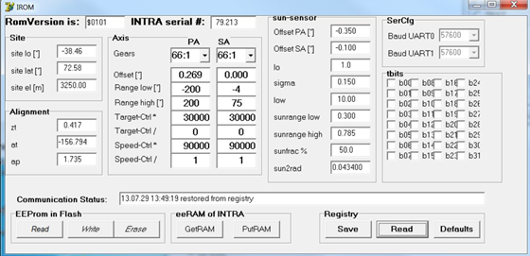

rwb: The above values in the eeprom are those for the controller board that was used until June 2016. This can be seen from the serial number. When I installed the new board (#252) in June, I edited the serial number accordingly and also changed the Io-value from 1.0 to 5.0. The low value for Io may cause problems during low elevation or partially clouded conditions, because low level signals on the sensor that should be discarded are considered valid and lead to wrong movements.

When the tracker reaches the 5° positions, its submode is changed to WAITZERO and a “search zero run” is triggered. As previously, an interval is scheduled during which these flags should be detected. If this does not happen in due time, an “zero-0 or zero-1 timed out” error is reported. Zero-0 for the PA and zero-1 for the SA. This message popped up on 30.10. But less than 2 minutes later, the PA found its zero mark. And it issued the message:  
16-10-30 02:36:07 chat,zero-0 found, eposo,9380, eerrs,0, hposo,59605, herrs,0  
eposo = 9380 is the value of the position of the PA at the moment of detection of the zero mark. The strange thing is that 9380 counts correspond to exactly 360°, hence one full turn. The value of hposo=59605 corroborates this, because this as well corresponds app. to one full turn. This means, that the tracker was far above PA=360° when it started its zero search (which moves ccw). Note that positions above 200° are “illegal”, because the settings in the eeprom limit the movement of the PA to the range (-200,+200). It looks as if the values in the eeprom were garbage to allow this to happen.

Q3:  
What values did you find in the eeprom when you connected to the tracker on 31.10.?

When we connected to the tracker on 31.10, we found that the EEPROM values were unchanged since the time that we input them on 25.10. That is, they still matched Dany’s values.

Q4:  
Following the fix of the eeprom values when you switched to sun mode: What was the time of the day and what did the tracker do?

The switch to Sun mode has had different effects during different attempts. In the attempt on 25.10, the sun had recently set, and the tracker moved to a position near the location of the sunset (near the horizon and to the south), but was shown to be 165 degrees behind the sun at sunrise the next morning. On later attempts, e.g., 31.10 at about 13:00z or 14:00z, the sun was visible in the sky to the south, but the tracker pointed to a location near the horizon and to the north. We had input a new set of EEPROM parameters from Dany for this attempt. These new settings are as follows:

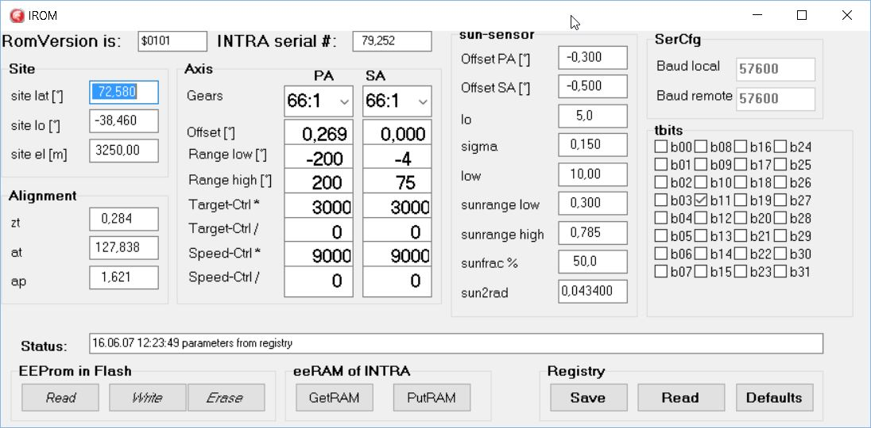

The final attempt to switch to Sun mode is described below. I should note that the sun is low during the entire day, given our high latitude at this time of year.

Q7:  
Silly question: The z following a time – does that mean “zonal time” at Summit UT – 2hours?

A word of caution: The most recent version of IntraCfg has a problem with the target and speed values in the Axis frame: The values 90000 and 30000 are shown as 9000 and 3000 because for some hitherto unknown reason, the right-most zero of these numbers is hidden. You can put the curser into such a field and using the shift right key, you may make this last digit to become visible. We will have to check IntraCfg to fix this issue.

The attempt on 25.10. You write: ….the next morning it pointed 165 degrees behind the sun. But according to the log, the tracker performed a successful rewind and zero check during all days until and including the night from 28.10 to 29.10.

SWD #2: Apologies for the confusion about the ‘z’ notation. This refers to ‘zulu’ time, or UTC. E.g., 12:00z is equal to 12:00 UTC.

I noticed earlier that the final digit of these numbers disappears out of the text field. I have used the numbers 30000 and 90000, including the final ‘0’ digit during my configurations on 31.10.

I cannot account for the successful log reports from the tracker during this time. It did not point at the sun. Could it be that it did move successfully through a daily routine, but that the alignment was off by 165 degrees?

Q8:  
How did the tracker recover from this “165° behind”-condition? Any interventions?

The intervention of 30.10. I understand you entered the new (shown above and hopefully with enough zeros for the 90000 and 30000 numbers) values into the eeprom, but otherwise did not send it any commands. Please check this if you connect to INTRA next time.

SWD #2: I believe that the tracker remained in this 165 degree behind mode after the intervention in which we sent the new EEPROM values.

I will confirm the number of zeroes in the 90000 and 30000 fields each time I connect to INTRA. You can see in the following screenshot that we entered the correct numbers on 31.10.

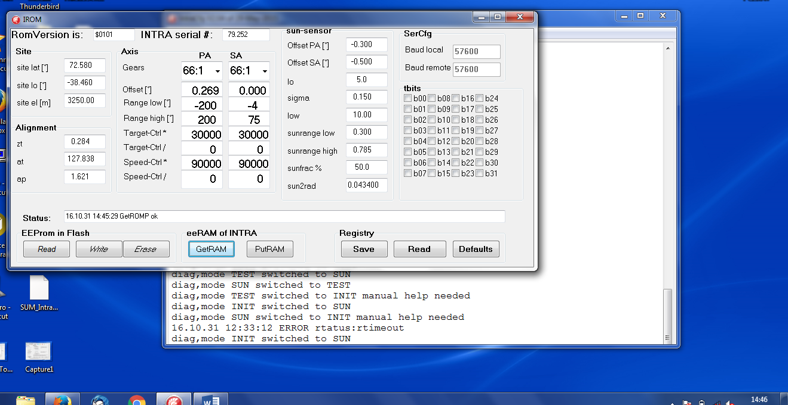

Q9:  
Did you check its position (with IntraCfg) and compare it with what you see when looking at the tracker?

Hint: Checking the position means: Open window “Positions and Modes”, then click GetPos to fetch the data from INTRA and to display them.

SWD #2: I believe we did perform this test. I will check our screenshots from our evening diagnostics on 31.10 and see if I have the results.

Q5:  
Is the tracker now up and running or what is its current status?

On the final time that we switched to Sun mode (31.10, 18:54z), the tracker completed a full 360 rotation in azimuth (moving ccw), and then continued to rotate. We were concerned that further rotation could damage the instrument, so we hit the ‘reset’ button in the ‘position window’ to stop motion. We used the “Run Motor” function to reverse this motion by 90 degrees, then hit ‘reset’ to stop. We left the instrument in this state.

Thank you for your help with the diagnosis of this issue!

Ok, this left the tracker with power on and mode “INIT”. It would be helpful to have an idea about the current position of the tracker and compare it with what you see. And then you could perform a search zero and relaunch the tracker in clock mode. Sun mode currently is not advised, because of the very low elevation of the sun. So we better use clock mode for our “diagnostics” operation.

Tracker system of coordinates: When the tracker points to the crossing of the south-meridian with the horizon, this corresponds to PA=0 and SA=0 or short 0.00/0.00. The crossing of the east-meridian with the horizon then corresponds to -90.00/0.00 – and correspondingly +90.00/0.00 for the crossing of the west-meridian with the horizon.

Procedure to follow – please do the following:

* Set up a connection IntraCfg to INTRA. Check the link by clicking on Utilities>WhoAmI. You should receive a string identifying the firmware – no timeouts! Please also check the issue about the 90000 and 30000 values in the eeprom. It might be helpful to also check the time setting of the tracker. Assuming you PC runs on (accurate) UT (not zone time) click on RemotCfg>TimeDate. Clicking on Now displays the time as read from the PC, clicking on Remote displays the time as fetched from INTRA and SendNow reads the time from the PC and sends it to INTRA, thereby updating INTRAs clock settings.
* Open the “Positions and Modes” window (if not yet open)
* Click GetPos and take a shot of this window.
* Write down what you think is the app. position the tracker is actually pointing to.
* Dismount the shader mechanism from the western flange (just to be cautious).
* Using the PA and SA settings in the “Run Motors” frame, position both axis of the tracker at slightly positive values. Do not believe the numbers you see in the position window, but check that the primary axis is slightly westward from the south point and the elevation points a few degrees up. The PA and SA fields in the “Run Motors” frame accept (speed-) numbers from -999 to +999. Then
* click Run and the tracker axis move accordingly. Click Reset to stop movements.
* Once the tracker is positioned to point to app. 5° / 5° check the settings in “FindZero” frame, both axis should be set for ccw operation.
* Click Go. Both axis start moving ccw and soon will hit their zero mark. This will stop the movement of the corr. axis, issue a message to the main window (and to the message buffer) and also clear the position of this axis. If the movement reaches a limit of -15°, the movement stops and an error message is generated. If you feel you might still be too far away from the true zero of this axis, you may e. g. set the other, possibly more successful axis to e. g. SA – and hit Go again. The PA will then move again, the SA will not move.
* Once both axis have found their zero mark, we recommend to repeat the procedure – but slightly modified as follows:
* Set the mode to REMOTE and enter 5 in both fields in the “Go to Position” frame
* Click on Set Target.
* Check by clicking on GetPos that the position has been reached.
* Set both axis for ccw zero search and click Go. Wait for the zero found messages.
* Set REMOTE again (check by clicking on GetMode), enter values -90 and 0 in the PA and SA field in the “Go to Position” frame and click SetTarget.
* Wait a few seconds, then set CLOCK-mode.
* Observe what the tracker does. Does it correspond to expectations? If so, attach the shader mechanism to its flange again.
* Check tracker the next day (visually only).

In case you run into too many problems, park the tracker by setting it into INIT-mode, leave its power on and contact us again.

Thank you.

SWD #2: Thank you for the detailed diagnostic instructions. I am looking forward to performing these tests, and returning the tracker to normal operation! Very best,

Sam