Solar Tracker Manual Operation and Troubleshooting – August 2020
Note: The tracker can be driven into positions in which its moving components collide, or the cables are over-tensioned and torn. When driving the tracker the use of a spotter on the TAWO roof is required to observe the tracker and provide feedback to the driver inside the building, such that the driver can always be at the controls to stop the tracker in the event that the tracker begins to move it ways that will damage it. The ‘Reset’ button on the ‘Positions and Modes’ window, ‘Run Motors’ pane stops tracker motion—this could save the tracker from self-destruction someday.

General information:
The solar tracker is located on the north side of the TAWO roof deck. Power is provided to the instrument via a power cord (yellow) running from an outlet in the NW corner of the main room in TAWO. The instrument is connected to the local network via a Digi One serial server (192.168.1.113) which allows for interface with the instrument’s data logger via Loggernet software, and with the instrument itself via the IntraCfg software. Note that the system that collects radiation science observations is different from the system that controls the tracker movement; only the tracker motion system is discussed here. For information on radiation data downloads, see the ‘Radiation Stand and Solar Tracker’ section of the GEOSummit protocol.

Outline
This document provides instruction on several relatively common maintenance or diagnostic actions:
Spatial coordinate system of the tracker
Connecting to the tracker
Verifying tracker date and time
Adjusting tracker fine alignment
Re-zeroing the tracker position

In addition, an appendix provides more detailed information on the menus of the IntraCfg software. Because this IntraCfg software is not very intuitive, it is highly recommended to review information on the relevant menus before starting work. Also included is information on system startup.

Spatial coordinates:
The solar tracker uses a unique set of coordinates to describe the position of the shade arm. Two coordinate axes are used to describe the horizontal rotation and vertical rotation of the arm, with the south horizon specified as the 0 degree / 0 degree origin. In further detail:
PA (‘Primary Axis’) – azimuth or horizontal rotation
- 0 degrees = south, -90 degrees = east, 90 degrees = west, 180/-180 = north
- ‘Clockwise’ (CW) movement is as viewed from above (e.g., moving from south to west), with position values increasing.

SA (‘Secondary Axis’) – elevation or vertical rotation
- 0 degrees = horizon, 90 degrees = zenith (up). Range is software limited to between -4 and 75.
- ‘Clockwise’ (CW) movement is down to up, with position values increasing.
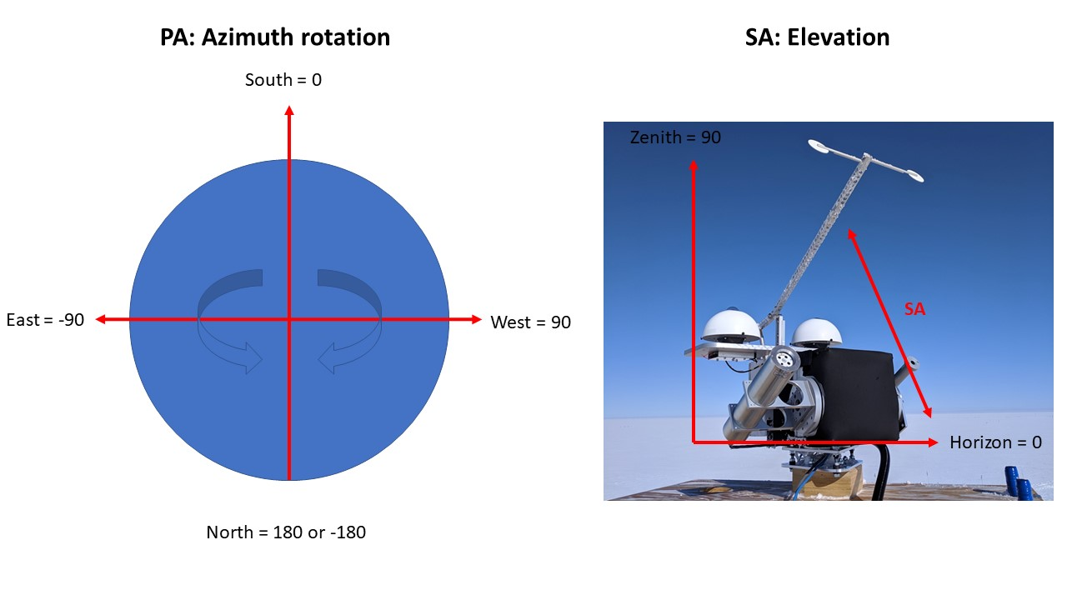

Connecting to the tracker:
Communication with the tracker is through ‘IntraCfg’ software, available at:
http://www.owel-swiss.ch/intra_downloads.html
To connect to the tracker, open the IntraCfg software on the TAWO tech computer. Select COM4 and click ‘connect’. Test the connection in the IntraCfg software by selecting Utilities > Who am I?. This should return a string of characters indicating the current software version and should not time out. If the connection is unsuccessful, verify the COM port is correct, and then try power cycling the Digi One (located on the ceiling above the CUGC, plugged in behind the HATS sampler; multiple power cycles may be necessary).

Verifying tracker date and time
Date and time

Adjusting tracker fine alignment
A set of diopters built into one of the instrument mounts on the tracker can be used to check how well aligned the tracker is with the sun. See the Radiation Instruments Protocol for specific instructions on how to check and grade instrument alignment.
The fine alignment of the tracker with the sun when in ‘CLOCL’ can be fine-tuned by inputting corrections into the “Alignment” section of the IROM window.
- zt = Zenith-distance of the pole of the tracker system
- at = Azimuth of the pole of the tracker system
- ap = rotational misalignment of the primary axis with respect to south.

Re-zeroing the tracker position
Note: While this realignment action is sometimes necessary, it does come with risks of damage, and so should only be done on instruction of the PIs. Before performing this step, it is recommended to (1) confirm the date, time and geographic coordinates are correct in the EEPROM settings (2) review the software modes and settings section below.
When the tracker does not correctly register its position, it may point in a completely incorrect direction and may or may not continue to move. It can be re-trained by directing the tracker into a special zero position where the tracker should once again recognize its position.
This process requires a partner on the roof as a spotter. In the ‘Positions and Modes’ window, use the ‘Run Motors’ command to direct the vertical axis of the tracker arm (SA) into a position about 10 degrees above the horizon. To do so, set SA to +400 to prepare an instruction to raise the arm at a moderate speed, click ‘Run’ to execute this instruction, and wait for the spotter on the roof to indicate that the position has reached 10 degrees above the horizon. Click ‘Reset’ to stop the motion. If the tracker arm needs to be lowered rather than raised, use a negative SA run motor value of -400. Beware that the ‘Run Motors’ command overrides any self-preservation protections on the motion of the arm and the tracker will damage itself if driven too far in any direction. Use a spotter on the roof and be ready to respond to their feedback.
Now repeat this process with the horizontal axis (PA) of the tracker arm. Use the ‘Run Motors’ command to orient the tracker arm to a location 10 degrees to the west of due south (this is about an outstretched fist’s width to the right of the Met Tower from TAWO). The recommended motor speed is +400 (move arm west from south) or -400 (move arm east from south). Do not drive the stand in a complete circle—the arm should never continue to rotate past due north. At this point, both the elevation and azimuth are within ~10 degrees of zero in the positive (up/west) direction.
In the adjacent ‘Find Zero’ pane, select PA ‘-‘ and SA ‘ccw’. The two selection boxes inside the FindZero frame allow to specify in which direction the motors should move: ccw, cw or – where – means "no movement". This instructs the system to search for the zero point moving the arm downwards in the vertical axis only. Click ‘Go’. The motors should run for a short time and stop automatically when the zero point is reached on the encoders. Following a click on the Go-button, the motors move until they encounter the zero mark or have moved 15° - whichever comes first. It is possible to repeat the FindZero command multiple times to approach the zero mark, but it is recommended to set the arms to the 10 degree position as described. Once the motors have stopped, click ChkAxis and view the status message to confirm valid positions. Click on GetPos to update the position information shown in in the fields above the button and confirm that the target and actual positions of the tracker are both correctly ‘0’ for the SA axis. If successful, repeat the find zero for the horizontal axis. To do so, in the ‘Find Zero’ pane, select PA ‘ccw‘ and SA ‘-’. This instructs the system to search for the zero point moving the arm CCW (eastward) in the horizontal axis only. Click ‘Go’ and confirm the result as above with ChkAxis and GetPos.
Once this find zero operation is successful the tracker should be ready to return to use. In the mode pan, click on ‘CLOCK’. The tracker will move to the position where it expects the sun – this based on current date, time, site- and misalignment parameters.

Appendices

Software modes and settings

File
- Save (may be used for documenting diagnostics) - Selecting save opens a dialog as shown:
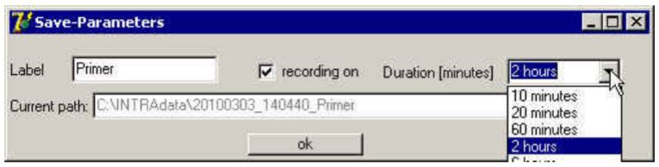
When recording on is selected, the save-menu appears checked and the program records all terminal input received from INTRA on disk. Periodically, a new file is started. The period may be selected in the Duration field. The filename generated consists of the date, time and the contents of the Label-field.
- Path - Selecting this entry opens a path/file selection dialog. Clicking on ok starts recording as described under "save". If recording is already in progress, a dialog box requests confirmation that indeed you want to close the current file and continue with a new one.
- Exit - Closes all files and terminates program.
RemoteCfg
- EEPROM – Opens the EEPROM dialog.
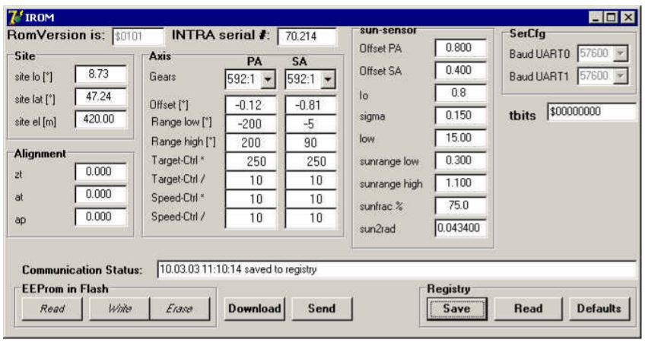

Some of these parameters are informative only, but most of them are actually used in computations by the firmware. Some of the parameters are defined at the factory (M), some are defined by the user (U) and some are computed/updated (P) by the firmware during operation.
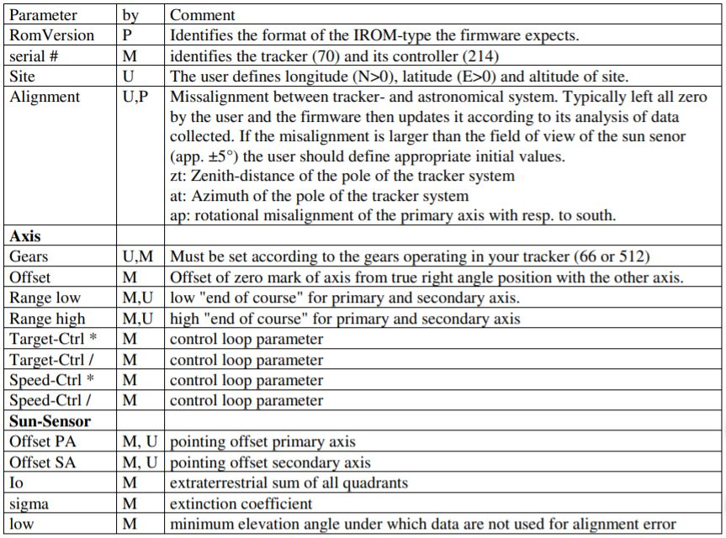
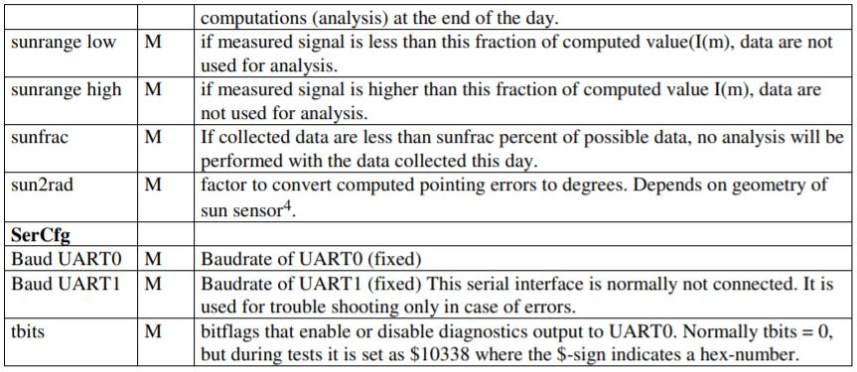

At the low rim of the IROM-windows one finds a field where communication status messages are displayed – as they result from clicking on any of the buttons below this field.
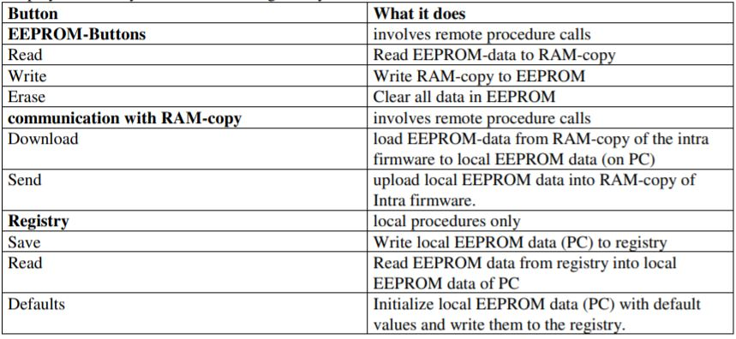
- TimeDate - Clicking on this menu entry brings up the time-date window as shown below.
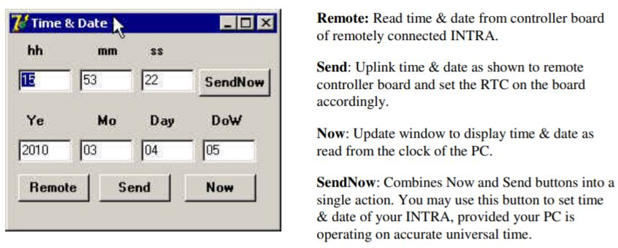
- Comsettings
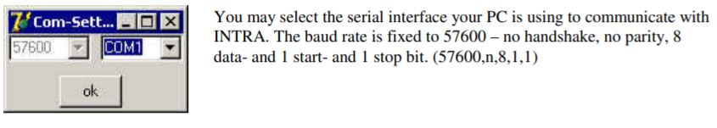

Utilities
- WhoAmI - Clicking on this entry will display the ROM-version and the version string as fetched from the remotely connected INTRA.
- Position - This entry brings up a window that allows to control many aspects of INTRA. The Position window is shown below:
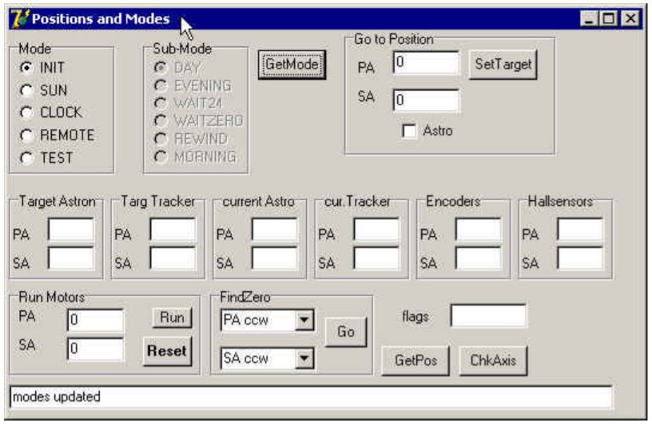
Some of the parameters of this window are fetched from INTRA upon start of the program. Other remain yet undefined until you press one of the relevant buttons.
GetMode: Updates the display of current Mode and Sub-Mode of the tracker. Clicking on any of the Modes (except TEST) will put the controller in the corresponding mode. Sub-Modes are read-only and controlled within the software functions. Modes are as follows:
- INIT: unknown
- SUN: One science operation mode. Points the tracker arm at the rough expected location based on location, time and astronomical tables. Uses the sensor eye on the tracker body to make fine adjustments based on the observed sun location. This can be problematic at Summit due to low sun angle, cloud cover, and frost on the sensor eye.
- CLOCK: Another science operation mode. Similar to SUN, but using only the expected sun position and no feedback from the fine-pointing sensor.
- REMOTE: Used when manually inputting target positions with the ‘Go to Position’ function.
- TEST: Automatically activated when using the ‘Run Motors’ function to position the tracker for zeroing.

SetTarget: The positions specified in the PA- and SA fields are uplinked to the tracker. If Mode is REMOTE (or later set to REMOTE) it will move to the specified position. Positions specified are wrt the tracker system – unless the Astro is checked, then positions are wrt the astronomical system.
Run Motors - Run: Runs the motors with the speed as specified in the PA- and SA-fields in the Run Motors frame. Speed is specified as a number in the range [-999,999] where – means ccw rotation of the axis. This command allows to move INTRAs axis under manual control – independently of the current status of the position and mode of the tracker. When clicking on Run, the tracker is set into TEST mode and just moves according to the speed specified.
Run Motors - Reset: Stops movement of either axis and restores previous mode of INTRA.
Find Zero - Go: Start movement to locate the zero marks of the PA and SA. The direction of the search is selected from the resp. selection boxes in the FindZero frame. ccw (counter-clockwise), cw (clockwise) or – (no search). The FindZero-Command moves an axis until it encounters the zero mark or it completed a move of 15° - whatever comes first.
GetPos: Updates the positions information displayed in the 12 fields above.
ChkAxis: Fetches flags from the tracker and displays them in the message field at the low rim of the Positions and Modes window.
The positions displayed include 4 systems of coordinates and target (where it should go) and current values (where it currently is). The 4 systems are:
Astron: Astronomical system – or better what INTRA assumes as the astronomical system, based on the misalignment parameters currently in effect.
Tracker: Position deduced from the signals of the encoder disk taking into account the offset of the zero mark from the EEPROM data.
Encoders: Raw count of encoder signals – 9380 per 360° The count is cleared when hitting the zero mark of an axis.
Hallsensors: Raw count of hall sensors. 3 per rotation of the motor. Ratio to encoder counts depends on gears installed and the ratio of the worm drive (150 nom.). The counts are cleared when hitting the zero mark of an axis.
- Sun
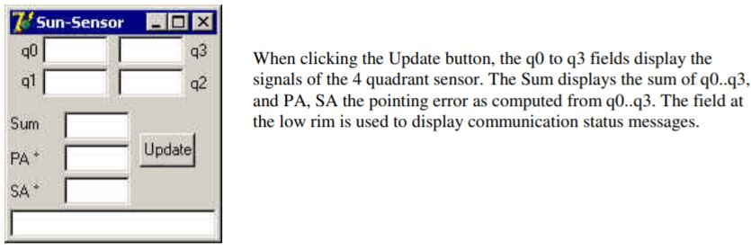
- Memory - This entry is for use by the manufacturer only and is not documented.
- ADC
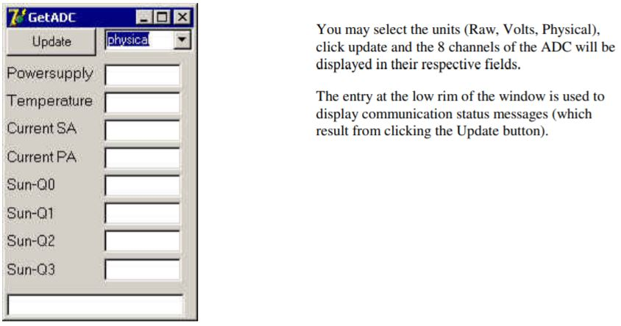

Messages
INTRAs controller implements an internal ring buffer (in RAM) where diagnostic messages are stored. The entries under this menu allow to see and administrate the contents of this (remote) ring buffer.
LoadLog: Fetches the remote ring buffer and displays it in a text window.
UpdateLog: Fetches possible new data from the ring buffer and displays it in a text window.
ClearLog: Brings up a window that allows to select the remote log-level (Severe, Short, Extensive).

LocalLog
Select loglevel for local program (IntraCfg). (Severe, Short, Extensive). The entry that is currently in force is checked.

Basic startup and shutdown
Doubleclick on the IntraCfg-Icon on your desktop and the program will open a window as shown below. This may take a few seconds, because the program tries to connect to INTRA – which has no power yet.
Now you switch INTRAs power on. The redboot startup message will be displayed in the terminal window and after 4s, redboot will start the intra firmware ifw.
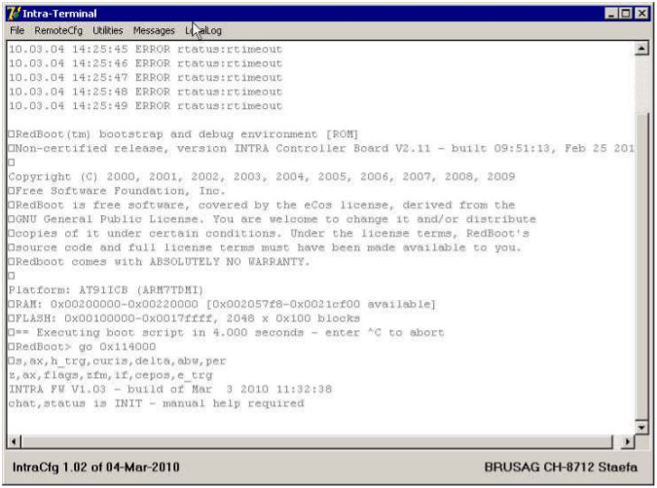
The second-last line in the windows shown above, reports the version of the firmware build into the tracker. Additionally, you see the version of IntraCfg at the lower rim of the Intra-Terminal window. This is important information, because the version of the firmware and of IntraCfg must be combined as shown in the following table:
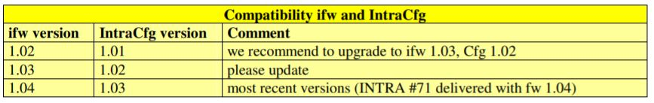
If the versions of your software do not match as indicated above, please update to the most recent firmware and also get the compatible version of IntraCfg – both from our website www.brusag.ch.
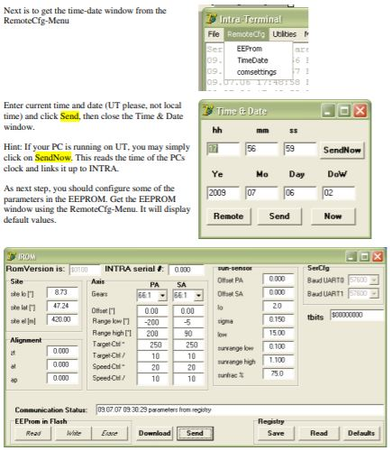
Now click on the Download-button. This will transfer the contents of the RAMcopy of the INTRAROM-contents to your PC and display it in the IROM window. Especially, you should note that INTRA serial # now displays the serial number of your tracker e.g. 66.203 where 66 is the number of the mechanical part of INTRA and 203 the serial number of the controller board.
Next, we recommend to save these original settings for later consultation. Click on the Save button in the Registry frame. This will write current settings to the registry under the key:
HKEY_LOCAL_MACHINE\SOFTWARE\Brusag\AT91

