# Zurich – Fixed Arm and Solar Tracker

***Primary contact*:** Konrad Steffen, [konrad.steffen@wsl.ch](mailto:konrad.steffen@wsl.ch)

***Secondary contacts:*** Derek Houtz, derek.houtz@colorado.edu

Karl Schroff, karl.schroff@env.ethz.ch

Guido Müller,[guido.mueller@env.ethz.ch](mailto:guido.mueller@env.ethz.ch)

How often: Daily – instrument check and cleaning

Weekly – data download

As needed- raising fixed arm instrument

Clean requirements: None

Supplies needed: Log sheets, laptop computer for data download

**Introduction**:

The radiation balance is a key factor for the climate. With the ‘Solar Tracker’ all components of the radiation have been measured since the year 2000 (with a break in winter 2002/3 and spring 18). With a long term monitoring of the radiation, the variability and changes in short and long wave radiation can be assessed. Together with climate parameters measured at the Swiss Tower an energy balance for the snow surface can be deducted.

**Procedure**:

* Daily check of the instruments: The daily checks should be done before 10 am and after each rime event.
* General note: Disturb snow surface as little as possible and use same footprints every time you access the instruments -> Figures 1a,b and 2a,b show the locations of all the instruments (‘I*’), the filters (‘F*’).
* **Fixed arm (Fig 1a,b)**: Clean rime off black filters underneath the up-facing instrument (F1 and F2) and at the end of the two orange tubes (F3 and F4). If there is rime on glass domes or dark dome (I1-I3) remove it with Kimwipes and ethanol.
* **Rotating Instrument ( Solar Tracker; Fig 2a,b)**: Clean rime off black filters underneath the instruments (F1-F3). If there is rime on the translucent glass dome or the dark glass dome (I1-I2) remove it with Kimwipes and ethanol. Clean rime off the grey tube - if necessary (I3): it is located on the right hand side of the white big box, measuring direct sunlight.
* Clean and check cables on solar tracker to confirm there are no snagging points or excessive wear on cables.
* After check/cleaning, fill in Excel sheet on ftp-Summit-server (Shortcut on desktop):

\\Server\ftp\science\Zurich\YY_FTP_ETH\YY_ETH_Logsheets.xls

**Weekly data download:**

* Throughout this process, record the appropriate information in the Swiss Logsheet:

\\Server\ftp\science\zurich\YY_FTP_ETH\YY_ETH_Logsheets.xls

***Swiss Tower***

* Check gold-colored antennas (located on the MSF roof east of the PAERI) for frost/rime build-up. Clean if necessary.
* The tower data is downloaded via radio modem at MSF. The radio modem (labeled ‘Tower’) connect to ICECAPS admin computer via the USB/Serial adapter.
* Make sure serial connectors are plugged snuggly into USB/Serial adapter.
* If not already done, create a new folder in \\server\ftp\science\Zurich\YY_FTP_ETH\YY_FTP_ETH\ (shortcut on the desktop) and name it “week##”
* Open PC208 software. There is a shortcut on the desktop of the ICECAPS PC for this.
  + - (Note: If the COM port needs to be changed, the settings in the PC208 software will need to be changed within the settings menu. The easiest way to do this is click and drag the “Tower” and its parent item in the communications tree on the left of the settings window to the new COM port number.)
* If the CR23X window does not appear, click the ‘Connect’ icon.
* Highlight ‘TOWER’ in left window in PC208W to select the 4-meter Swiss tower
* Click on ‘Connect’ button in right lower corner
* Compare data logger time with time server.
* Note the time difference and adjust if necessary (>= 2sec) with ‘Set Data logger Clk’ button
* Ensure that ‘Prompt for data filename’ is enabled
* Click button ‘Advanced’ and confirm that displayed pointer number matches that on log sheet from previous week. Adjust if necessary.
* Click ‘Collect’ button to download the new data
* In the dialog box that opens, select the Z:\ drive. NOTE: many directories will appear as garbage characters in this dialog box. You may have to do some guesswork. Select the directory: \\server\ftp\science\Zurich\YY_FTP_ETH\YY_FTP_ETH\week##\‘TU###.dat’. The week number coincides with the folder created above, and the file number follows the log sheet.
* Click on the ‘ok’ button to start the download
* When the download is completed click again the ‘Advanced’ button and record the new pointer number on the log sheet
* Open the downloaded file and note the day of year and the time (the first and the last row of file, 3rd and 4th position) on the log sheet
* Click ‘Disconnect’
* Exit PC208W software by pressing the “X” in the upper right.
* If this process fails due to radio issues, consult alternative procedure in Zurich FTP folder.

***Solar Tracker***

* On Dell ruggedized laptop in TAWO (or other computer with RealPort and LoggerNet software) open LoggerNet
* Browse to ‘Main’ and click ‘Connect’ and then select CR23X
* If the connection does not work then click the Start/Windows icon and type ‘Device Manager’, open dropdown menu for COM and LPT ports, and check if COM5 – Digi One is there. If not first check if the Digi One is visible by opening a web browser and typing 192.168.1.113. This should take you to the login page for the Digi One serial to Ethernet converter device. The username is ‘root’ and the password is ‘eth_wsl’. Login to the Digi One with these settings. Now open the RealPort software and make sure the Digi One with this IP address is located and assigned at COM5 port on the computer. These steps should diagnose any software issues. If it still doesn’t work there may be a lose connection or hardware issue.
* Click ‘Connect’ in the upper left and then ‘Collect Now’ to download the data from the logger. The default location for the data is on the network drive \\Fileshare\ftp\science\zurich\DIF.dat (if it has been more than 1 week there may also be a DIF2.dat file, copy this over too). Drag this file to the week directory in \\Fileshare\ftp\science\zurich\YY_FTP_ETH\YY_FTP_ETH\week##\DIF##.dat
* It may take ~40 min to download the data, then the user MUST click Disconnect in the upper left for the logger to resume logging data.

***Albedo Stand (Fixed Arm)***

* At the albedo stand / fixed arm data box, PRESS THE WHITE BUTTON on the CR1000 before doing anything. When the LED shows solid Green, remove the CF memory card from the logger. Insert the other card (STEFFEN ALBEDO 1 or STEFFEN ALBEDO 2).
* Insert the card into a computer or card reader and open LoggerNet software. Select ‘Data’ and then click ‘Card Convert’.
* Click ‘Change Output Dir…’ and select the directory for the data download: \\Fileshare\ftp\science\zurich\YY_FTP_ETH\YY_FTH_ETH\weekXX\
* Click ‘Start Conversion’ to download the data from the card
* When download is complete, delete all the files on the card and safely eject it from the PC for exchange next week

**Raising radiation stands:**

See raise protocol at /ftp/science/Zurich/resources/Steffen Solar Raise Protocol.

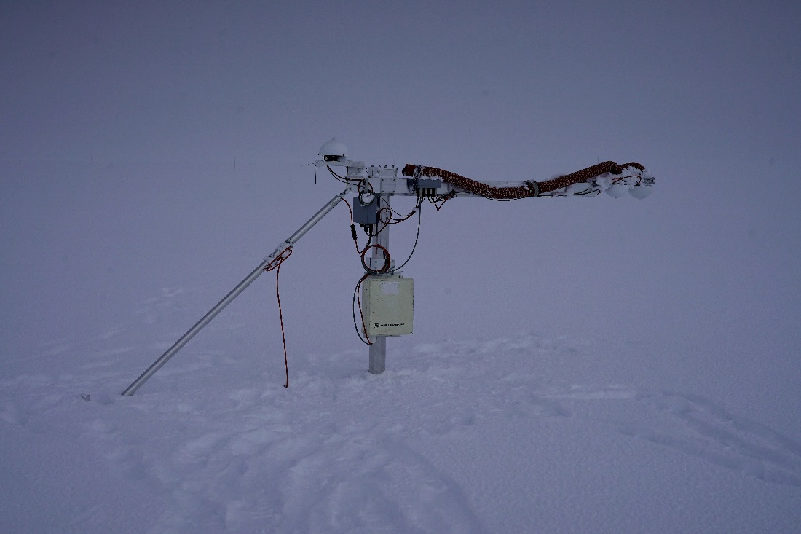

I3

I2

I1

**Fig 1a: Fixed radiometer stand with instruments I 1-3.**

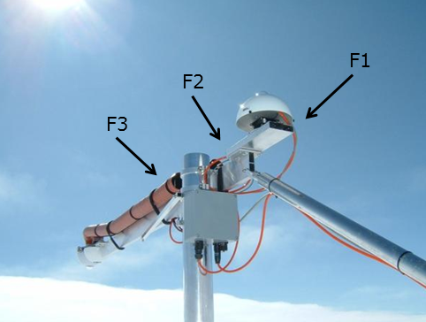

**Fig 1b: Fixed radiometer stand with filters F 1-4.**

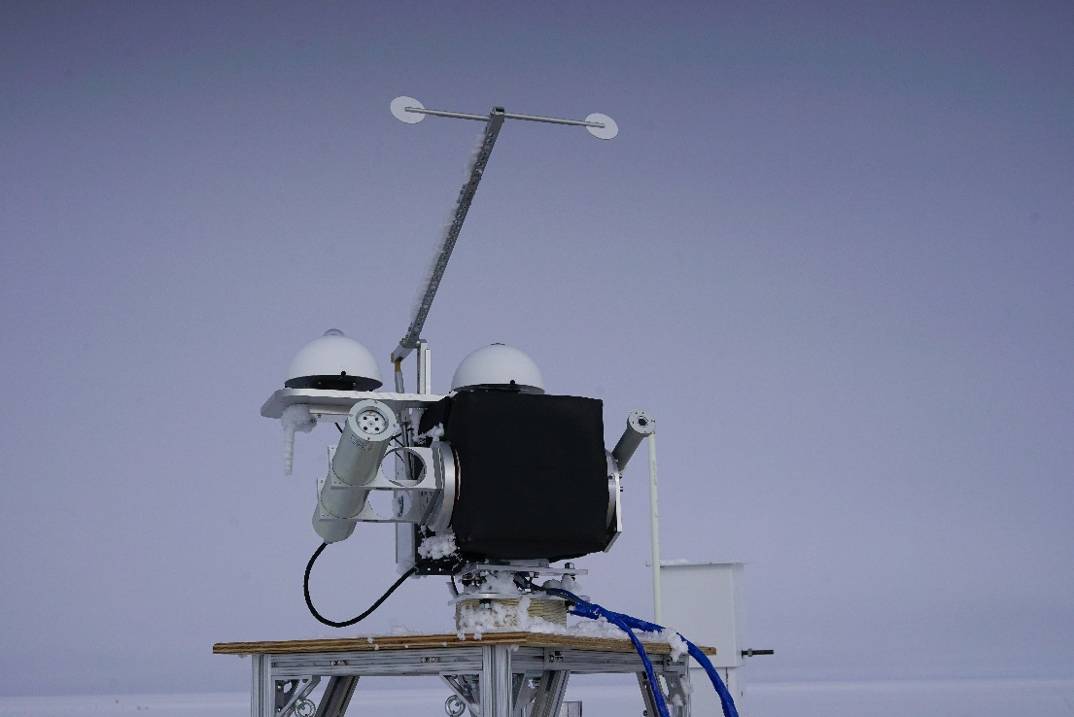

PFR

I3

I2

I1

**Fig 2a: Solar Tracker with instruments I 1-3.**

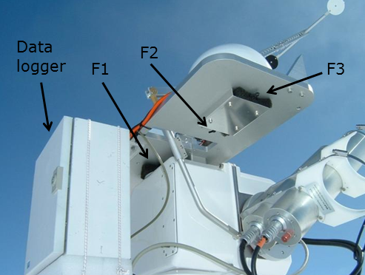

**Fig 2b: Solar Tracker with filters F1-3 and data logger.**

# Zurich – Precision Filter Radiometer (PFR) Sunphotometer

***Primary contact:*** Dr. Stephan Nyeki, stephan.nyeki@pmodwrc.ch

***Secondary contacts:*** Konrad Steffen, konrad.steffen@wsl.ch

Karl Schroff, karl.schroff@env.ethz.ch

How often: Daily – instrument check and cleaning

Weekly – data download

Clean requirements: None

Supplies needed: Daily: Ethanol

Kim wipes (left over from BSI cleaning)

soft-bristled brush.

Weekly: triangular key to open PFR enclosure (attached to the PFR)

SciTech-2 Toughbook laptop computer

SC32A (to reset PFR clock)

black or white data storage module.

ICECAPS admin computer (in MSF)

“IceBox” with SC532 for data download (in MSF)

**Introduction:**

Aerosol optical depth (AOD) is critically important to an understanding of how Earth's climate is radiatively forced, and to complement satellite observations and global scale model calculations. AOD is a quantitative measure of the extinction of solar radiation by the vertically integrated aerosol load.

The Precision Filter Radiometer (PFR) is a four-channel (368, 412, 500, and 862 nm) solar instrument. It is mounted on the west side of the CIRES solar tracker (when the tracker is facing south). The datalogger and storage module reside in the east facing enclosure. To check the PFR tracking and alignment look at look at how the sun illuminates the two small red circles located on the outside of the aluminum PFR mount.

*This instrument is removed from the tracker in the fall when the internal temperature loses stability. It is reinstalled in the spring. Remove the instrument from the mount, and the data storage module from the enclosure. Store the PFR and Data Storage Modules at MSF.

**Daily Check:**

* Check the PFR’s window for snow, rime or frost. Note in log.
* If necessary, clean using a soft bristled paint brush.
* Use alcohol and a Kim wipe to clean window.
* Check the PFR’s alignment (Fig 1), note position in log. This check may be difficult given the solar tracker’s relocation to the roof of the TAWO building. The only time this alignment check could be safely conducted would be in the early morning or late evening when the sun is in a position where the diopters can be viewed from the stand.
* Clear diopter pinholes of snow.

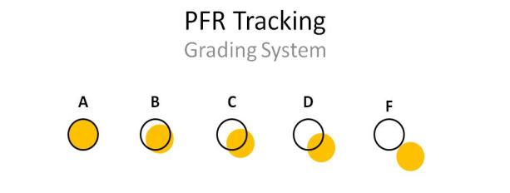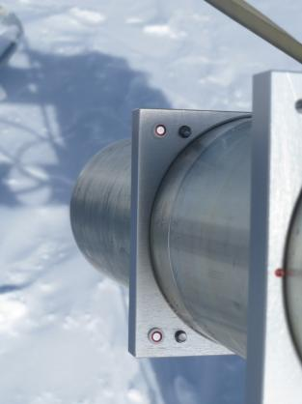

**Fig 1: Daily tracking check using the diopters on the side of the PFR tube**

**Weekly Data Download:**

The PFR data can be downloaded either via a laptop (make sure PC200W software is installed) at the instrument, or by bringing the storage module into MSF.

**At instrument:**

* Check that the time on the laptop is synced with the NIST time server.
* Take the following to the PFR:
  + SciTech2 Toughbook laptop (ensure that it is the correct laptop, only the Toughbook with a serial port will connect to the PFR)
  + SC32A optically isolated RS232 interface (with cable)
  + Triangularly shaped key for opening the PFR electrical enclosure
  + Replacement Data Storage Module (black or white)
* At the solar tracker open the East-facing enclosure labeled PFR Box
* Disconnect the DB-9 connector from the Data Storage Module.
* Connect the laptop to the CR10 with the blue flat ribbon cable via the SC32.
* Start PC200W if it isn’t already running.
* Click the ‘Connect’ button and select ‘CR10’ from the list of instruments.
* Click ‘connect’ on the bottom right.
* Check the “Datalogger Date/Time.” Record the time offset in the ETH spreadsheet and click “Set Datalogger Clock.”
* Disconnect the Toughbook laptop.
* Swap storage modules. There is one labeled PFR 1 and one labeled PRF 2. Take the one you removed to the MSF.

**At MSF:**

Use the ICECAPS admin computer in the MSF with the PC208W software. It will keep track of the data pointer. Alternatively, this number is logged in the Swiss log sheet.

* Make sure the DC converter power for the Campbell SC532 is plugged in.
* Connect the Data Storage Module (SM4) to the “peripheral” end of the SC532. Connect the “PC” end of the SC532 to a serial port.
* Start up the PC208W software.
* Click the button labeled “Storage Module.”
* Choose the tab for SM4M/SM16M.
* Click the button for “File Naming Options” and navigate to \\server\ftp\science\Zurich\YY_FTP_ETH\YY_FTP_ETH\week##. Increase the file-name-number by one: “PFR###.dat” (check log sheet for last file number). Click “ok.”
* Click “Connect” to download. If download doesn’t start, click “get new” and wait 2 minutes.
* Record the pointer number in the spreadsheet and check the file to see if it is complete.
* Store the Data Storage Module to swap out the following week.

**PFR Seasonal Removal:**

The PFR is removed every fall (usually September) under direction from the PI.

* Remove the Data Storage Module from the PFR electrical enclosure per the Weekly Data Download instructions.
* Disconnect the LEMO connector from the back of the PFR (pull straight out, no twisted necessary), cover the LEMO connector with a whirlpack and stow (zip-tie securely) on the Solar Tracker.
* Loosen the two socket head cap screws using a 3mm hex wrench (this will loosen the Teflon pads that hold the PFR in place).
* Remove the PFR and return to MSF for safe storage.

**PFR Seasonal Installation:**

The PFR is installed every spring (usually mid-March to May) under direction from the PI.

* Slide the PFR into the outermost of two of large mounting holes (Fig 2) on the Solar Tracker. The LEMO connector should be down (Fig 3)
* Gently tighten the two socket head cap screws on the top of the aluminum mount using a 3mm hex wrench; this will cause Teflon pads to tighten down on the PFR.
* Connect the LEMO connector to the back end of the PFR.
* If necessary, connect the short orange power cable
* from the power box to the PFR box
* Set the PFR clock and install the Data Storage Module (black or white taped) per the Weekly Data Download instructions.
* Check the PFR tracking/alignment per the introduction.

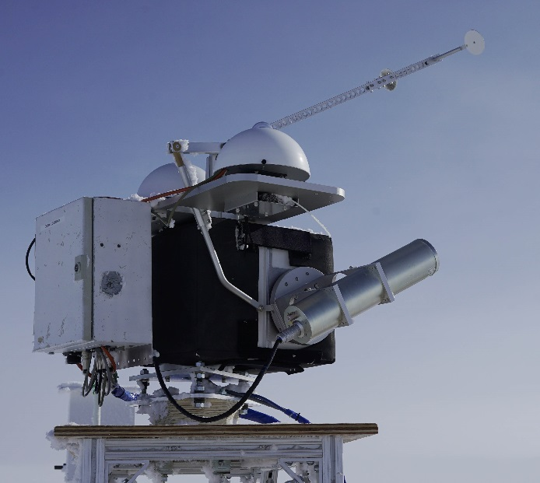

**Fig 2: Install the PFR in the outermost slot.**

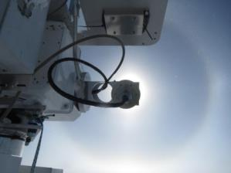 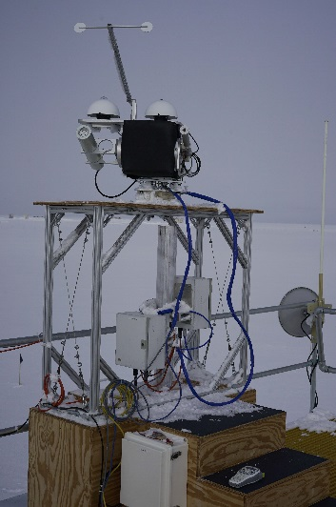

**Fig 3: LEMO connector should be down and the cable should run securely behind the CR23X logger box and down into the PFR box under the table.**

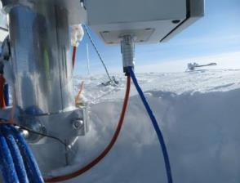

**Fig 4: The LEMO connector and orange power cable should both be connected to the bottom of the PFR electronics box.**

**Retro:**

None

**Consumable Resupply Items:**

Soft bristled brush

Isopropyl Alcohol

Kim wipes (left over from BSI cleaning)

# Zurich – Meteorology at Former 50-Meter Tower

***Primary contact:*** Konrad Steffen, konrad.steffen@wsl.ch

***Secondary contact:*** Karl Schroff, karl.schroff@env.ethz.ch

**How often:** Daily – instrument check and cleaning

Weekly – data download

**Clean requirements:** None

**Supplies needed:** Soft bristled brush

**Introduction:**

This project aims to assess the energy balance of the surface and the planetary boundary layer. Profiles of temperature, relative humidity, wind speed, and wind direction are measured up to a height of 50 meters. The data is used to examine the planetary boundary layer and - together with the data of the radiation station - an energy balance for the snow surface can be evaluated.

**Procedure:**

**Daily check:** The daily checks should be done before 10am and after rime events. As of July 2016, the 50-Meter Tower is not climbed for rime cleaning. Any rime removal is only done on lowest two instruments. Instruments are located at various heights and positions around the tower (Fig 1). Note the following:

* An instrument measuring the snow surface height is located 1 meter above the surface on a boom directing south. Avoid disturbing the snow surface in this area.
* To the east of the tower is a small, now buried, ‘Bamboo forest’. Buried sensors measure snow temperatures down to 18 meters. An upward-pointing radar is also buried10m to the northeast of the tower in the undisturbed snow sector. As a reminder, no travel is permitted in this area unless approved.
* The instruments installed at multiple heights are numbered starting with 1 at the base.

Inspect silver temperature/relative humidity tubes (Fig. 1). The black filters at the end of the tubes are subject to rime accumulation during foggy conditions, as are the aspiration fans. Spare filters are stored in the box in MSF. Do not bang on the side of the tube to remove rime; instead, brush the surface of the filter. DO NOT use a paintbrush mounted on a long bamboo pole. Inspection of upper-level instruments should be performed from the ground.

Inspect heated sonic anemometers (Fig. 1). Remove rime with a soft-bristled brush. After performing checks and cleaning, note activities in the electronic log sheet:

\\Server\ftp\science\zurich\YY_FTP_ETH\YY_ETH_Logsheets.xls

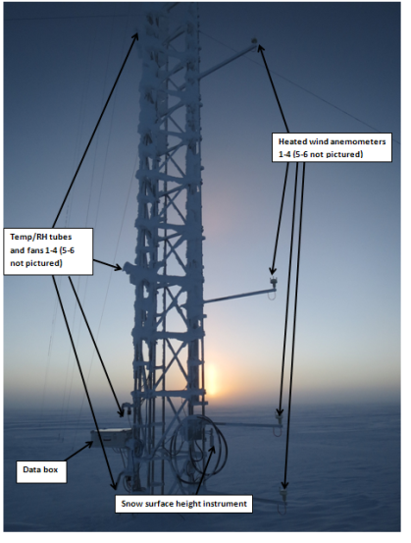

**Fig 1. Fifty-Meter Tower with lower-level instruments.**

**Cleaning sensors on upper-level booms:**

* The cleaning of these sensors is not part of regular tasking, and should only be performed after consultation with the Science Operations Manager.
* To clean the rime off the anemometers on the higher levels the boom can be retrieved: open the two black screws on the bracket.
* Grab arm outside of tower, push up and in at same time. Grab arm inside of tower, push up and in at same time. Grab arm inside of tower and pull back the rest. Guide cable so it doesn’t tangle or crinkle.
* After cleaning, push arm back, support last bit from outside tower. Tighten black screws again. Make sure the arm is level again.
* The lower arms are only cleaned from the ground. Never retrieve in the three lowers arms – the cables are not long enough for that.

**Weekly data download**

* For data download instructions, see the shared parallel procedure for Zurich – Fixed Arm and Solar Tracker.